

Name = Pratish S

Roll no = 21049

TASK - 4

**sQuestion-1**

**Write a program to perform addition on two user input numbers.**

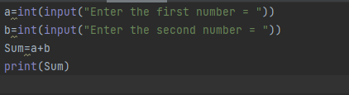

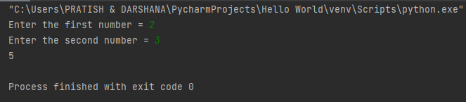

**Question-2**

#### Write a program to accept a string from the user and display characters, that are present at an even index number.



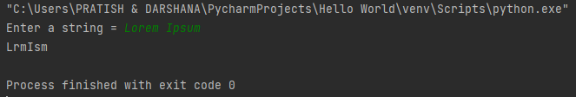

**Question-3**

#### Write a python program to make a 2-dimensional list that contains represents a table of records, for instance, student details like Roll no, Student Name, Marks; And complete the following 2 sub-tasks.

#### i) Add some records in the list and print the list in tabular form,

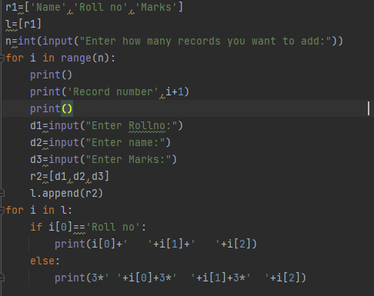

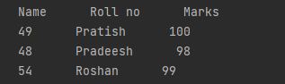

#### ii) From created list, extract and print second record/row that contains

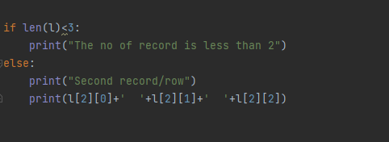

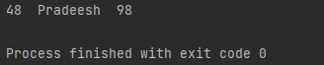

**Question-4**

#### Write a program to check if the given number is a palindrome number.

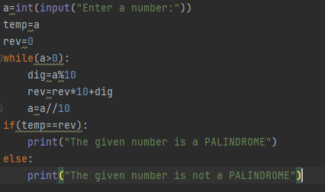

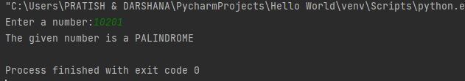

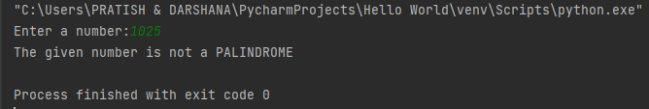

**Question-5**

#### Print the following pattern.

