

5CS037 –

## Concepts of AI and Machine Learning

Assignment: 01

Title: Analysis of the World Happiness Report: Exploring South Asia and Middle East Perspectives

Name: Pratisha Bista

Group: L5CG1

Student ID: 2408284

Module Leader: Mr. Siman Giri

Lecturer: Ms. Sunita Parajuli

Module Leader’s Signature:

___________________

Background

This report aims to statistically represent the World Happiness Report by breaking it into smaller components and analyzing the dataset and its characteristics. Metrics such as GDP per capita, social support, healthy life expectancy, freedom to make life choices, generosity, perception, and dystopia + residual were all used as measures for the final score of each country in the dataset. The main objective is to make comparative analysis of the South Asian and the Middle East region. I aim to explore whether any of the metrics show discrepancies in relation to the score and, ultimately, question whether other factors might better determine the overall happiness of a population.

The dataset includes 143 countries and 8 key metrics. The analysis focuses on two specific regions: South Asia and Middle East. The top and bottom-performing countries within these regions will help identify the regional disparities and patterns in happiness metrics.

1. Analyzing the overall Dataset
   1. Top 10 Happiest Countries by Score

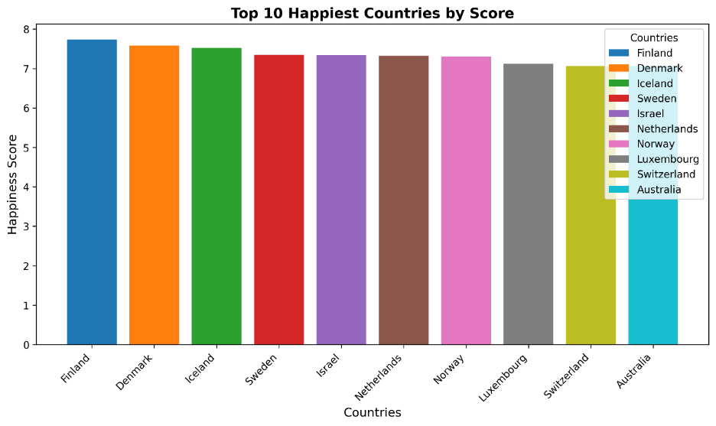

Figure 1: Top 10 Happiest Countries by Score

The bar chart above displays the top 10 happiest countries by score. X-axis represents the countries, and the happiness score is represented by y-axis. Each bar is plotted using distinctive colors to identify each one of them. The Y-axis range fits the minimum and maximum values of score which is (0-8). We can clearly observe that Finland stands as the top country with the highest happiness score, which is about 7.741, which is an impressive score for a top country. However, there isn’t much difference between Finland and all 9 other countries (7.057 – 7.741), this suggests that these nations share similar characteristics that promote happiness. If we were to observe the pattern, interestingly, except for Israel and Australia, 8 other nations are from Europe, suggesting a possible regional trend in happiness.

Figure : Top scores

* 1. How much did GDP per Capita contribute to the overall score?

Figure : Top 10 GDP per capita

From what we can observe, Finland does not even enter the top 10 in terms of the GDP per capita yet earns the highest score. Hence, GDP per capita is not contributing much to its overall score, there seems to be other metrics that are highly contributing to its impressive score. Again, the pattern suggests that 5 countries out of 10 enter the top 10 countries with the highest GDP per capita. So, the data shows, that while for 5 of the top countries, GDP per capita seemed to highly contribute to their score, the remaining countries’ score are affected by other metrics. Finnish society is built on trust, and trust is based on openness – freedom of communication and information, as well as opportunities for citizens and civil society to get involved in improving society. High levels of trust and freedom contribute to Finnish happiness (peter.marten, 2024). The mean happiness score is 5.53, with a median of 5.785, meaning that most countries fall in this range. Notably, all these top 10 countries with highest scores have scores above the global average.

* 1. Top 10 unhappiest countries by score

Figure : Top 10 unhappiest countries by Score

Afghanistan with the lowest score of 1.721 serves as an extreme outlier. It has a notable gradual decline in the happiness score. The score from Lesotho (3.186) to Eswatini (3.502) show a gradual increase. The gap between Afghanistan and Lebanon suggests that its overall score is slightly higher, from we can predict that it may have relatively better social support or infrastructure than Afghanistan. The report (*Afghanistan Is the World’s Unhappiest Country; a Look at the Top Ten Countries with Most Unhappiest People*, 2022) suggests that Afghanistan ranked first among the list of unhappiest countries in terms of physical pain, mental stress, mental disorders triggered by poverty and unemployment, anxiety, and anger.

1. Exploring South Asia and Middle East Perspectives.
   1. The South Asia Dataset

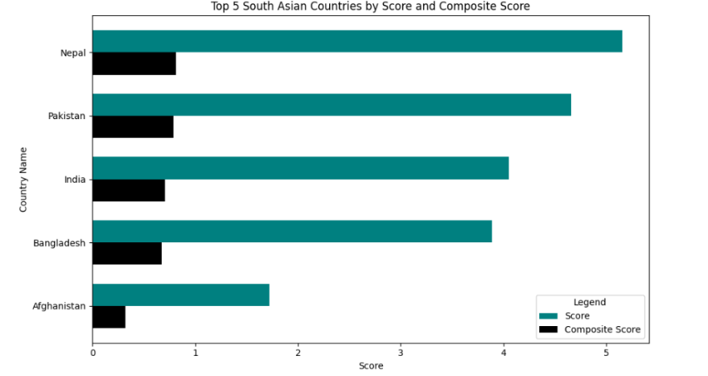

Figure : Top 5 South Asian Countries by Score and Composite Score

Nepal stands out with a high happiness score despite potentially lower economic and social support metrics. The strong cultural or psychological factors may have influenced overall happiness. Afghanistan being the unhappiest country in the world has the lowest scores in both happiness and composite metrics in South Asia and still securing top 5 in South Asia is quite tricky. In the dataset, it is an extreme outlier. This will be justified by the evidence and reasoning in the upcoming interpretation. Overall, Afghanistan faces a significant challenge in improving overall well-being and economic conditions. The composite scores, which incorporate GDP per Capita, Social Support, and Healthy Life Expectancy, are generally lower than the happiness scores for all countries suggesting that the happiness scores are influenced by factors beyond just economic and social indicators. The disparity between happiness scores and composite scores across these countries suggests that subjective well-being may not always align with objective economic and social indicators.

* 1. Outlier in South Asia based on Score and GDP per Capita.

Figure : Outlier in South Asian based on Score and GDP per capita

The scatter plot shows the relationship between the Log GDP per capita(x-axis) and the Score(y-axis) for South Asian Countries. Afghanistan is marked as an outlier with a red dot while other countries are represented with teal dots. These countries have higher scores(ranging from about 3.5 to 5.5) and Log GDP per capita values(ranging from about 0.9 to 1.2). The plot visually confirms that Afghanistan is indeed an outlier. Given that other South Asian countries are not represented, make Afghanistan appear as one of the “top 5” by default due to data limitations. Furthermore, the lack of comprehensive dataset might skew the comparison. This makes sense considering Afghanistan’s status as the unhappiest country in the world.

* 1. Top and Bottom 3 Countries in South Asia vs Middle East

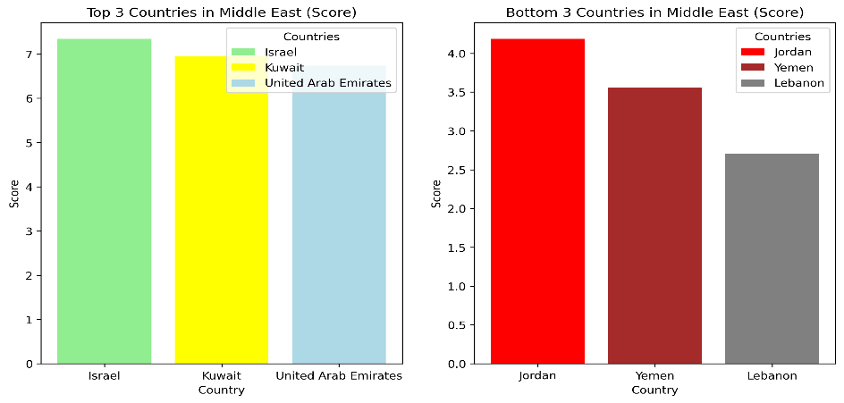

Figure : Top 3 and Bottom 3 Performers in Middle East

Israel leads with the highest score of approximately 7.5. Kuwait follows closely (approximately 7.0), and UAE ranks third. High scores in Israel, Kuwait, and the UAE are closely tied to their economic wealth and social support systems. In contrast, South Asia’s happiest country Nepal’s score (5.158) is significantly higher than the scores of Jordan, Yemen and Lebanon. This suggests better overall well-being and satisfaction among Nepal’s residents compared to these bottom 3 middle eastern countries. Despite having a significantly lower GDP per capita, Nepal's happiness score remains relatively high compared to these bottom 3 countries.

Figure : Top 3 countries with largest negative GDP-score Gaps

* 1. Mean and Standard Deviation of Score: South Asia vs. Middle East

Figure : Mean and Standard Deviation of Score: South Asia vs. Middle East

Excluding Afghanistan, an outlier, raises the mean happiness score of South Asian countries from 3.90 to 4.44 and reduces the standard deviation from 1.32 to 0.58. These South Asian countries likely share more similar socio-economic conditions and cultural factors, which is resulting in lower variability. Afghanistan’s inclusion increases variability and pulls the average down, which greatly impacts a fair comparison. Factors like prolonged conflict, poor infrastructure, and lack of social support make Afghanistan an outlier, and its exclusion provides a clearer representation of the rest of South Asia. Regardless of Afghanistan's inclusion, the Middle East region has the highest mean and standard deviation. Diverse economic conditions, cultural or regional differences might be the reason for their higher variability.

* 1. Comparison of Key Metrics between South Asia and Middle East

Figure : Comparison of Key Metrics between South Asia and Middle East

There is a high disparity in social support between South Asia and Middle East (0.53), according to the chart it seems that the countries in middle east have high social support of 1.15 whereas that in south Asia is 0.62. GDP per capita follows with a disparity of 0.42, suggesting higher income and prosperity levels in middle east. Healthy life expectancy shows the smallest disparity which could mean both regions maintain relatively similar standards in health and longevity.

1. Conclusion

We could see the patterns such as the dominance of European nations in the top 10 happiest countries and the influence of factors like trust and freedom on happiness, as seen in Finland’s case were the key patterns. However, the well-being of population is also shaped by more than just economic and social indicators evidenced by the disparity between happiness score and composite metrics like GDP per capita. Compared to South Asia, the Middle East has higher variability in happiness. Afghanistan standing as an outlier suggests that this nation needs to highly improve its overall condition. Impressively, the role of cultural or psychological factors seemed to have shaped to the Nepal’s comparatively high happiness score.

1. References

*peter.marten. (2024, March 20). For seventh year running, Finland is first in World Happiness Report – other Nordics in top 7. ThisisFINLAND. https://finland.fi/life-society/for-seventh-year-running-finland-is-first-in-world-happiness-report-other-nordics-in-top-7/*

*Afghanistan is the world’s unhappiest country; a look at the top ten countries with most unhappiest people*. (2022, September 12). Moneycontrol. https://www.moneycontrol.com/news/photos/world/afghanistan-is-the-worlds-unhappiest-country-a-look-at-the-top-ten-countries-with-most-unhappiest-people-9165731.html

Evidence of Similarity Score

