**JAYPEE INSTITUTE OF INFORMATION TECHNOLOGY, NOIDA**



**DEPARTMENT OF COMPUTER SCIENCE ENGINEERING & INFORMATION TECHNOLOGY**

**MINOR PROJECT SUMMARY SHEET**

**Title – Handwritten Character Recognition**

**Submitted By -**

|  |  |  |
| --- | --- | --- |
| **Enrollment** | **Name of the Student** | **Batch** |
| 20103012 | Pratishtha Bhateja | B1 |
| 20103016 | Muskan Mittal | B1 |
| 20103020 | Manika Agarwal | B1 |

**Under the guidance of- Ms. Kirti Aggarwal**

**Motivation behind the project**

We want to convert handwritten text to formattable text. Characters which cannot be typed easily using the day-to-day qwerty keyboard can be converted to text which can then be easily copied and used anywhere.

**Type of project**

Development cum Research Project.

**Critical Analysis of Research Paper**

|  |  |
| --- | --- |
| **TITLE** | **SUMMARY** |
| Diagonal based feature extraction for handwritten character recognition system using neural network | * Recogntion systems can be online or offline * In offline systems, neural networks yeild high accuracy * Steps are per processing, segmentation and feature extraction * a diagonal feature extraction scheme for the off-line handwritten character recognition system is proposed * Experimental results show that the diagonal feature extraction with feed forward propagation neural network yields good recognition accuracy of 96.52% with 54 features and 97.84% with 69 features.[1] |
| Comparative Study of Devnagari Handwritten Character Recognition Using Different Feature and Classifiers | * in this paper a comparative study of Devnagari handwritten character recognition using twelve different classifiers is reported * Mirror Image Learning gave overall better results among the classifiers and shown highest results (95.19%) accuracy on grey-scale curvature features.[2] |
| [Handwritten character recognition using neural network](https://www.researchgate.net/profile/Ripal-Patel-5/publication/259486519_Handwritten_Character_Recognition_using_Neural_Network/links/0a85e53aba6cce8533000000/Handwritten-Character-Recognition-using-Neural-Network.pdf) | * Objective : recognize the characters in a given scanned documents and study the effects of changing   the Models of ANN.   * Preprocess : Create a TraverseList, Scan row Pixel-by-Pixel, apply Edgedetection Algorithm. * A large number of neurons in the hidden layer help in   increasing the accuracy   * Accuracy is increased by increasing the number   of cycles.   * Accuracy could also be increased by increasing the   training set. |
| Optical-Character Recognition by Open Source OCR Tool Tesseract: A Case Study | * Optical character recognition (OCR) method has been used in converting printed text into editable text * Input images are specific * Accuracy of OCR can be dependent on text preprocessing and segmentation algorithms. * OCR performed by Tesseract on different kinds of images * Colour image to gray-scale image |
| Handwritten Digit Recognition Using Machine Learning Algorithms | * Representation of isolated handwritten digits that allow their effective recognition. * Algorithms: Multilayer Perceptron, Random Forest Algorithm, Random Tree, Naïve Bayes, Bayes Net and j48 Decision * The overall highest accuracy 90.37% * Highest accuracy is achieved for Multilayer Perceptron(neural network) * Digit dataset provided by Austrian Research Institute for Artificial Intelligence, Austria. [5] |

**Overall design of the project**

Neural networks reflect the behavior of the human brain, allowing computer programs to recognize patterns and solve common problems in the fields of AI, machine learning, and deep learning.

Once an input layer is determined, weights are assigned. These weights help determine the importance of any given variable, with larger ones contributing more significantly to the output compared to other inputs. All inputs are then multiplied by their respective weights and then summed. Afterward, the output is passed through an activation function, which determines the output. If that output exceeds a given threshold, it “fires” (or activates) the node, passing data to the next layer in the network. This results in the output of one node becoming in the input of the next node. This process of passing data from one layer to the next layer defines this neural network as a feedforward network.

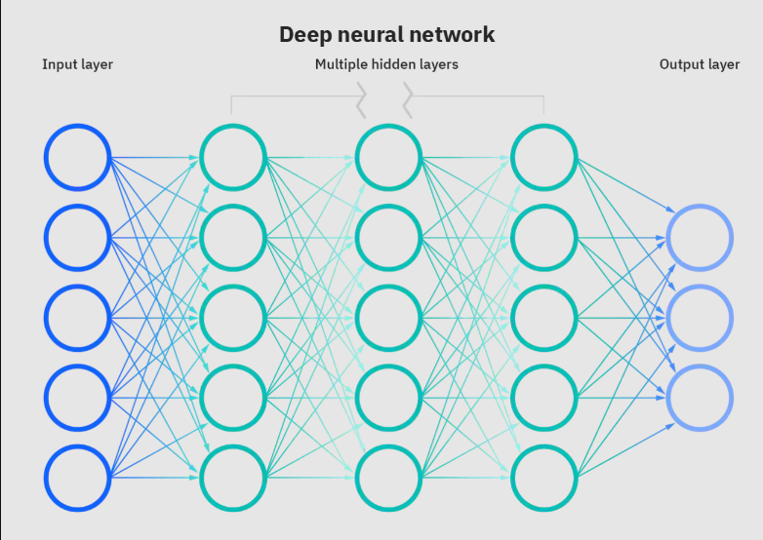

Fig -1 : Deep Neural Network model

**Features Build**

* Handwritten symbol recognition
* Testing the accuracy of the model
* Confusion Matrix

**Language Used**

Python(Jupyter Notebook and Google Colab)

Open CV

**Proposed Methodology**

We will use a neural network-based approach to train the model on available training data, and then test it. Neural networks rely on training data to learn and improve their accuracy over time. However, once these learning algorithms are fine-tuned for accuracy, thus allowing us to classify and cluster data at a high velocity. One of the most well-known neural networks is Google’s search algorithm.

**Algorithm/Description of the Work**Handwritten Image Recognition:

* Convert image to binary
* Find the characters
* Draw contours around them
* Resize to particular size
* Align the digits to center

Training the Model:

* Load dataset
* Flatten the pixels
* Pass training data through layers with different activation functions
* Printing accuracy and confusion matrix

**Division of the work among students**

i) Pratishtha Bhateja: Loading dataset and reshaping it, contouring and

preprocessing

ii) Muskan Mittal: Model making and compilation, resizing and centralizing digits

iii) Manika Agarwal: Evaluating model and confusion matrix, binarizing and

finding digits.

**Results**

We are able to recognize different handwritten characters and predict the accuracy of our model.

The dataset for these results is MNIST.



FIG 1: accuracy on test data

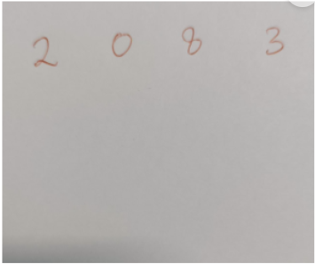

FIG 2: input image

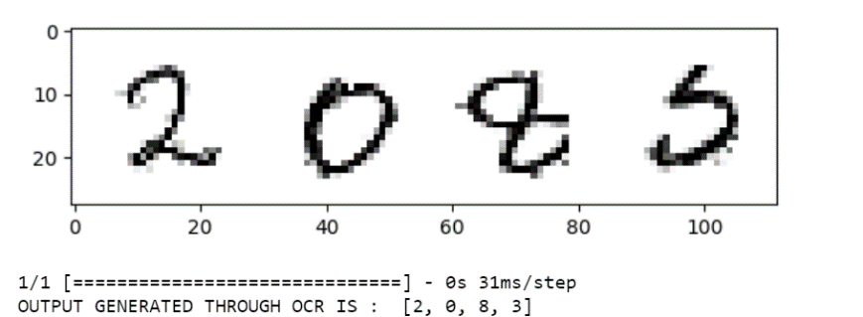

FIG-3: processed image and the generated output.

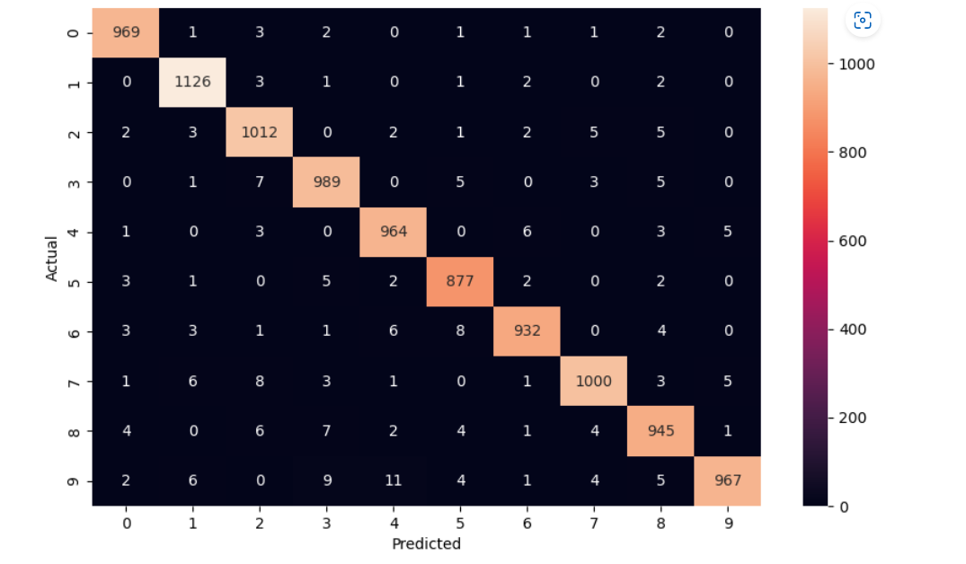

FIG 3:Confusion Matrix

**Conclusion**

As seen in the result, the model correctly predicts the numbers in the image. The accuracy on the test data is 97.81%

**Refrences**

1. Pradeep, J., Srinivasan, E., & Himavathi, S. (2011, April). Diagonal based feature extraction for handwritten character recognition system using neural network. In *2011 3rd international conference on electronics computer technology* (Vol. 4, pp. 364-368). IEEE.
2. Pal, U., Wakabayashi, T., & Kimura, F. (2009, July). Comparative study of Devnagari handwritten character recognition using different feature and classifiers. In *2009 10th International Conference on Document Analysis and Recognition* (pp. 1111-1115). IEEE.
3. Patel, C. I., Patel, R., & Patel, P. (2011). Handwritten character recognition using neural network. *International Journal of Scientific & Engineering Research*, *2*(5), 1-6.
4. Patel, C., Patel, A., & Patel, D. (2012). Optical character recognition by open source OCR tool tesseract: A case study. *International Journal of Computer Applications*, *55*(10), 50-56.
5. Shamim, S. M., Miah, M. B. A., Angona Sarker, M. R., & Al Jobair, A. (2018). Handwritten digit recognition using machine learning algorithms. *Global Journal Of Computer Science And Technology*.