## ****WEEK - 5 Microservices****

**Loyout.json**

{

"Version": 1,

"WorkspaceRootPath": "C:\\Users\\KIIT\\source\\repos\\mocroservices_project\\mocroservices_project.sln",

"Documents": [],

"DocumentGroupContainers": [

{

"Orientation": 0,

"VerticalTabListWidth": 256,

"DocumentGroups": []

}

]

}

## ****JWT****

Microsoft Visual Studio Solution File, Format Version 12.00

# Visual Studio Version 17

VisualStudioVersion = 17.14.36203.30 d17.14

MinimumVisualStudioVersion = 10.0.40219.1

Project("{FAE04EC0-301F-11D3-BF4B-00C04F79EFBC}") = "Jwt1", "Jwt1\Jwt1.csproj", "{0AE8217E-8112-4353-8061-FA3A9B0521E4}"

EndProject

Global

GlobalSection(SolutionConfigurationPlatforms) = preSolution

Debug|Any CPU = Debug|Any CPU

Release|Any CPU = Release|Any CPU

EndGlobalSection

GlobalSection(ProjectConfigurationPlatforms) = postSolution

{0AE8217E-8112-4353-8061-FA3A9B0521E4}.Debug|Any CPU.ActiveCfg = Debug|Any CPU

{0AE8217E-8112-4353-8061-FA3A9B0521E4}.Debug|Any CPU.Build.0 = Debug|Any CPU

{0AE8217E-8112-4353-8061-FA3A9B0521E4}.Release|Any CPU.ActiveCfg = Release|Any CPU

{0AE8217E-8112-4353-8061-FA3A9B0521E4}.Release|Any CPU.Build.0 = Release|Any CPU

EndGlobalSection

GlobalSection(SolutionProperties) = preSolution

HideSolutionNode = FALSE

EndGlobalSection

GlobalSection(ExtensibilityGlobals) = postSolution

SolutionGuid = {74DD7565-5310-40B5-A2ED-5D991FFC0AE4}

EndGlobalSection

EndGlobal

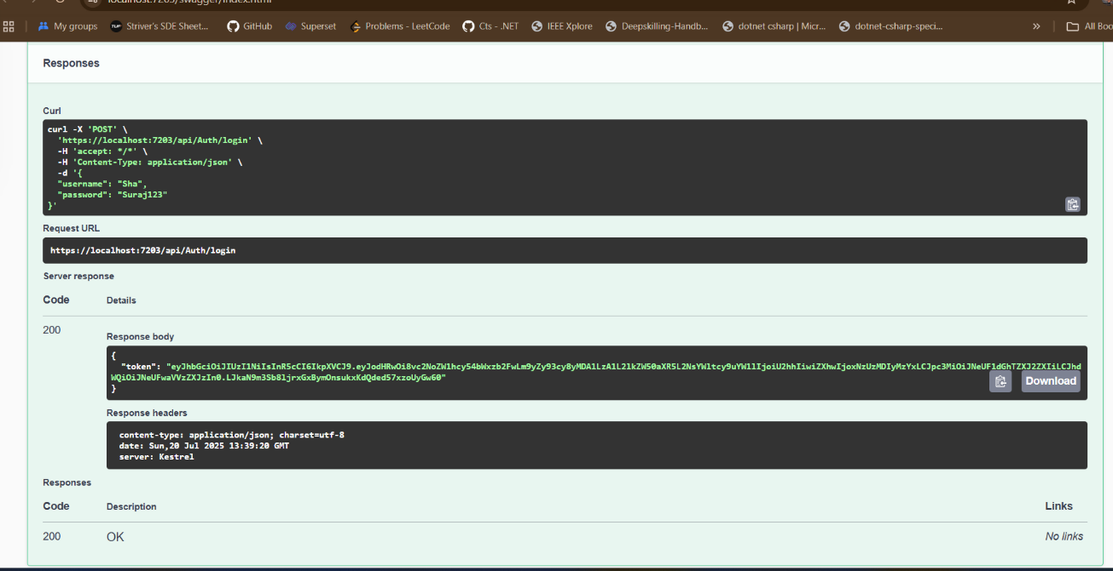

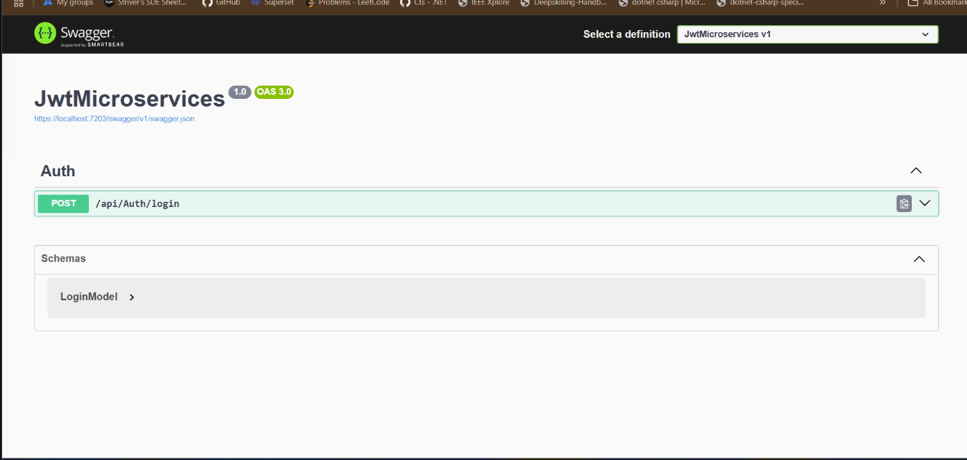

root = true

# C# files

[*.cs]

#### Core EditorConfig Options ####

# Indentation and spacing

indent_size = 4

indent_style = space

tab_width = 4

# New line preferences

end_of_line = crlf

insert_final_newline = false

#### .NET Code Actions ####

# Type members

dotnet_hide_advanced_members = false

dotnet_member_insertion_location = with_other_members_of_the_same_kind

dotnet_property_generation_behavior = prefer_throwing_properties

# Symbol search

dotnet_search_reference_assemblies = true

#### .NET Coding Conventions ####

# Organize usings

dotnet_separate_import_directive_groups = false

dotnet_sort_system_directives_first = false

file_header_template = unset

# this. and Me. preferences

dotnet_style_qualification_for_event = false

dotnet_style_qualification_for_field = false

dotnet_style_qualification_for_method = false

dotnet_style_qualification_for_property = false

# Language keywords vs BCL types preferences

dotnet_style_predefined_type_for_locals_parameters_members = true

dotnet_style_predefined_type_for_member_access = true

# Parentheses preferences

dotnet_style_parentheses_in_arithmetic_binary_operators = always_for_clarity

dotnet_style_parentheses_in_other_binary_operators = always_for_clarity

dotnet_style_parentheses_in_other_operators = never_if_unnecessary

dotnet_style_parentheses_in_relational_binary_operators = always_for_clarity

# Modifier preferences

dotnet_style_require_accessibility_modifiers = for_non_interface_members

# Expression-level preferences

dotnet_prefer_system_hash_code = true

dotnet_style_coalesce_expression = true

dotnet_style_collection_initializer = true

dotnet_style_explicit_tuple_names = true

dotnet_style_namespace_match_folder = true

dotnet_style_null_propagation = true

dotnet_style_object_initializer = true

dotnet_style_operator_placement_when_wrapping = beginning_of_line

dotnet_style_prefer_auto_properties = true

dotnet_style_prefer_collection_expression = when_types_loosely_match

dotnet_style_prefer_compound_assignment = true

dotnet_style_prefer_conditional_expression_over_assignment = true

dotnet_style_prefer_conditional_expression_over_return = true

dotnet_style_prefer_foreach_explicit_cast_in_source = when_strongly_typed

dotnet_style_prefer_inferred_anonymous_type_member_names = true

dotnet_style_prefer_inferred_tuple_names = true

dotnet_style_prefer_is_null_check_over_reference_equality_method = true

dotnet_style_prefer_simplified_boolean_expressions = true

dotnet_style_prefer_simplified_interpolation = true

# Field preferences

dotnet_style_readonly_field = true

# Parameter preferences

dotnet_code_quality_unused_parameters = all

# Suppression preferences

dotnet_remove_unnecessary_suppression_exclusions = none

# New line preferences

dotnet_style_allow_multiple_blank_lines_experimental = true

dotnet_style_allow_statement_immediately_after_block_experimental = true

#### C# Coding Conventions ####

# var preferences

csharp_style_var_elsewhere = false

csharp_style_var_for_built_in_types = false

csharp_style_var_when_type_is_apparent = false

# Expression-bodied members

csharp_style_expression_bodied_accessors = true

csharp_style_expression_bodied_constructors = false

csharp_style_expression_bodied_indexers = true

csharp_style_expression_bodied_lambdas = true

csharp_style_expression_bodied_local_functions = false

csharp_style_expression_bodied_methods = false

csharp_style_expression_bodied_operators = false

csharp_style_expression_bodied_properties = true

# Pattern matching preferences

csharp_style_pattern_matching_over_as_with_null_check = true

csharp_style_pattern_matching_over_is_with_cast_check = true

csharp_style_prefer_extended_property_pattern = true

csharp_style_prefer_not_pattern = true

csharp_style_prefer_pattern_matching = true

csharp_style_prefer_switch_expression = true

# Null-checking preferences

csharp_style_conditional_delegate_call = true

# Modifier preferences

csharp_prefer_static_anonymous_function = true

csharp_prefer_static_local_function = true

csharp_preferred_modifier_order = public,private,protected,internal,file,static,extern,new,virtual,abstract,sealed,override,readonly,unsafe,required,volatile,async

csharp_style_prefer_readonly_struct = true

csharp_style_prefer_readonly_struct_member = true

# Code-block preferences

csharp_prefer_braces = true

csharp_prefer_simple_using_statement = true

csharp_prefer_system_threading_lock = true

csharp_style_namespace_declarations = block_scoped

csharp_style_prefer_method_group_conversion = true

csharp_style_prefer_primary_constructors = true

csharp_style_prefer_top_level_statements = true

# Expression-level preferences

csharp_prefer_simple_default_expression = true

csharp_style_deconstructed_variable_declaration = true

csharp_style_implicit_object_creation_when_type_is_apparent = true

csharp_style_inlined_variable_declaration = true

csharp_style_prefer_implicitly_typed_lambda_expression = true

csharp_style_prefer_index_operator = true

csharp_style_prefer_local_over_anonymous_function = true

csharp_style_prefer_null_check_over_type_check = true

csharp_style_prefer_range_operator = true

csharp_style_prefer_tuple_swap = true

csharp_style_prefer_unbound_generic_type_in_nameof = true

csharp_style_prefer_utf8_string_literals = true

csharp_style_throw_expression = true

csharp_style_unused_value_assignment_preference = discard_variable

csharp_style_unused_value_expression_statement_preference = discard_variable

# 'using' directive preferences

csharp_using_directive_placement = outside_namespace

# New line preferences

csharp_style_allow_blank_line_after_colon_in_constructor_initializer_experimental = true

csharp_style_allow_blank_line_after_token_in_arrow_expression_clause_experimental = true

csharp_style_allow_blank_line_after_token_in_conditional_expression_experimental = true

csharp_style_allow_blank_lines_between_consecutive_braces_experimental = true

csharp_style_allow_embedded_statements_on_same_line_experimental = true

#### C# Formatting Rules ####

# New line preferences

csharp_new_line_before_catch = true

csharp_new_line_before_else = true

csharp_new_line_before_finally = true

csharp_new_line_before_members_in_anonymous_types = true

csharp_new_line_before_members_in_object_initializers = true

csharp_new_line_before_open_brace = all

csharp_new_line_between_query_expression_clauses = true

# Indentation preferences

csharp_indent_block_contents = true

csharp_indent_braces = false

csharp_indent_case_contents = true

csharp_indent_case_contents_when_block = true

csharp_indent_labels = one_less_than_current

csharp_indent_switch_labels = true

# Space preferences

csharp_space_after_cast = false

csharp_space_after_colon_in_inheritance_clause = true

csharp_space_after_comma = true

csharp_space_after_dot = false

csharp_space_after_keywords_in_control_flow_statements = true

csharp_space_after_semicolon_in_for_statement = true

csharp_space_around_binary_operators = before_and_after

csharp_space_around_declaration_statements = false

csharp_space_before_colon_in_inheritance_clause = true

csharp_space_before_comma = false

csharp_space_before_dot = false

csharp_space_before_open_square_brackets = false

csharp_space_before_semicolon_in_for_statement = false

csharp_space_between_empty_square_brackets = false

csharp_space_between_method_call_empty_parameter_list_parentheses = false

csharp_space_between_method_call_name_and_opening_parenthesis = false

csharp_space_between_method_call_parameter_list_parentheses = false

csharp_space_between_method_declaration_empty_parameter_list_parentheses = false

csharp_space_between_method_declaration_name_and_open_parenthesis = false

csharp_space_between_method_declaration_parameter_list_parentheses = false

csharp_space_between_parentheses = false

csharp_space_between_square_brackets = false

# Wrapping preferences

csharp_preserve_single_line_blocks = true

csharp_preserve_single_line_statements = true

#### Naming styles ####

# Naming rules

dotnet_naming_rule.interface_should_be_begins_with_i.severity = suggestion

dotnet_naming_rule.interface_should_be_begins_with_i.symbols = interface

dotnet_naming_rule.interface_should_be_begins_with_i.style = begins_with_i

dotnet_naming_rule.types_should_be_pascal_case.severity = suggestion

dotnet_naming_rule.types_should_be_pascal_case.symbols = types

dotnet_naming_rule.types_should_be_pascal_case.style = pascal_case

dotnet_naming_rule.non_field_members_should_be_pascal_case.severity = suggestion

dotnet_naming_rule.non_field_members_should_be_pascal_case.symbols = non_field_members

dotnet_naming_rule.non_field_members_should_be_pascal_case.style = pascal_case

# Symbol specifications

dotnet_naming_symbols.interface.applicable_kinds = interface

dotnet_naming_symbols.interface.applicable_accessibilities = public, internal, private, protected, protected_internal, private_protected

dotnet_naming_symbols.interface.required_modifiers =

dotnet_naming_symbols.types.applicable_kinds = class, struct, interface, enum

dotnet_naming_symbols.types.applicable_accessibilities = public, internal, private, protected, protected_internal, private_protected

dotnet_naming_symbols.types.required_modifiers =

dotnet_naming_symbols.non_field_members.applicable_kinds = property, event, method

dotnet_naming_symbols.non_field_members.applicable_accessibilities = public, internal, private, protected, protected_internal, private_protected

dotnet_naming_symbols.non_field_members.required_modifiers =

# Naming styles

dotnet_naming_style.pascal_case.required_prefix =

dotnet_naming_style.pascal_case.required_suffix =

dotnet_naming_style.pascal_case.word_separator =

dotnet_naming_style.pascal_case.capitalization = pascal_case

dotnet_naming_style.begins_with_i.required_prefix = I

dotnet_naming_style.begins_with_i.required_suffix =

dotnet_naming_style.begins_with_i.word_separator =

dotnet_naming_style.begins_with_i.capitalization = pascal_case

Microsoft Visual Studio Solution File, Format Version 12.00

# Visual Studio Version 17

VisualStudioVersion = 17.14.36301.6 d17.14

MinimumVisualStudioVersion = 10.0.40219.1

Project("{FAE04EC0-301F-11D3-BF4B-00C04F79EFBC}") = "KafkaProducerApp", "KafkaProducerApp\KafkaProducerApp.csproj", "{995853ED-CBB7-4C94-8BD3-6A817206DDE4}"

EndProject

Global

GlobalSection(SolutionConfigurationPlatforms) = preSolution

Debug|Any CPU = Debug|Any CPU

Release|Any CPU = Release|Any CPU

EndGlobalSection

GlobalSection(ProjectConfigurationPlatforms) = postSolution

{995853ED-CBB7-4C94-8BD3-6A817206DDE4}.Debug|Any CPU.ActiveCfg = Debug|Any CPU

{995853ED-CBB7-4C94-8BD3-6A817206DDE4}.Debug|Any CPU.Build.0 = Debug|Any CPU

{995853ED-CBB7-4C94-8BD3-6A817206DDE4}.Release|Any CPU.ActiveCfg = Release|Any CPU

{995853ED-CBB7-4C94-8BD3-6A817206DDE4}.Release|Any CPU.Build.0 = Release|Any CPU

EndGlobalSection

GlobalSection(SolutionProperties) = preSolution

HideSolutionNode = FALSE

EndGlobalSection

GlobalSection(ExtensibilityGlobals) = postSolution

SolutionGuid = {434F689E-49AC-4E32-87D8-FBF2A1928148}

EndGlobalSection

EndGlobal