Coding Practice 4

Prativa Chhetri

2025-02-26

install.packages('tinytex')  
tinytex::install_tinytex()

data("mtcars")  
ggplot(mtcars, aes(x = wt, y = mpg)) +  
 geom_smooth(method = lm, se = FALSE) +  
 geom_point(aes(color = wt)) +  
 xlab("Weight") +   
 ylab("Miles per gallon") +  
 scale_colour_gradient(low = "forestgreen", high = "black")

## `geom_smooth()` using formula = 'y ~ x'

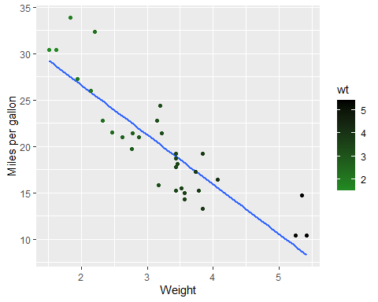

# First-level header

## Second-level header

### Third-level header

*italic* *italic* **bold** **bold** > “I thoroughly disapprove of duels. If a man should challenge me, I would take him kindly and forgivingly by the hand and lead him to a quiet place and kill him.” > > — Mark Twain

* one item
* one item
* one item
  + one more item
  + one more item
  + one more item

1. the first item
2. the second item
3. the third item
   * one unordered item
   * one unordered item

<https://agriculture.auburn.edu/about/directory/faculty/zachary-noel/> <https://agriculture.auburn.edu/about/directory/faculty/zachary-noel/> [Noel Lab](https://agriculture.auburn.edu/about/directory/faculty/zachary-noel/)

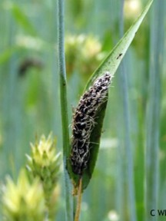

Smut

| First Header | Second Header |
| --- | --- |
| Content Cell | Content Cell |
| Content Cell | Content Cell |

kable(head(mtcars, n = 5), digits = 3, format = "markdown")

|  | mpg | cyl | disp | hp | drat | wt | qsec | vs | am | gear | carb |
| --- | --- | --- | --- | --- | --- | --- | --- | --- | --- | --- | --- |
| Mazda RX4 | 21.0 | 6 | 160 | 110 | 3.90 | 2.620 | 16.46 | 0 | 1 | 4 | 4 |
| Mazda RX4 Wag | 21.0 | 6 | 160 | 110 | 3.90 | 2.875 | 17.02 | 0 | 1 | 4 | 4 |
| Datsun 710 | 22.8 | 4 | 108 | 93 | 3.85 | 2.320 | 18.61 | 1 | 1 | 4 | 1 |
| Hornet 4 Drive | 21.4 | 6 | 258 | 110 | 3.08 | 3.215 | 19.44 | 1 | 0 | 3 | 1 |
| Hornet Sportabout | 18.7 | 8 | 360 | 175 | 3.15 | 3.440 | 17.02 | 0 | 0 | 3 | 2 |

* [Coding Pratice 4](Coding%20Practice%204.Rmd)

## File Tree

.  
└── TinyTeX-1.zip