Coding Challenge 4

Prativa Chhetri and Karamjit Kaur Baryah

2025-02-27

Table of Contents

# Link for the Paper

* [Link for paper](https://doi.org/10.1094/PDIS-06-21-1253-RE)

# Q1

*In the context of R Markdown , the YAML header appears at the top of the document, enclosed by — lines, and it contains metadata about the document.* *Literate Programming(For eg. R Markdown) is documentation and code live together in the same file, making it easy for others (and your future self!) to understand not just what the code does, but why it was written that way.*

# Q2

## 2 (B)

mycotoxin=read.csv("MycotoxinData.csv", na.strings = "na")  
mycotoxin$Treatment <- as.factor(mycotoxin$Treatment)  
mycotoxin$Cultivar <- as.factor(mycotoxin$Cultivar)

## 2(C)

### CbbPalette

cbbPalette <- c("#56B4E9", "#009E73")

### DON_PLOT1

Plot1 <- ggplot(mycotoxin, aes(x = Treatment, y = DON, fill = Cultivar)) +  
 geom_boxplot() + # add boxplot layer  
 xlab("Treatment") +   
 ylab("DON (ppm)") + # y label  
 geom_point(alpha = 0.6,pch = 21, color = "black", position = position_jitterdodge()) +  
 scale_fill_manual(values = cbbPalette)+ # transparency of the jittered points to 0.6. #Jitter points over the boxplot and fill the points and boxplots Cultivar with two colors from the cbbPallete   
 facet_wrap(~Cultivar)+ #faceted by Cultivar  
 theme_classic() # for classic theme   
Plot1

## Warning: Removed 8 rows containing non-finite outside the scale range  
## (`stat_boxplot()`).

## Warning: Removed 8 rows containing missing values or values outside the scale range  
## (`geom_point()`).

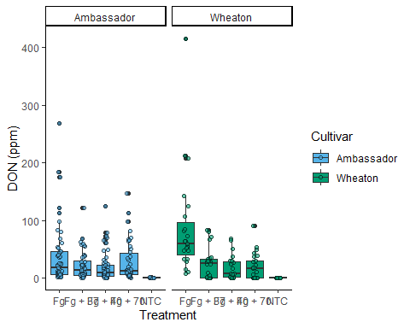

### 15XADON_PLOT2

Plot2 <- ggplot(mycotoxin, aes(x = Treatment, y = DON, fill = Cultivar)) +  
 geom_boxplot() + # add boxplot layer  
 xlab("Treatment") +   
 ylab("15XADON") + # y label  
 geom_point(alpha = 0.6,pch = 21, color = "black", position = position_jitterdodge()) +  
 scale_fill_manual(values = cbbPalette)+ # transparency of the jittered points to 0.6. #Jitter points over the boxplot and fill the points and boxplots Cultivar with two colors from the cbbPallete   
 facet_wrap(~Cultivar)+ #faceted by Cultivar  
 theme_classic() # for classic theme   
  
Plot2

## Warning: Removed 8 rows containing non-finite outside the scale range  
## (`stat_boxplot()`).

## Warning: Removed 8 rows containing missing values or values outside the scale range  
## (`geom_point()`).

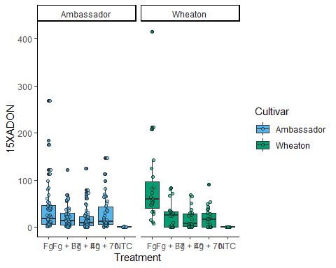

### SeedMass_PLOT3

Plot3 <- ggplot(mycotoxin, aes(x = Treatment, y = DON, fill = Cultivar)) +  
 geom_boxplot() + # add boxplot layer  
 xlab("Treatment") +   
 ylab("Seed Mass (mg)") + # y label  
 geom_point(alpha = 0.6,pch = 21, color = "black", position = position_jitterdodge()) +  
 scale_fill_manual(values = cbbPalette)+ # transparency of the jittered points to 0.6. #Jitter points over the boxplot and fill the points and boxplots Cultivar with two colors from the cbbPallete   
 facet_wrap(~Cultivar)+ #faceted by Cultivar  
 theme_classic() # for classic theme   
Plot3

## Warning: Removed 8 rows containing non-finite outside the scale range  
## (`stat_boxplot()`).

## Warning: Removed 8 rows containing missing values or values outside the scale range  
## (`geom_point()`).

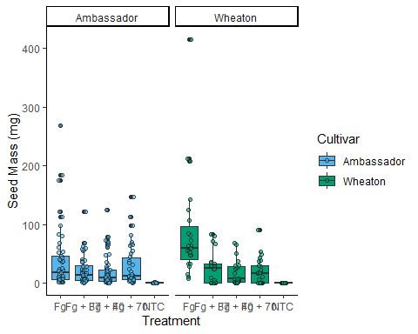

### 3Combined_PLOT

figure=ggarrange(  
 Plot1,  
 Plot2,  
 Plot3,  
 labels = c("A", "B", "C"),  
 nrow = 1,  
 ncol = 3,  
 common.legend=TRUE  
)

## Warning: Removed 8 rows containing non-finite outside the scale range  
## (`stat_boxplot()`).

## Warning: Removed 8 rows containing missing values or values outside the scale range  
## (`geom_point()`).

## Warning: Removed 8 rows containing non-finite outside the scale range  
## (`stat_boxplot()`).

## Warning: Removed 8 rows containing missing values or values outside the scale range  
## (`geom_point()`).

## Warning: Removed 8 rows containing non-finite outside the scale range  
## (`stat_boxplot()`).

## Warning: Removed 8 rows containing missing values or values outside the scale range  
## (`geom_point()`).

## Warning: Removed 8 rows containing non-finite outside the scale range  
## (`stat_boxplot()`).

## Warning: Removed 8 rows containing missing values or values outside the scale range  
## (`geom_point()`).

figure

