Lab 5: Static Code Analysis
Fitness Booking System — Final Lab Report

NAME: Pratik Patil
SRN : PES2UG24CS372
SECTION: G

1. Objective
Use static analysis tools to identify code-quality, security, and style issues, fix at least four findings, rerun the tools, and reflect on the improvements.

2. Final Results
Tool | Final result | Status
Pylint | 10.00/10 | Passed
Bandit | No issues identified | Passed
Flake8 | No violations printed; report empty | Passed

3. Issue Log and Fixes
Issue | Type | Original line(s) | Description | Fix applied
Dangerous shell execution | Security | 36 | Bandit B605: os.system() invoked a shell command using a constructed string; this also failed on Windows because `rm` is not a Windows command. | Replaced shell execution with pathlib.Path.glob(), is_file(), and unlink() to remove matching old_*.json files.
Mutable default argument | Bug / maintainability | 8 | A default list could be shared across function calls. | Changed attendance_log=[] to attendance_log=None and initialized a new list inside the function.
Bare exception | Reliability | 21 | A bare except could hide unrelated errors. | Caught the specific KeyError and ValueError exceptions expected from the cancellation operation.
Function naming style | Style | 27 | addMembers did not follow snake_case naming convention. | Renamed the function to add_members and updated its call sites.
File encoding and resource management | Maintainability | 32 | open() did not explicitly specify an encoding or use a context manager. | Used `with open(..., encoding='utf-8')` to ensure proper encoding and automatic file closure.
Missing documentation | Maintainability | 1, 8, 18, 24, 27, 31, 35, 38, 42 (original findings) | Pylint reported missing module/function docstrings. | Added a module docstring and descriptive docstrings for functions.
Formatting violations | Style | Multiple | Flake8 reported blank-line and exception-formatting violations in the original file. | Adjusted spacing and exception handling to comply with Flake8.
String formatting | Style / readability | 15 | Pylint recommended f-string formatting instead of percent-formatting. | Changed the attendance log entry to an f-string.

4. Reflection Questions

1. Which issues were the easiest to fix, and which were the hardest? Why?
Style issues such as blank-line spacing, f-string formatting, and renaming addMembers were easiest because they were localized. The hardest was the high-severity shell-execution finding: the shell command was security-sensitive and also incompatible with Windows. It was replaced with pathlib file operations.

2. Did the static analysis tools report any false positives? If so, describe one example.
No confirmed false positives were identified. The Bandit os.system() warning was actionable because it flagged shell execution and the command failed in the Windows environment. Findings should be checked against context before being classified as false positives.

3. How would you integrate static analysis tools into your actual software development workflow?
Run Flake8 and Pylint locally before committing, and run Bandit alongside them or in continuous integration. CI can flag new high-severity security issues and agreed quality violations in pull requests. Review and document justified exceptions rather than suppressing warnings without explanation.

4. What tangible improvements did you observe in code quality, readability, or robustness?
Pylint improved from 6.60/10 to 10.00/10. Bandit went from one high-severity shell-execution issue to no issues, and the final Flake8 report was empty. The code now uses a safe default-argument pattern, specific exceptions, docstrings, UTF-8 file handling, a context manager, snake_case naming, and pathlib. It ran on Windows without the original rm command error.

5. Verification and Evidence
The student captured terminal screenshots during setup, original program execution, initial findings, corrected program execution, and final tool reports. Attach the actual screenshots from the lab session to this report before submission if screenshots are required.
Final results are transcribed from the terminal screenshots provided during the session. The Word report does not embed the screenshots because they were supplied across separate chat messages; insert them in the evidence section if your instructor requires screenshots inside the document.

6. Files to Submit
- gym_system.py — corrected source file
- issues.md — issue table and fixes
- reflection.md — four reflection answers
- pylint_report.txt — final Pylint output
- bandit_report.txt — final Bandit output
- flake8_report.txt — final Flake8 output
- Lab5_Static_Code_Analysis_Report.docx — formatted report

7. Screenshot Evidence
The following screenshots were captured during the lab workflow and show setup, initial analysis, code changes, and final verification.

Screenshot 1: Repository setup and virtual environment
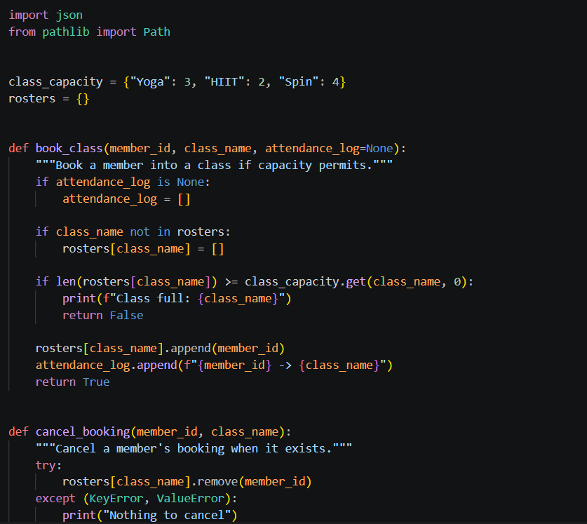

Screenshot 2: Static analysis tools installed
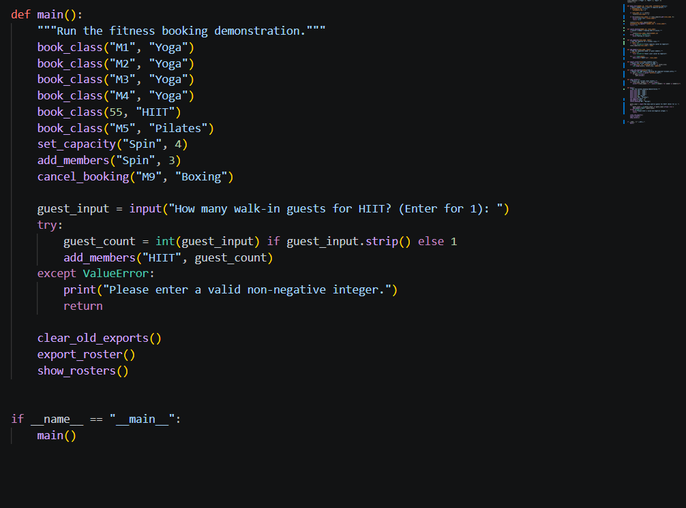

Screenshot 3: Project files inspected

Screenshot 4: Original program execution
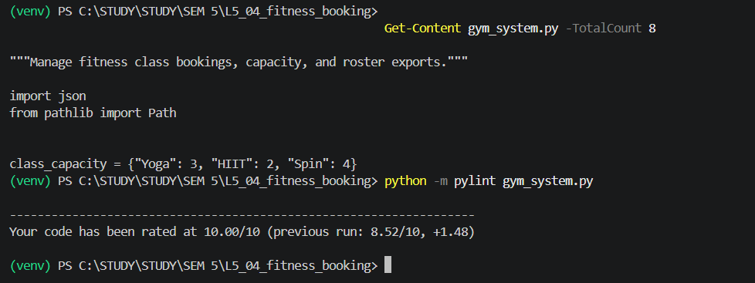

Screenshot 5: Initial reports generated
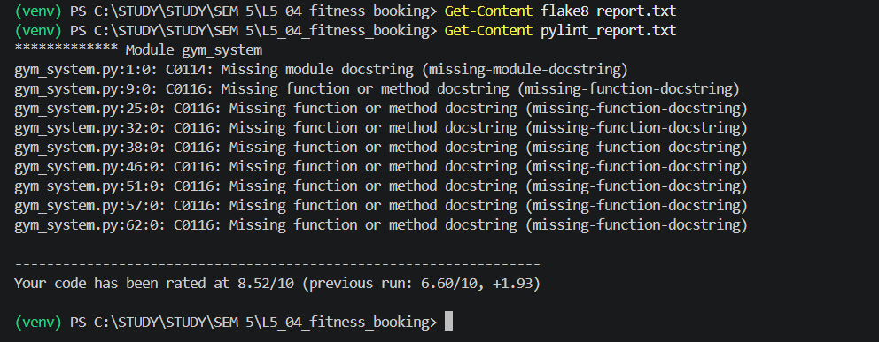

Screenshot 6: Initial Pylint, Bandit, and Flake8 findings
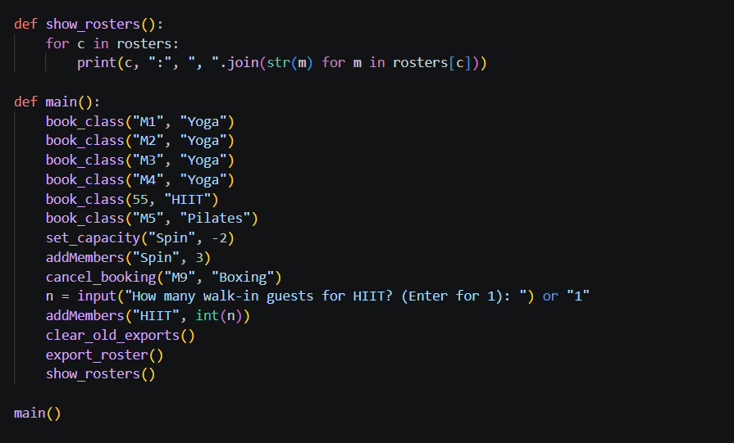

Screenshot 7: Corrected program execution
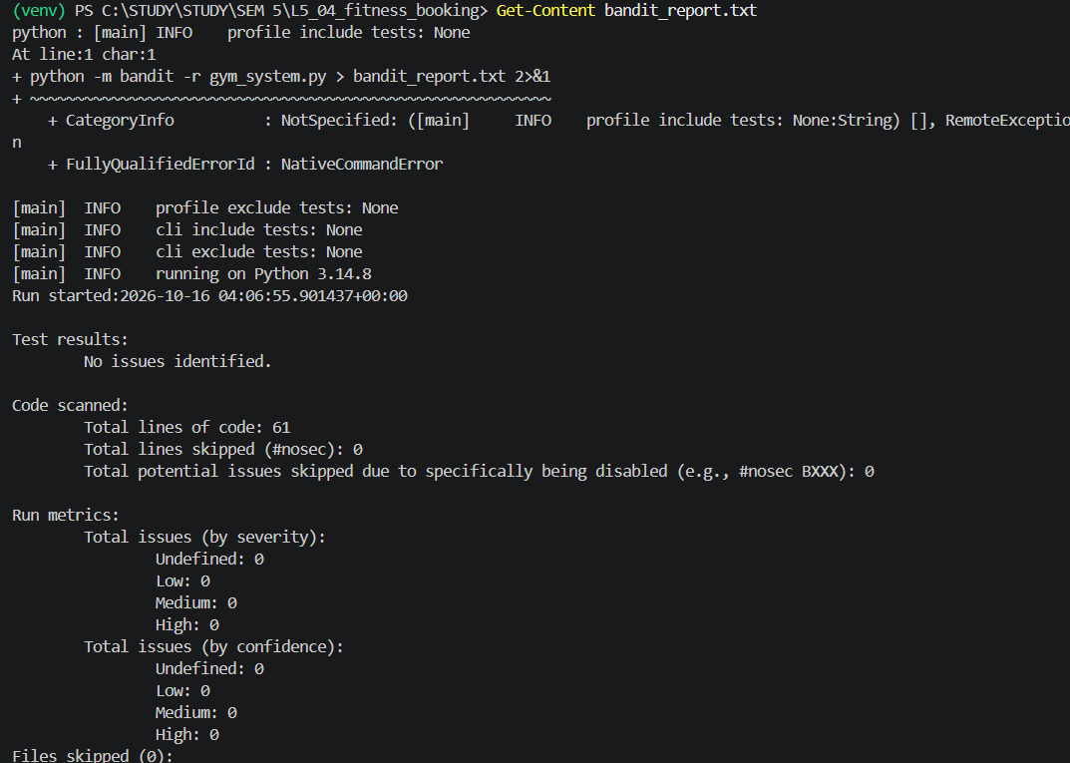

Screenshot 8: Final Pylint and Bandit results
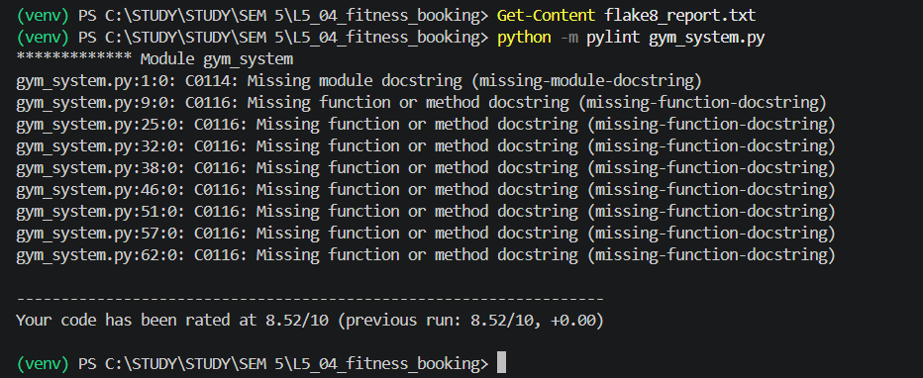

Screenshot 9: Final verification results
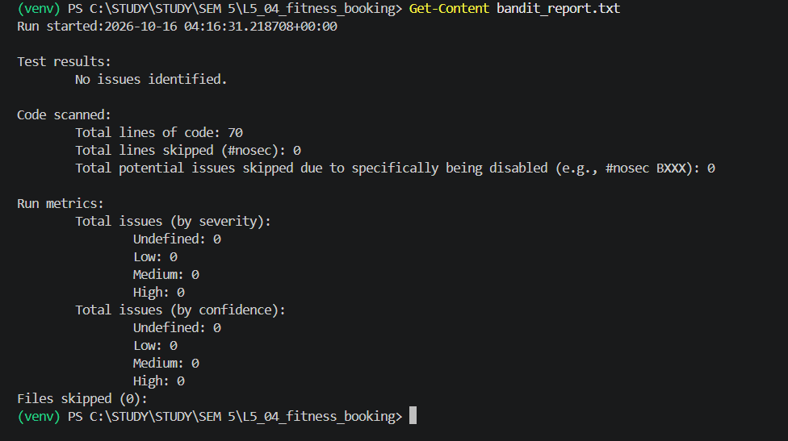

Screenshot 10: Lab terminal evidence
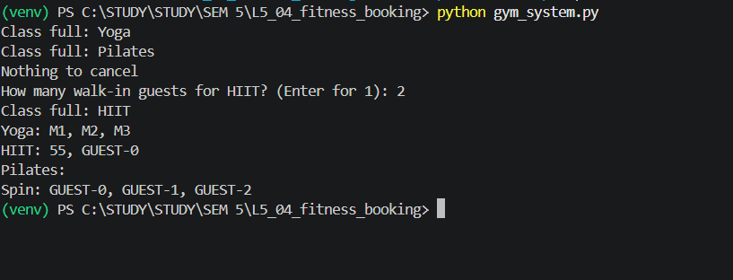

Screenshot 11: Lab terminal evidence
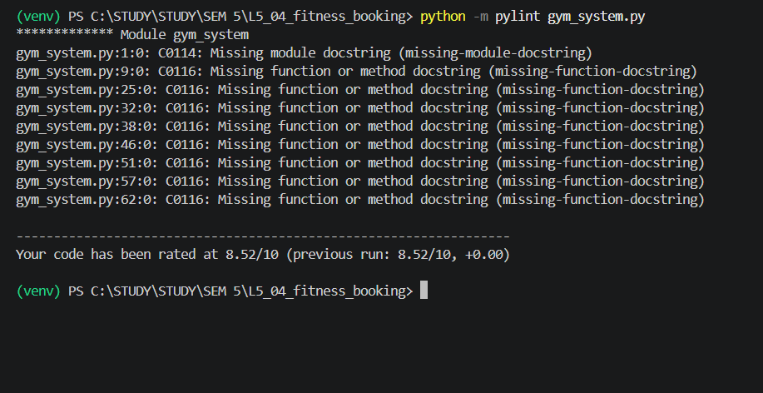

Screenshot 12: Lab terminal evidence
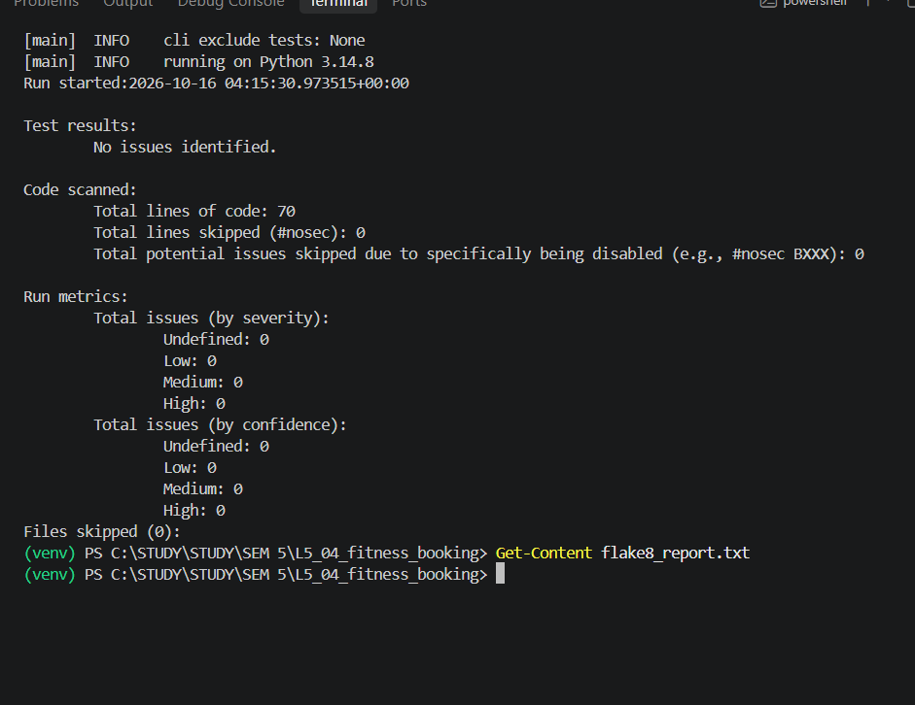

Screenshot 13: Lab terminal evidence
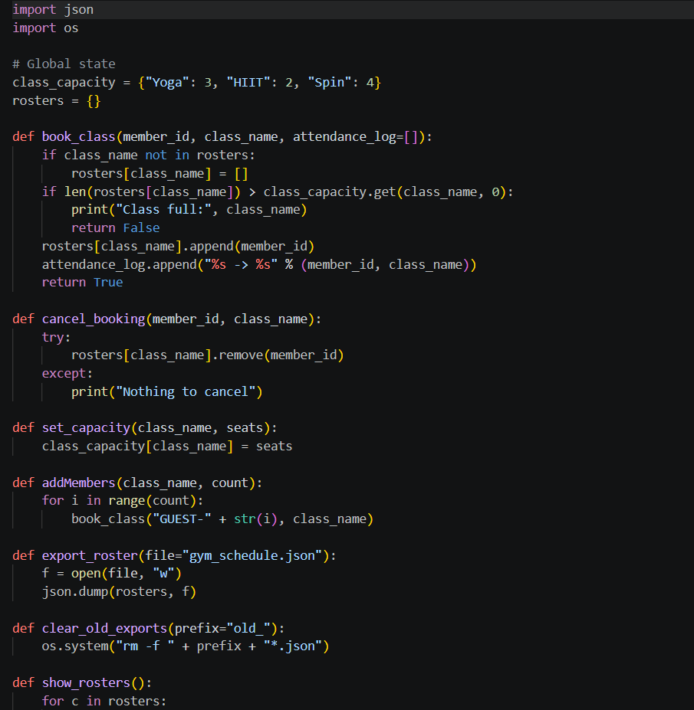

Screenshot 14: Lab terminal evidence
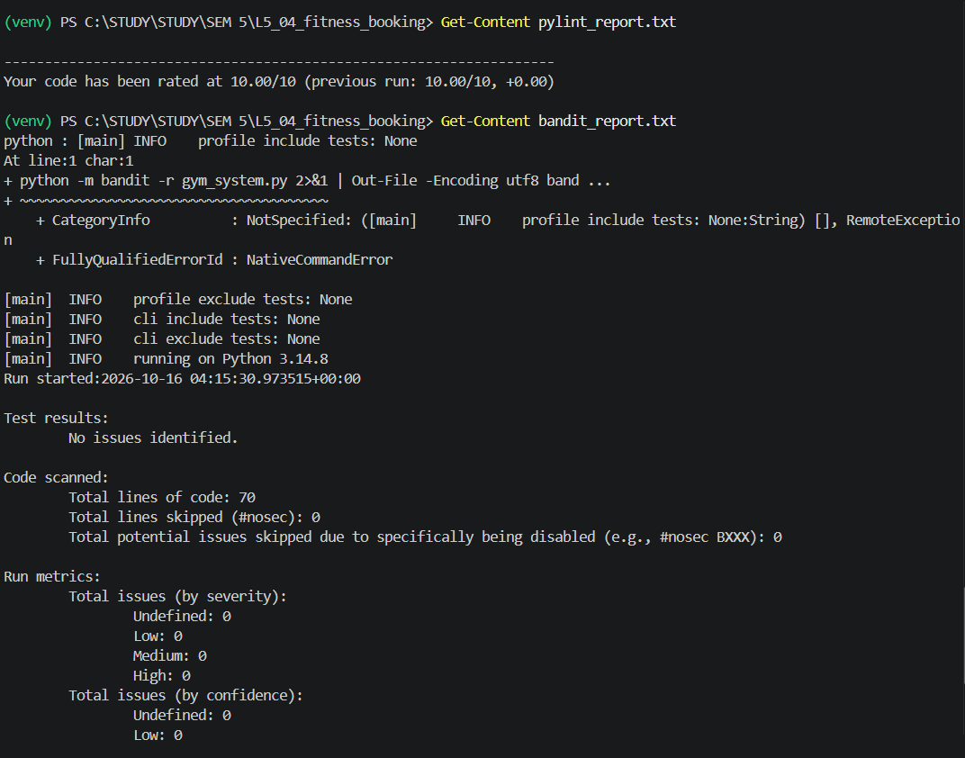

Screenshot 15: Lab terminal evidence
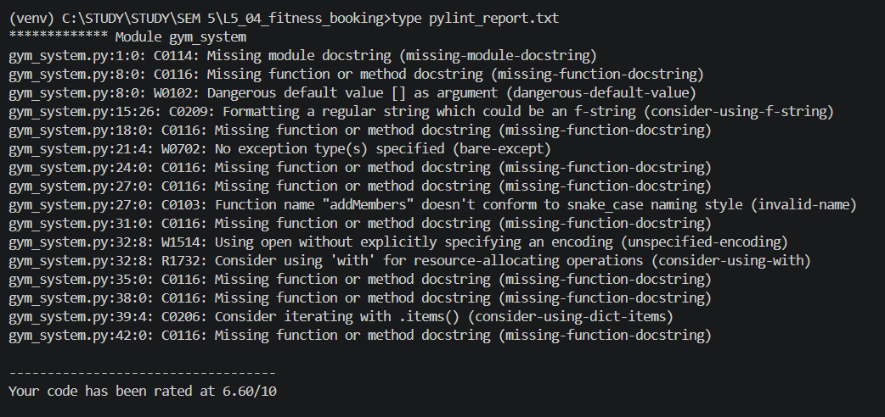

Screenshot 16: Lab terminal evidence
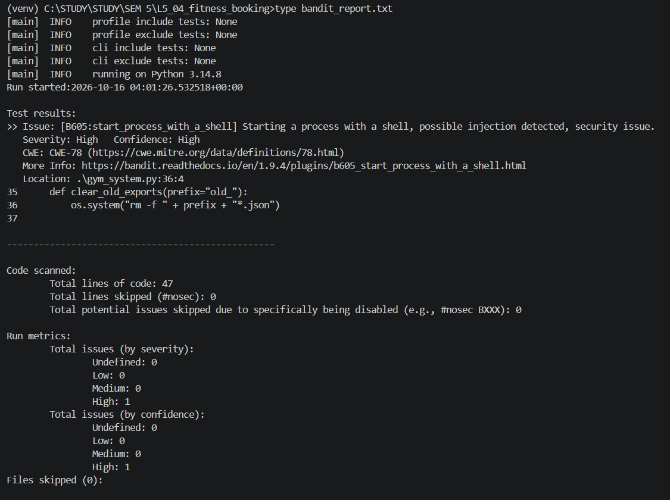

Screenshot 17: Lab terminal evidence
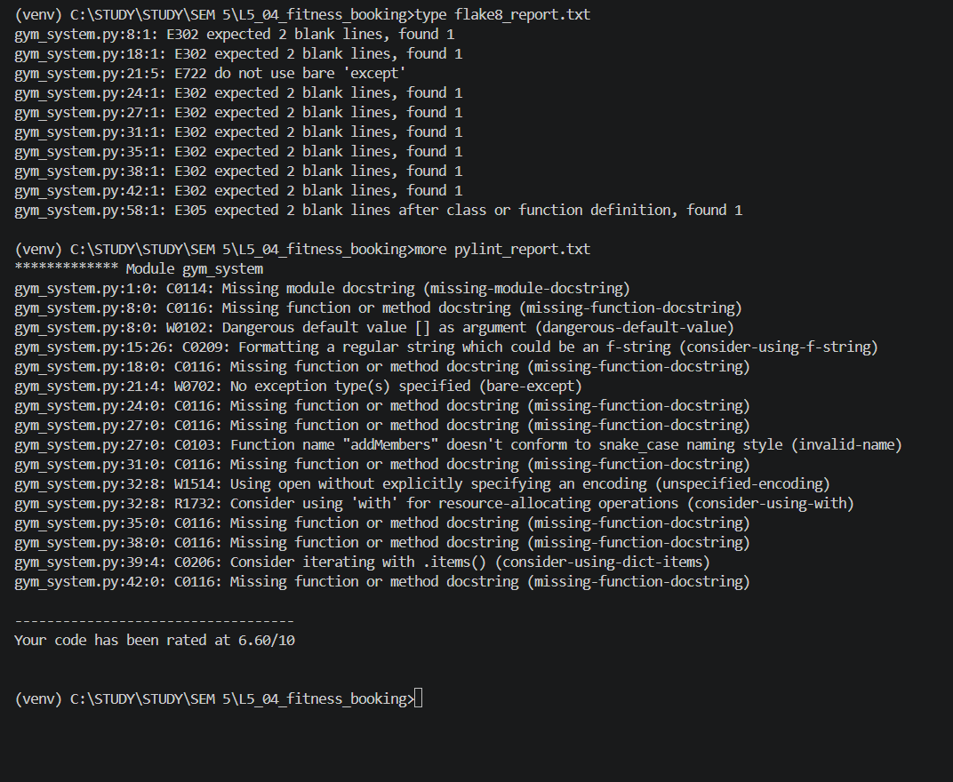

Screenshot 18: Lab terminal evidence
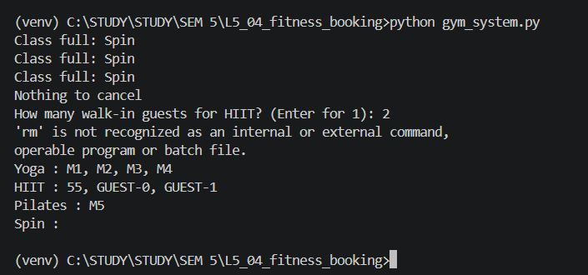

Screenshot 19: Lab terminal evidence
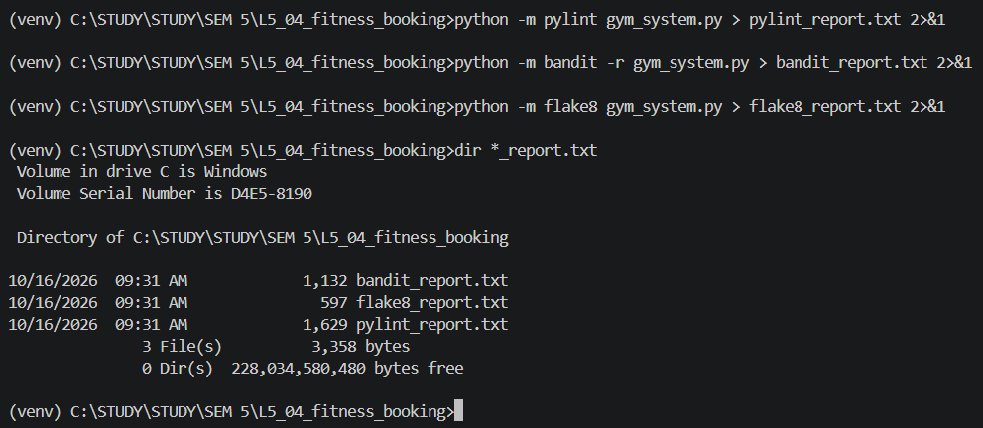

Screenshot 20: Lab terminal evidence
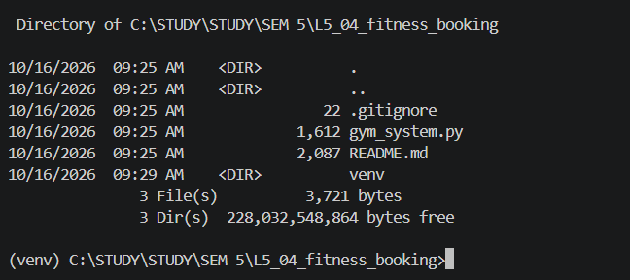

Screenshot 21: Lab terminal evidence
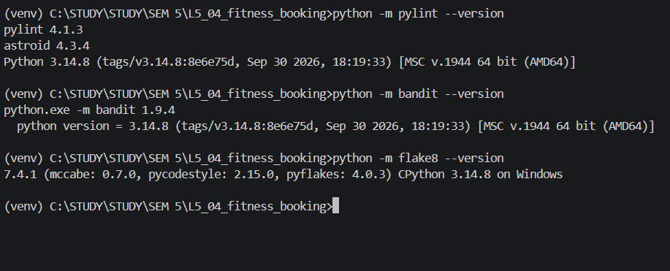

Screenshot 22: Lab terminal evidence
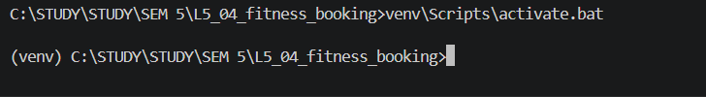

Screenshot 23: Lab terminal evidence
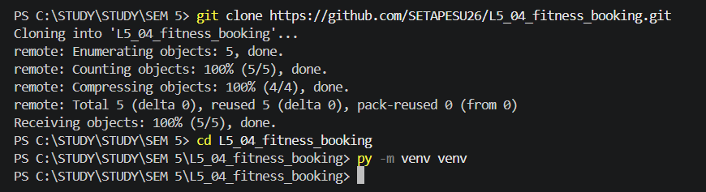

Screenshot 24: Lab terminal evidence
