1. Pick a graph from ​http://www.tylervigen.com/spurious-correlations​ and recreate it using matplotlib (you can also use numpy and pandas). You can generate the data manually by looking at the points. Ensure the axes are labeled properly.
2. Create a pair-plot of the iris dataset similar to the below one using only numpy and matplotlib (you can use Scikit-learn to load the data with Sklearn.datasets.load_iris, you are not allowed to use pandas or seaborn). Ensure all axes are labeled. The diagonals need to contain histograms, the different species need to be distinguished by color, and there needs to be a legend for the species.

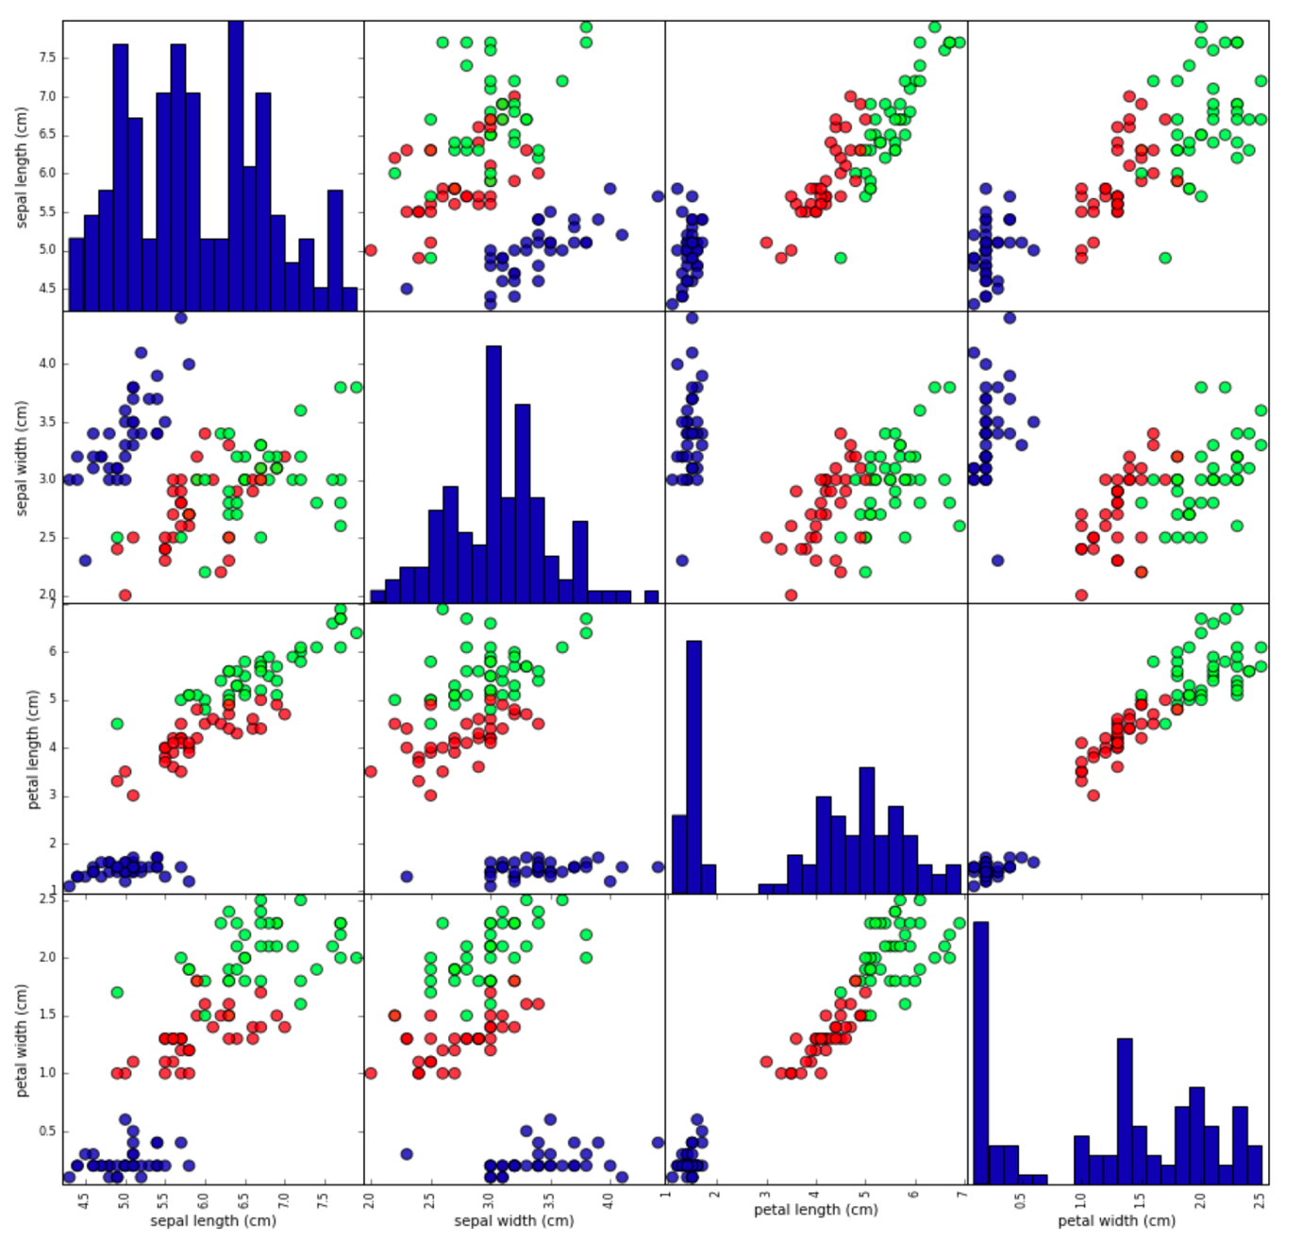

1. Reproduce the graphs on overlapping data from “Fundamentals of Data Visualization” https://serialmentor.com/dataviz/overlapping-points.html​ that is figures 18.1 to 18.4, using matplotlib as subplots in a single figure. You can read the data from following link. Please use the weblink for reading the data, not the local path.

<https://raw.githubusercontent.com/pratoolbharti/NIU/master/Applied_Machine_Learning_S20/Homework-1/mpg.csv>