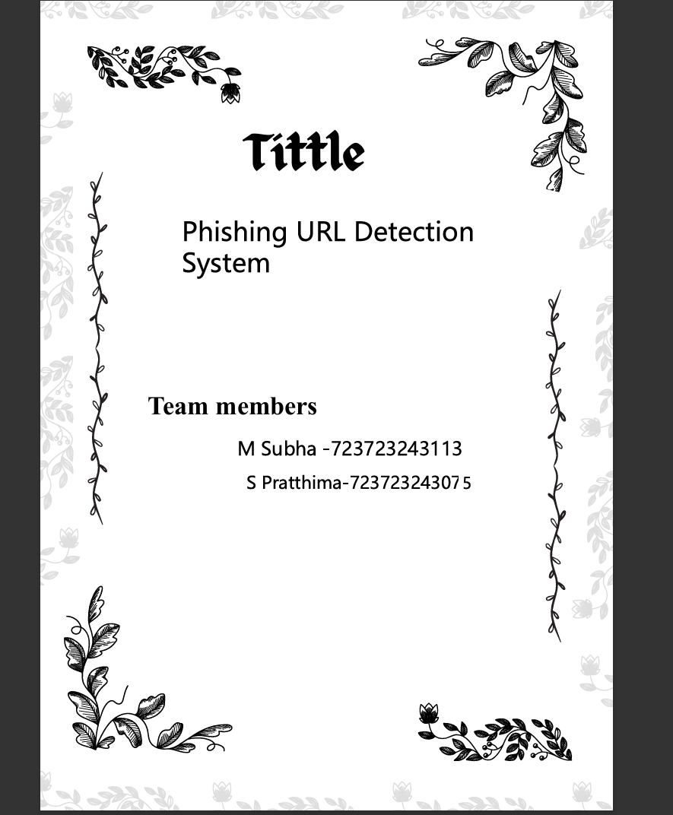
Abstract:
Phishing attacks pose a serious threat to online security by tricking users into revealing sensitive information such as login credentials, financial details, and personal data. Detecting phishing URLs efficiently is crucial to safeguard individuals and organizations. This project presents a Phishing URL Detection System that integrates both traditional machine learning and advanced deep learning techniques to enhance detection accuracy.
Initially, the system uses a Random Forest (RF) model, a traditional machine learning algorithm, trained on handcrafted URL features such as URL length, number of dots, presence of special characters, HTTPS usage, and domain patterns. The RF model classifies URLs as phishing or legitimate and outputs a confidence score, representing the probability of a URL being malicious. While effective, this approach is limited by its reliance on manually engineered features and may struggle with newly crafted or obfuscated phishing URLs.
To overcome these limitations, the system is enhanced with a Tokenized Transformer-based model. Unlike character-based CNN or LSTM models, the Transformer model uses structured tokenization, breaking URLs into domain, subdomain, path, query components, and special tokens representing suspicious features (e.g., URL shortening, presence of digits, or @ symbols). The model leverages self-attention mechanisms to capture global context and relationships between URL components, allowing it to generalize better to unseen and sophisticated phishing URLs.
By combining these approaches, the system benefits from the interpretability and reliability of Random Forest and the advanced pattern recognition capability of the Transformer model. Users receive a phishing/legitimate classification along with a confidence score, enabling informed decision-making. The hybrid approach demonstrates improved detection accuracy, adaptability to new phishing tactics, and practical usability for real-time URL analysis, contributing significantly to proactive online security measures.

