Asking Before Critiquing: Ambiguity-Aware Intent Clarification for LLM-Based Pull Request Review
Yashika Gupta Pratyaksh Gupta Arivoli A
School of Computer Science and Engineering
Vellore Institute of Technology, Vellore, India
Abstract—LLM-based pull request reviewers read a change once, infer what its author intended, and comment on that inference; when the intent is ambiguous they guess. We present ClarifyReview, a reviewer that decides before critiquing whether the available context is sufficient, and asks the author a targeted question when it is not. Its single-pass baseline is the same pipeline with a detector that never asks, so the two differ in one stage. We evaluate it in a two-by-three ablation on SWE-bench Verified, crossing correct and execution-verified defective patches (32 mutants) with three conditions: intent withheld, intent withheld with clarification, and full context. A pilot showed that withholding only the linked issue leaves intent recoverable from the patch itself; withholding every natural-language statement of intent opened a gap. On 36 instances, intent recovery was 81% without clarification, 83% with it and 97% with full context (gap recovery 0.17, McNemar p = 1.00). Tracing each instance shows that clarification recovered intent where it was given the chance, and that the binding limit is detector recall: the detector flagged 2 of the 7 changes the reviewer misread. Defect detection was low in every condition, including full context, so it is limited by the reviewer rather than by missing intent. A replication with a local model (qwen3:4b-instruct-2507-q4_K_M) on 96 instances finds intent recovery of 67% without clarification, 70% with it and 100% with full context. Gap recovery was 0.09 (interval -0.22 to 0.33), not significant, and the upper limit rules out recovering more than a third of the gap. Re-scoring with the agent judge preserved this verdict but not the effect size. Running the replication set on the original reviewer raised intent recovery from 65% to 72%, but 10 of the 11 changed outcomes came from instances where no question was asked, so the difference is reviewer variation, not clarification. We release the system, harness, verified mutants and study log.
Index Terms—automated code review, large language models, intent clarification, ambiguity detection, mutation testing, empirical software engineering
I. Introduction
Code review is a persistent bottleneck in software delivery, and most of a reviewer's effort goes into understanding what a change is for [1], [2]. Tools such as CodeRabbit, Qodo and Greptile now use large language models (LLMs) to review pull requests automatically [3]. All of them explain their comments, so explanation is no longer distinguishing. What they share is a structural limitation: each reviews a pull request in a single pass, inferring the author's intent and commenting on that inference as though it were established.
When the change is ambiguous—a validation check removed with no linked issue and a commit message reading only "fix"—a human reviewer asks. Current tools do not. They commit to a reading, producing false alarms on intentional changes and missed defects on unintentional ones, and both erode the trust that keeps such tools switched on.
Clarification-seeking improves code generation [4], [5], but we are not aware of work applying it to review of an existing change, where a wrong guess costs a human reviewer's attention rather than a compiler cycle. We ask whether a reviewer that asks before critiquing understands and detects more than one that does not. This paper makes five contributions:
1) ClarifyReview, a four-stage reviewer whose second stage decides per pull request whether to ask, with four interchangeable detector designs and a baseline that differs from it in exactly one stage;
2) an evaluation design for intent-dependent review on SWE-bench [6]: a manipulation that withholds all natural-language intent while leaving code untouched, and 32 execution-verified defects;
3) a two-by-three ablation with a per-instance trace that separates the value of an answer from the chance to ask, locating the limit of the approach in detector recall;
4) an account of a pilot whose principal result was a correction to the evaluation design, and of a protocol deviation, both reported in full; and
5) a judge-calibration analysis of AI-vs-AI agreement across three AI judges, and a replication on a local reviewer that is reported separately from the original study.
II. Related Work
A. Automated code review
Empirical studies at Microsoft and Google found that understanding a change is the reviewer's first and costliest task [1], [2]. Learned reviewers generate comments from review data [7], [8], and deployed LLM tools differ mainly in how much repository context they retrieve [3]. All are single-pass; none resolves intent before commenting.
B. Clarification in code generation
ClarifyGPT detects ambiguous requirements through a code-consistency check and asks targeted questions before generating code, improving Pass@1 [4]. TiCoder clarifies intent through generated tests and, in a fifteen-person study, improved correctness judgement and lowered cognitive load [5]. Both concern greenfield generation; both show that asking must be scaffolded and selective.
C. Uncertainty quantification
Self-consistency treats disagreement across samples as a signal [9]; semantic uncertainty clusters samples by meaning before measuring dispersion [10]. We adapt both to measure instability in a reviewer's reading of a change's intent.
D. Benchmarks and evaluation
SWE-bench pairs real issues with the patches that resolved them and the tests those patches make pass [6]; its Verified subset was validated by human annotators [11]. Known tests allow defective variants whose defectiveness is established by execution [12]. LLM judges agree with human raters about as often as humans agree, with known biases including self-preference [13], which motivates using a judge from a different model family than the reviewer.
III. ClarifyReview
ClarifyReview has four stages (Fig. 1). Stage 1 parses the diff and resolves changed lines to changed symbols using the Python AST for Python and tree-sitter grammars for JavaScript, TypeScript/TSX, Java, C, C++ and Rust, with Python behaviour byte-identical to before, assembling a bounded context in a deterministic order and fingerprinting it. Stage 2 decides whether to ask. Stage 3 generates at most two questions—each required by its output schema to name a file, line or symbol, so that it cannot degenerate into "please explain this PR"—and sends them through a Responder. Stage 4 produces structured findings with severity, category, evidence, suggested fix and confidence.
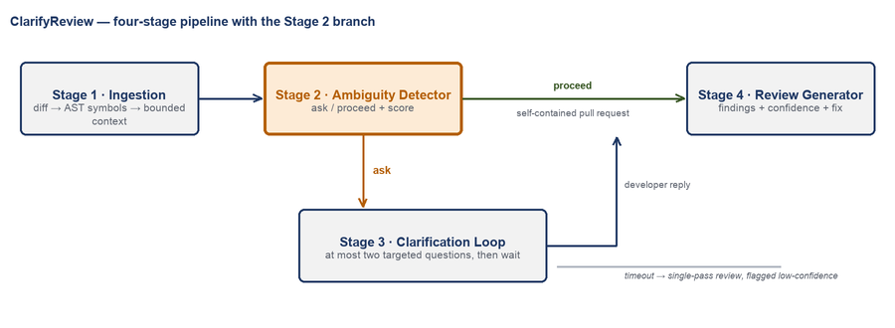
Fig. 1. ClarifyReview's four stages. Stage 2 is the decision point; when it proceeds, Stage 3 does not run.
A. Ambiguity detectors
Four detectors implement one interface, score(context) → s ∈ [0, 1], and a shared decision asks when s ≥ τ for a threshold τ frozen in configuration. The heuristic combines fifteen diff features—missing linked issue, generic commit message, removed guard, no test alongside, public symbol touched, deletion ratio and others—as weighted evidence, s = Σ wᵢfᵢ / Σ wᵢ, so the score reads as the fraction of ambiguity evidence present; it makes no model call. A logistic-regression classifier learns weights over the same features from labelled pull requests. Two uncertainty detectors sample eight one-sentence hypotheses about what the change is for—by temperature sampling, or by perturbing the prompt at fixed temperature—and score their mean pairwise embedding distance and semantic entropy.
B. One pipeline, two conditions
The single-pass baseline is not separate code: it is the same pipeline with a detector that never asks, and a test asserts that, with the detector forced to proceed, both conditions render byte-identical prompts. Stage 3 talks to the author through a Responder protocol with three implementations—a GitHub responder that posts a comment and waits, a benchmark responder that calls a simulated author, and a null responder—so the experiment exercises the code that would be deployed. The system is written in Python, runs as a GitHub App or from a command line, records every run to an SQLite log, and is covered by 446 automated tests. Three provider backends sit behind one interface: Gemini, Anthropic and local Ollama. The Ollama backend runs a model on the user's own machine, with no key, no traffic beyond that machine and no monetary cost. Parked runs persist in SQLite across restarts, a timeout sweep publishes reviews that go unanswered, rate limits are handled, and signed webhooks are verified. The bot has been exercised end to end on a local server, but it has not yet been run against live GitHub.
IV. Experimental Design
We ask three questions. RQ1: does clarification recover intent that is lost when the author's stated intent is withheld? RQ2: does it improve defect detection or reduce false alarms? RQ3: how well do the detectors identify the changes that need a question?
A. Conditions
Each instance is reviewed three times by the same reviewer model with the same prompt template (Fig. 2): with full context (the ceiling); with intent withheld, single-pass (the floor); and with intent withheld, through ClarifyReview (the treatment). Floor and treatment see byte-identical code, asserted per instance. Gap recovery G = (treatment − floor)/(ceiling − floor) is the share of the context-induced loss that clarification restores.
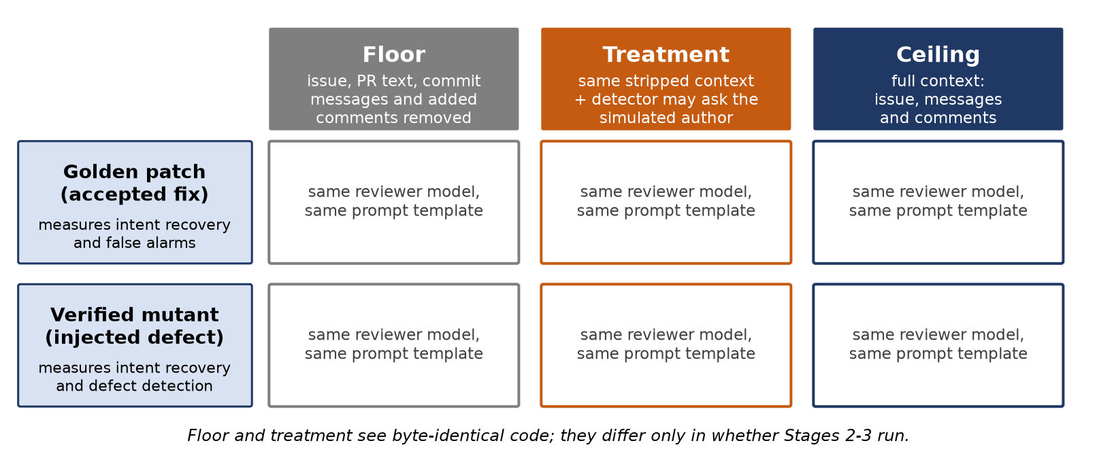
Fig. 2. The two-by-three design. Golden patches measure intent recovery and false alarms; verified mutants measure intent recovery and defect detection.
B. Withholding intent
Version 1 of the manipulation removed the linked issue, title, description and commit messages. Version 2 additionally removes every comment, trailing comment and docstring the patch adds, leaving every line of code intact. A docstring is removed only when the patch opens it on an added line, after an earlier rule deleted real code in a hunk that began inside an existing docstring.
C. Execution-verified defects
Golden patches are correct by construction, so they measure false alarms but not detection. We inject defects into the lines a golden patch adds with six operators—invert comparison, negate condition, flip constant, drop guard, swap boolean operator, off-by-one—and keep a mutant only if the repository's FAIL_TO_PASS tests pass with the golden patch and fail with the mutant [12]. Of 75 sympy instances, 32 yielded a verified mutant; 27 admitted no operator, 7 produced only mutants the tests did not catch, and 9 could not run in the available environment.
D. Instances
The study set has 36 rows: twelve sympy instances reviewed both as the golden patch and as its verified mutant, and twelve golden patches from xarray, sphinx, astropy, django, pylint, pytest and scikit-learn. Instances were chosen hardest-first by SWE-bench's own difficulty annotation, assigned by the benchmark's annotators rather than by our detector, so selection does not favour the detector under evaluation.
E. Simulated author, judge and statistics
When the treatment asks, a simulated author answers using only the withheld issue text and commit messages; it never sees the diff, the defect, or whether one exists, and must decline when its notes are silent. Every exchange is logged with its prompt version. Reviews are scored by an LLM judge from a different model family than the reviewer on three checklist questions: was the intent recovered, was the injected defect caught, and was a false alarm raised on correct code. Paired outcomes are compared with McNemar's exact test [14]; gap recovery is reported with a bootstrap 95% interval. The reviewer is gemini-3.5-flash-lite; questions, the simulated author and the judge use gemma-4-31b-it; all calls ran on free-tier access.
F. Second-model replication (v3)
The replication uses 96 rows: the 36 rows of the original set plus 60 new rows. The set includes all 32 verified mutants, scored in both arms, and 32 golden-only rows from 7 other repositories. The reviewer was qwen3:4b-instruct-2507-q4_K_M, served through Ollama, with the heuristic detector at τ = 0.50. The 288 runs had 0 failures and took 52 minutes on a laptop GPU. The question and oracle model was n/a, whose identity is recorded in the oracle log but not per database row. Conditions were the same as in the original study. The replication is never pooled with the original study, and the judge is chosen in Section V-G rather than here.
V. Results
A. Pilot (manipulation v1)
The pilot attempted 10 instances from ten repositories; 5 completed all three conditions before the daily quota was exhausted. Intent recovery was 100% at the ceiling, 100% at the floor and 100% in the treatment: with the floor equal to the ceiling there was nothing to recover. The patches stated their purpose in the comments and docstrings they added, so withholding the issue removed nothing a reader needed. This led to manipulation v2, the mutant arm and difficulty-ordered selection.
B. RQ1: intent recovery
All 36 rows completed all three conditions and all 108 reviews were judged (Table I, Fig. 3). Withholding all natural-language intent lowered intent recovery from 97% to 81%, opening the gap v1 did not. Clarification raised it to 83%: G = 0.17 (95% CI 0.00–0.50), with 1 discordant pair favouring the treatment and 0 the floor (p = 1.00). The direction is as hypothesised; at this sample size the effect is not significant, and could not have been, since only pairs where the detector asked can differ for a reason other than sampling variation.
TABLE I
Judged outcomes, manipulation v2
Measure | Floor | Treat. | Ceiling | p
Intent, all | 29/36 | 30/36 | 35/36 | 1.00
Intent, golden | 19/24 | 20/24 | 24/24 | 1.00
Intent, mutant | 10/12 | 10/12 | 11/12 | 1.00
Defect caught | 2/12 | 2/12 | 1/12 | 1.00
False alarm | 2/24 | 2/24 | 1/24 | 1.00

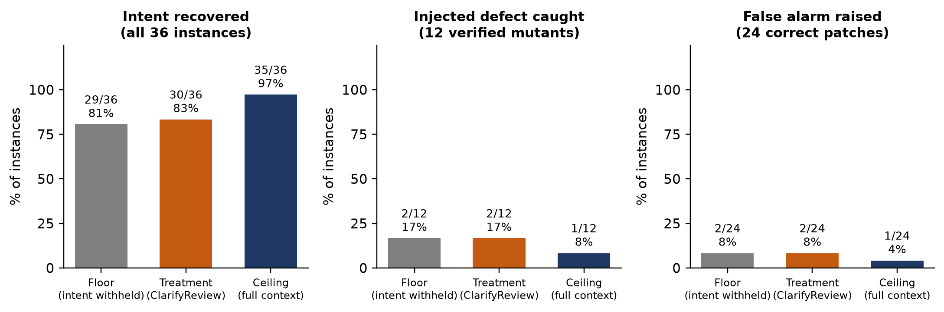
Fig. 3. Outcomes by condition. Bars show the share of instances; labels give counts.
C. Where the effect is lost
The treatment can improve on the floor only for an instance the floor got wrong, that the detector flagged, and whose author answered (Fig. 4). The floor misread 7 changes. The detector asked on 2; the author answered 1 substantively; and the treatment recovered intent in 1. The other flagged miss received a refusal: its question concerned a parameter the issue never mentions. Of the detector's 6 questions, 4 went to instances the floor already understood, where an answer cannot raise intent recovery. Clarification worked where it was given the chance (too few cases to estimate a rate), and the chance arose rarely: the binding constraint is detector recall.
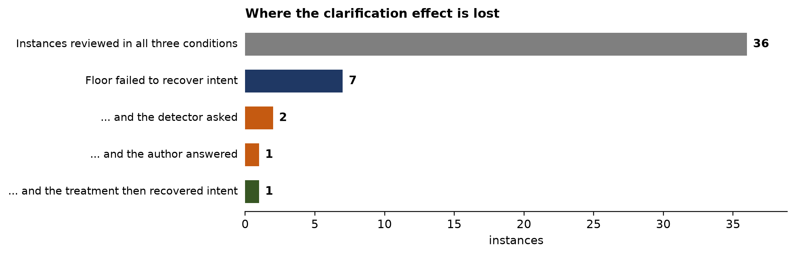
Fig. 4. Tracing each instance from a floor miss to recovery.
In the recovered case (sympy-12481) the patch lets the Permutation constructor accept non-disjoint cycles. The floor summarised it as "tidy up permutation instantiation logic". The detector scored the stripped change 0.556 and asked whether removing the specialised error was intended; the author replied that non-disjoint cycles should be applied left to right; the treatment's summary then matched the ceiling's.
D. RQ2: defects and false alarms
The reviewer caught 2/12 injected defects at the floor, 2/12 with clarification and 1/12 with full context. The full-context figure bounds what intent can contribute: given the issue, the reviewer still approved eleven of twelve broken patches, so on this model detection is limited by reading the code, not by knowing its purpose. One mutant was caught without the issue and approved with it—an isolated case, but consistent with stated intent anchoring a reviewer toward acceptance. False alarms on correct patches were rare in every condition (2/24, 2/24, 1/24).
E. RQ3: detectors
With constructed labels—a stripped context is ambiguous by construction, its full counterpart clear—Table II and Fig. 5 compare the detectors. A detector keyed on a missing issue gains recall for free under these labels, so recall is bounded from above.
TABLE II
Detectors on constructed labels
Detector | n | Ask | Prec. | Rec. | Score s / f
heuristic | 48 | 10% | 1.00 | 0.21 | 0.45 / 0.06
sampling | 8 | 100% | 0.50 | 1.00 | 0.70 / 0.56
perturbation | 8 | 100% | 0.50 | 1.00 | 0.85 / 0.85

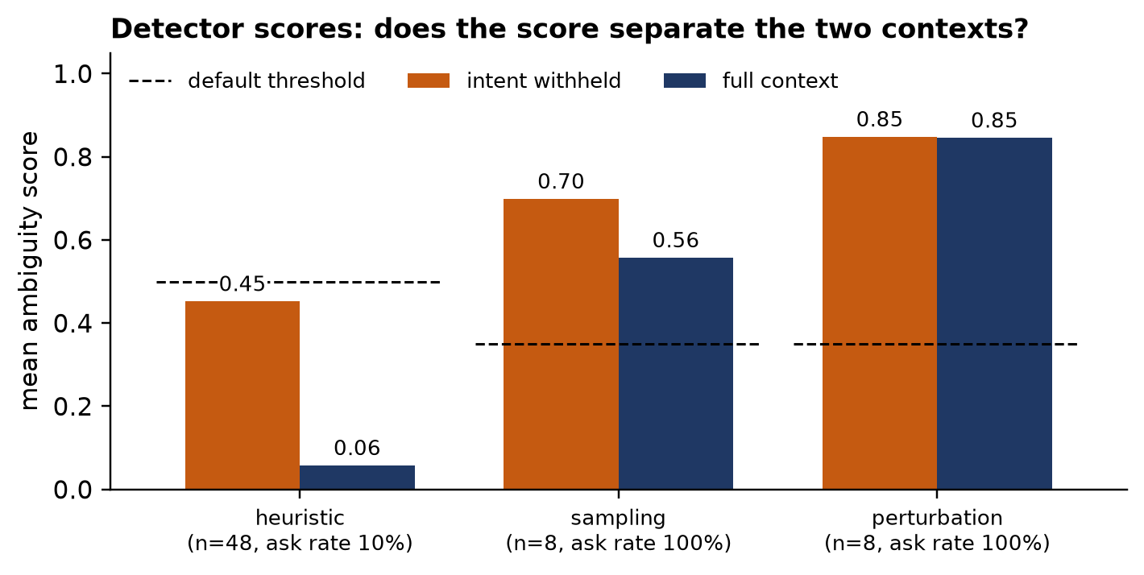
Fig. 5. Mean detector score with intent withheld and with full context; dashed lines mark default thresholds.
The heuristic never asked on a full-context instance but found only 21% of stripped ones—the recall limit of Section V-C. The uncertainty detectors cost eight calls per decision and were run on 4 instances. At their default thresholds both asked on every decision. Sampling dispersion separated the contexts (0.70 vs 0.56); re-sweeping its recorded scores suggests a threshold near 0.60 would separate them, which we report as a diagnosis rather than adopt, since those scores come from the study set. Prompt perturbation did not separate them (0.85 vs 0.85).
F. Replication on a local reviewer
Table III reports the same measures as Table I for the local reviewer qwen3:4b-instruct-2507-q4_K_M, served through Ollama, with outcomes scored by the Claude agent judge claude-sonnet-agent. That judge was chosen after seeing its agreement with the local judge, as explained in Section V-G. The replication is reported separately from the original study and is never pooled with it.
TABLE III
Judged outcomes, local replication (v3)
Measure | Floor | Treat. | Ceiling | p
Intent, all | 64/96 | 67/96 | 96/96 | 0.66
Intent, golden | 44/64 | 44/64 | 64/64 | 1.00
Intent, mutant | 20/32 | 23/32 | 32/32 | 0.51
Defect caught | 1/32 | 2/32 | 3/32 | 1.00
False alarm | 1/64 | 3/64 | 3/64 | 0.50

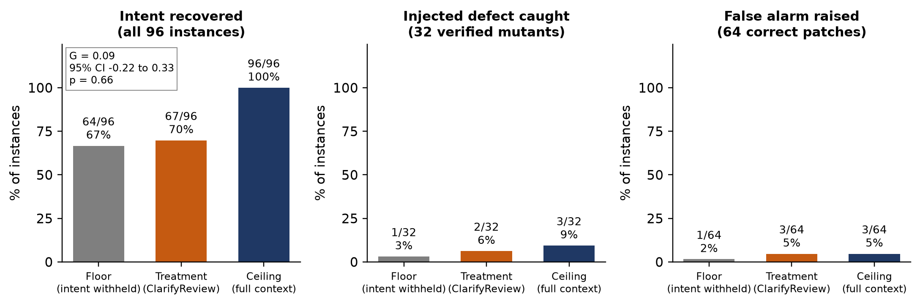
Fig. 6. Outcomes by condition in the local replication (v3). Counts are of instances; the box gives G, its 95% interval and the McNemar p.
Clarification did not significantly recover intent in the replication. Over 96 instances, intent recovery was 67% without clarification, 70% with it and 100% with full context. Gap recovery was 0.09 (interval -0.22 to 0.33, McNemar p = 0.66), not significant. The upper limit of the interval rules out recovering more than about a third of the gap at this sample size. The manipulation works: withholding intent cost 33 points of intent recovery against full context, and clarification restored 3 of those points. By subset, gap recovery was 0.00 on the golden rows (p = 1.00) and 0.25 on the mutants (p = 0.51), neither significant.
Detector recall was the limit, as in the original study. The detector asked on 17 of 96 treatment reviews. Of the 32 changes that the reviewer misread without clarification, the detector asked on 8 and missed 24. The simulated author answered 7 of those 8 questions, and the treatment recovered intent on 3 of the 32 changes. Effects went in both directions: clarification helped on 12 instances and hurt on 9. Once a question was answered, the treatment recovered intent in 3 of 7 cases, so most of the loss lies in deciding when to ask. Recall, not the answer, is the limit.
Defect detection stays near the floor even with full context. The mutant rows caught the injected defect on 1 of 32 without clarification, 2 with it and 3 with full context (3%, 6% and 9%; McNemar p = 1.00). A small local reviewer, qwen3:4b-instruct-2507-q4_K_M, limits defect detection, as in the original study. Over 64 golden rows, false alarms were 1 without clarification, 3 with it and 3 with full context, too few to separate the conditions (p = 0.50). The study makes no claim about an effect on defects.
G. Judge calibration
Three AI judges scored the original reviews: the API judge gemma-4-31b-it, Claude Sonnet agents (claude-sonnet-agent), and the Gemini 4 Argon (web app) on a stratified sample of 30 runs, stratified by condition and variant. Table IV gives percent agreement, kappa and n for each judge pair. All of this is AI-vs-AI agreement, not validation against human scorers.
TABLE IV
Agreement between AI judges (% agreement / kappa / n)
Judge pair | Intent | Defect | False alarm
v2: gemma-4-31b-it vs agent | 89% / 0.40 / 108 | 99% / 0.88 / 108 | 100% / 1.00 / 108
v2: Gemini web vs agent | 90% / 0.62 / 30 | 100% / 1.00 / 30 | 100% / 1.00 / 30
v2: Gemini web vs gemma-4-31b-it | 87% / 0.52 / 30 | 97% / 0.65 / 30 | 100% / 1.00 / 30
v3: llama3.2:3b vs agent | 68% / 0.20 / 288 | 93% / 0.06 / 288 | 98% / 0.00 / 288

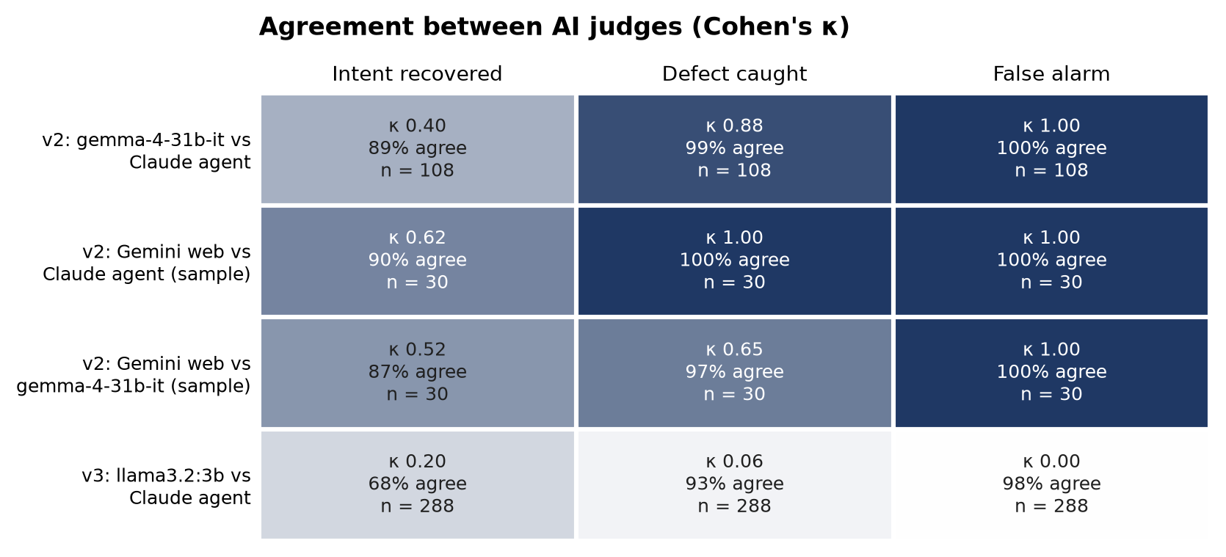
Fig. 7. Cohen's kappa between pairs of AI judges. This is AI-vs-AI agreement, not validation against human scorers.
Against the agent judge, the API judge agreed almost perfectly on defects (kappa 0.88, 99% agreement, n = 108) and on false alarms (kappa 1.00), and was fair on intent (kappa 0.40, 89% agreement, n = 108). The Gemini web app agreed with the agent judge on intent at kappa 0.62, and the three judges agreed on intent for 25 of 30 runs. Re-scoring the original study with the agent judge gave intent floor 86%, treatment 92% and ceiling 100%, and gap recovery 0.40 (interval -0.75 to 1.00, McNemar p = 0.63). The verdict holds: the effect is not significant. The size of gap recovery does not: under the API judge it was 0.17 (interval 0.00 to 0.50). These comparisons are AI-vs-AI agreement, not validation against human scorers.
In the replication, the local judge, llama3.2:3b, is unusable: its agreement with the agent judge was fair on intent (kappa 0.20, 68%, n = 288), slight on defects (kappa 0.06) and slight on false alarms (kappa 0.00). It never flagged a false alarm (total 0) and wrote that no defect was injected on 54 of 96 mutant rows (56%). The Claude agent judge claude-sonnet-agent is therefore the primary judge for the replication. That choice was made after seeing the agreement figures, so it is a post hoc choice. The local judge's own intent result, gap recovery 0.17 (interval -0.31 to 0.52), is reference only, and its intent recovery across the three conditions was 58%, 63% and 83%. All of this is AI-vs-AI agreement. Only the original study's API judge has been checked against human scorers, as reported in Section VII; the replication's judges have not.
H. The replication set on the original reviewer
Sections V-B and V-F differ in rows and reviewer at once. To separate the two, all 96 rows of the replication set were also run on the original reviewer (gemini-3.5-flash-lite) with the original question, author and judge models (gemma-4-31b-it). 94 rows completed all three conditions; for the other 2 the question model failed with a server error on every attempt.
TABLE V
Judged outcomes, replication set on the original reviewer
Measure | Floor | Treat. | Ceiling | p
Intent, all | 61/94 | 68/94 | 92/94 | 0.07
Intent, golden | 43/62 | 47/62 | 61/62 | 0.29
Intent, mutant | 18/32 | 21/32 | 31/32 | 0.25
Defect caught | 10/32 | 13/32 | 12/32 | 0.25
False alarm | 1/62 | 5/62 | 0/62 | 0.13

Intent recovery was 65% with intent withheld, 72% with clarification and 98% with full context: G = 0.23 (95% interval 0.03–0.41, McNemar p = 0.07). Read alone, the interval excludes zero. The trace says otherwise. The detector asked on 15 of 94 instances and the simulated author gave a substantive answer to 2; of the 33 floor misses it asked on 9 and recovered 0. Of the 11 discordant pairs, 10 came from instances where no question was asked, so floor and treatment sent the reviewer identical input, and they split 8 to 2. The difference is the reviewer's run-to-run variation, not clarification. Clarification also raised false alarms on golden patches from 1/62 to 5/62. The lesson for the design is that one review per condition cannot resolve an effect of this size: repeated reviews per condition, or a reviewer run deterministically, are needed.
VI. Discussion
Asking is cheap to add and hard to target. Once a question reached an author who could answer it, the answer did what it was meant to do; nearly all of the loss happened earlier, in deciding when to ask. This shifts the research problem: the quality of a clarifying question matters less than the recall of the decision to pose one, at a precision that keeps the tool tolerable. A detector built from diff features was precise and conservative; a sampling-based detector separated the conditions but needs calibration on held-out data.
Golden patches are a poor population for studying ambiguity. Well-written fixes state their purpose in the code, comments and docstrings they add; evaluating intent-dependent review requires withholding all of it, and even then most changes remain self-explanatory. Benchmarks of genuinely under-specified changes would strengthen this line of work.
Finally, clarification cannot exceed the reviewer. On a small free-tier model, full context did not make the reviewer catch injected defects, so detection gains, if they exist, require a stronger reviewer before intent can matter.
Two reviewers and two judge configurations give the same qualitative picture: recall is the binding limit, defect detection is limited by the reviewer, and no gap-recovery interval excludes zero. The size of the effect depends on which judge scores the reviews. In the original study, gap recovery was 0.17 under the API judge (interval 0.00 to 0.50) and 0.40 under the agent judge (interval -0.75 to 1.00). In the replication, under the agent judge, it was 0.09 (interval -0.22 to 0.33) on 96 instances. The sign of the effect is therefore not established under any of these judges, and magnitudes should be read together with the judge that produced them.
VII. Threats to Validity
The sample is small (36 instances under per-model daily quotas), so intervals are wide. The judge was validated against 2 independent human scorers on a stratified sample of 60 of its own reviews, shown without the judge's answers or the condition; blank cells were excluded, not counted as disagreement. On defects and false alarms it agreed with them almost perfectly (Cohen's κ [15] 0.92 and 1.00; 99% and 100% agreement). On intent recovery it agreed on 88% of reviews, but κ was -0.01: the humans judged intent recovered in 99% of reviews and the judge in 88%, so the near-zero κ reflects one dominant answer rather than random agreement. The judge is the stricter of the two, so the intent recovery rates reported here are conservative rather than inflated. The simulated author answers from withheld text only, but leakage requires the hand audit the tooling prepares. We report a protocol deviation: in the first v2 run the simulated author's token budget was exhausted by its model's hidden reasoning, returning empty answers, and its prompt refused questions phrased in terms of unseen code. Both were corrected and the treatment re-run for the six affected instances; floor and ceiling were not re-run, and the prompt revision, made after observing refusals, is logged with every exchange. All verified mutants come from sympy and the operators produce simple defects. The reviewer is a small model; results may differ for stronger ones.
The replication adds further limits. Both studies have small samples: the original study has 36 instances and the replication 96, so intervals are wide. The replication's agent judge was chosen after seeing its agreement with the local judge, which makes the choice post hoc. The question and oracle model, n/a, is small, and its identity is recorded in the oracle log but not per database row. The two studies differ in reviewer, judge and rows, and they are never pooled. Running the full replication set on the original reviewer showed that the reviewer's own run-to-run variation is as large as the effect being measured, so a single review per condition cannot resolve it. The bot has not been run against live GitHub, and the 356 collected real pull requests are not yet labelled.
Human labelling. Two annotators independently labelled 300 pull requests as clear or unclear from the code change alone; Cohen's κ [15] was 0.21 (fair, observed agreement 98%). The 7 disagreements were adjudicated by an AI model (Claude (claude-opus-5-5, AI)) applying the same codebook, at the authors' request; these 7 labels are therefore not human judgements. Thresholds were frozen on a development split of these labels (300 labelled, 4 ambiguous) before any threshold-dependent evaluation; note that Study A itself ran with the default thresholds.
VIII. Conclusion
ClarifyReview inserts a decision before critique: ask the author when the intent of a change cannot be read from the change. Evaluating the idea required withholding all natural-language intent, because golden patches document their own. With that manipulation, clarification recovered 0.17 of the intent gap on 36 instances—in the expected direction, not significant at this size—and a per-instance trace shows it succeeded where it was given the chance, with detector recall as the limit. A second reviewer, a small local model, and a second judge reproduce the null result: gap recovery was 0.09 (interval -0.22 to 0.33, McNemar p = 0.66), not significant, and its upper limit rules out recovering more than about a third of the gap. The effect size depends on the judge. Future work is labelling the 356 real pull requests already collected (none is labelled yet), a paired developer study of usefulness and trust, deploying the bot against live GitHub, repeated reviews per condition to separate the effect from the reviewer's run-to-run variation, and a larger run with a stronger reviewer.
Acknowledgment
The authors thank the School of Computer Science and Engineering, Vellore Institute of Technology, for supporting this work.
References
[1] A. Bacchelli and C. Bird, "Expectations, outcomes, and challenges of modern code review," in Proc. ICSE, 2013, pp. 712-721.
[2] C. Sadowski, E. Söderberg, L. Church, M. Sipko, and A. Bacchelli, "Modern code review: A case study at Google," in Proc. ICSE-SEIP, 2018, pp. 181-190.
[3] Greptile, "Best AI code review tools 2026—comparison benchmarks," greptile.com, 2026; Morph, "GitHub AI code review: 6 tools tested on real PRs," morphllm.com, 2026.
[4] F. Mu, X. Chen, L. Shi, S. Wang, and Q. Wang, "ClarifyGPT: Empowering LLM-based code generation with intention clarification," arXiv:2310.10996, 2023.
[5] S. Fakhoury, A. Naik, G. Sakkas, S. Chakraborty, and S. K. Lahiri, "LLM-based test-driven interactive code generation: User study and empirical evaluation," IEEE Trans. Softw. Eng., vol. 50, no. 9, pp. 2254-2268, 2024.
[6] C. E. Jimenez, J. Yang, A. Wettig, S. Yao, K. Pei, O. Press, and K. Narasimhan, "SWE-bench: Can language models resolve real-world GitHub issues?" in Proc. ICLR, 2024.
[7] R. Tufano, L. Pascarella, M. Tufano, D. Poshyvanyk, and G. Bavota, "Towards automating code review activities," in Proc. ICSE, 2021, pp. 163-174.
[8] Z. Li et al., "Automating code review activities by large-scale pre-training," in Proc. ESEC/FSE, 2022, pp. 1035-1047.
[9] X. Wang, J. Wei, D. Schuurmans, Q. Le, E. Chi, S. Narang, A. Chowdhery, and D. Zhou, "Self-consistency improves chain of thought reasoning in language models," in Proc. ICLR, 2023.
[10] L. Kuhn, Y. Gal, and S. Farquhar, "Semantic uncertainty: Linguistic invariances for uncertainty estimation in natural language generation," in Proc. ICLR, 2023.
[11] OpenAI, "Introducing SWE-bench Verified," openai.com, 2024.
[12] Y. Jia and M. Harman, "An analysis and survey of the development of mutation testing," IEEE Trans. Softw. Eng., vol. 37, no. 5, pp. 649-678, 2011.
[13] L. Zheng et al., "Judging LLM-as-a-judge with MT-Bench and Chatbot Arena," in Proc. NeurIPS Datasets and Benchmarks Track, 2023.
[14] Q. McNemar, "Note on the sampling error of the difference between correlated proportions or percentages," Psychometrika, vol. 12, no. 2, pp. 153-157, 1947.
[15] J. Cohen, "A coefficient of agreement for nominal scales," Educ. Psychol. Meas., vol. 20, no. 1, pp. 37-46, 1960.

