List of all edits and fixes that have to be made for WUNOMO AI:
1)After first sign up of user or after every login it asks to choose workspace remove that whole thing i dont wanna choose a workspace we enter into the workspace of the last login and then in the dashboard we can toggle the workspaces but remove that pop up at the start of every login to choose workspace we directly login into the dashboard of last logged in workspace.
2)in the backend;
- Date and time after profiling the data source is not correct
- Add data source page closes sometimes own its own on tab switichin g
3) pipeline feature also date and time is wrong does not match the date and time of the machine or the pc.
4) In the axiom chat page there is no delete chat option for individual chat windows in the side panel
5) remove the ask axiom button from the bottom left completely
6) Axiom -> view progress -> each task should have bigger box in which we can edit anf review at once in the edit plan tab.
7) notification duration of every action or completion of the noptifications appearing on bottom left should be increased more smooth animation
8) in step #3.30 in self test guide. After running the completion button is not coming back
9) 3.30 → 3.32 steps in self test guide are not working
10) increase all button sizes make them more aesthetic easy to click and only text is written when cursor hovers on top then a greay button boundary appears just like claude or any other website
11) ‘help’ → should give error and not generate any plan in step 4.1 in self test guide but it is working and still appearing in the task list with plan approval
12) when rejected the assurance box is not appearing back again
13) Add re run buttons
14) step 4.50 in self test guide Terminal response not correct
15) 4.54 check terminal output again
16) in step 6.1 in self test guide cards not reloading after refresh
17) 6.3 → 6.4 check from different accounts
18) 6.6 → dosent go to the conversation when clicked
19) 8.3 → SQL execute and dry run not running for csv but it should as per the sel;f test guide from claude
20) got logged out randomly maybe after 1 hour
21) incidents banner does not go from dashboard notifications evenm after resolving and checking the incident. No clode button to clode the popup on investigate prompt tab
22) Settings page full customize it. The timezone should be a drop down menu instead of manually typing timezone and after setting timezone it should work and should be correct according to machines timezone
23) Onm first sign up some questionnaire is asked for more better understanding of user so store those answers in the user profile section in the setting tab
24) Main change very important; PUT AXIOM in a sub folder in the dashboard with all the other employees. The side panel make it free free up some space. Like first i click on ai employees then i choose axiom and then the side panel changes accordingly and all axiom chat features appear in the side panel. Axiom is not the main employee is just the first on to be built so put it with all the other employees yet to come in a sub section.
25) double verification for changing the mail or slack url anbd invalid email task should be there when the email not verified.
26) approvals: check from different accounts for cicd action/ agent action
27) The self test guide has nothing on testing the CICD and automations feature please see into that too.
28) ALL OF THIS HAS TO BE AUTOMATED the user upload data in the axiom chat is what we want and then the ai employee carries out all the remaining steps on its opwnm is what the main idea is just like claude code try to make the possible . make it chat friendly all the major working the user does while chatting with axiom if data needed axiom asks for it user uploads the data csv and axiom puts it in datasources and does profiling and all other steps on its own this is what we want fully automated process to reduce human effort.
The same above list i have with screenshots of the issues that i am pasting down below so that you understand better.
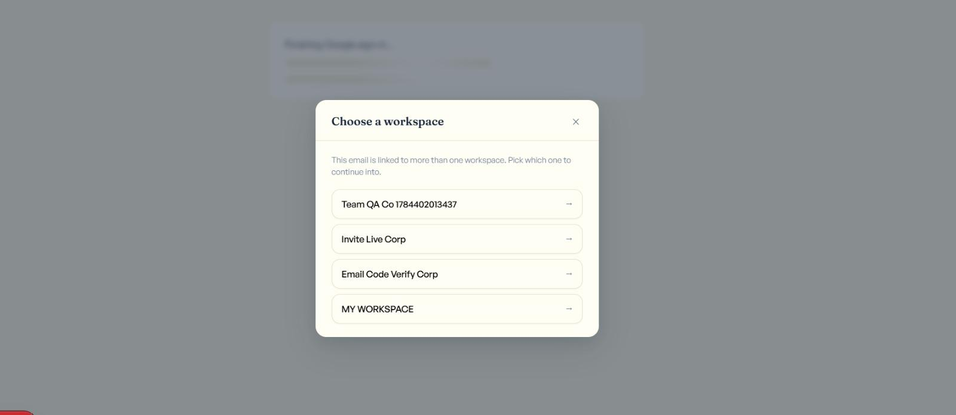
change workspace choosing page after login.first login then option ton change workspace
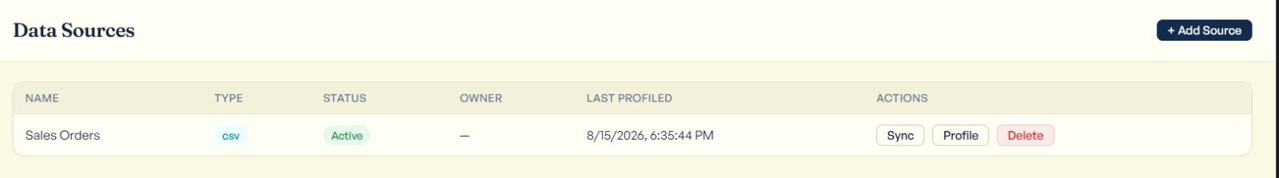
date time issue after data profiled
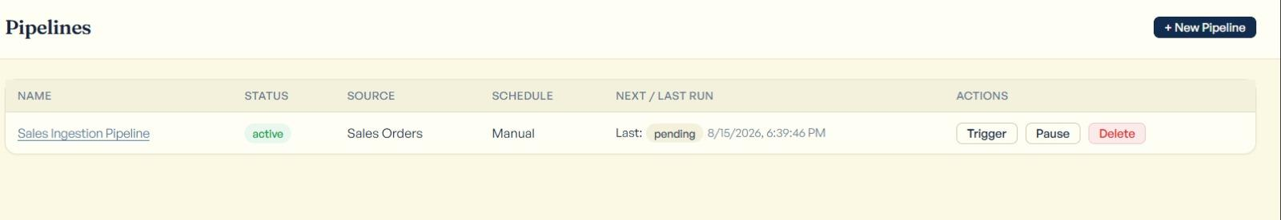
date time issue pipelines
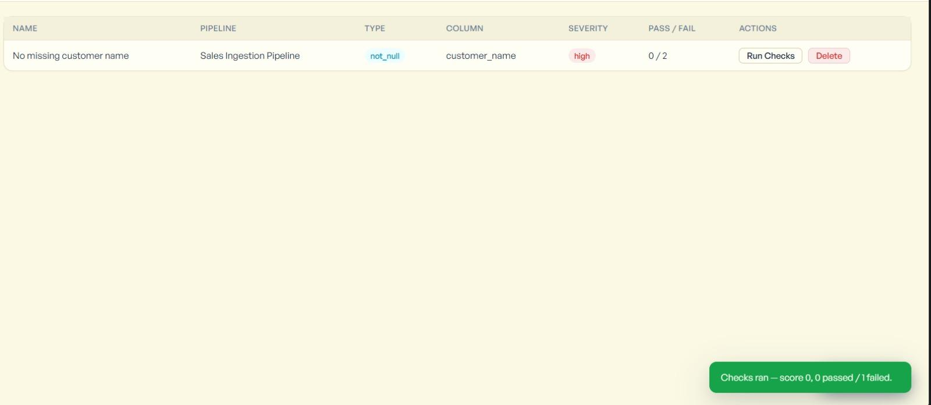
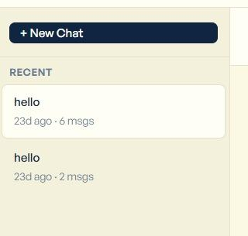delete chat option
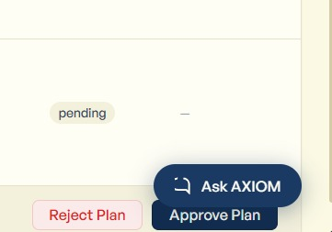ask axiom button overlaps all functions fix. Remove this button
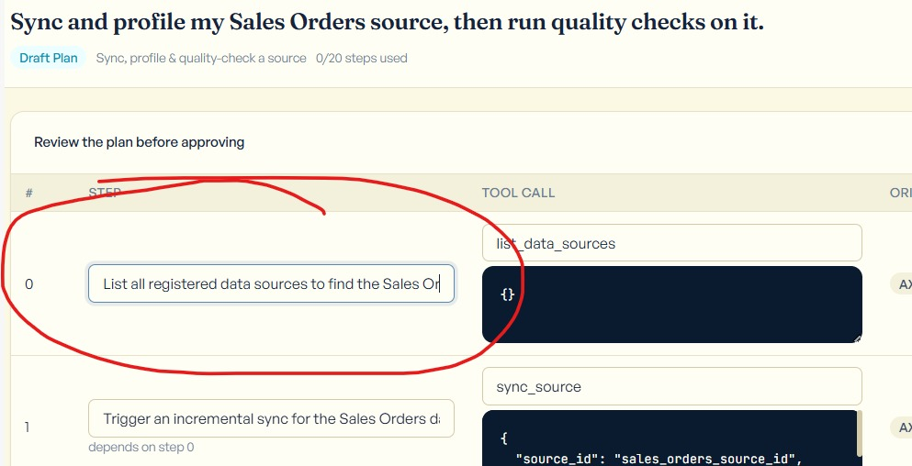
increase box size like skip to next line to see what tyuped in
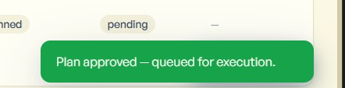
more soft text notification messages
duration more
**3.30** Click **Approve & Resume**.

**What you should see:** a "Step approved — resuming." message. The
status flips back to **Running**, and the step's row in the timeline now
shows **succeeded** with a real outcome (e.g. real row counts from the
sync). The **Advance one step** / **Run to completion** buttons come back.

buttons not coming back
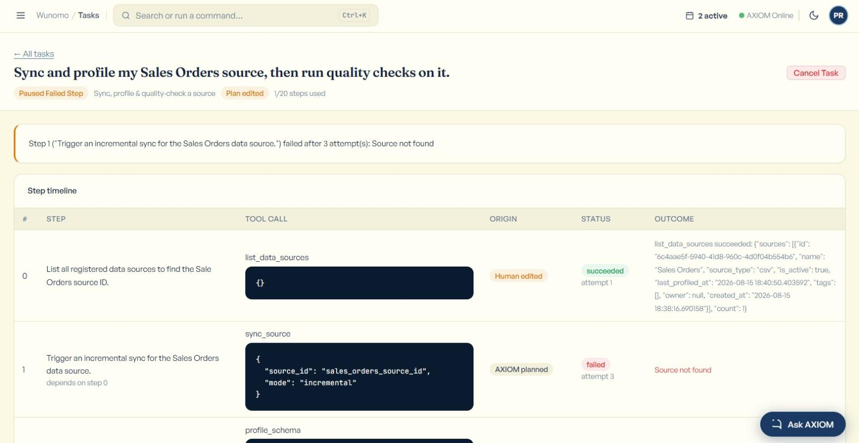
buttons didnt come so cant execute this part

**3.31** Click **Run to completion** again.

**What you should see:** this plan has more than one step that needs
approval (`sync_source`, `profile_schema`, and `run_quality_checks` are
all in this "riskier" category) — so it will likely **pause again**,
asking for approval a second (or third) time. That's expected, not a
bug. **Repeat step 3.30** (click **Approve & Resume**) each time it
pauses, until it reaches a final state (Completed, Completed With
Unconfirmed Steps, or Paused Failed Step). Every pause is real — you're
approving one genuinely new action each time, not clicking through the
same thing twice.

You've now seen the entire arc the Tasks feature is built around: a real
plan, a human edit, approval, real execution, a real safety stop, and a
real resume.

**3.32** *(Optional — seeing the other half of an approval decision.)*
Everything above showed you **Approve & Resume**. To see its sibling:
start one more small task (repeat 3.24–3.28 with the same
"Sync, profile & quality-check" goal/type — this costs one more AI call,
see Section 5), and when it pauses on **Paused Needs Approval** this time,
type anything into the optional notes field (e.g. `Not needed right now`)
and click **Reject Step** instead of Approve & Resume.
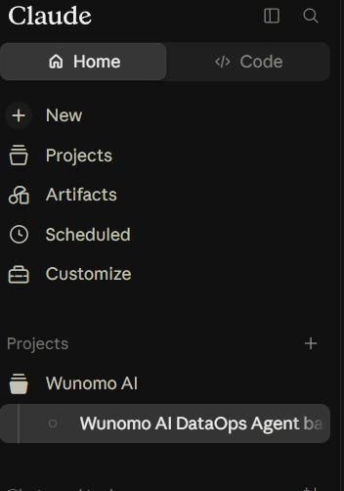
increase button sizes.only text hover an d bubble button appears for all buttons
### 4.1 Start a task with a vague, useless goal

Click **+ Start a Task**, type just: `help` — leave the type on
**"Diagnose pipeline failure"** — click **Generate Plan**.

**Cost: 1 real AI call** (occasionally 2, same rule as 3.16) — only if
you actually do this optional test.

**Two valid outcomes**, both fine:
- A red error message appears saying it couldn't generate a valid plan.
Check the **Tasks** list — nothing new should be there (a failed
generation never creates a task).
- AXIOM generates *some* real plan anyway, even though your goal was
vague — AI models generally try their best rather than refusing. If
this happens, open it and just click **Reject Plan** (see 4.2) instead
of approving something you didn't really want.

in this stepo task got created ran completed after approval and run toi completion and also appeared in task list page
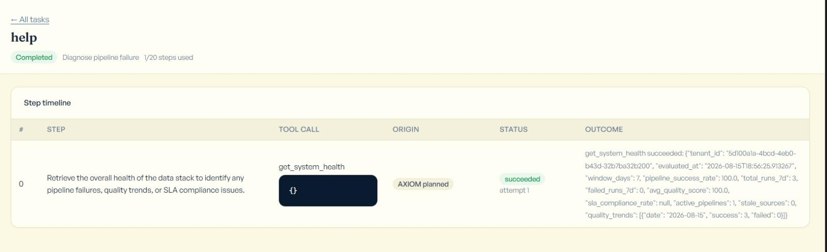
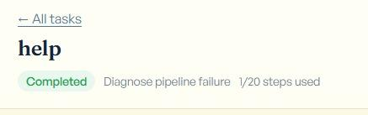
increase this small vague grey button all taks
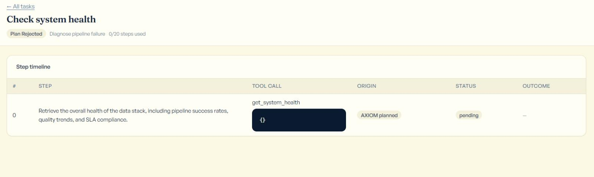
On the plan review screen, click
*Reject Plan* (red button, bottom right — it fires immediately, no
"are you sure" prompt).
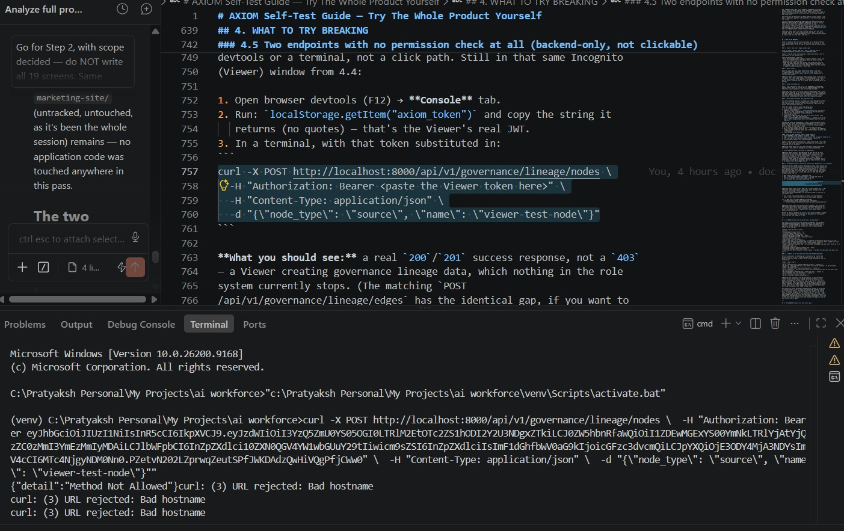
terminal response not correct as per 4.5
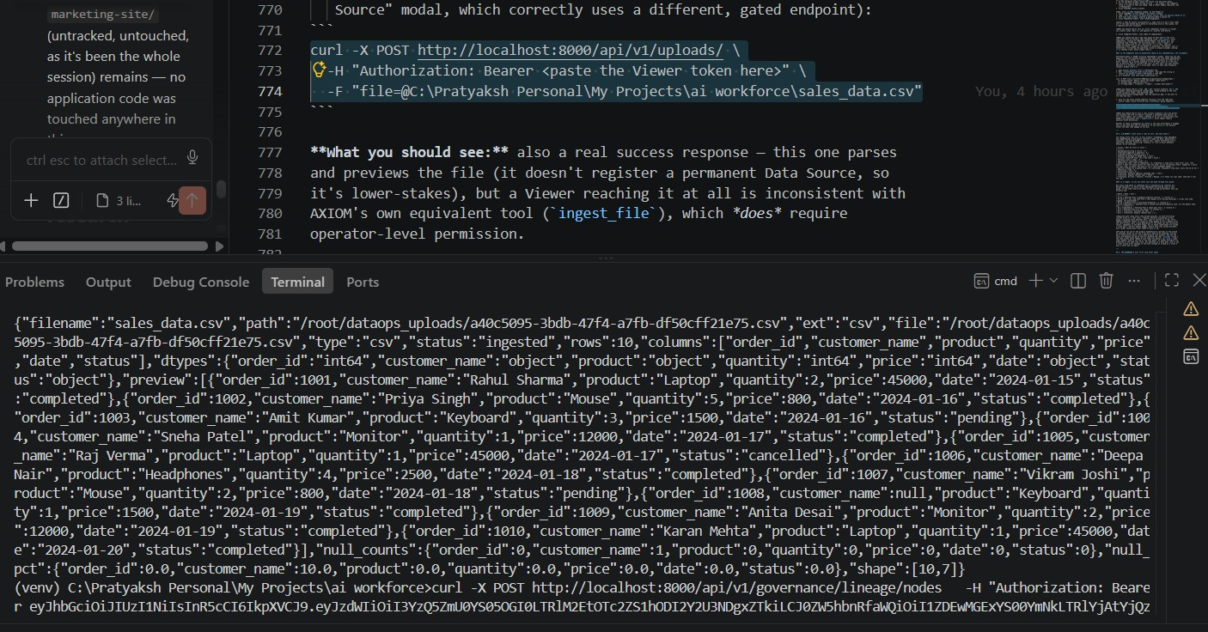
4.5.4 check the output once with claude
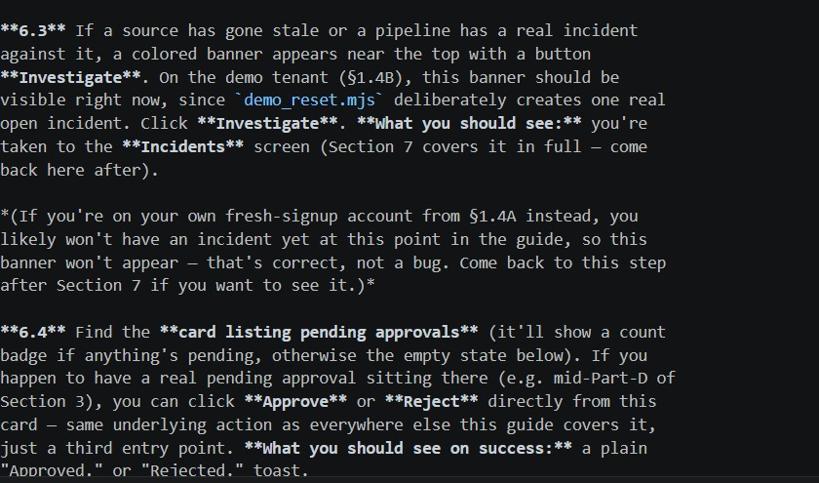
check from different account
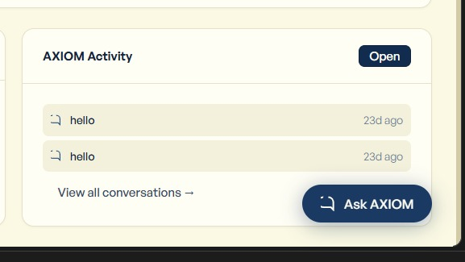
doesnt go to convo which we clicked as per 6.6
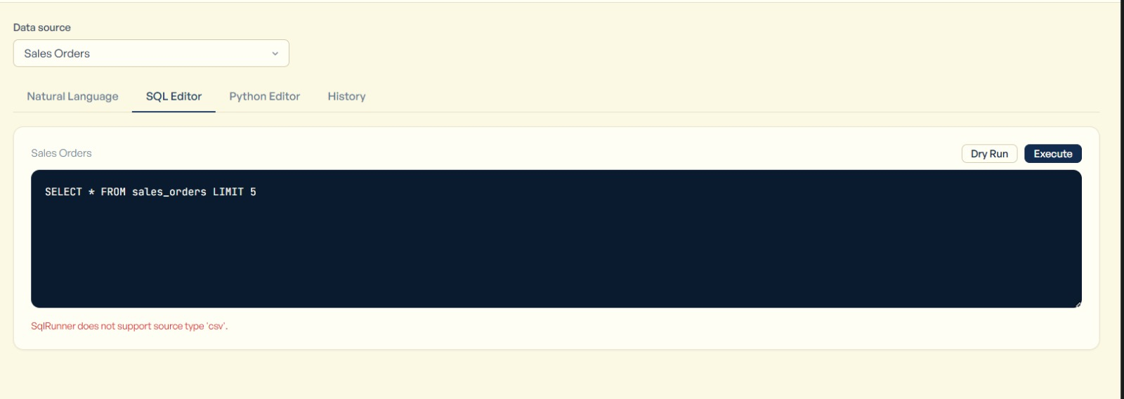
as per 8.3 sql execute and dry run not working for csv but in the userflow its stated it will run
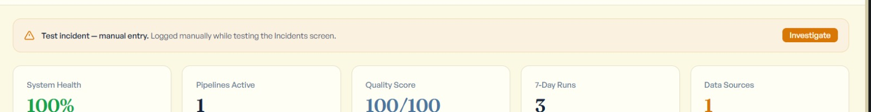
incident investigation banner doesnt go even after resolving or after investigate (theres no cross icon)
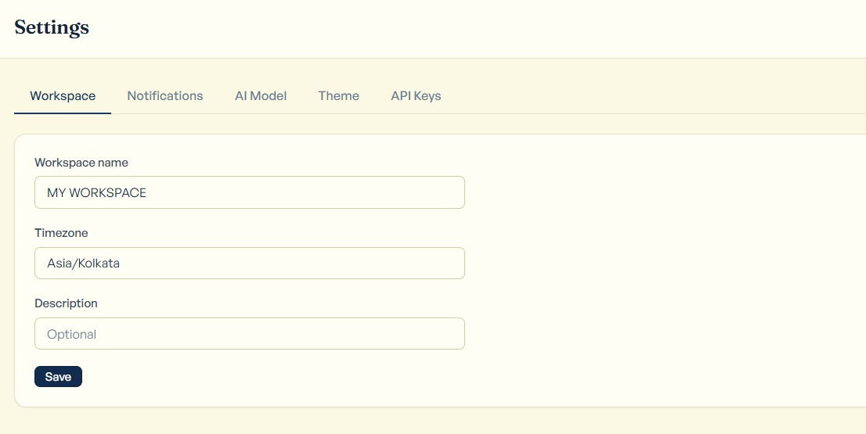
timezone in settings should be drop down menu but its typing field
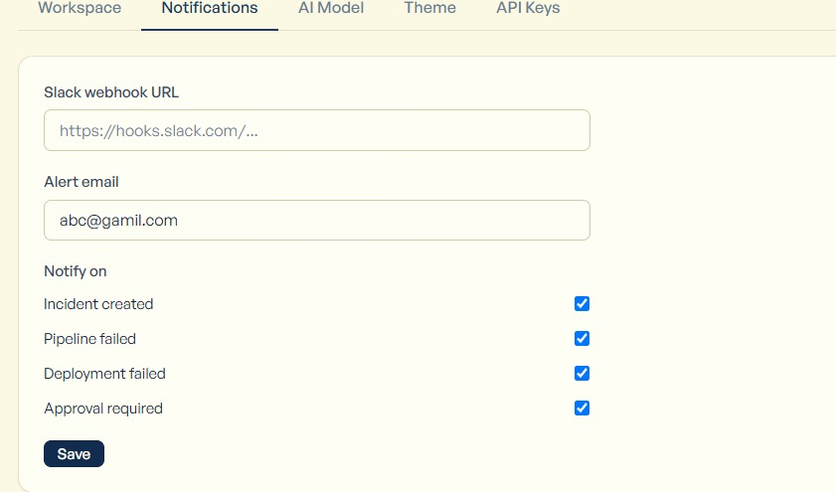
double verification for chaning the mail or slack url and invalid email toast should be there when the email not verified
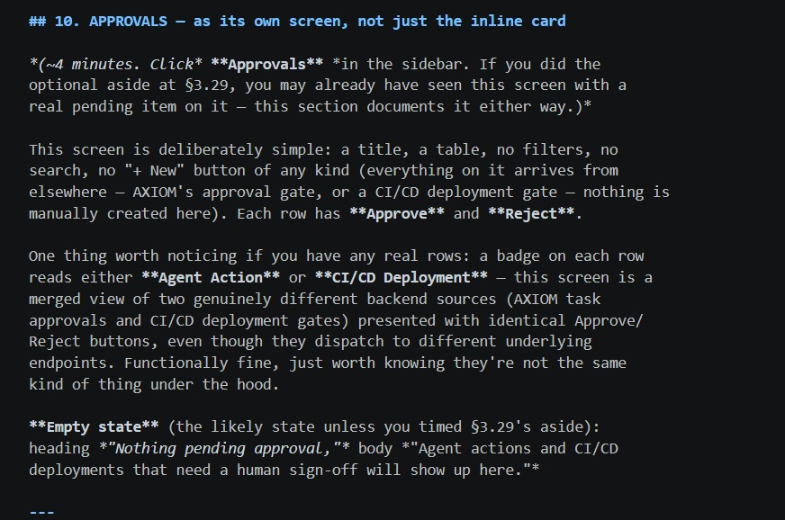
check approval agent action or cicd deployement with some other account in whihc we wait for approval deliberately and check these button

