**Robbery Not Solved**

While an arrest has been made in this week's West Fargo robbery at Jimmy John's, investigators tell our reporter today who say robberies and burglaries are some of the toughest cases to crack.

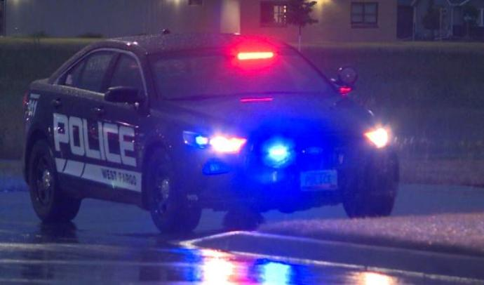

West Fargo Police Lieutenant Greg Warren calls the Fargo-Moorhead's geographic situation unique when it comes to catching criminals.

“We have two interstate systems that crisscross here that go to every corner in the united states: Canada, Mexico, you got our western borders, so we don’t know if they were passing through or coming in," Warren said.

With suspects covering themselves up or changing their appearance figuring out who’s behind a robbery or burglary can be a tough task for officers, but Warren says it’s much better than it used to be.

“What helps us a lot more today that we didn’t have back in the day were cameras,” he said.

Warren says on top of the business' cameras, officers also piece together a timeline using traffic cameras, those on neighboring businesses, as well as from homes nearby.

“It’s unbelievable how many people have cameras outside on their garages or they have the doorbell cameras,” he said.

Warren says in order to serve your home or business justice you should have three or four cameras, and say it’s a good idea to talk to police about the best places to put them.

“Getting a decent camera is number one, but your camera placement, if you don’t have good camera placement you’re really losing out,” Warren said.

He says while the department does still have a few unsolved cases, the statute of limitations gives investigators three years to bring criminals to justice.

“Does it get cold and a case gets slid aside? Sure does, but one thing to remember is if we’re looking for someone that did an armed robbery or a burglary or a construction site burglary, they don’t do one burglary and they’re done. What we don’t know today, we could know tomorrow, or we could know in a month.”

Warren says one of the department's open cases is an armed robbery at Casey's gas station last August.

The male suspect was wearing a black hoodie and a white mask covering their face. The suspect was described as under 6-feet tall with a slender build. Police say he displayed a gun and demanded money and left the store on foot with an undetermined amount of money.