Name: Pratyay Prasad Dhond
MIS : 142203004
Dept: Computer Engineering DIV 2

Study of Linux Networking Commands

1. ifconfig:
- Used to configure the kernel-resident network interfaces.
- Used at the boot time to set up interfaces as needed.
- It is only needed explicitly for debugging or when system tuning is needed.
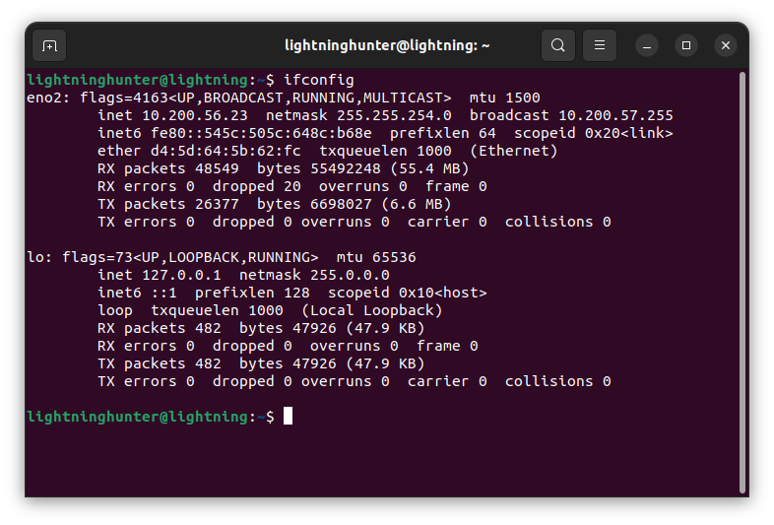

2. ip
- show/manipulate routing, network devices, interfaces and tunnels.
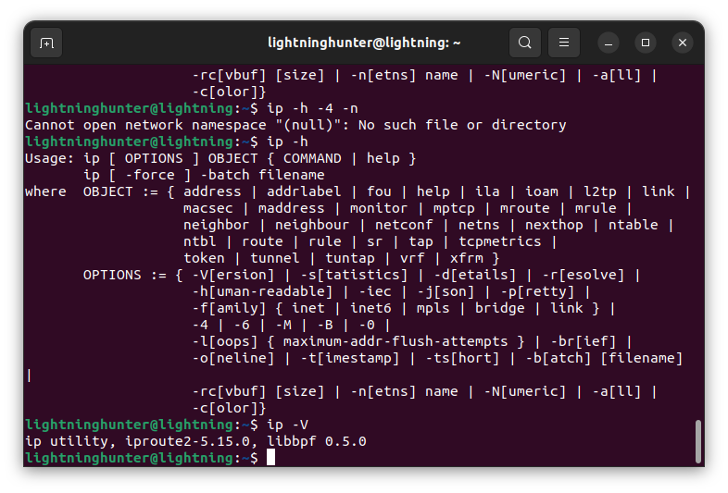
3. traceroute
- Print the route packets trace to network host.
- It tracks the route packets from an IP Network on their way to a given host.
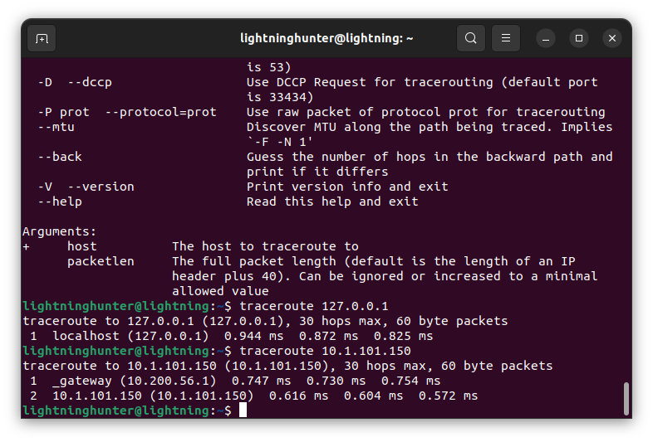

4. tracepath
- Traces a path to a network host discovering MTU along this path.
- Uses UDP port or some random port. It is similar to traceroute.
- The limitation is that it doesn’t require super user privilages and has a less options.
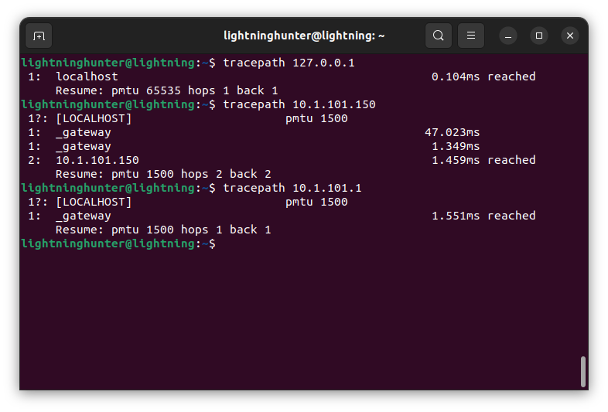

5. ping
- Send ICMP ECHO_REQUEST to specified network hosts.
- Used to check if a host/server is listening on the other end.
ping uses the ICMP protocol's mandatory ECHO_REQUEST datagram to elicit an ICMP ECHO_RESPONSE from a host or gateway. ECHO_REQUEST datagrams (“pings”) have an IP and ICMP header, followed by a struct timeval and then an arbitrary number of “pad” bytes used to fill out the packet.

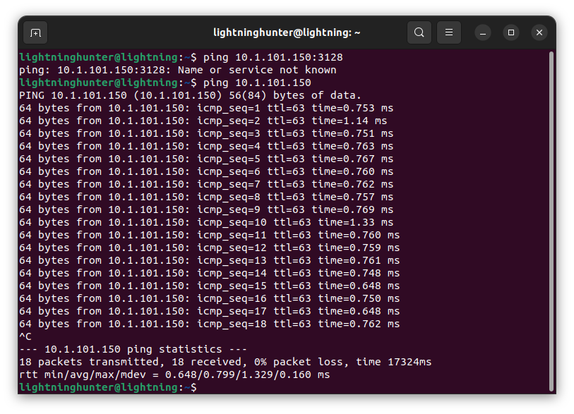

6. netstat

- Used to print network connections, routing tables, interface statistics, masquerade connections and multicast memberships.
This program is mostly obsolete. Replacement for netstat is ss. Re‐ placement for netstat -r is ip route. Replacement for netstat -i is ip -s link. Replacement for netstat -g is ip maddr.
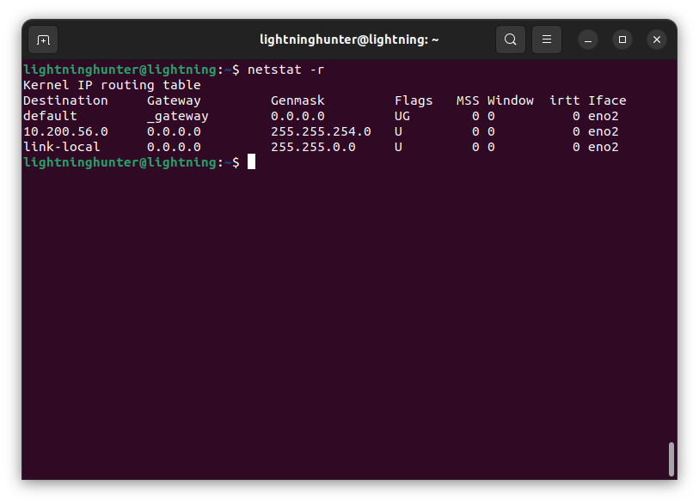

7. nslookup

- Used to query Internet name servers interactively.
- It is a program used to query Internet Domain Name Servers.
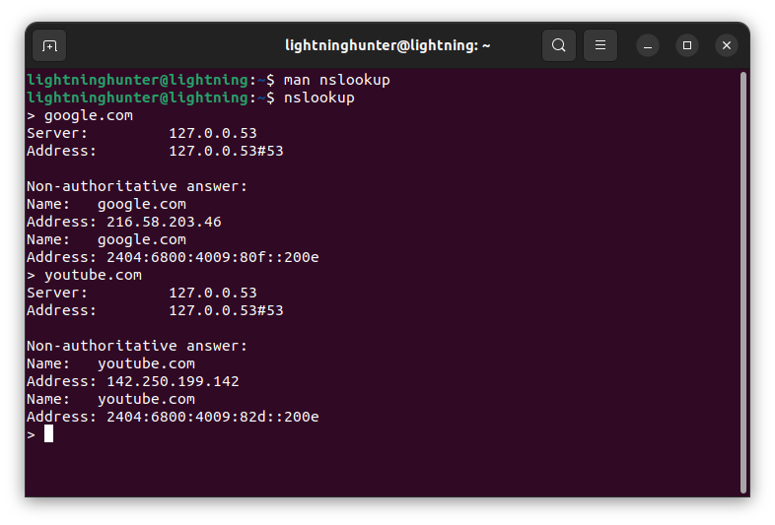

8. dig

- DNS lookup utility. It is a flexible tool for interrogating DNS name servers.
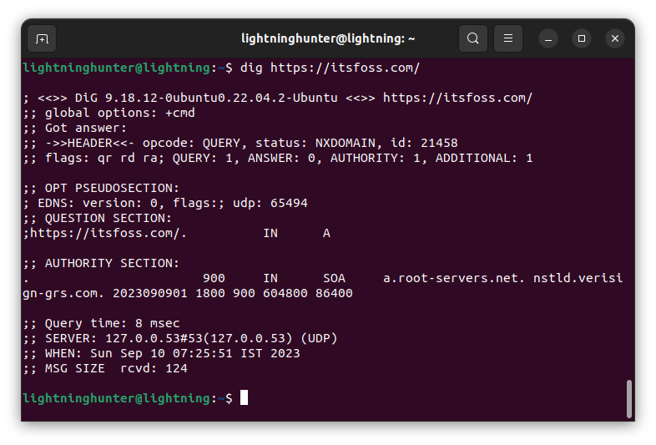

9. route

- It allows us to view/manipulate the IP routing table
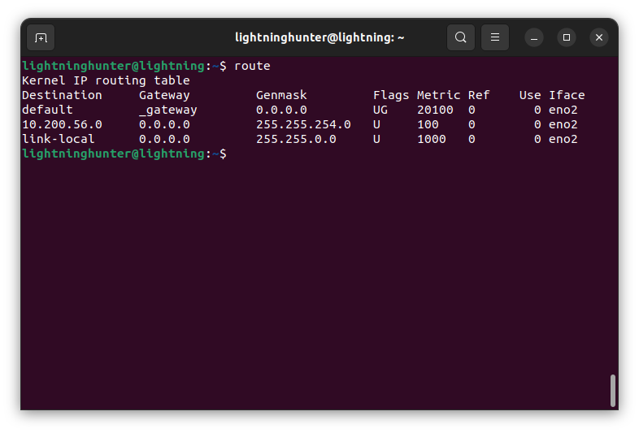

10. Host

- It is a simple utility for performing DNS Lookups.
- Normally used to convert names to IP Addresses and vice versa.
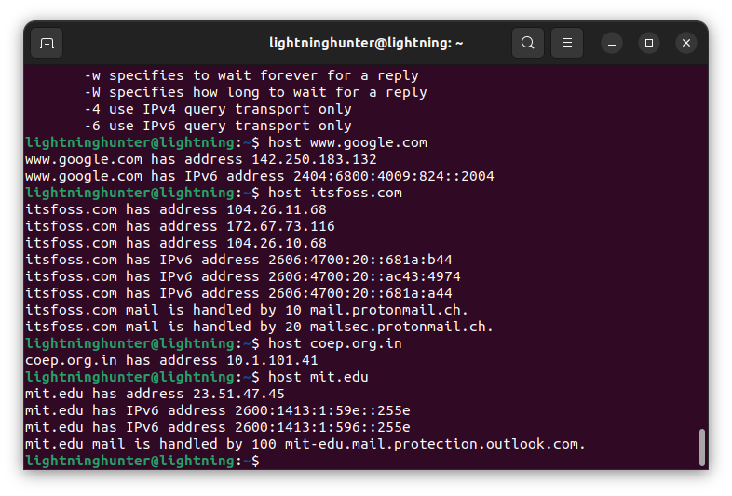

11. arp

- This utility is used to manipulate the system ARM cache.
- ARP manipulates or displays the kernel’s Ipv4 network neighbour cache.
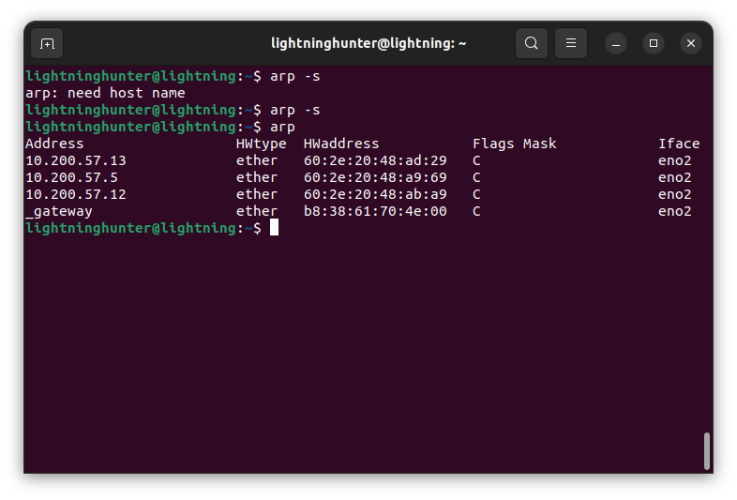

12. iwconfig

- Configure a wireless network interface
- It is similar to ifconfig but it is solely dedicated to wireless interfaces.

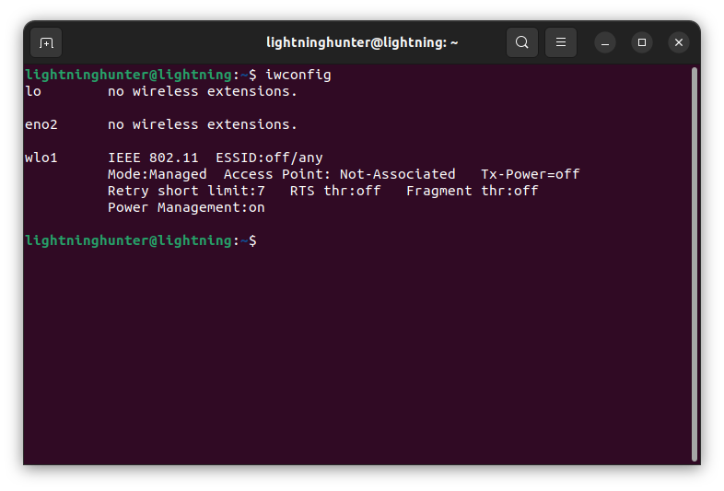

13. curl

- It is a tool for transferring data to and from a server.
- The command is designed to work without needing user interaction.

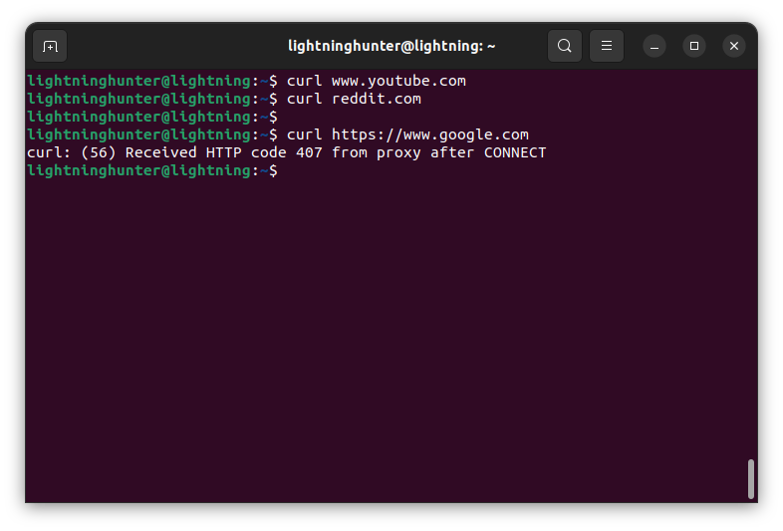

Couldn’t display detailed result as I was getting PROXY 407 error. Tried resolving it but it didn’t work due to hostel network proxy set on terminal.

14. wget

- GNU Wget is a free utility for non-interactive download of files from the Web. It supports HTTP, HTTPS, and FTP protocols, as well as retrieval through HTTP proxies.

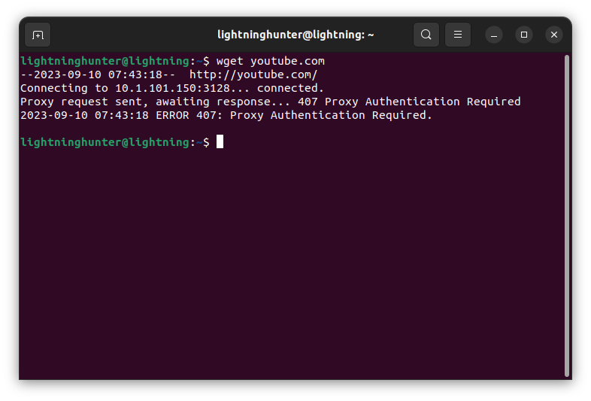

Tried setting up the HTTP_PROXY and HTTPS_PROXY for the same but it still didn’t show any changes.

15. telnet

- It is an utility which give user interactivity for the telnet protocol
- It is used for interactive communication with another host using the same i.e. the telnet protocol.

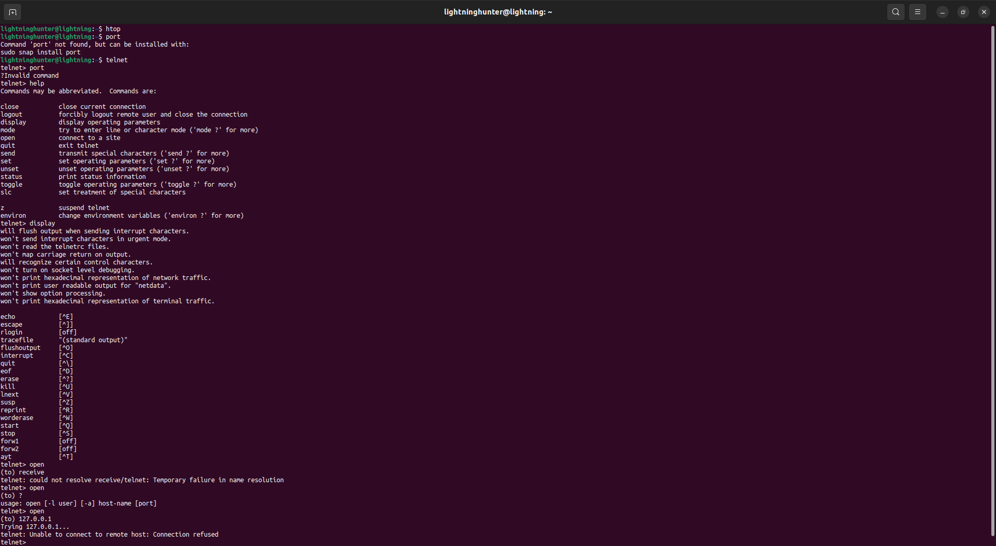

16. whois

- It is the client for whois directory service
- It is used to retrive information about domain names.
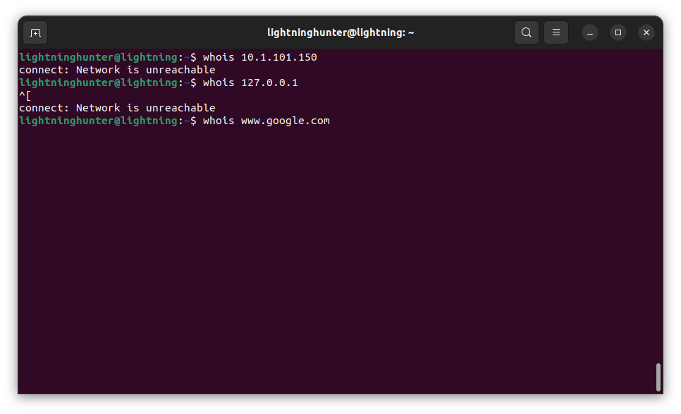

17. ifplugstatus

- ifplugstatus is a link beat detection tool.
- ifplugstatus is an utility which may be used to detect the link status of a local Linux ethernet device, much in the same way mii-diag, mii-tool and ethtool work.

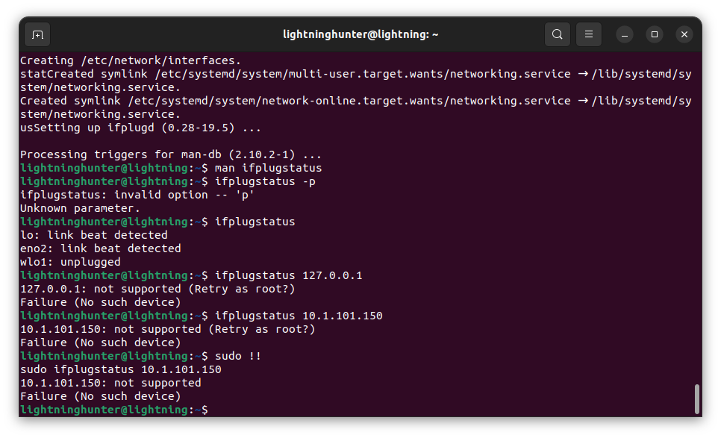

18. nload

- Used to display the current Network usage
- nload is a console application which monitors network traffic and bandwidth usage in real time. It visualizes the in- and outgoing traffic using two graphs and provides additional info like the to‐ tal amount of transferred data and min/max network usage.

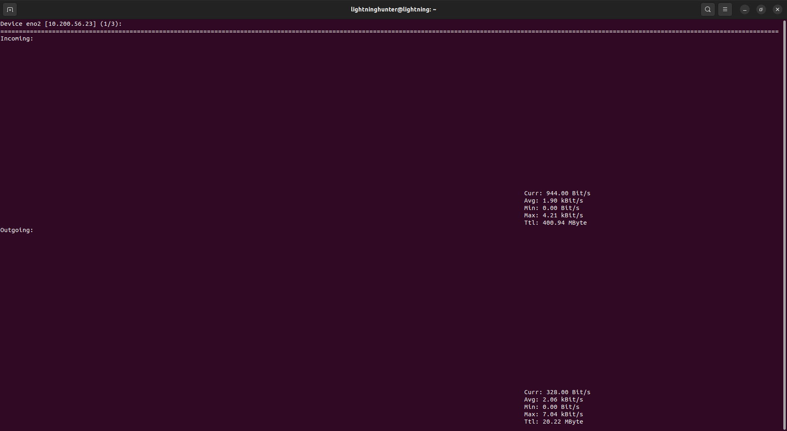

19. mail
- mail.mailutils - process mail messages

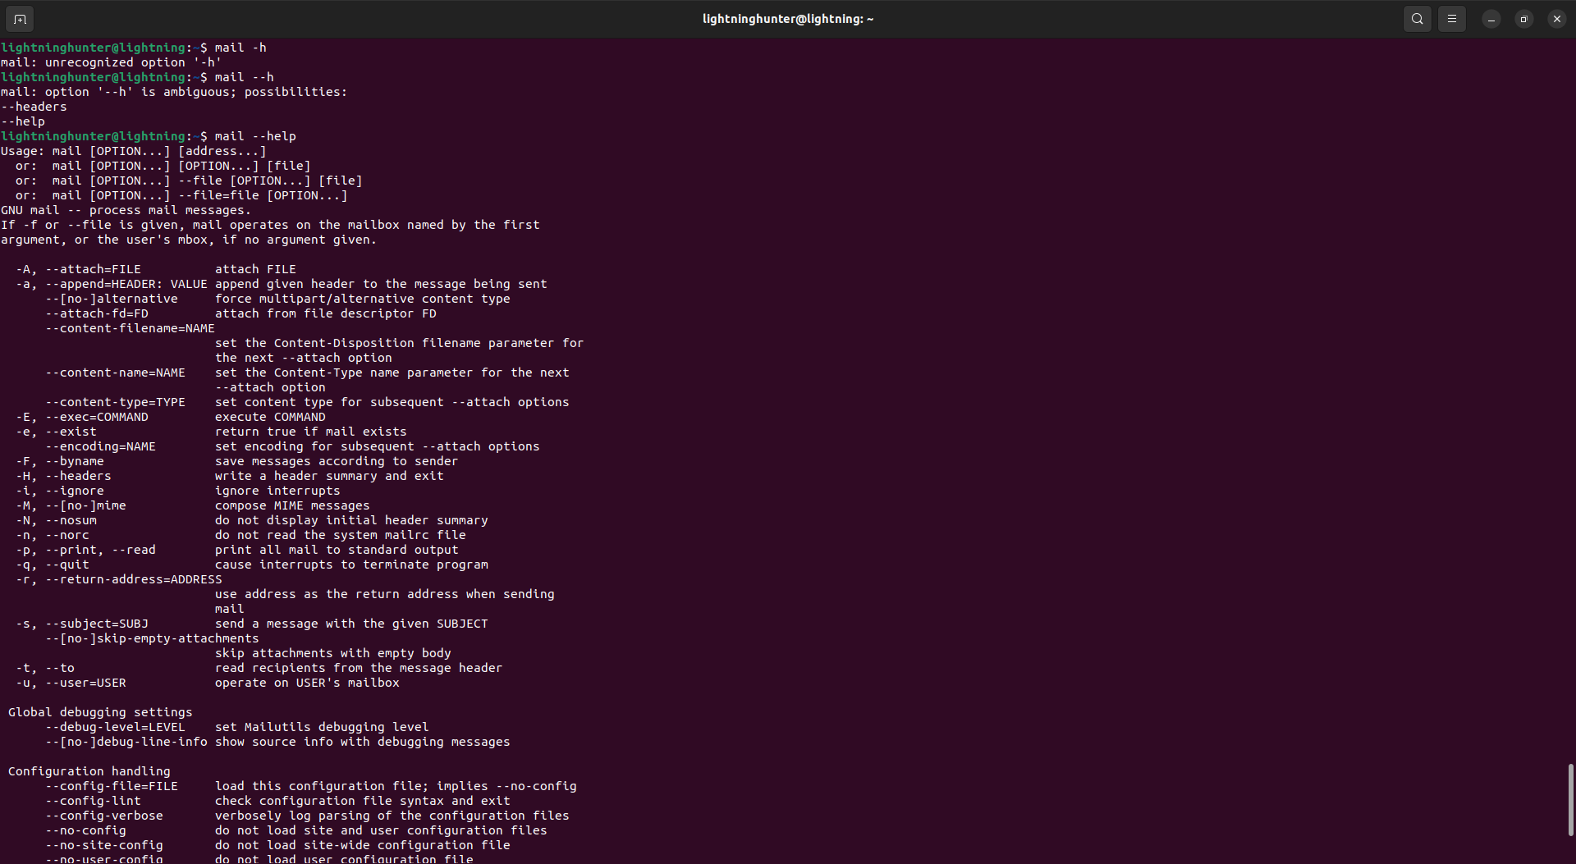

** Some commands could not be executed so I have attached the error messages/ help attribute outputs of the same.

