As a | new user of http://mywebsite.com
I want | to be able to register online
So that | I can myself create my login credential without waiting to receive my login credential via paper mail.
Acceptance Criteria | - On http://mywebsite.com , system shall display ‘Register’ hyperlink which shall be placed adjacent to the left of ‘Login’ hyperlink (refer Appendix 2: Display ‘Registration’ Link wireframe and Appendix 3: Data Table for ‘Registration’ Link)  - On Click of ‘Register’ hyperlink, system shall navigate the user to ‘New User Registration’ page in the same browser window (refer Appendix 4: ‘New User Registration’ Wireframe and Appendix 5: ‘New User Registration’ Page Data Table)  - System shall allow the user to enter registration data.  - On Click on ‘Register’ command button, system shall perform the following validations:  - All required data is entered  - Email address is in a valid format  - Email address is unique  - Password entered is in a valid format  - Re-entered password matches the password entered  4.1 In the event of passing of all the validations, system shall navigate the user to ‘Registration Complete’ page (refer Appendix 6: ‘Registration Complete’ Wireframe and Appendix 7: ‘Registration Complete’ Page Data Table)  4.2 In the event of failure of one or more validations, system shall display inline error messages. (refer Appendix 8: Inline Error Messages)  5. On Click of ‘Cancel’ command button, system shall discard the data entered by the user and shall navigate the user to home page (http://mywebsite.com)

Appendix 1: ‘New User Registration’ Process Flow

Appendix 2: Display ‘Registration’ Link wireframe1

Appendix 3: Data Table for ‘Registration’ Link
ID | Field Name | Field Type | Content | Required Field? | Notes
1 | Register | Hyperlink | N/A | No | On click, navigate the user to ‘New User Registration’ page in the same browser window

Appendix 4: ‘New User Registration’ Wireframe
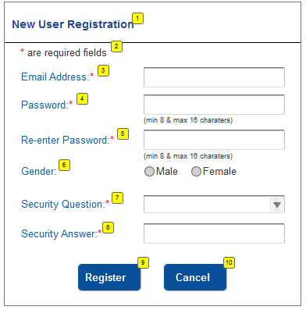

Appendix 5: ‘New User Registration’ Page Data Table
ID | Field Name | Field Type | Content | Required Field? | Notes
1 | New User Registration | Text | N/A | No | Page title
2 | * are required fields | Text | N/A | No
3 | Email Address | Text Box | Alpha Numeric with special characters | Yes | Min char: 6  Max char: 100
4 | Password | Text Box | Alpha Numeric | Yes | Data is encrypted  Min char: 8  Max char: 16
5 | Re-enter Password | Text Box | Alpha Numeric | Yes | Data is encrypted  Min char: 8  Max char: 16
6 | Gender | Radio Button | Male, Female | No | No default selection
7 | Security Question | Dropdown | 1) What is your pet’s name?  2) What is your best friend’s name?  3) What is your mother’s maiden name? | Yes | No default selection.  Sort the questions in alphabetical order
8 | Security Answer | Text Box | Alpha Numeric | Yes | Min char: 2  Max char: 36
9 | Register | Command Button | N/A | N/A | On click, if all validations pass, navigate user to ‘Registration Complete’ page in same browser or else display inline error messages
10 | Cancel | Command Button | N/A | N/A | On click, discard the data entered and navigate the user to home page

Appendix 6: ‘Registration Complete’ Wireframe
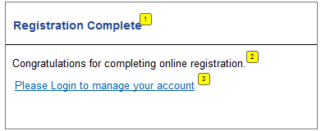

Appendix 7: ‘Registration Complete’ Page Data Table
ID | Field Name | Field Type | Content | Required Field? | Notes
1 | Registration Complete | Text | N/A | No | Page Title
2 | Congratulations for completing online registration. | Text | N/A | No
3 | Please Login to manage your account | Hyperlink | N/A | No | On click, navigate the user to ‘Login’ page in the same browser window

Appendix 8: Inline Error Messages
Failed Validation | Error Message Displayed
All required data is entered | <Data Field Name> is a required data.
Email address is in a valid format | Please enter a valid email address.
Email address is unique | Email address entered is already associated with an active account
Password entered is in a valid format | Password must be between 8 and 16 characters
Re-entered password matches the password entered | Re-entered password does not match the password entered

