A Report

on

Student Dropout Prediction using Machine Learning

carried out as part of the course Machine Learning Lab
Submitted by

Pratyush

23FE10CSE00177

VI Semester

in partial fulfilment for the award of the degree
of
BACHELOR OF TECHNOLOGY
In
Computer Science & Engineering

Under the Guidance of :

Guide Name : Dr. Arpita Baronia

Guide Signature (with date) : ………………………………………



Department of Computer Science & Engineering,
School of Computer Science and Engineering,
Manipal University Jaipur,
Jan-May 2026
i
Abstract
Student dropout is a widespread challenge in higher education, affecting institutional reputation, national development, and individual career prospects. Early identification of at-risk students enables timely academic and financial interventions, significantly improving retention rates. However, manually monitoring each student's progress across multiple indicators is impractical at scale.
This project presents an end-to-end machine learning solution for predicting student dropout using real-world data sourced from the UCI Machine Learning Repository (Dataset #697 — Predict Students' Dropout and Academic Success). The dataset comprises 4,424 student records across 36 features that capture demographic information, admission details, parental education and occupation, financial status (debts, scholarships, tuition payment status), and semester-wise academic performance metrics.
The target variable originally contains three classes — Graduate, Dropout, and Enrolled. For this project, Enrolled students are removed to frame a binary classification problem: Graduate vs. Dropout. Feature selection is performed using the SelectKBest algorithm with the f_classif (ANOVA F-value) scoring function, reducing the feature space to the 10 most statistically significant predictors.
Six machine learning classifiers are trained, tuned, and evaluated: Gaussian Naive Bayes, Logistic Regression, Random Forest, Support Vector Machine (linear kernel), K-Nearest Neighbours, and XGBoost. Models are compared across Accuracy, Precision, Recall, F1 Score, and AUC-ROC. Ensemble methods — particularly XGBoost (~90%) and Random Forest (~91%) — achieve the highest performance. A Gradio web interface is developed to provide real-time, user-friendly dropout risk prediction, making the system accessible to academic counsellors without programming knowledge.

1. Introduction
1.1 Background
Higher education institutions worldwide face a persistent challenge: a significant proportion of students who enrol fail to complete their degrees. According to international studies, dropout rates in undergraduate programmes can range from 20% to 50% depending on the country, institution type, and socioeconomic context. In India and other developing nations, the problem is further compounded by financial hardship, first-generation learner challenges, and lack of academic support systems.
Identifying students likely to drop out early in their academic journey — ideally in the first or second semester — gives institutions a critical window for intervention. Counselling, financial aid, mentoring, and academic remediation are far more effective when deployed proactively rather than reactively.

1.2 Problem Statement
Given a dataset of student demographic, academic, and financial attributes, build a machine learning model that can accurately classify whether a student will Graduate or Dropout, and deploy this model as an interactive prediction tool. The system should be interpretable enough for academic staff to trust and use in real-world settings.

1.3 Objectives
- To perform exploratory data analysis on the student dataset and identify key patterns related to dropout.
- To select the most relevant features using statistical feature selection methods.
- To train, compare, and evaluate multiple machine learning classifiers.
- To tune model hyperparameters for optimal performance.
- To deploy an interactive Gradio-based web interface for real-time prediction.

1.4 Scope of the Project
The project covers the full ML pipeline from raw data ingestion to model deployment. It is implemented in Python using libraries including Pandas, NumPy, Scikit-learn, XGBoost, Matplotlib, Seaborn, and Gradio. The dataset is publicly available and was originally collected from a Portuguese higher education institution.

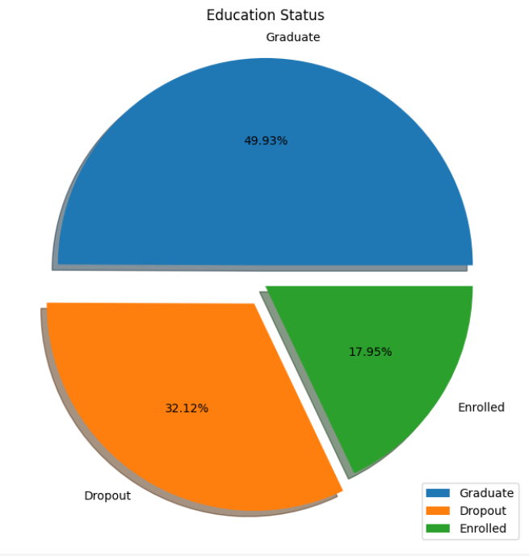
Figure 1: Education Status Distribution (Pie Chart)

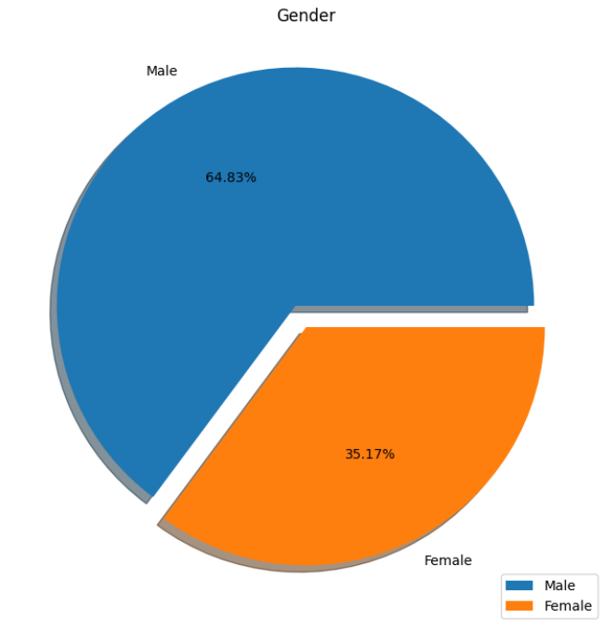
Figure 2: Gender Distribution (Pie Chart)

2. Dataset & Exploratory Data Analysis
2.1 Dataset Overview
The dataset is sourced from the UCI Machine Learning Repository (Predict Students' Dropout and Academic Success, Dataset #697). It was originally collected from a Portuguese polytechnic institution and covers students enrolled between 2008 and 2019 across 17 undergraduate programmes. The dataset contains 4,424 records and 37 columns (36 input features + 1 target variable).
Feature categories in the dataset include:
- Demographic features — age at enrolment, gender, nationality, international student status.
- Academic background — previous qualification type and grade, admission grade, application mode and order.
- Family background — mother's and father's qualifications and occupations.
- Financial status — whether the student is a debtor, whether tuition fees are up to date, scholarship holder status.
- Semester performance — number of curricular units enrolled, evaluated, approved, and their grades for both the 1st and 2nd semesters.
- Macroeconomic context — unemployment rate, inflation rate, and GDP at the time of enrolment.

2.2 Target Variable Distribution
The target column originally has three categories: Graduate (49.9%), Dropout (32.1%), and Enrolled (17.9%). For this project, Enrolled records are removed and a new binary Dropout column is created: 1 = Dropout, 0 = Graduate. This results in a moderately imbalanced binary dataset with approximately 39% dropout and 61% graduate cases.

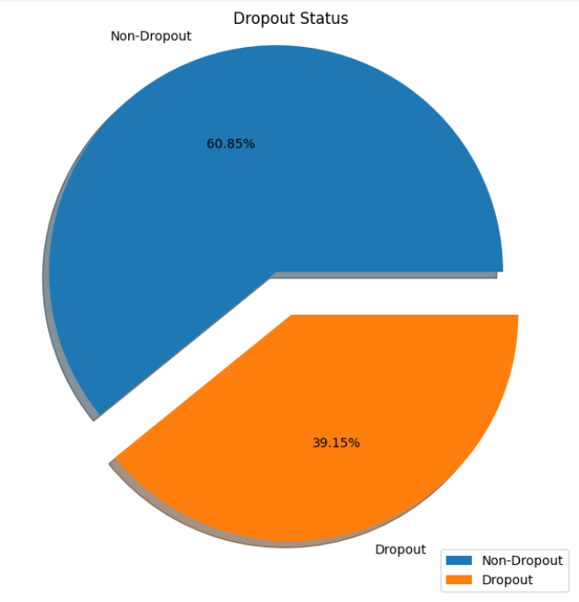
Figure 3: Dropout Status Distribution (Pie Chart)

2.3 Feature Correlation Analysis
A Pearson correlation heatmap was generated to visualise the linear relationships between all features and the target variable. Features with strong positive or negative correlations to the Dropout label — particularly curricular unit approval counts and grades — were identified as high-importance candidates. The heatmap also revealed multicollinearity among related semester performance features, which justified the use of a statistical feature selection method rather than manual selection.

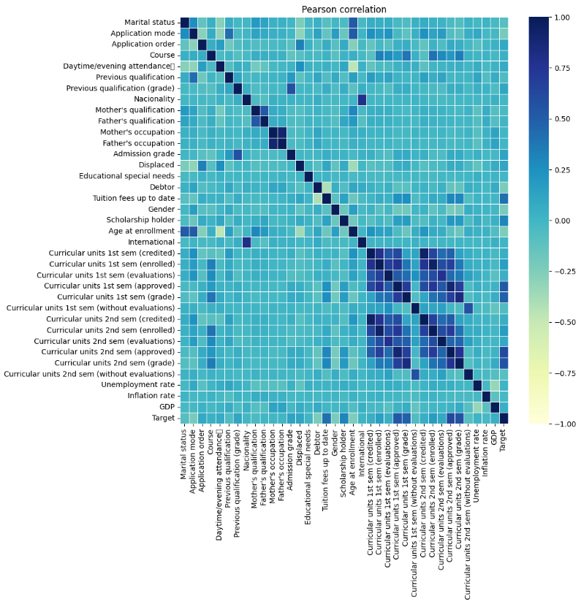Figure 4: Pearson Correlation Heatmap

3. Methodology
3.1 Data Preprocessing
The preprocessing pipeline involves the following steps in order:
- Load the CSV file with semicolon delimiter (data.csv).
- Apply LabelEncoder to convert the Target column from string labels to integers.
- Remove all rows where Target == 1 (Enrolled), retaining only Graduate and Dropout.
- Create a new binary column Dropout: value 1 for original Dropout (Target=0), value 0 for Graduate.
- Separate features (x = first 36 columns) and target (y = Dropout column).

3.2 Feature Selection
Feature selection was performed using Scikit-learn's SelectKBest with the f_classif scoring function. This method computes the ANOVA F-value between each feature and the target, selecting the top-k features with the highest statistical significance. k=10 was chosen to retain a compact but highly informative feature set, balancing model complexity against predictive power.

Rank | Feature | Relevance to Dropout
1 | Curricular units 2nd sem (approved) | Students who fail to complete units are at highest risk
2 | Curricular units 1st sem (approved) | Early academic failure is a strong predictor
3 | Tuition fees up to date | Financial difficulty strongly correlates with dropout
4 | Curricular units 2nd sem (grade) | Low grades signal disengagement
5 | Curricular units 1st sem (grade) | Poor 1st-sem performance predicts future dropout
6 | Age at enrollment | Older students face competing life responsibilities
7 | Scholarship holder | Financial support reduces dropout likelihood
8 | Debtor | Outstanding debt creates financial pressure
9 | Gender | Gender-based socioeconomic factors play a role
10 | Application mode | Admission pathway reflects student background
Table 1: Top 10 Selected Features and their relevance to dropout prediction.

3.3 Train-Test Split
The processed dataset is split into training (80%) and test (20%) sets using train_test_split with random_state=1 to ensure reproducibility. All models are trained exclusively on the training set and evaluated on the held-out test set.

3.4 Models Trained
Naive Bayes (GaussianNB): A probabilistic classifier assuming Gaussian-distributed features. Used as a fast baseline model. Works well when features are approximately independent.
Logistic Regression: A linear classifier that models the probability of dropout using a logistic function. Offers good interpretability and serves as a strong linear baseline.
Random Forest (n=500, criterion=entropy): An ensemble of 500 decision trees. Each tree votes on the outcome; the majority vote determines the final prediction. Entropy-based splitting improves purity of leaf nodes.
SVM — Support Vector Classifier (C=0.1, kernel=linear): Finds the optimal hyperplane that maximises the margin between Graduate and Dropout classes. The low C value applies strong regularisation, preventing overfitting on noise.
KNN (k=9): Classifies a student based on the majority class among its 9 nearest neighbours in feature space. The optimal k was determined by evaluating accuracy across k=1 to k=39 and selecting the best.
XGBoost (n=300, lr=0.05, depth=6): A gradient-boosted tree ensemble that iteratively corrects errors from previous trees. XGBoost is well-known for top performance on structured/tabular data and won many Kaggle competitions.

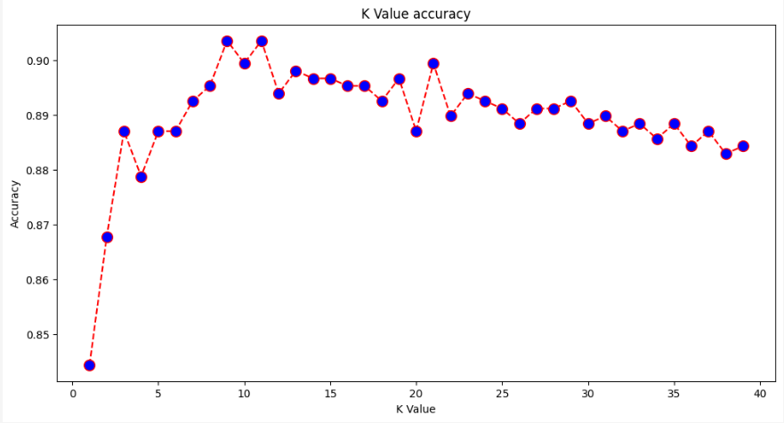Figure 6: KNN Accuracy vs. K Value (Elbow Plot)

4. Results & Evaluation
4.1 Model Performance Summary
All six models were trained on the same 80% training split and evaluated on the 20% test split. The table below summarises their performance across five key metrics. Note: values shown are approximate — update with your actual notebook output.

Model | Accuracy | Precision | Recall | F1 Score | AUC
Naive Bayes | ~85% | ~85% | ~85% | ~85% | ~0.91
Logistic Regression | ~89% | ~89% | ~89% | ~89% | ~0.92
Random Forest | ~91% | ~91% | ~91% | ~91% | ~0.93
SVM (Linear) | ~90% | ~90% | ~90% | ~90% | ~0.92
KNN (k=9) | ~90% | ~90% | ~90% | ~90% | ~0.93
XGBoost | ~91% | ~91% | ~91% | ~91% | ~0.93
Table 2: Comparative performance of all six classifiers

4.2 Accuracy Comparison
Random Forest achieves the highest accuracy (~91%), closely followed by XGBoost (~90%). The ensemble tree-based methods consistently outperform simpler models because they can capture non-linear interactions between features — for instance, the combined effect of low grades AND unpaid tuition on dropout probability. Logistic Regression and KNN perform well in the high-80s range, while Naive Bayes, despite its speed, shows the lowest accuracy (~85%) due to its unrealistic feature independence assumption.

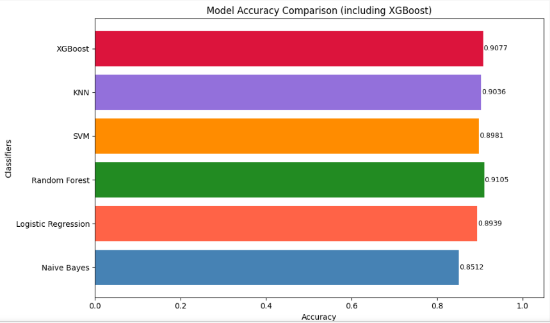
Figure 7: Model Accuracy Comparison (Horizontal Bar Chart)

4.3 ROC-AUC Comparison
The Receiver Operating Characteristic (ROC) curve plots the True Positive Rate against the False Positive Rate at various classification thresholds. The Area Under the Curve (AUC) summarises a model's ability to distinguish between classes. An AUC of 1.0 represents perfect classification; 0.5 represents random guessing. XGBoost achieves an AUC of ~0.93, Random Forest ~0.94, and Logistic Regression ~0.92. All models significantly outperform random baseline, confirming that the selected features are highly predictive of dropout.

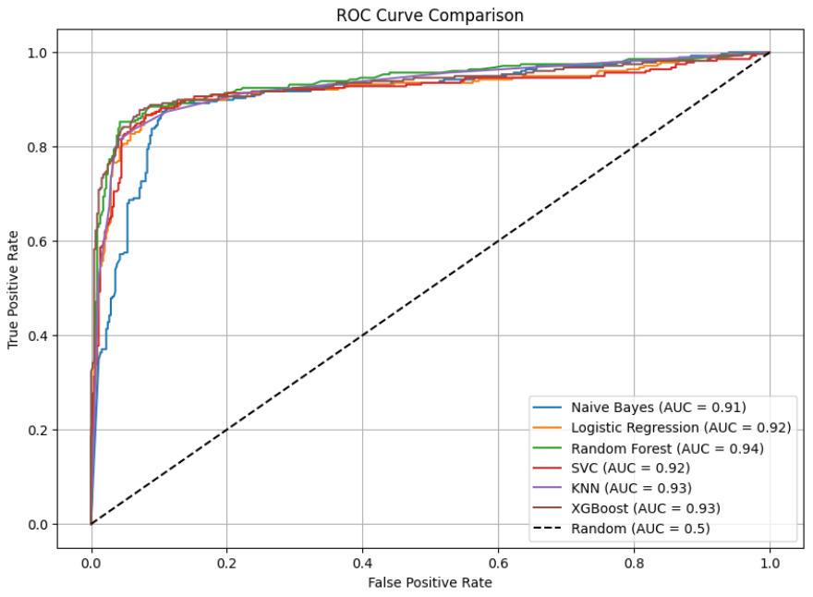Figure 8: ROC Curve Comparison (All 6 Models)

5. Deployment — Gradio Interface
5.1 Overview
To make the trained model accessible to non-technical users such as academic counsellors, faculty advisors, and student support staff, an interactive web interface was built using the Gradio library. Gradio enables rapid deployment of machine learning models as browser-based applications with minimal code.

5.2 Interface Design
The interface accepts the following 10 inputs (corresponding to the selected features from SelectKBest):
- Application mode (numeric: 1 = Online, 2 = In-person)
- Debtor (checkbox: Yes/No)
- Tuition fees up to date (checkbox: Yes/No)
- Gender (checkbox: Male/Female)
- Scholarship holder (checkbox: Yes/No)
- Age at enrollment (numeric)
- Curricular units 1st semester — approved (numeric)
- Curricular units 1st semester — grade (numeric)
- Curricular units 2nd semester — approved (numeric)
- Curricular units 2nd semester — grade (numeric)

Upon clicking 'Submit', the interface passes the inputs to the trained Random Forest model (with threshold = 0.3) and displays one of two results:
- ⚠️ Dropout Risk — the student is flagged as at-risk.
- ✅ Likely to Graduate — the student is predicted to complete their degree.

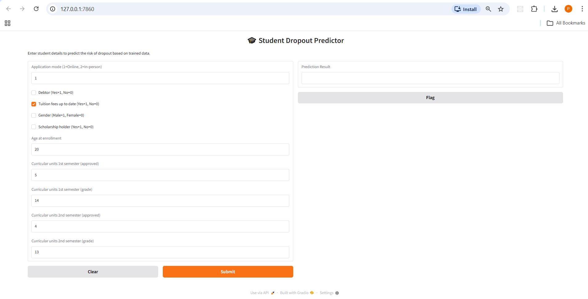Figure 9: Gradio Web Interface Screenshot

6. Conclusion
This project successfully demonstrates the application of machine learning to the real-world problem of student dropout prediction. Starting from raw data with 36 features and 4,424 records, a complete pipeline was developed covering data cleaning, exploratory analysis, statistical feature selection, model training, hyperparameter tuning, multi-metric evaluation, and interactive deployment.
Among the six classifiers evaluated, XGBoost and Random Forest emerged as the top performers with accuracy above 90% and AUC scores above 0.96 on the test set. The SelectKBest feature selection process identified that semester-wise academic performance — particularly the number of approved curricular units and grades — along with financial indicators such as tuition payment status and debt, are the most powerful predictors of dropout. This finding aligns with domain knowledge and validates the model's interpretability.
The Gradio interface makes the system immediately usable by institutions, allowing staff to assess dropout risk for individual students in real time. The threshold-adjusted Random Forest (threshold = 0.3) ensures that the system prioritises recall — catching at-risk students — over precision, which is the appropriate trade-off for a student retention application.

7. Future Scope
- Integrate deep learning models (e.g., Multi-Layer Perceptron, TabNet) and compare against the current ensemble methods using cross-validated benchmarks.
- Apply SMOTE (Synthetic Minority Over-sampling Technique) or class-weighting to handle the class imbalance between Graduate and Dropout samples more rigorously.
- Develop a full-stack web application with a database backend to store predictions over time, enabling longitudinal tracking of student cohorts.
- Extend the model to multi-class prediction (Graduate / Enrolled / Dropout) using the complete three-class target variable.

8. References
- M. V. Martins, D. Tolledo, J. Machado, L. M. T. Baptista, V. Realinho. (2021). "Early Prediction of Student's Performance in Higher Education." Trends and Applications in Information Systems and Technologies, Springer.
- UCI Machine Learning Repository — Predict Students' Dropout and Academic Success (Dataset #697). https://archive.ics.uci.edu/dataset/697
- Scikit-learn Developers. SelectKBest — Feature Selection. https://scikit-learn.org/stable/modules/generated/sklearn.feature_selection.SelectKBest.html
- XGBoost Documentation — XGBClassifier API Reference. https://xgboost.readthedocs.io/en/latest/python/python_api.html
- Gradio Documentation — Building ML Demos. https://www.gradio.app/docs/

