**ABV – INDIAN INSTITUTE OF INFORMATION TECHNOLOGY AND MANAGEMENT**

**GWALIOR**

In Partial Fulfillment of

**SYSTEM ANALYSIS AND DEVELOPMENT(SAD) PROJECT**

**DONATE FOR SMILES**

Submitted to:

**DR. NEETESH KUMAR**

Instructor

Submitted by:

PRATYUSH RANJAN

(roll no:-2016IPG074)

Date of submission:

03 APRIL 2018

**CONTENT**

* **PLANNING**

1. **PROBLEM STTATEMENT**
2. **SYSTEM DESCRIPTION**

* **REQUIREMENT ANALYSIS**
* **TECHNICAL ANALYSIS**
* **SYSTEM ANALYSIS**

1. **USE CASES**
2. **DATA FLOW DIAGRAM**

**PROBLEM STATEMENT**

At present, the basic need of every child (our coming future) is Education. The government is also supporting this by campaigns like **“Padhega India tabhi toh badhega India**" or " **Sab padho, Sab** **badho**". To be a surviver in this world of cut-throat competition, being eduacted/literate is the main & most powerful weapon.

Normally, a middle class, upper-middle class & rich class family can get their children admitted to good private schools having all facility but what about those who don't have enough money nad rely on government schools for their children education.

According to a survey in the year 2016, there are 315 million school students and from which 113 million students study in government schools( which means 36% of our future is in dark).

Government is providing many facilities like mid-day meal, school dress & no fees education but what about the main reason of going to school, which is studying. What about the books for government school students?

Government have taken many initiative like providing E-books to government school student but if you think deeply then you will realise that those family which don't have enough money to feed their children even twice a day and are sending their children to government school so that they can get proper mid-day meal, how can they afford Smartphone's for E-book facility.

There are also some other initiatives like government & many NGO's (running for education of children) who raise fund to provide books to needy government school students. The funds raised by government to print/publish books and make it available to student have a huge flaw. According to survey in various government schools specially in capital Delhi, out of 100% of government schools, government can cover only 35-40% of the school plus according to the students firstly they get these books after half of their session is over ( means after 6 months) and second thing is that the print quality is also very poor.

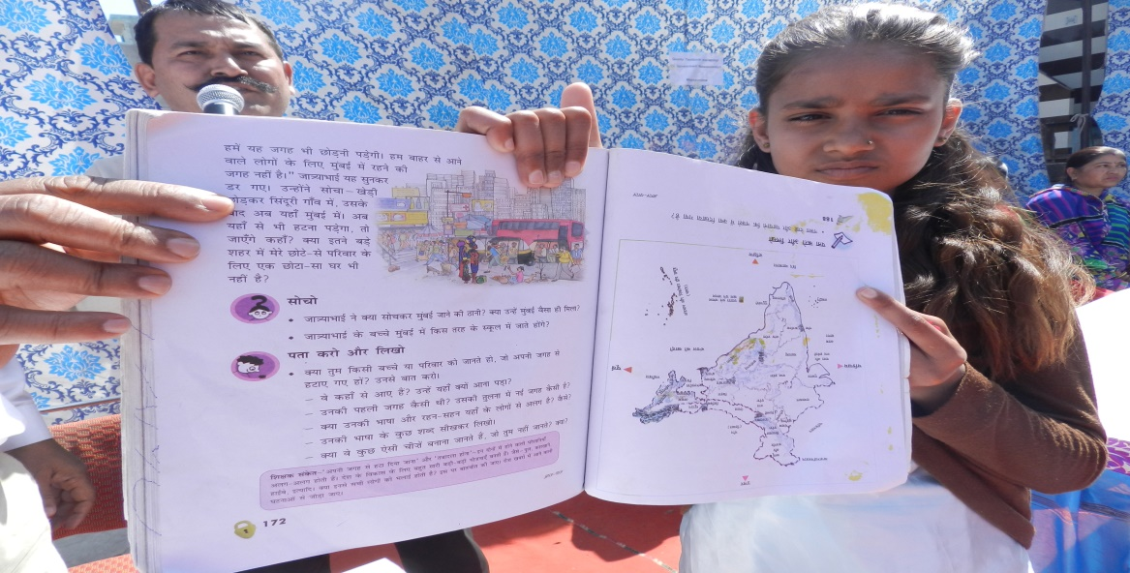

WHO WE ARE?

DonationforSmile.com is a platform of government school students, teachers, principal & book donators. On DonationforSmile.com anyone can donate their used books in bulk of class 1st to 12th and a needy government school authority can buy those books in bulk for their school students at free of cost ( just have to pay delivery charges ).

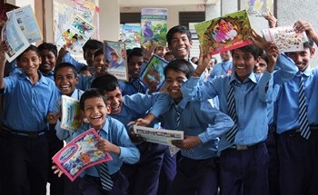WHAT WE DO ?

### Many of us have lot of books on our shelves that go largely untouched from long period of time. We recruit that someday we’ll read them, and then we pack them up in boxes and pull them with us every time we move. Instead, why not reduce the load and do some social work to make someone smile by just sitting at home.

### So we are here to help you to send these books to those who really need them. We will take out these books from your shelves and send them directly to those who are unable to buy them and bring smiles to their faces.

### OUR GOAL

### "We don't need a course based study material to make someone educated, we just need a handful book to make someone knowledgeable".

### Our goal is to provide quality knowledge to each needy government school students nearly free of cost. Make convenient for each student for reuse books, so it can help in saving trees and make Eco Environment.

### SYSTEM DESCRIPTION

### The product being developed is a web application. DonationforSmile.com ia a platform to everyone make educated/literate, Eco & Digital India.

### 1.) The application authenticates each and every user of the system by his/her email and password. The user is required to register with the system by providing his /her credentials.

### 2.) The application is linked to a centralised database that holds the records of all the Government school authority who have registered with the application.

### 3.) Anyone who wish to donate books in bulk of various classes can register with the system by providing the essentials book details then through database its advertisement is processed on website for users. Now we can communicate with donor and can get the books.

### 4.) Now any government school student, teacher, principal in need of the book can search through the website to view the list of the donated books and can order all the different books he/she require.

### 5.) Now the users have to provide documents (such as license number of their government school, document of being teacher or principal of that school) for verification so that we can be assured that book has been asked for government schools.

### 6.) After 2 days of verification, the delivery process will start and when the delivery will be made the user have to pay delivery charges for the box of ordered books (means COD system).

### REQUIREMENT ANALYSIS

### Business Requirement

### No business needs, the product is to be developed for the welfare of the society.

### User Requirement

### User Login Id & Password.

### Product Details.

### Fast Delivery of Product.

### System Requirement

### Active Internet Connection.

### Any modern web browser.

### Functional Requirement

### Interface for User login & registration.( Process Oriented)

### Interface for donation of book. (Process Oriented)

### Display details of available books. (Process Oriented)

### The system must retain user cart history. (Information Oriented)

### The system may create another information database for books being donated rather than advertisement one to pick those books up. (Information Oriented)

### Document verification and updating user about delivery process being started.(Process Oriented)

### Non-Functional Requirement

### OPERATIONAL:- The system will be able to work on any browser. The system can run on any device(computer, laptop, mobile, tablet) having proper internet connection.

### PERFORMANCE:- The speed, capacity and reliability of the system is good.

### SECURITY:- The system has wherever needed proper validation for input credentials with md5 password protection. There is document verification process so that only government school authority can buy the books.

### TECHNICAL Software Used

The product is a website application so the list of the major software /technologies and the programming languages used is as follows:

* **Netbeans** Integrated Development Environment.
* **Sublime** Text editor.
* **HTML, CSS (BOOTSTRAP), JAVASCRIPT** languages used for front-end development.
* **PHP, MYSQL** languages used for back-end development.
* **WAMP SERVER** to create a local web server for testing and deployment purposes.
* External websites such as [*stackoverflow.com*](http://stackoverflow.com)*,* [*google.com*](http://google.com)etc...

**USE CASES**

***USE CASE 1- REGISTER THE USER***

|  |  |  |
| --- | --- | --- |
| **Use Case ID:** | **1** | |
| **Use Case Name:** | **Sign Up** | |
| **Last Updated By:** | | **Administrator** |
| **Date Last Updated:** | | **03-04-2018** |

|  |  |
| --- | --- |
| **Actor:** | **User of application** |
| **Description:** | **This use case describes how the new user is handled.** |
| **Preconditions:** | **User must have the application and proper internet connection on his/her device.** |
| **Post conditions:** | 1. **The user is registered successfully.** 2. **He is guided to the next activity of the application.** |
| **Priority:** | **HIGH** |
| **Trigger:** | **A new user needs to interact with the application.** |
| **Normal Course of Events:** | **1. The user enters the credentials.**  **2. The system checks if the credentials entered are valid.**  **3. If the credentials are valid then the user is registered with the application and taken to the next screen of the application. Also the credentials are stored in the database.**  **4. If the credentials are invalid then an appropriate message is displayed on the screen.** |

***USE CASE 2- LOGIN***

|  |  |  |
| --- | --- | --- |
| **Use Case ID:** | **2** | |
| **Use Case Name:** | **Login** | |
| **Last Updated By:** | | **Administrator** |
| **Date Last Updated:** | | **03-04-2018** |

|  |  |
| --- | --- |
| **Actor:** | **User of application** |
| **Description:** | **This use case describes how user the user is authenticated..** |
| **Preconditions:** | **1. User should have already registered with the application.**  **2. User must have the application and proper internet connection on his/her device.** |
| **Post conditions:** | **1. The user is authenticated successfully.**  **2. He is guided to the next activity of the application.** |
| **Priority:** | **HIGH** |
| **Trigger:** | **A user needs to access full features of website.** |
| **Normal Course of Events:** | **1. The user enters email and password.**  **2. The system checks iff the credentials entered are valid.**  **3. If the credentials entered are valid then the user is logged in and taken to the next screen of the application.**  **4. If the credentials are invalid then an appropriate message is displayed to the user.** |

***USE CASE 3- DONATION***

|  |  |  |
| --- | --- | --- |
| **Use Case ID:** | **3** | |
| **Use Case Name:** | **Donation** | |
| **Last Updated By:** | | **Administrator** |
| **Date Last Updated:** | | **03-04-2018** |

|  |  |
| --- | --- |
| **Actor:** | **Donor** |
| **Description:** | **This use case describes how the user can donate books and advertise it.** |
| **Preconditions:** | **1. Donor must have been authenticated.**  **2. User must have the application and proper internet connection on his/her device.**  **3. Donor must have some books to donate.** |
| **Post conditions:** | **1. The donor details are saved to the database.**  **2. The donor various book details are displayed on the website.** |
| **Priority:** | **HIGH** |
| **Trigger:** | **A person wants to donate books.** |
| **Normal Course of Events:** | **1. The donor enter the details of the book.**  **2. The system checks if the credentials entered are valid.**  **3. If the credentials entered are valid then the donor details are send to database and donor book details to another database & is shown an appropriate message.**  **4. If the credentials are invalid then an appropriate message is displayed to the user.** |

***USE CASE 4- ORDER***

|  |  |  |
| --- | --- | --- |
| **Use Case ID:** | **4** | |
| **Use Case Name:** | **Order** | |
| **Last Updated By:** | | **Administrator** |
| **Date Last Updated:** | | **03-04-2018** |

|  |  |
| --- | --- |
| **Actor:** | **Government School Authority seeking for books.** |
| **Description:** | **This use case describes how the user can buy books in bulk for free of cost.** |
| **Preconditions:** | **1. Donor must have been authenticated.**  **2. User must have the application and proper internet connection on his/her device.**  **3. Needy must have requirement of some books to order.** |
| **Post conditions:** | **1. The needy cart details are saved to the database.**  **2. He is guided to the next activity of the website.** |
| **Priority:** | **HIGH** |
| **Trigger:** | **User will see the list of books and want to add required books to cart.** |
| **Normal Course of Events:** | **1. The needy choose the books and quantity he/she require.**  **2. The needy add all the different required books and their quantity to his cart.**  **3. Then the details of the cart are send to database and is shown an appropriate message and taken to the next activity of the website.** |

***USE CASE 5- DOCUMENT VERIFICATION AND DELIVERY***

|  |  |  |
| --- | --- | --- |
| **Use Case ID:** | **5** | |
| **Use Case Name:** | **Document Verification and Delivery** | |
| **Last Updated By:** | | **Administrator** |
| **Date Last Updated:** | | **03-04-2018** |

|  |  |
| --- | --- |
| **Actor:** | **Government School seeking for books.** |
| **Description:** | **These use cases describes how the document of needy will be verified and after verification books will be send to given address.** |
| **Preconditions:** | 1. **User needs to provide valid documents for verification that the book being asked for is for government school students.** |
| **Post conditions:** | 1. **User needs to wait for 2 days for the verification.** 2. **If credentials are correct, books delivery process to given address will start.** |
| **Priority:** | **HIGH** |
| **Trigger:** | **Needy have to provide documents for verification.** |
| **Normal Course of Events:** | **1. The needy will provide documents.**  **2. The documents will be verified within 2 days.**  **3. If the provided documents are correct then the user will be informed and process of delivery will be started.**  **4. If the provided documents are not correct then a message for wrong credentials will be sent to the needy.** |