Tableau Dashboard Report
Financial Fraud Detection Using Credit Card Transactions

1. Amount Spent by Gender Across Different Categories (Box & Whisker Plot)
Objective
To analyze the distribution of transaction amounts across different spending categories and compare customer spending patterns based on gender.
Analysis
A Box and Whisker Plot was created using Transaction Amount (Amt), Category, and Gender. This visualization highlights the median, quartiles, variability, and potential outliers within each transaction category.
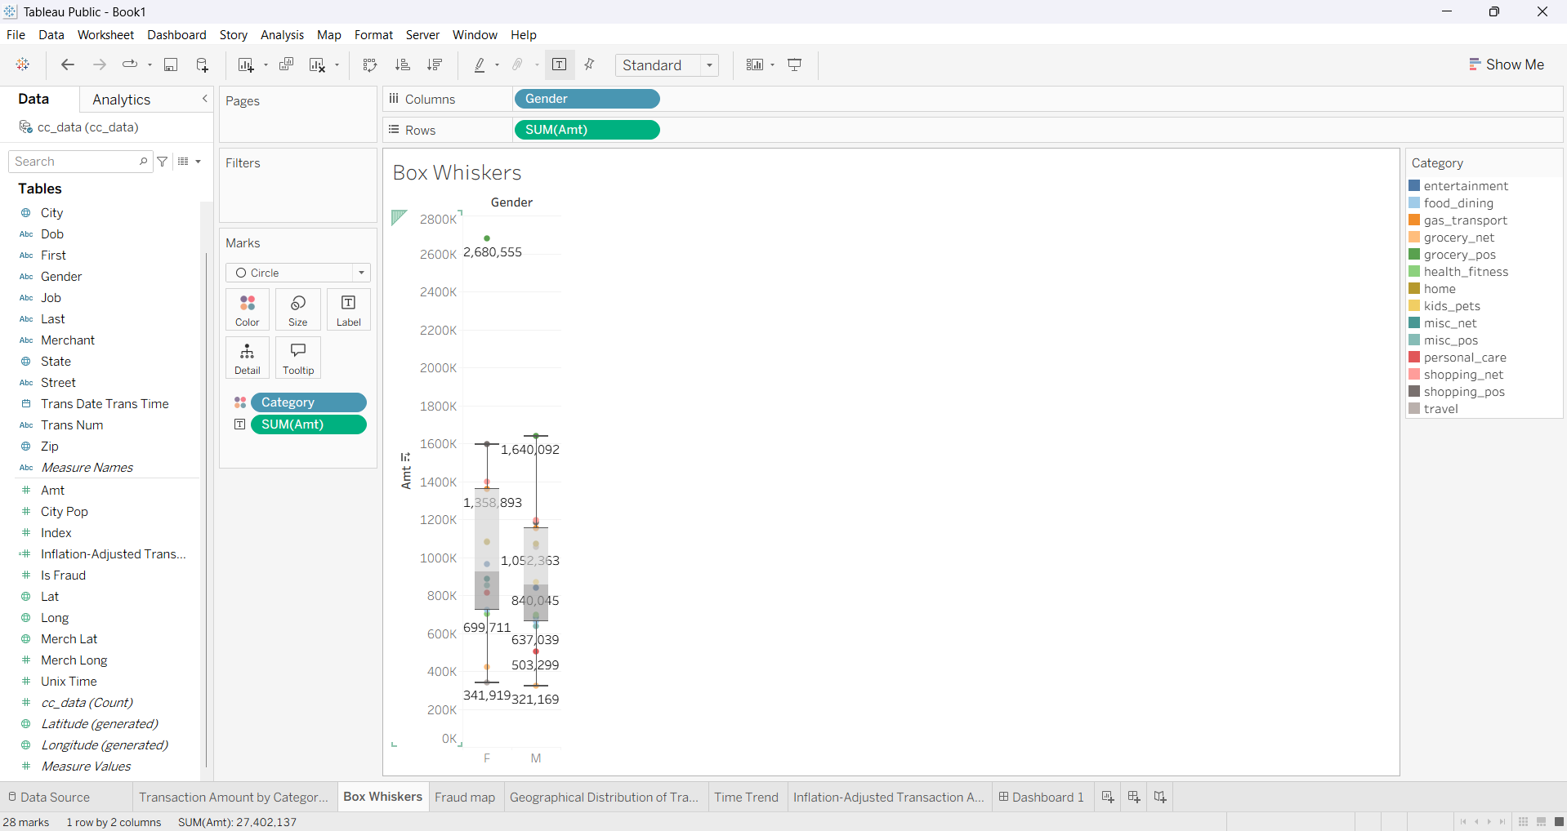

Key Findings
- Transaction amounts vary significantly across different spending categories.
- Several categories exhibit numerous high-value outliers, indicating occasional unusually large purchases.
- Spending behavior between male and female customers appears relatively similar across most categories.
- The visualization effectively identifies categories with greater transaction variability, which may require additional fraud monitoring.

2. Geographical Distribution of Transactions
Objective
To visualize the geographical locations where customer transactions occurred.
Analysis
Latitude and longitude coordinates were plotted using Tableau's mapping functionality. Transaction amount was represented using color intensity and marker size to indicate spending magnitude.

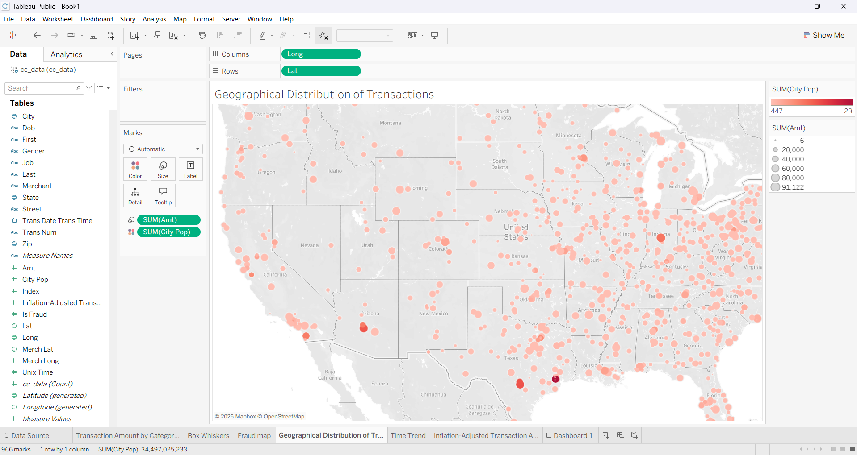

Key Findings
- Transactions are distributed across multiple geographic locations.
- Larger transaction amounts are represented by larger markers, making high-value transactions easier to identify.
- Geographic visualization provides valuable spatial insight into customer transaction behavior.

3. Fraudulent Transaction Map
Objective
To identify the geographic distribution of fraudulent transactions.
Analysis
Fraud status (is_fraud) was plotted on a geographical map using latitude and longitude coordinates.

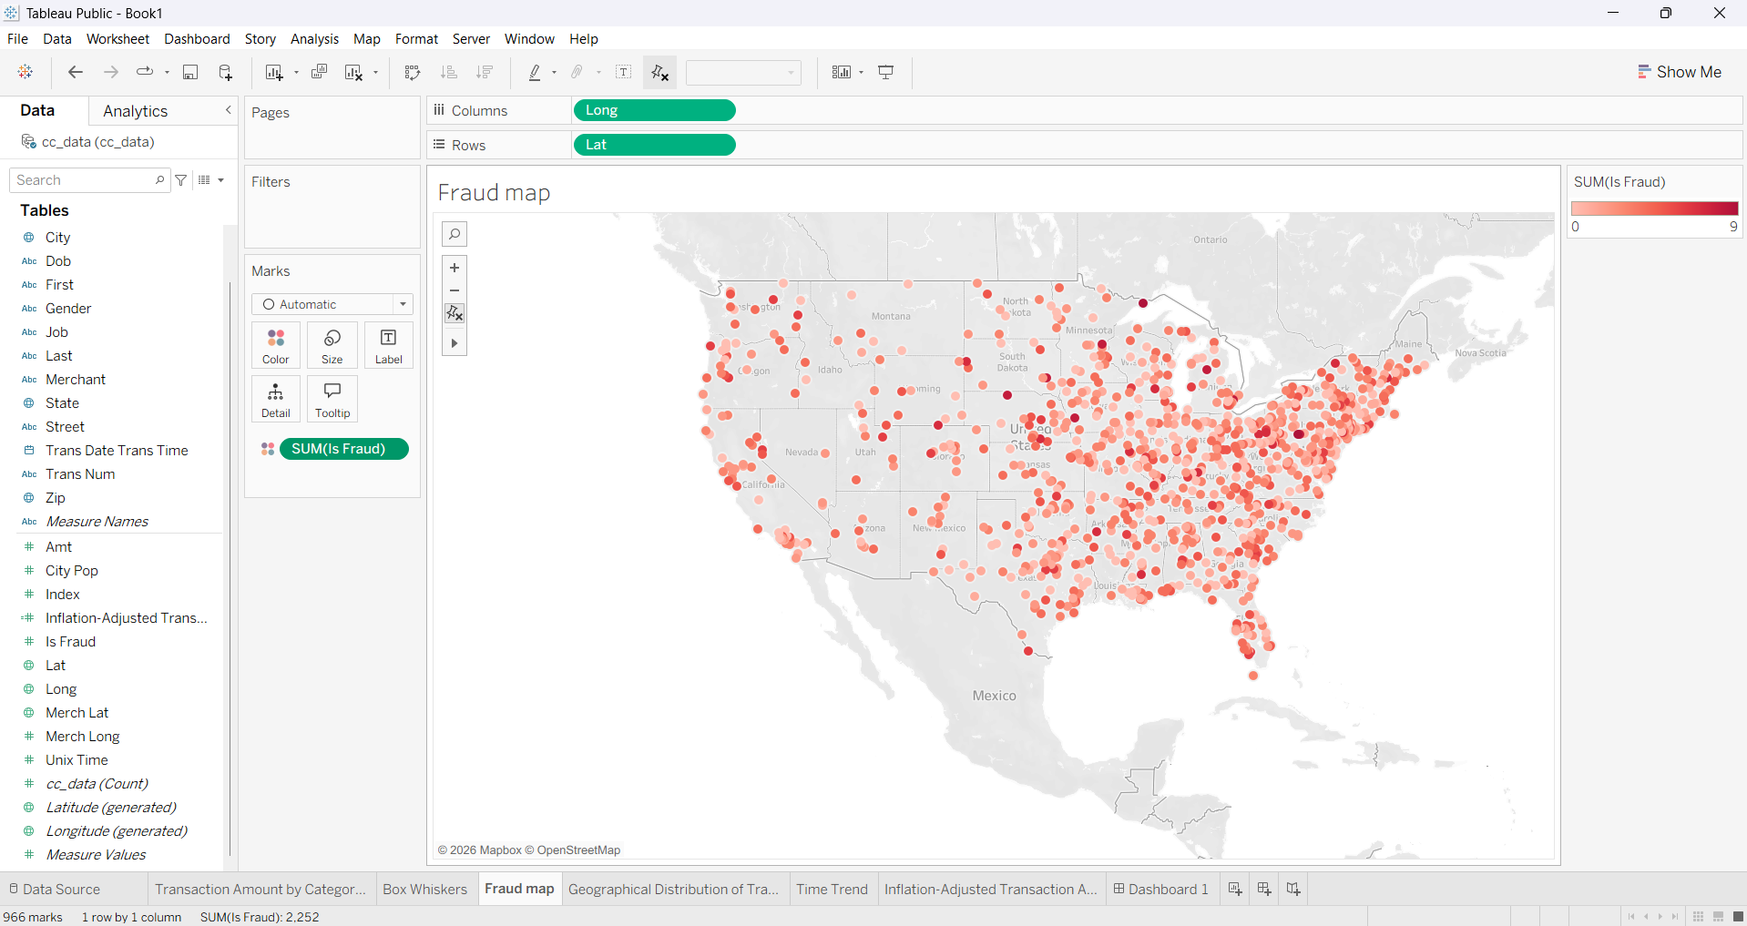

Key Findings
- Fraudulent transactions are geographically dispersed rather than concentrated in a single location.
- Certain regions contain relatively higher numbers of fraudulent transactions, making them suitable candidates for enhanced fraud monitoring.
- Geographical analysis enables financial institutions to identify potential fraud hotspots and regional risk patterns.

4. Monthly Transaction Trend (Time Series Analysis)
Objective
To analyze monthly transaction trends over the available time period.
Analysis
A time series line chart was created using the transaction date field, aggregated monthly, with transaction counts represented on the vertical axis.
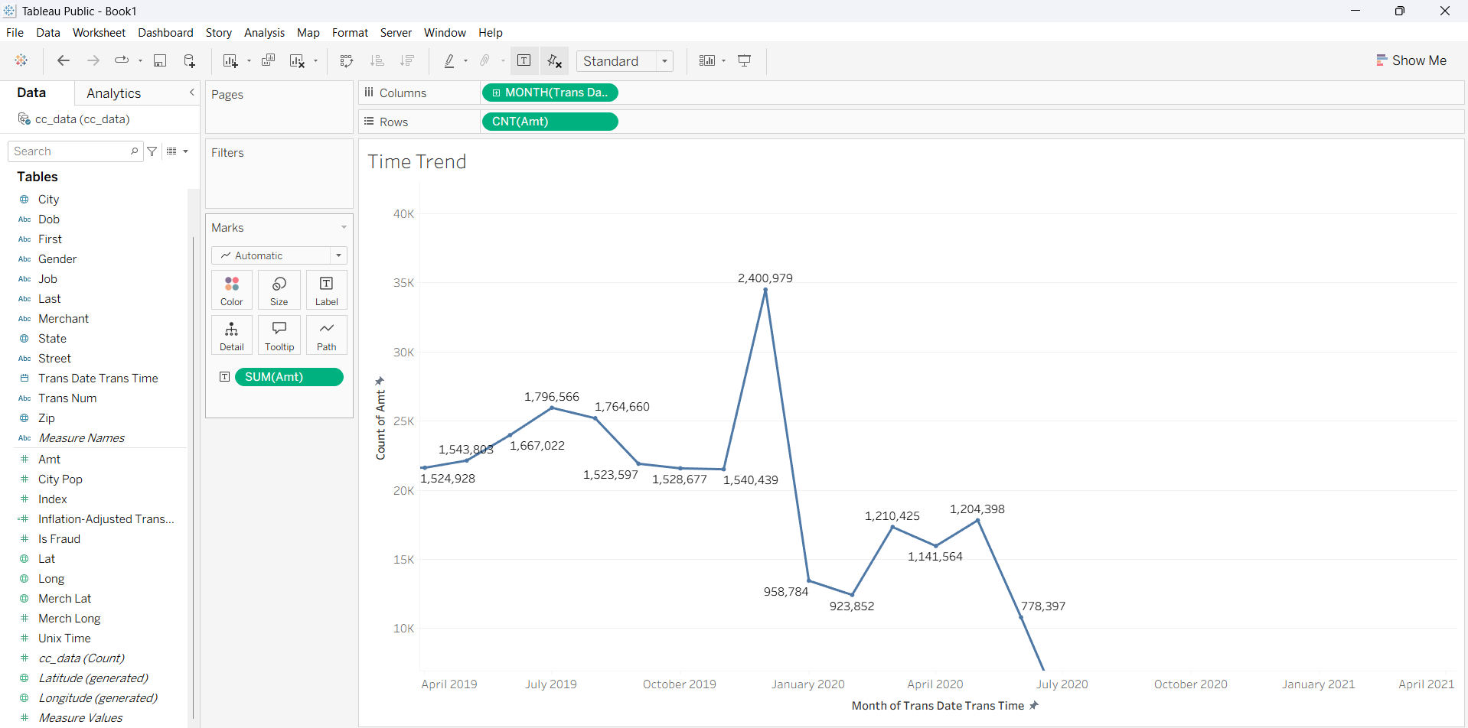
Key Findings
- Transaction activity changes over time, reflecting fluctuations in customer purchasing behavior.
- The visualization highlights periods of increased transaction volume that may correspond to seasonal shopping patterns or promotional events.
- Time-based analysis supports the identification of transaction trends and long-term customer behavior.

5. Inflation-Adjusted Transaction Amount
Objective
To estimate transaction values after adjusting for inflation.
Analysis
A calculated field was created in Tableau to estimate inflation-adjusted transaction amounts using a 2% annual inflation factor.
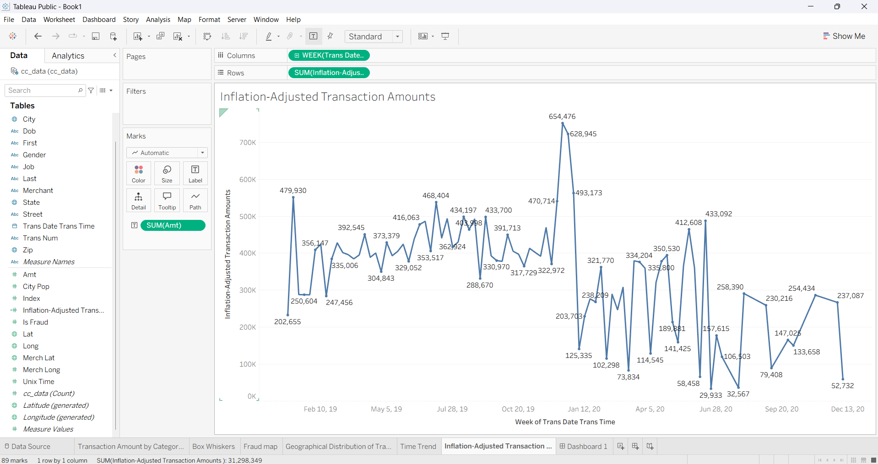
Key Findings
- Inflation adjustment provides a more realistic comparison of transaction values across different time periods.
- The adjusted values demonstrate how purchasing power changes over time.
- This analysis enables more meaningful long-term financial comparisons.

6. Interactive Dashboard
Objective
To combine all visualizations into a single interactive dashboard for comprehensive fraud analysis.
Dashboard Components
- Box and Whisker Plot
- Geographic Transaction Map
- Fraud Location Map
- Monthly Transaction Trend
- Inflation-Adjusted Transaction Analysis
Dashboard Features
- Interactive filtering
- Dynamic visualization
- Geographic analysis
- Time-series monitoring
- Comparative transaction analysis
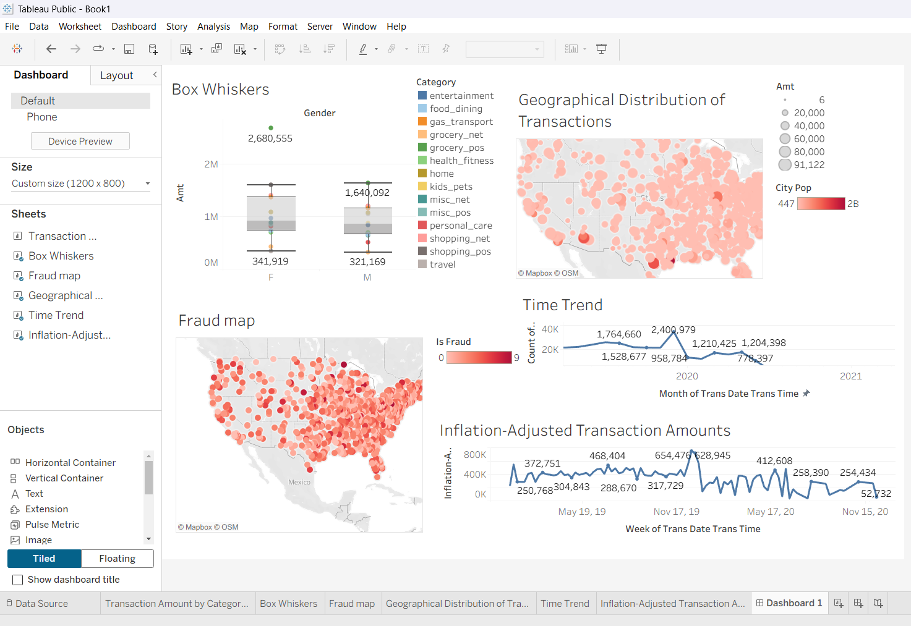

Overall Tableau Conclusion
The Tableau dashboard provides an interactive visualization platform for analyzing customer transaction behavior and fraudulent activities. The dashboard integrates statistical distributions, geographic mapping, temporal trends, and inflation-adjusted transaction analysis into a unified reporting interface. These visualizations enable users to identify spending patterns, detect high-risk transaction categories, monitor fraud distribution across geographical regions, and observe transaction trends over time. The interactive dashboard enhances decision-making by presenting complex financial data in an intuitive and visually informative manner.

Overall Project Conclusion
The Financial Fraud Detection project successfully integrated Excel, SQL, Python, and Tableau to perform end-to-end data analysis on credit card transaction data.
- Excel was used for descriptive statistics, pivot table analysis, correlation analysis, and business reporting.
- SQL enabled efficient data storage, retrieval, aggregation, and querying to extract meaningful business insights.
- Python facilitated exploratory data analysis, statistical evaluation, visualization, correlation analysis, and fraud pattern identification.
- Tableau transformed analytical findings into interactive dashboards, allowing intuitive visualization of transaction behavior, fraud distribution, geographic trends, and temporal patterns.

