PAGADE
ಪಗಡೆ
A Research Document on the Royal Cross-Board Game of South India

Karnataka / Goa · Medieval Period · South & West India

Players  2 – 4 | Pieces  4 per player | Dice  Cowrie shells / stick dice | Category  Race / Strategy

1. Overview
Pagade (ಪಗಡೆ in Kannada) is one of India's oldest and most culturally significant board games — a cross-shaped race game in which two to four players compete to move all their pawns around the board and bring them safely home to the centre. It is the regional variant of the broader Pachisi/Chaupar family of games, with its own distinct safe-square rules, cowrie-shell dice, and visually striking board geometry that has been described as the most beautiful board shape in Indian gaming tradition.

The game is known by different names across the subcontinent:
- Pagade / Pagadi — Kannada (Karnataka, Goa)
- Chaupar / Chausar / Chopat — Hindi (North India)
- Pachisi — Standard Hindi; gave rise to the English Parcheesi
- Sokkattan / Dayakattam — Tamil (Tamil Nadu)
- Pagdi Pat — Marathi (Maharashtra)

Cultural Note | Pagade is sometimes referred to as the national board game of India. Its cross-shaped board, carved into the floors of ancient palaces and temples, reflects the game's deep roots in the social and spiritual life of medieval South India.

2. Origin & History

2.1 Ancient Roots
The origins of Pagade stretch back to at least the 4th century CE, though evidence of similar race games has been found at Indus Valley sites dating to around 2,300 BCE — in the form of oblong dice recovered from excavations. The word Pachisi itself is derived from the Sanskrit/Hindi word paccīs, meaning twenty-five, the highest score achievable in one throw.

References to the game also appear in the Mahabharata, where a version played with cowrie shells (called Pasha) is central to the dramatic gambling scene between the Pandavas and Kauravas. This cultural embedding suggests that race games of this family were well-established at court level for millennia.

2.2 The Karnataka & Goa Variant
Pagade as a specifically Karnataka and Goa variant belongs to the medieval period. It is closely related to Pachisi but carries several regional distinctions — particularly in its safe-square configuration and capture rules. The cross-shaped board (called the chaupar) became iconic in Deccan royal culture. The game was carved into the floors of palaces and royal halls across Karnataka, and versions of it have been documented at heritage sites such as Hampi, Lepakshi, and Chidambaram.

One of the most famous connections is the life-size Pachisi court at Fatehpur Sikri, built by the Mughal Emperor Akbar, where human beings from the royal harem served as the playing pieces. While this example is Mughal rather than Deccan, it illustrates how the game transcended class and geography to become a symbol of regal leisure.

Royal Connection | Krishna Raja Wadiyar III of Mysore (19th century) is documented to have invented and refined several complex board games, including the Navagraha Pagade Ata — a version incorporating Indian astrology and astronomy. His inventions were recorded in the manuscript Sritattvanidhi.

2.3 Significance in Karnataka's Gaming Tradition
Within Karnataka, Pagade was not only a pastime but also a craft tradition. The Ramsons Kala Pratishtana in Mysore has documented its revival by creating Pagade boards using traditional crafts — Kasuti embroidery, Navalgund dhurries, and Bidriware — interweaving the game's geometry with regional artistic heritage. Game boards etched in stone have been found inside temples such as the Chennakeshava Temple at Belur, attesting to the game's integration into the sacred landscape of medieval Karnataka.

3. Modern Evolution

3.1 The Ludo Connection
Pagade's most famous modern descendant is Ludo, introduced by the British in 1896 as a simplified, commercialised version of Pachisi. Ludo reduced the complexity of the original game — the four-pawn strategy, capture rules, and safe squares were simplified, and the cowrie-shell or stick dice were replaced with a single cubic die. Other commercial descendants include Parcheesi (USA), Sorry! (UK/USA), Aggravation, and Trouble — all tracing their design lineage back to the ancient Indian cross board.

3.2 Decline and Revival
Through the 20th century, Pagade and Pachisi largely retreated from urban households as Ludo, television, and eventually digital gaming took over. However, in recent years there has been a conscious revival effort — particularly in Karnataka — to document and re-popularise traditional Indian board games. Researchers, cultural trusts, and educational institutions have worked to reconstruct forgotten rules, publish guidebooks, and introduce Pagade at school competitions and cultural festivals.

Initiatives like the Krida Kaushalya project and the Ramsons Kala Pratishtana have been at the forefront of this revival, partnering with craft communities to produce handcrafted Pagade sets. Today, the game is also available as a digital app in some versions, though the tactile experience of cowrie shells and a handwoven board remains its authentic form.

Fun Fact | Researchers have noted that a game called Patoli, played by the Aztec community in pre-colonial Mexico, shares striking similarities with Pagade — suggesting possible ancient connections across continents, or a remarkable case of independent parallel invention.

4. How to Play Pagade

4.1 What You Need
- One cross-shaped Pagade board (3 columns × 8 rows per arm, with a central Home square)
- 4 sets of 4 pawns each — traditionally in Red, Black, Yellow, and Green
- Two stick dice (each showing 1, 3, 4, or 6 dots) OR six to seven cowrie shells

The Board
The board is shaped like a plus sign (+). Each arm has three columns and eight rows. The middle column of each arm is considered a "safe lane" — the column your own pawns travel home through. Where all four arms meet is the central Home square, which players race to reach. Each player owns one arm as their "home arm", and the innermost squares of that arm (the Belly) form a private zone no opponent can enter.

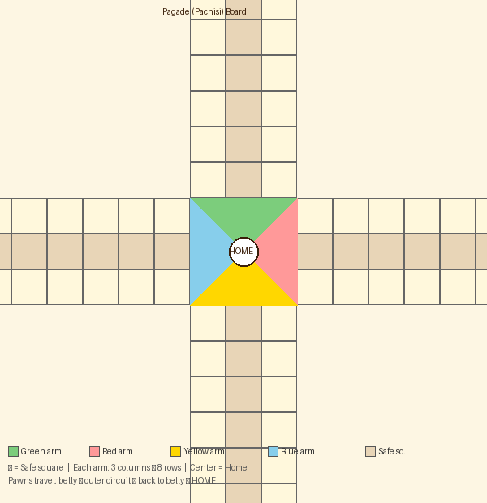
Figure 1 — Pagade Board Layout (3 × 8 arms; coloured zones = player bellies; safe lane = centre column of each arm)

4.2 Setting Up
- Each player chooses a colour and sits at the corresponding arm of the board.
- Place two pawns inside the Belly (the first row/column of your arm) and two pawns on the same starting square just outside the Belly.
- Decide who goes first (usually by rolling the dice — highest roll starts).

4.3 Rolling the Dice
Two stick dice are rubbed together and rolled. Each face shows 1, 3, 4, or 6 dots. The total of both top faces gives the number of squares a pawn (or pair of pawns) may move.

If both dice show the same number (called a doublet — e.g. 3 and 3), you may either move one pawn the total distance, move two pawns individually, or move two paired pawns together. There is no bonus extra turn for a doublet.

Cowrie Shell Dice | In the traditional version, six cowrie shells are used instead of stick dice. The score equals the number of shells that land with their aperture (mouth) facing upward. If all six show the back, the score is 6. If all show the mouth, it scores 12 — the highest.

4.4 Moving Your Pawns
- On your turn, roll the dice and move one or more of your pawns the number of squares shown.
- Pawns travel along the outer squares of the board, going around the entire cross before returning up their home arm and into the Belly.
- The full journey path for Red (example): Squares 1 → 75 → then back down the home arm (8 → 7 → 6 → 5 → 4 → 3 → 2 → 1 → HOME).
- No pawn may enter the Belly section of another player's arm — these are private zones.
- Two of your own pawns may occupy the same square and move together as a "pawn-pair", acting as a single unit until separated.

4.5 Capturing (Cutting) Opponents
If your pawn lands on a square already occupied by an opponent's pawn, that opponent is cut — their pawn is removed from the board and must restart from the beginning of their home arm. You do not get a bonus turn for making a cut.

However, some squares are Safe Squares (typically the central column of each arm and certain marked squares). A pawn resting on a safe square cannot be captured, regardless of what an opponent rolls.

4.6 Winning
The goal is to be the first player to move all four of your pawns around the entire board, back down your home arm Belly, and into the central HOME square. A pawn can only enter Home when you roll the exact number needed — you cannot overshoot. The player who gets all four pawns into Home first wins.

Important Rule | When two opponents' pawns are on the same square, only one capture applies. A pawn-pair (two pawns of the same colour together) acts as a blockade — opponent pawns cannot pass through a square occupied by a pair, and the pair itself cannot be captured.

4.7 Summary of Key Rules
Rule | Details
Belly | Private zone — only your pawns may enter. Opponents cannot capture here.
Safe Square | Marked squares on which pawns cannot be captured by opponents.
Capture / Cut | Land on an opponent's pawn to send it back to the start of their home arm.
Pawn-pair | Two same-colour pawns on same square — acts as a blockade, cannot be captured.
Doublet | Both dice show the same number — may split move between two pawns or use on one.
Entering Home | Exact roll required. Cannot overshoot the central Home square.
Winning | First player to bring all four pawns into the central Home square.

Sources: Krida Kaushalya project · Karnataka.com Traditional Games documentation · Vidyaranya Kannada Kuta Pagade rules (2013) · The News Minute, traditional board games feature · Cultural Heritage of India research archive

