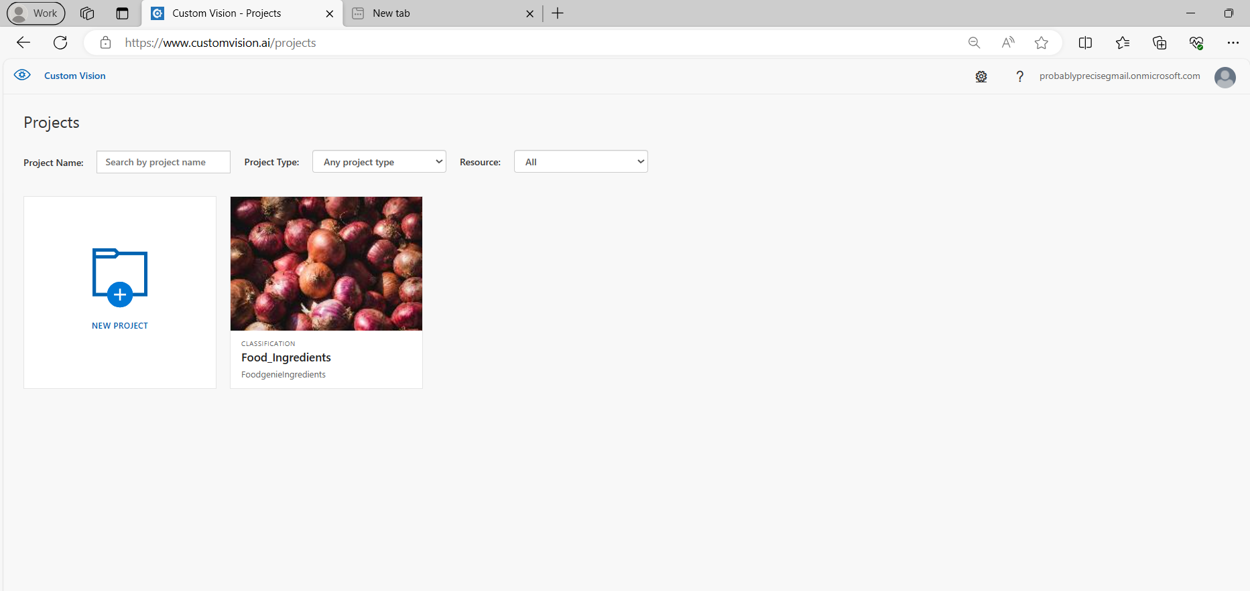

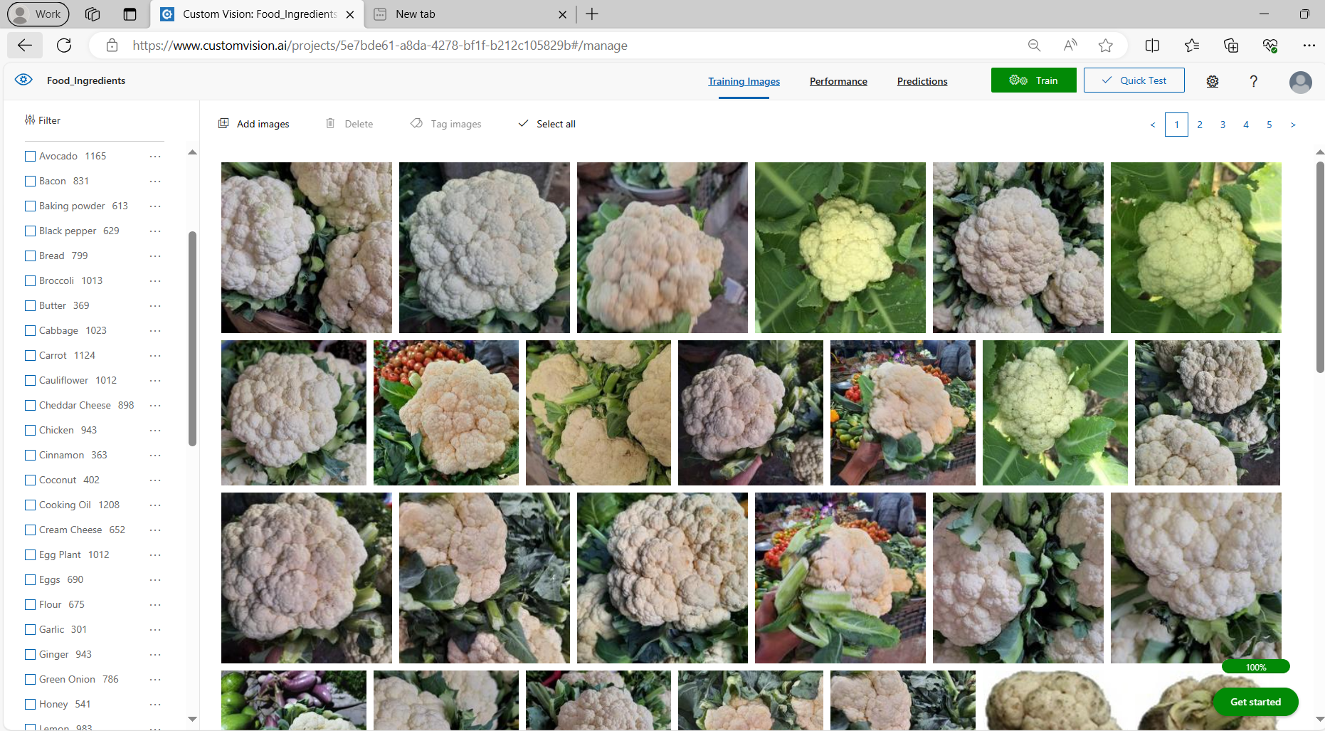

Results of Classification type: **Multiclass (Single tag per image)**

10hrs training for 51 classes:

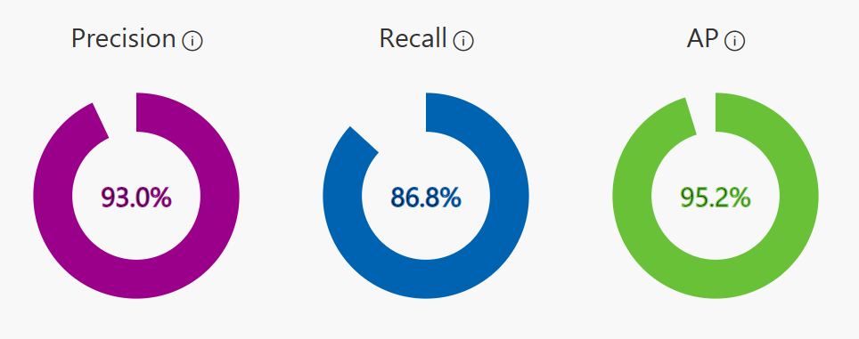

| Performance Per Tag | | | | |
| --- | --- | --- | --- | --- |
| **Tag** | **Precision** | **Recall** | **A.P.** | **Image count** |
| [Egg Plant](https://www.customvision.ai/projects/5e7bde61-a8da-4278-bf1f-b212c105829b#/manage?iterationId=17da81dc-3f61-41bb-b3ce-bc09235fedea&tagIds=adec67f4-1692-487e-bd1a-22e547f026c7) | 100.0% | 98.5% | 99.5% | 1012 |
| [Tomato](https://www.customvision.ai/projects/5e7bde61-a8da-4278-bf1f-b212c105829b#/manage?iterationId=17da81dc-3f61-41bb-b3ce-bc09235fedea&tagIds=1a00433b-4ff6-4086-b300-1b290021a47a) | 99.6% | 98.3% | 100.0% | 1157 |
| [Carrot](https://www.customvision.ai/projects/5e7bde61-a8da-4278-bf1f-b212c105829b#/manage?iterationId=17da81dc-3f61-41bb-b3ce-bc09235fedea&tagIds=20cf07bc-50d0-421e-a8d0-b414562a847c) | 99.6% | 100.0% | 100.0% | 1124 |
| [Strawberry](https://www.customvision.ai/projects/5e7bde61-a8da-4278-bf1f-b212c105829b#/manage?iterationId=17da81dc-3f61-41bb-b3ce-bc09235fedea&tagIds=5725f4d4-d811-4cf3-933f-9b6bef42d2e7) | 99.5% | 98.5% | 100.0% | 1002 |
| [Vanilla](https://www.customvision.ai/projects/5e7bde61-a8da-4278-bf1f-b212c105829b#/manage?iterationId=17da81dc-3f61-41bb-b3ce-bc09235fedea&tagIds=19347656-dafb-4461-9577-538edfb5b16c) | 99.0% | 96.5% | 99.8% | 1005 |
| [Ginger](https://www.customvision.ai/projects/5e7bde61-a8da-4278-bf1f-b212c105829b#/manage?iterationId=17da81dc-3f61-41bb-b3ce-bc09235fedea&tagIds=9dd3dd1f-68d7-43ab-8dfb-00006ea1c9b9) | 98.9% | 98.4% | 99.5% | 943 |
| [Pineapple](https://www.customvision.ai/projects/5e7bde61-a8da-4278-bf1f-b212c105829b#/manage?iterationId=17da81dc-3f61-41bb-b3ce-bc09235fedea&tagIds=4c6a2277-3fb5-4fec-9135-205e7ce3fe55) | 98.7% | 97.8% | 99.8% | 1155 |
| [Potato](https://www.customvision.ai/projects/5e7bde61-a8da-4278-bf1f-b212c105829b#/manage?iterationId=17da81dc-3f61-41bb-b3ce-bc09235fedea&tagIds=f685bbfe-039e-40f6-9b20-883467648b2d) | 98.7% | 98.7% | 100.0% | 1121 |
| [Garlic](https://www.customvision.ai/projects/5e7bde61-a8da-4278-bf1f-b212c105829b#/manage?iterationId=17da81dc-3f61-41bb-b3ce-bc09235fedea&tagIds=f6e3c6b7-f716-45a7-a3bc-efdbdbb8d328) | 98.2% | 91.7% | 97.5% | 301 |
| [Zucchini](https://www.customvision.ai/projects/5e7bde61-a8da-4278-bf1f-b212c105829b#/manage?iterationId=17da81dc-3f61-41bb-b3ce-bc09235fedea&tagIds=0a1bfaa7-d05e-486d-9b9f-9312a5e8708c) | 98.0% | 98.5% | 99.9% | 1000 |
| [Pumpkin](https://www.customvision.ai/projects/5e7bde61-a8da-4278-bf1f-b212c105829b#/manage?iterationId=17da81dc-3f61-41bb-b3ce-bc09235fedea&tagIds=56b38a43-70fd-43ae-a2bf-088cbcdac95e) | 98.0% | 99.0% | 99.9% | 967 |
| [Eggs](https://www.customvision.ai/projects/5e7bde61-a8da-4278-bf1f-b212c105829b#/manage?iterationId=17da81dc-3f61-41bb-b3ce-bc09235fedea&tagIds=0ebe6706-a07f-41c5-93ab-7cc37a782526) | 97.8% | 96.4% | 97.7% | 690 |
| [Pepper](https://www.customvision.ai/projects/5e7bde61-a8da-4278-bf1f-b212c105829b#/manage?iterationId=17da81dc-3f61-41bb-b3ce-bc09235fedea&tagIds=cb38f4b0-8775-41fe-bf43-86bb3ec9404b) | 97.5% | 94.7% | 98.5% | 1423 |
| [Coconut](https://www.customvision.ai/projects/5e7bde61-a8da-4278-bf1f-b212c105829b#/manage?iterationId=17da81dc-3f61-41bb-b3ce-bc09235fedea&tagIds=b2d5cf20-07bd-4f33-8614-a755ba208c36) | 97.3% | 88.9% | 97.4% | 402 |
| [Broccoli](https://www.customvision.ai/projects/5e7bde61-a8da-4278-bf1f-b212c105829b#/manage?iterationId=17da81dc-3f61-41bb-b3ce-bc09235fedea&tagIds=57902385-dce3-40f1-8e6a-f8fcaf505c07) | 97.0% | 94.6% | 98.3% | 1013 |
| [Bread](https://www.customvision.ai/projects/5e7bde61-a8da-4278-bf1f-b212c105829b#/manage?iterationId=17da81dc-3f61-41bb-b3ce-bc09235fedea&tagIds=07c65eb1-937e-42e4-92d0-2ae433be2b62) | 96.7% | 91.3% | 96.9% | 799 |
| [Green Onion](https://www.customvision.ai/projects/5e7bde61-a8da-4278-bf1f-b212c105829b#/manage?iterationId=17da81dc-3f61-41bb-b3ce-bc09235fedea&tagIds=93dd342f-b04e-460f-b970-27ac9537ebfb) | 96.4% | 84.7% | 96.4% | 786 |
| [Cauliflower](https://www.customvision.ai/projects/5e7bde61-a8da-4278-bf1f-b212c105829b#/manage?iterationId=17da81dc-3f61-41bb-b3ce-bc09235fedea&tagIds=80fbba47-944c-4ece-9ebc-0f6db9773cd1) | 96.3% | 90.6% | 96.2% | 1012 |
| [Lemon](https://www.customvision.ai/projects/5e7bde61-a8da-4278-bf1f-b212c105829b#/manage?iterationId=17da81dc-3f61-41bb-b3ce-bc09235fedea&tagIds=2eada6f8-0b0c-4e38-b1f0-0e946ad09164) | 96.1% | 88.3% | 97.5% | 983 |
| [Black pepper](https://www.customvision.ai/projects/5e7bde61-a8da-4278-bf1f-b212c105829b#/manage?iterationId=17da81dc-3f61-41bb-b3ce-bc09235fedea&tagIds=55f29486-e00f-4cba-9b87-58dcbd8d1768) | 95.8% | 89.7% | 95.9% | 629 |
| [Orange](https://www.customvision.ai/projects/5e7bde61-a8da-4278-bf1f-b212c105829b#/manage?iterationId=17da81dc-3f61-41bb-b3ce-bc09235fedea&tagIds=d344e1ab-e131-4b17-b2ea-f136e32575ad) | 95.6% | 96.5% | 98.4% | 1003 |
| [Cabbage](https://www.customvision.ai/projects/5e7bde61-a8da-4278-bf1f-b212c105829b#/manage?iterationId=17da81dc-3f61-41bb-b3ce-bc09235fedea&tagIds=e99d2982-0456-47a6-9e7f-66aee5778537) | 95.5% | 93.7% | 98.0% | 1023 |
| [Avocado](https://www.customvision.ai/projects/5e7bde61-a8da-4278-bf1f-b212c105829b#/manage?iterationId=17da81dc-3f61-41bb-b3ce-bc09235fedea&tagIds=fc84f690-3a16-441a-997a-9321586cb2f1) | 95.2% | 94.0% | 98.9% | 1165 |
| [Onion](https://www.customvision.ai/projects/5e7bde61-a8da-4278-bf1f-b212c105829b#/manage?iterationId=17da81dc-3f61-41bb-b3ce-bc09235fedea&tagIds=0fe05ca3-d0cf-49a9-9dae-ad1d33ca0128) | 94.4% | 92.2% | 97.2% | 831 |
| [Chicken](https://www.customvision.ai/projects/5e7bde61-a8da-4278-bf1f-b212c105829b#/manage?iterationId=17da81dc-3f61-41bb-b3ce-bc09235fedea&tagIds=8ea8e19a-f112-4c8d-adc7-770da08ae301) | 94.3% | 87.8% | 96.2% | 943 |
| [Nuts](https://www.customvision.ai/projects/5e7bde61-a8da-4278-bf1f-b212c105829b#/manage?iterationId=17da81dc-3f61-41bb-b3ce-bc09235fedea&tagIds=611c055a-1435-44f3-a881-4a4b17182dc8) | 94.2% | 80.2% | 93.3% | 506 |
| [Bacon](https://www.customvision.ai/projects/5e7bde61-a8da-4278-bf1f-b212c105829b#/manage?iterationId=17da81dc-3f61-41bb-b3ce-bc09235fedea&tagIds=72e8ee4e-ee7e-4403-b008-83c143d855f8) | 94.2% | 87.3% | 94.6% | 831 |
| [Tomato Sauce](https://www.customvision.ai/projects/5e7bde61-a8da-4278-bf1f-b212c105829b#/manage?iterationId=17da81dc-3f61-41bb-b3ce-bc09235fedea&tagIds=a1b0cd17-2cde-46d0-8a21-997f8f25b396) | 93.5% | 93.5% | 98.8% | 309 |
| [Lime](https://www.customvision.ai/projects/5e7bde61-a8da-4278-bf1f-b212c105829b#/manage?iterationId=17da81dc-3f61-41bb-b3ce-bc09235fedea&tagIds=a839583e-e3ee-435d-8913-285153f756a1) | 92.3% | 93.8% | 98.3% | 966 |
| [Milk](https://www.customvision.ai/projects/5e7bde61-a8da-4278-bf1f-b212c105829b#/manage?iterationId=17da81dc-3f61-41bb-b3ce-bc09235fedea&tagIds=ee501cf0-c220-47ce-a147-1c789f6482cc) | 91.5% | 84.3% | 94.5% | 830 |
| [Cinnamon](https://www.customvision.ai/projects/5e7bde61-a8da-4278-bf1f-b212c105829b#/manage?iterationId=17da81dc-3f61-41bb-b3ce-bc09235fedea&tagIds=fc3125fe-ba00-48c9-a612-901ed14d5690) | 90.3% | 76.7% | 90.1% | 363 |
| [Paprika](https://www.customvision.ai/projects/5e7bde61-a8da-4278-bf1f-b212c105829b#/manage?iterationId=17da81dc-3f61-41bb-b3ce-bc09235fedea&tagIds=1fc4cbcd-2b85-4059-9b91-6ea20e58b72a) | 89.9% | 89.9% | 96.5% | 442 |
| [Paneer](https://www.customvision.ai/projects/5e7bde61-a8da-4278-bf1f-b212c105829b#/manage?iterationId=17da81dc-3f61-41bb-b3ce-bc09235fedea&tagIds=658c62be-99df-4815-9de9-4906b93ede1b) | 89.4% | 85.7% | 91.9% | 487 |
| [Soy Sauce](https://www.customvision.ai/projects/5e7bde61-a8da-4278-bf1f-b212c105829b#/manage?iterationId=17da81dc-3f61-41bb-b3ce-bc09235fedea&tagIds=15d34572-0341-4484-8487-360b2d29f505) | 89.3% | 84.4% | 93.8% | 543 |
| [Baking powder](https://www.customvision.ai/projects/5e7bde61-a8da-4278-bf1f-b212c105829b#/manage?iterationId=17da81dc-3f61-41bb-b3ce-bc09235fedea&tagIds=2f9d1116-77f3-45ff-a465-9ab6a9b9408a) | 89.0% | 52.8% | 74.7% | 613 |
| [Honey](https://www.customvision.ai/projects/5e7bde61-a8da-4278-bf1f-b212c105829b#/manage?iterationId=17da81dc-3f61-41bb-b3ce-bc09235fedea&tagIds=77029fb4-179d-4e56-a183-ce7a0d907a2f) | 88.8% | 88.0% | 95.3% | 541 |
| [Rice](https://www.customvision.ai/projects/5e7bde61-a8da-4278-bf1f-b212c105829b#/manage?iterationId=17da81dc-3f61-41bb-b3ce-bc09235fedea&tagIds=e24564a0-0bcc-48a1-b732-f2ac50f98bb7) | 88.5% | 82.5% | 89.4% | 516 |
| [Mushroom](https://www.customvision.ai/projects/5e7bde61-a8da-4278-bf1f-b212c105829b#/manage?iterationId=17da81dc-3f61-41bb-b3ce-bc09235fedea&tagIds=9b6238be-1997-41e5-8dde-ae8738df73e9) | 88.1% | 83.2% | 94.0% | 536 |
| [Cooking Oil](https://www.customvision.ai/projects/5e7bde61-a8da-4278-bf1f-b212c105829b#/manage?iterationId=17da81dc-3f61-41bb-b3ce-bc09235fedea&tagIds=0d920ddc-e195-487e-b772-cea7acbdabe7) | 87.9% | 84.3% | 92.5% | 1208 |
| [Sugar](https://www.customvision.ai/projects/5e7bde61-a8da-4278-bf1f-b212c105829b#/manage?iterationId=17da81dc-3f61-41bb-b3ce-bc09235fedea&tagIds=fdff36a9-6611-46fb-bc8d-fc07d9ba0c8c) | 85.3% | 73.6% | 85.1% | 550 |
| [Nutmeg](https://www.customvision.ai/projects/5e7bde61-a8da-4278-bf1f-b212c105829b#/manage?iterationId=17da81dc-3f61-41bb-b3ce-bc09235fedea&tagIds=c1c796a0-c6c7-4849-8141-1f9d5c000cbf) | 85.2% | 74.3% | 84.7% | 502 |
| [Vinegar](https://www.customvision.ai/projects/5e7bde61-a8da-4278-bf1f-b212c105829b#/manage?iterationId=17da81dc-3f61-41bb-b3ce-bc09235fedea&tagIds=6019e2bf-1054-47ed-81bc-5f8a69dbb7c5) | 84.1% | 63.9% | 78.7% | 540 |
| [Mayonnaise](https://www.customvision.ai/projects/5e7bde61-a8da-4278-bf1f-b212c105829b#/manage?iterationId=17da81dc-3f61-41bb-b3ce-bc09235fedea&tagIds=7567bf1b-3045-410b-8265-90125d9853a4) | 84.1% | 77.3% | 87.5% | 750 |
| [Flour](https://www.customvision.ai/projects/5e7bde61-a8da-4278-bf1f-b212c105829b#/manage?iterationId=17da81dc-3f61-41bb-b3ce-bc09235fedea&tagIds=7156bcd9-9b6f-4186-80af-703c5ca0e457) | 80.6% | 74.1% | 79.7% | 675 |
| [Sour Cream](https://www.customvision.ai/projects/5e7bde61-a8da-4278-bf1f-b212c105829b#/manage?iterationId=17da81dc-3f61-41bb-b3ce-bc09235fedea&tagIds=f2d33e26-920d-4e97-a7ae-8c361326b741) | 79.0% | 65.4% | 79.5% | 635 |
| [Mozzarella Cheese](https://www.customvision.ai/projects/5e7bde61-a8da-4278-bf1f-b212c105829b#/manage?iterationId=17da81dc-3f61-41bb-b3ce-bc09235fedea&tagIds=c4c8912b-a255-4cc6-86be-6a5ba2335f2e) | 77.3% | 54.0% | 73.2% | 692 |
| [Cream Cheese](https://www.customvision.ai/projects/5e7bde61-a8da-4278-bf1f-b212c105829b#/manage?iterationId=17da81dc-3f61-41bb-b3ce-bc09235fedea&tagIds=8c502a9d-664b-4c48-8fdc-3b0fa09a2ce1) | 77.2% | 59.5% | 78.1% | 652 |
| [Cheddar Cheese](https://www.customvision.ai/projects/5e7bde61-a8da-4278-bf1f-b212c105829b#/manage?iterationId=17da81dc-3f61-41bb-b3ce-bc09235fedea&tagIds=61c3ad1e-f382-4708-9c29-6905b9e97e88) | 75.8% | 62.8% | 75.2% | 898 |
| [Butter](https://www.customvision.ai/projects/5e7bde61-a8da-4278-bf1f-b212c105829b#/manage?iterationId=17da81dc-3f61-41bb-b3ce-bc09235fedea&tagIds=4aafc749-5400-4c28-8cde-e65fdebfbc74) | 75.4% | 58.1% | 73.4% | 369 |
| [Parmesan Cheese](https://www.customvision.ai/projects/5e7bde61-a8da-4278-bf1f-b212c105829b#/manage?iterationId=17da81dc-3f61-41bb-b3ce-bc09235fedea&tagIds=c4a28231-4c39-4697-82c9-8026fc790178) | 75.0% | 59.2% | 74.1% | 785 |
| [Salt](https://www.customvision.ai/projects/5e7bde61-a8da-4278-bf1f-b212c105829b#/manage?iterationId=17da81dc-3f61-41bb-b3ce-bc09235fedea&tagIds=9478de5d-c196-4ffa-9be5-029881a8cee8) | 73.7% | 56.0% | 66.5% | 373 |