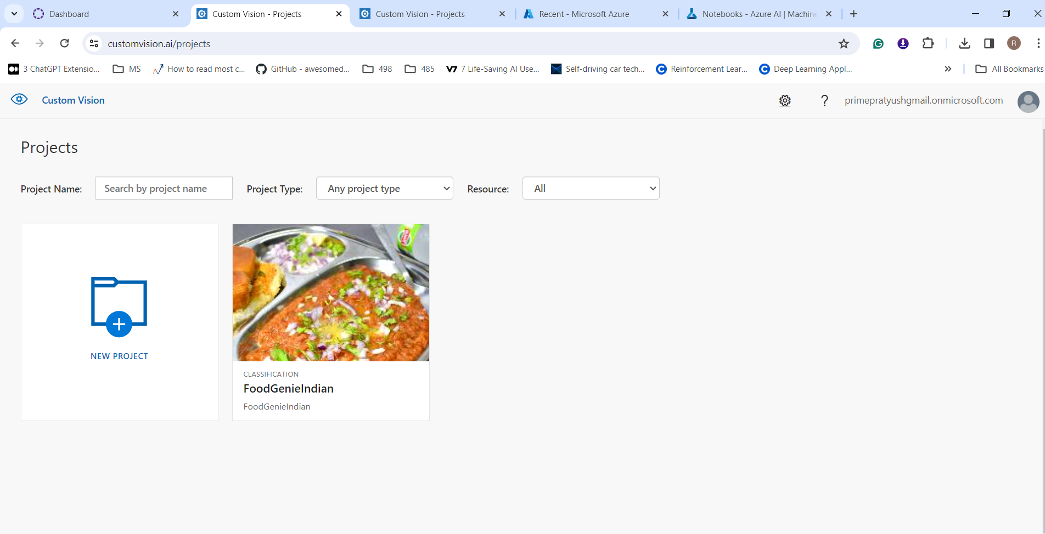

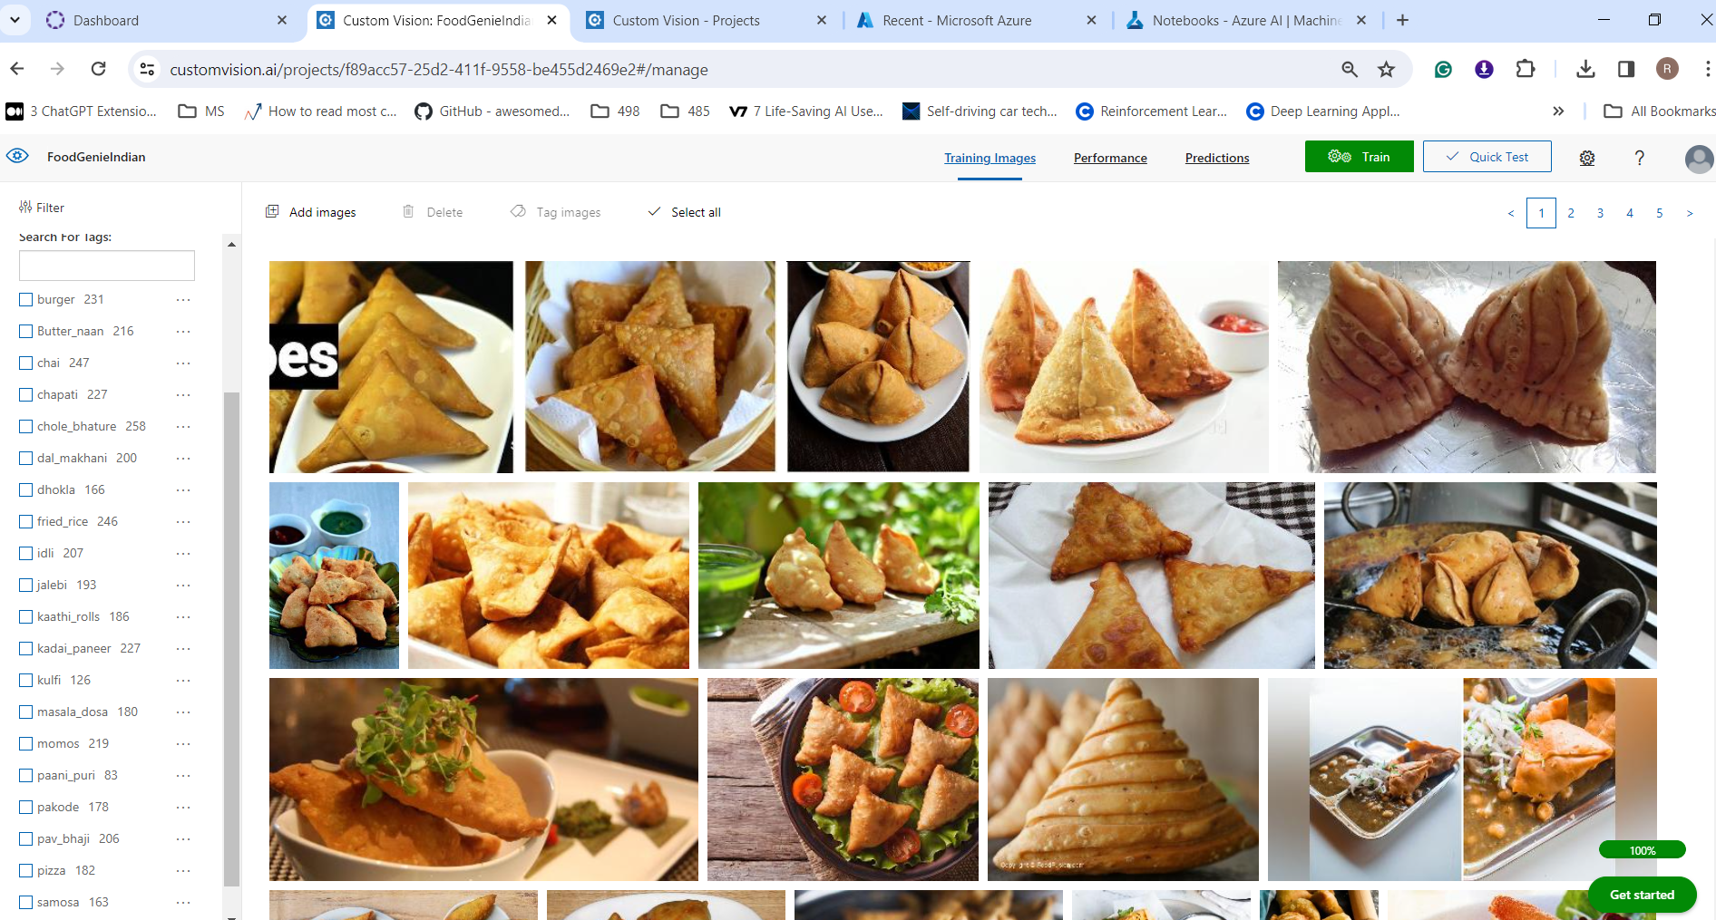

Classification Model Results for Indian Food Dishes

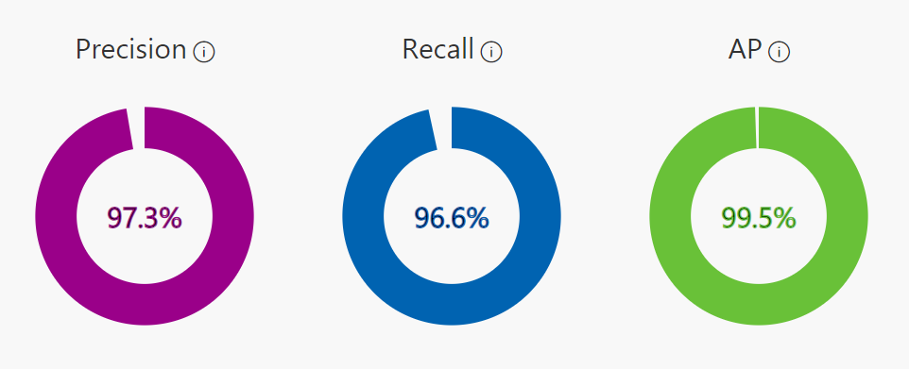

|  |  |  |  |  |
| --- | --- | --- | --- | --- |
| **Performance Per Tag** | | | | |
| Tag | Precision | Recall | A.P. | Image count |
| pizza | 100.00% | 97.30% | 100.00% | 182 |
| pakode | 100.00% | 94.40% | 99.80% | 178 |
| paani_puri | 100.00% | 100.00% | 100.00% | 83 |
| momos | 100.00% | 95.50% | 100.00% | 219 |
| jalebi | 100.00% | 100.00% | 100.00% | 193 |
| idli | 100.00% | 100.00% | 100.00% | 207 |
| fried_rice | 100.00% | 100.00% | 100.00% | 246 |
| dal_makhani | 100.00% | 100.00% | 100.00% | 200 |
| chai | 100.00% | 100.00% | 100.00% | 247 |
| burger | 100.00% | 100.00% | 100.00% | 231 |
| chole_bhature | 98.10% | 98.10% | 99.90% | 258 |
| pav_bhaji | 97.60% | 97.60% | 99.90% | 206 |
| masala_dosa | 97.30% | 100.00% | 99.90% | 180 |
| dhokla | 96.90% | 93.90% | 99.70% | 166 |
| samosa | 96.80% | 90.90% | 96.40% | 163 |
| kulfi | 96.00% | 96.00% | 99.80% | 126 |
| kadai_paneer | 95.70% | 95.70% | 99.50% | 227 |
| chapati | 94.90% | 80.40% | 97.70% | 227 |
| kaathi_rolls | 92.30% | 97.30% | 96.00% | 186 |
| Butter_naan | 83.70% | 95.30% | 98.60% | 216 |