Importing Multiple CSV Files into MySQL and MSSQL Using Python

Initially there is no tables in test3 database MySQL

After running python script

Python console

CSV files have been imported in database and created as a table under test3 database.

Now the same process needs to done below for MSSQL

Initially there is no tables in tst_csv database MSSQL

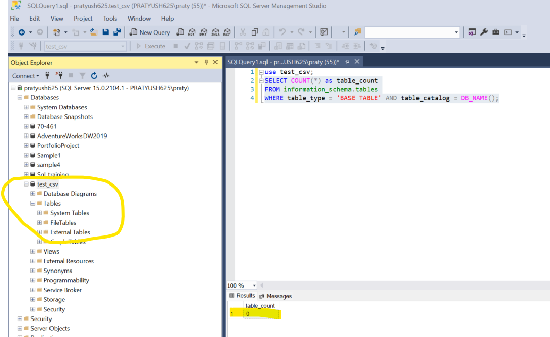

After running python script

Python console

CSV files have been imported in database and created as a table under test3 database.

