- package mongodb;

import java.sql.Connection; import java.sql.DriverManager; import java.sql.ResultSet; import java.sql.Statement;

public class Testing {

public static void main(String[] args){ try {
Class.forName("com.mysql.cj.jdbc.Driver");
Connection con =
DriverManager.getConnection("jdbc:mysql://localhost:3306/exercise",
"root","root123");

Statement stmt = con.createStatement();
ResultSet rs = stmt.executeQuery("select * from students"); while(rs.next()) {
System.out.println(rs.getInt(1)+" "+
rs.getString(2)+" "+rs.getInt(3));
}
con.close();
}catch(Exception e){
System.out.println("Sorry for the inconvinence happened..! "
+ "Check the inputs properly one more time");
}
}

}
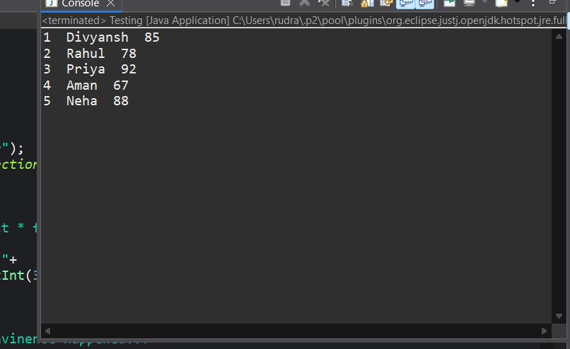

- CRUD_Test;
package CRUD;
import java.sql.Connection;
import java.sql.PreparedStatement; import java.sql.ResultSet;

public class CRUD_Test {

public void create_data(String sl_no,String name,String email){
DB_Connection obj_DB_Connection=new DB_Connection();
Connection connection=obj_DB_Connection.get_connection(); PreparedStatement ps=null;
try {

(?,?,?)";;
String query="insert into student(sl_no,name,email) values

ps=connection.prepareStatement(query); ps.setString(1, sl_no);
ps.setString(2, name); ps.setString(3, email); System.out.println(ps); ps.executeUpdate();
} catch (Exception e) {

System.out.println(e);
}
}

public void read_data(String sl_no){
DB_Connection obj_DB_Connection=new DB_Connection();
Connection connection=obj_DB_Connection.get_connection(); PreparedStatement ps=null;
ResultSet rs=null; try {
String query="select * from student";
ps=connection.prepareStatement(query);
//ps.setString(1, sl_no); System.out.println(ps); rs=ps.executeQuery(); while(rs.next()){
System.out.println("Sl no -"+rs.getString("sl_no")); System.out.println("name -"+rs.getString("name")); System.out.println("email -"+rs.getString("email")); System.out.println(" ");
}
} catch (Exception e) {
System.out.println(e);
}
}

public void update_data(String sl_no,String new_sl_no,String name,String email){ DB_Connection obj_DB_Connection=new DB_Connection();
Connection connection=obj_DB_Connection.get_connection(); PreparedStatement ps=null;
try {

sl_no=?";
String query="update student set sl_no=?,name=?,email=? where

ps=connection.prepareStatement(query); ps.setString(1, new_sl_no);
ps.setString(2, name); ps.setString(3, email); ps.setString(4, sl_no); System.out.println(ps); ps.executeUpdate();
} catch (Exception e) {
System.out.println(e);

}
}

public void delete_data(String sl_no){
DB_Connection obj_DB_Connection=new DB_Connection();
Connection connection=obj_DB_Connection.get_connection(); PreparedStatement ps=null;
try {
String query="delete from student where sl_no=?"; ps=connection.prepareStatement(query);
ps.setString(1, sl_no); System.out.println(ps); ps.executeUpdate();
} catch (Exception e) {
System.out.println(e);
}

}

public static void main(String[] args) {
CRUD_Test objTest=new CRUD_Test();
//insert data
objTest.create_data("1", "jinu", "jinu@gmail.com");
objTest.create_data("2", "jawad", "jawad@gmail.com");
//read data
objTest.read_data("2");
//update data
objTest.update_data("2", "22", "jawad2", "jawad2@gmail");
//delete data
objTest.delete_data("1");
}
} 2.1:
package CRUD;
import java.sql.Connection; import java.sql.DriverManager;

public class DB_Connection {
public Connection get_connection(){ Connection connection=null;
try {
Class.forName("com.mysql.cj.jdbc.Driver"); connection =
DriverManager.getConnection("jdbc:mysql://localhost:3306/exercise","root", "root123");

} catch (Exception e) { System.out.println(e);
}

return connection;
}
public static void main(String[] args) {
DB_Connection obj_DB_Connection=new DB_Connection(); System.out.println(obj_DB_Connection.get_connection());
}
}

OUPUT:
