package CRUD;

import java.sql.Connection;
import java.sql.PreparedStatement;
import java.sql.ResultSet;

public class CRUD_Test1 {

public static void main(String[] args) {
CRUD_Test1 objTest = new CRUD_Test1();

// 1. Initial cleanup to start fresh
objTest.truncate_table();

// 2. CREATE
System.out.println("=== 1. PERFORMING CREATE ===");
objTest.create_data("201", "Arun", "arun@gmail.com");
objTest.create_data("202", "Jinu", "jinu@gmail.com");

// 3. READ (Modified to pull full details via ID parameter)
System.out.println("\n=== 2. PERFORMING READ (SPECIFIC ID) ===");
objTest.read_data("201");

// 4. UPDATE (Standard data update)
System.out.println("\n=== 3. PERFORMING STANDARD UPDATE ===");
objTest.update_data("201", "201", "Arun Kumar", "arunkumar@gmail.com");
objTest.read_data("201");

// 5. ALTER UPDATE (Structural schema update)
System.out.println("\n=== 4. PERFORMING STRUCTURAL ALTER ===");
objTest.alter_table_structure("phone", "VARCHAR(15)");

// 6. DELETE (Standard specific row removal)
System.out.println("\n=== 5. PERFORMING STANDARD DELETE ===");
objTest.delete_data("202");

// 7. DELETE TRUNCATE (Full data wipeout)
System.out.println("\n=== 6. PERFORMING DELETE VIA TRUNCATE ===");
objTest.truncate_table();
objTest.read_data("201");
}

// C - CREATE DATA
public void create_data(String sl_no, String name, String email) {
DB_Connection obj_DB_Connection = new DB_Connection();
Connection connection = obj_DB_Connection.get_connection();
PreparedStatement ps = null;
try {
String query = "INSERT INTO user(sl_no, name, email) VALUES (?,?,?)";
ps = connection.prepareStatement(query);
ps.setString(1, sl_no);
ps.setString(2, name);
ps.setString(3, email);
ps.executeUpdate();
System.out.println("Inserted: " + name);
} catch (Exception e) {
System.out.println(e);
} finally {
try { if (ps != null) ps.close(); } catch (Exception e) {}
try { if (connection != null) connection.close(); } catch (Exception e) {}
}
}

public void read_data(String sl_no) {
DB_Connection obj_DB_Connection = new DB_Connection();
Connection connection = obj_DB_Connection.get_connection();
PreparedStatement ps = null;
ResultSet rs = null;
try {
String query = "SELECT * FROM user WHERE sl_no = ?";
ps = connection.prepareStatement(query);
ps.setString(1, sl_no);
rs = ps.executeQuery();

boolean hasRows = false;
while (rs.next()) {
hasRows = true;
System.out.println("Sl no - " + rs.getString("sl_no"));
System.out.println("Name - " + rs.getString("name"));
System.out.println("Email - " + rs.getString("email"));
}
if (!hasRows) {
System.out.println("No record found matching sl_no: " + sl_no);
}
} catch (Exception e) {
System.out.println(e);
} finally {
try { if (rs != null) rs.close(); } catch (Exception e) {}
try { if (ps != null) ps.close(); } catch (Exception e) {}
try { if (connection != null) connection.close(); } catch (Exception e) {}
}
}

public void update_data(String sl_no, String new_sl_no, String name, String email) {
DB_Connection obj_DB_Connection = new DB_Connection();
Connection connection = obj_DB_Connection.get_connection();
PreparedStatement ps = null;
try {
String query = "UPDATE user SET sl_no = ?, name = ?, email = ? WHERE sl_no = ?";
ps = connection.prepareStatement(query);
ps.setString(1, new_sl_no);
ps.setString(2, name);
ps.setString(3, email);
ps.setString(4, sl_no);
ps.executeUpdate();
System.out.println("Row updated successfully.");
} catch (Exception e) {
System.out.println(e);
} finally {
try { if (ps != null) ps.close(); } catch (Exception e) {}
try { if (connection != null) connection.close(); } catch (Exception e) {}
}
}

public void alter_table_structure(String columnName, String columnType) {
DB_Connection obj_DB_Connection = new DB_Connection();
Connection connection = obj_DB_Connection.get_connection();
PreparedStatement checkPs = null;
PreparedStatement alterPs = null;
ResultSet rs = null;
try {
String checkQuery = "SELECT COUNT(*) FROM INFORMATION_SCHEMA.COLUMNS " +
"WHERE TABLE_NAME = 'user' AND COLUMN_NAME = ?";
checkPs = connection.prepareStatement(checkQuery);
checkPs.setString(1, columnName);
rs = checkPs.executeQuery();

if (rs.next() && rs.getInt(1) == 0) {
String alterQuery = "ALTER TABLE user ADD COLUMN " + columnName + " " + columnType;
alterPs = connection.prepareStatement(alterQuery);
alterPs.executeUpdate();
System.out.println("Table structure altered. Column added: " + columnName);
} else {
System.out.println("Column '" + columnName + "' already exists in layout structure.");
}
} catch (Exception e) {
System.out.println(e);
} finally {
try { if (rs != null) rs.close(); } catch (Exception e) {}
try { if (checkPs != null) checkPs.close(); } catch (Exception e) {}
try { if (alterPs != null) alterPs.close(); } catch (Exception e) {}
try { if (connection != null) connection.close(); } catch (Exception e) {}
}
}

// D - STANDARD DELETE (Deletes specific targeted rows)
public void delete_data(String sl_no) {
DB_Connection obj_DB_Connection = new DB_Connection();
Connection connection = obj_DB_Connection.get_connection();
PreparedStatement ps = null;
try {
String query = "DELETE FROM user WHERE sl_no = ?";
ps = connection.prepareStatement(query);
ps.setString(1, sl_no);
ps.executeUpdate();
System.out.println("Deleted row with ID: " + sl_no);
} catch (Exception e) {
System.out.println(e);
} finally {
try { if (ps != null) ps.close(); } catch (Exception e) {}
try { if (connection != null) connection.close(); } catch (Exception e) {}
}
}

// DELETE TRUNCATE - Total quick cleanup wipeout
public void truncate_table() {
DB_Connection obj_DB_Connection = new DB_Connection();
Connection connection = obj_DB_Connection.get_connection();
PreparedStatement ps = null;
try {
String query = "TRUNCATE TABLE user";
ps = connection.prepareStatement(query);
ps.executeUpdate();
System.out.println("Table wiped clean using TRUNCATE.");
} catch (Exception e) {
System.out.println(e);
} finally {
try { if (ps != null) ps.close(); } catch (Exception e) {}
try { if (connection != null) connection.close(); } catch (Exception e) {}
}
}
}

OUTPUT :
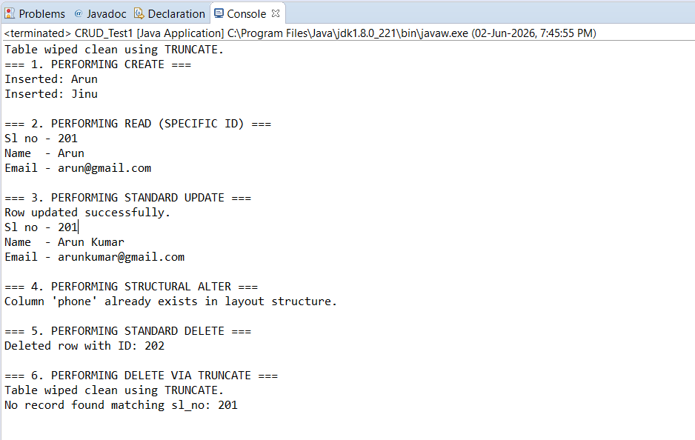

MONGODB CONNECTION
import com.mongodb.client.MongoClient;
import com.mongodb.client.MongoClients;
import com.mongodb.client.MongoDatabase;

public class MongoDBConnection {
public static void main(String[] args) {
String connectionString = "mongodb://localhost:27017";

try (MongoClient mongoClient = MongoClients.create(connectionString)) {
// FIXED: Changed "testdb" to your exact database name "vitbhopal"
MongoDatabase database = mongoClient.getDatabase("vitbhopal");
System.out.println("Connected successfully to MongoDB database: " + database.getName());
} catch (Exception e) {
System.out.println("Connection failed: " + e.getMessage());
}
}
}
