CO2 Capture cost model for Indian coal power and cement plants

Pratyush Dash, B.Tech Chemical Engineering, KIIT University, Bhubaneswar

1. Introduction
A solvent that absorbs CO2 well is only half the story. Once I had a working picture of how MEA behaves in an absorber, the obvious next question was what it would cost to run one at an Indian power station or cement works. This report is my attempt at an answer.
For each of two plants I worked out three things: how much heat it takes to regenerate the solvent, what a tonne of captured CO2 costs, and how much that pushes up the price of electricity or cement.
I chose these two on purpose. Coal still generates most of India's electricity, so any serious climate plan has to say something about it. Cement is harder. About two thirds of the CO2 from a kiln comes from the limestone itself, and changing the fuel does nothing about that.

2. Background
In post-combustion capture the flue gas goes up an absorber while a liquid amine solution runs down. The amine picks up CO2. That loaded solution is then heated in a stripper, the CO2 comes off almost pure, and the regenerated solvent goes back to the top of the absorber. The CO2 is dried and compressed afterwards.
Nearly all the trouble is in the heating. Each tonne of CO2 needs a few gigajoules of steam at the reboiler. At a power plant that steam would otherwise have gone through the turbine, so the plant pays twice. Once for the extra equipment, and again in electricity it can no longer sell.
Earlier Indian numbers are scattered. A set of case studies in Energy Procedia (volume 54) put the added electricity cost at 2.2 to 2.6 rupees per kWh, with 2,600 to 3,200 rupees for each tonne of CO2 avoided. A 2016 paper in Greenhouse Gases: Science and Technology gave 42 to 82 dollars per tonne, depending on the technology. A small project near Chennai was announced at 30 dollars per tonne, but that was a 10 MW plant sending its CO2 to soda ash production, so I wouldn't compare it with a full-size unit. For power plants worldwide, people usually quote 60 to 90 dollars per tonne.

3. How the model works

3.1 The capture unit
I kept the capture unit simple on purpose. It is a short-cut model, not a rate-based simulation.
The balance between CO2 and loaded MEA comes from a simple carbamate-type fit. Its temperature dependence is set by a heat of absorption of 85 kJ per mol, and I pinned its level at a single point: 0.05 kPa of CO2 pressure at 40 degrees Celsius and a loading of 0.20. That is a typical value for 30 wt% MEA, but it is one point, not a fitted data set.
Rich loading is taken as 90% of the way from the lean loading to the equilibrium value at the bottom of the absorber. A CO2 balance then tells me how much solvent has to circulate.
The reboiler duty is the sum of three pieces. Desorption heat is just the heat of absorption. Sensible heat is what it takes to bring the solvent up to reboiler temperature after the cross exchanger. The third piece is the steam that leaves with the CO2 at the top of the stripper, which the reboiler has to make as well.
For absorber height I integrate the CO2 balance up the column with one lumped mass transfer coefficient. My first run gave only about 9 m of packing, which is too short for 90% capture, so I lowered the coefficient until the height came out at 16 m. That makes it a tuned value and not a measured one.
The rest is electricity: a flue gas blower, solvent pumps, cooling water pumps, and a five-stage CO2 compressor with intercooling that takes the gas from 1.5 to 110 bar.

3.2 Energy penalty at the coal plant
Steam sent to the reboiler no longer drives the turbine. I turn the reboiler heat into lost electricity using the steam temperature, the condenser temperature and a turbine efficiency of 0.85. For the condenser I used 45 degrees Celsius, which is fair for an Indian summer. The answer is about 0.18 MW of electricity for every MW of heat taken. Compression and auxiliary power come on top of that.

3.3 Cement
A cement kiln has no spare steam, so the model adds a dedicated coal boiler. That boiler makes CO2 too, and I assume its flue gas joins the kiln gas and gets captured with it. The size of the boiler depends on how much CO2 is captured, and the CO2 depends on the boiler, so the program loops until the two agree. Power for the compressor and pumps comes from the grid.

3.4 Costs
For capital cost I started from a reference capture island of 560 million dollars (2020 prices) at 400 tonnes of CO2 per hour and scaled it with an exponent of 0.67. I adjust for CO2 concentration and for the plant cost index, then multiply by an India location factor. My first guess for that factor was 0.55, which made the capture plant cost more than the power station it was attached to, so I brought it down to 0.45. Indian supercritical plants seem to cost well under half of what they do in OECD countries, though that is my own rough estimate, and part of a capture island is imported equipment anyway.
Compression and the cement boiler are priced per kilowatt. A factor of 1.15 covers owner's costs and contingency. Running costs use a 10% cost of capital over 25 years, maintenance at 4% of capital a year, 1.5 kg of MEA make-up per tonne of CO2, and a small allowance for water and other chemicals.
I report two figures. Cost per tonne captured is the extra annual cost divided by the CO2 caught. Cost per tonne avoided divides the same cost by the net drop in emissions. The second number is always bigger, because the capture unit itself burns energy that causes emissions.

4. The two plants
The coal plant is a 660 MW supercritical unit with a net heat rate of 2,400 kcal per kWh, which works out to 35.8% efficiency. The coal has a gross calorific value of 3,800 kcal per kg and costs 5,000 rupees a tonne delivered. The plant runs at an 80% load factor. After desulphurisation the flue gas holds 13% CO2, and I assume 90% of it is captured.
The cement plant makes 6,000 tonnes of clinker a day for 330 days a year. That is 1.98 million tonnes of clinker, or 2.83 million tonnes of cement at a clinker factor of 0.70. The kiln releases 0.805 tonnes of CO2 per tonne of clinker, 0.52 of it from the raw meal. Kiln flue gas holds 20% CO2. Boiler fuel costs 380 rupees per GJ, grid power costs 7 rupees per kWh, and the grid emits 0.72 tonnes of CO2 per MWh.
I used 88 rupees to the dollar. Every one of these inputs is my own assumption, and all of them sit in the configuration file if you want to change them.

5. Results

5.1 Regeneration energy
The reboiler needs 3.62 GJ per tonne of CO2 for coal and 3.60 for cement (Figure 1). Desorption takes 1.93 GJ, sensible heat about 0.8 and stripping steam 0.88. Papers on 30 wt% MEA usually report 3.5 to 4.0 GJ, so the model is at least in the right place. Lean and rich loadings come out at 0.22 and 0.43, and about 22 kg of solvent circulates for each kg of CO2.
Compression uses 105 kWh per tonne of CO2, which is also within the usual 90 to 120.
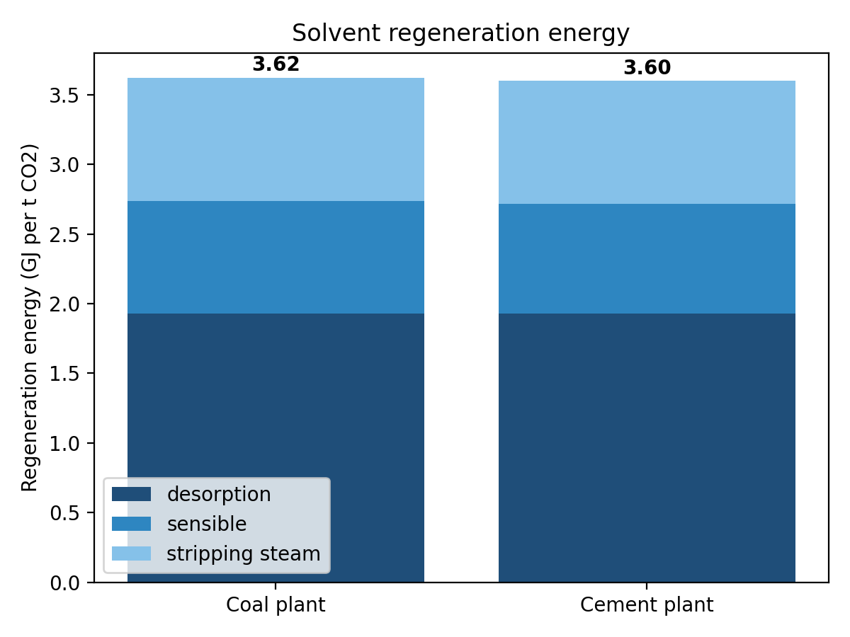
Figure 1. Solvent regeneration energy split into desorption, sensible heat and stripping steam.

5.2 Coal plant
Adding capture takes 26.5% of the plant's output. Steam extraction costs 99 MW, compression 58 MW and auxiliaries 18 MW, so a 660 MW unit ends up at 485 MW. Net efficiency falls from 35.8% to 26.3%, a drop of 9.5 points. Published studies mostly give 8 to 12 points, so that looks reasonable.
The plant captures 3.85 million tonnes of CO2 a year, and emissions per MWh fall from 0.926 tonnes to 0.126. The capture equipment costs about 5,436 crore rupees, or roughly 82,000 rupees per kW of the original capacity. The power plant itself was assumed at 80,000 rupees per kW, so the capture side costs slightly more than the plant it serves. I found that surprising at first, but it is what the numbers say.
Electricity goes from 4.85 to 9.30 rupees per kWh, which is 4.45 rupees or 92% more (Figure 2). A tonne of CO2 captured costs 3,439 rupees (39 dollars) and a tonne avoided costs 5,567 rupees (63 dollars). Of the 3,439, annualised capital is 1,554, fixed running cost 564, solvent and chemicals 270 and the energy penalty 1,051 (Figure 3).
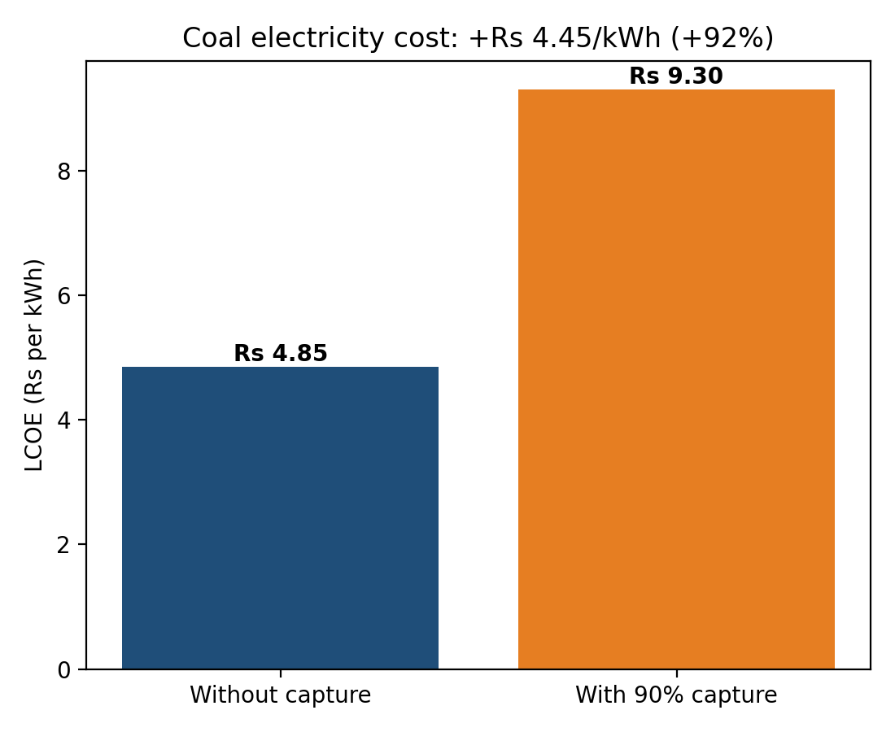
Figure 2. Coal electricity cost with and without 90% capture.
In dollars, the avoided cost lands inside the usual global range of 60 to 90. In rupees it is well above the Energy Procedia figures. I couldn't recover that study's inputs, so I can't say how much of the gap is price inflation and how much comes from a different method. The dollar comparison is the safer one to lean on.

5.3 Cement plant
The kiln emits 1.59 million tonnes of CO2 a year. The steam boiler adds another 0.90 million, and the capture unit handles both, removing 2.24 million tonnes a year. The boiler is big, about 333 MW of heat, and the capture unit draws about 38 MW of electricity.
Because the boiler and the grid power both emit CO2, the net reduction is only 1.13 million tonnes. That is 71% of what the kiln emitted before, even though the capture rate is 90%.
A tonne captured costs 5,054 rupees (57 dollars) and a tonne avoided costs 10,038 rupees (114 dollars). Steam fuel is the biggest item at 1,609 rupees per tonne captured, then capital at 1,645 and electricity at 932. Spread across the product, capture adds about 5,726 rupees per tonne of clinker and 4,008 per tonne of cement. For a 50 kg bag that is around 200 rupees.
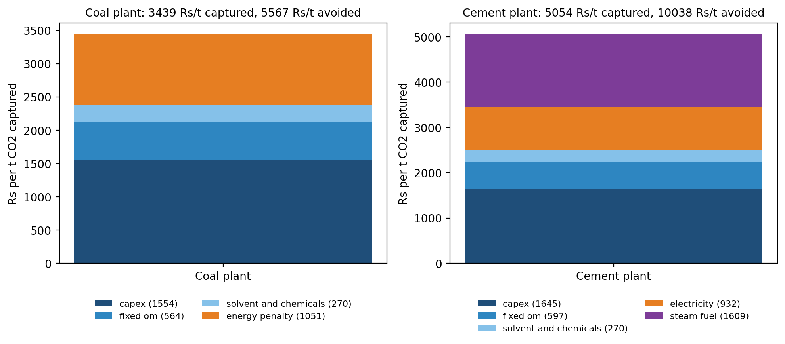
Figure 3. Cost per tonne of CO2 captured for the coal and cement cases, by cost item.
Item | Coal plant | Cement plant
Regeneration energy (GJ per t CO2) | 3.62 | 3.60
Cost per tonne captured (Rs) | 3,439 | 5,054
Cost per tonne avoided (Rs) | 5,567 | 10,038
Cost per tonne avoided (USD) | 63 | 114
CO2 captured (Mt per year) | 3.85 | 2.24
Capture capital cost (Rs crore) | 5,436 | 3,350
Table 1. Summary of base case results.

6. Which inputs matter
I moved each input to a low and a high value, one at a time, and watched the cost of CO2 avoided (Figures 4 and 5).
For coal, the capital cost location factor is the biggest lever. Going from 0.35 to 0.70 shifts the avoided cost from about 5,050 to 6,870 rupees per tonne. Plant load factor is second, giving 6,420 at 65% and 5,160 at 90%. Coal at 3,500 rupees a tonne gives 5,140 and at 7,000 gives 6,140. A cost of capital of 8% gives 5,150 and 12% gives 6,000. Solvent price, lean loading and heat of absorption each move the answer by a few hundred rupees at most.
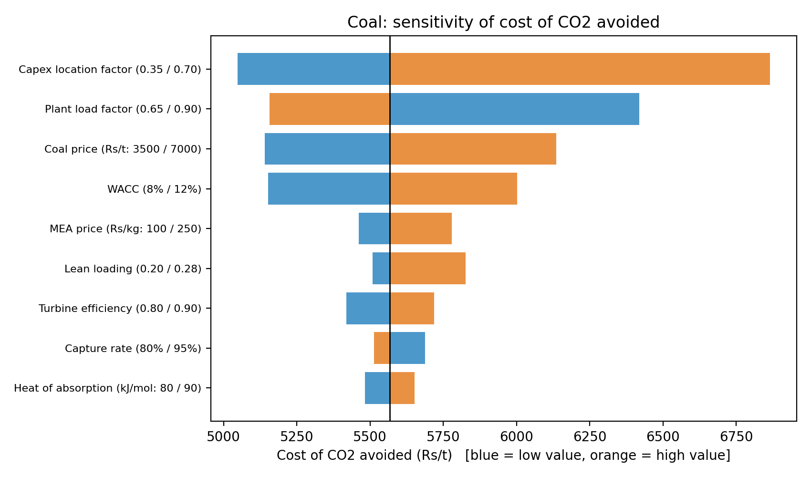
Figure 4. Coal case: sensitivity of the cost of CO2 avoided.
Cement tells a similar story. The location factor again comes first, spanning 9,230 to 12,060 rupees per tonne. Boiler fuel is next: 8,940 at 250 rupees per GJ and 11,050 at 500. Grid power price, cost of capital and the grid emission factor each shift the result by about a thousand rupees.
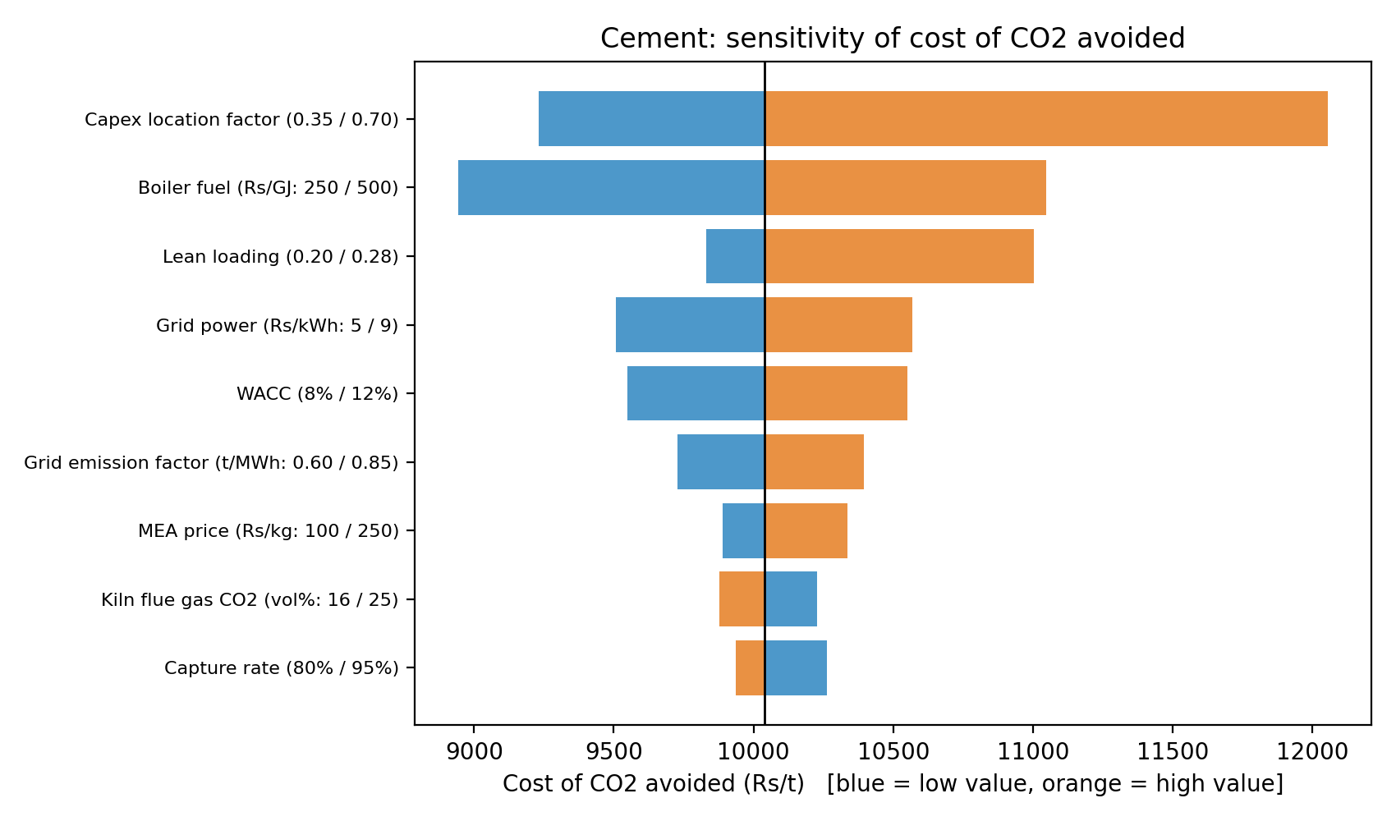
Figure 5. Cement case: sensitivity of the cost of CO2 avoided.
The electricity price increase barely reacts to the coal price. It runs from about 4.0 rupees per kWh when coal is 3,000 rupees a tonne to 5.1 when it is 8,000 (Figure 6). Most of the jump is already built in by the efficiency loss and the extra equipment.
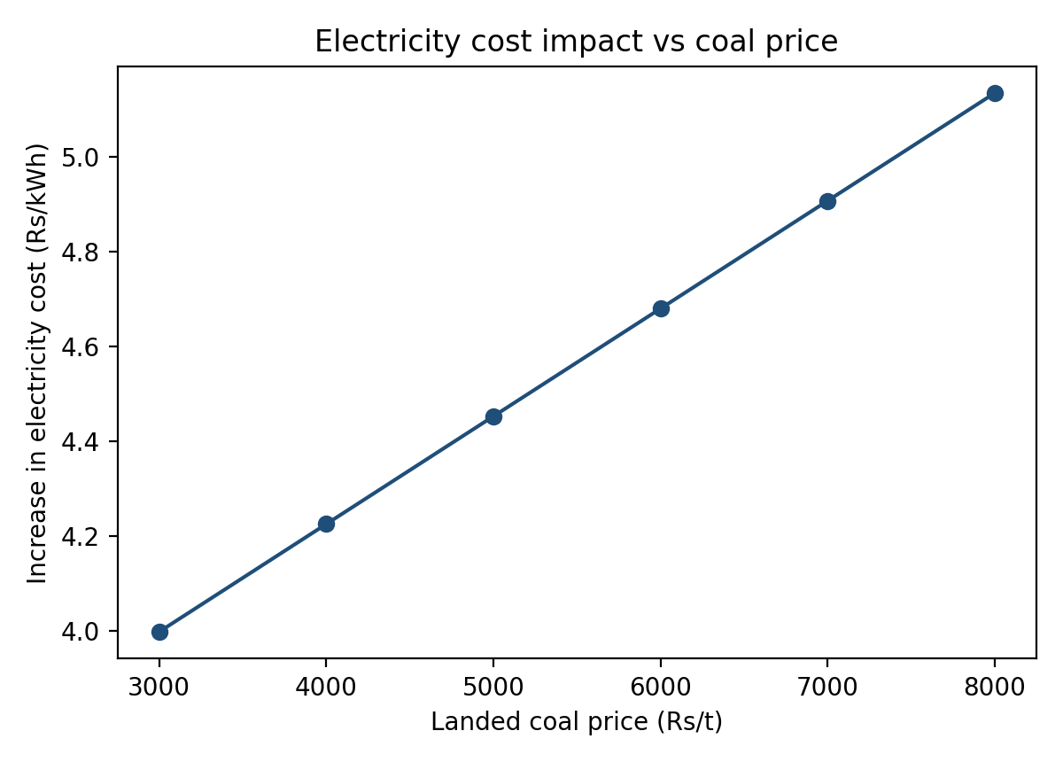
Figure 6. Increase in coal electricity cost against landed coal price.
Two of the curves in Figure 7 are easy to misread. The cost of CO2 avoided drops as capture rate rises, but that is only because fixed costs get spread over more CO2, and I wouldn't treat it as a general rule. Reboiler duty also climbs steadily with lean loading, which makes the lowest loading look best. In a real stripper a lower lean loading needs a taller column, and my model doesn't include that, so it can't find the true optimum.
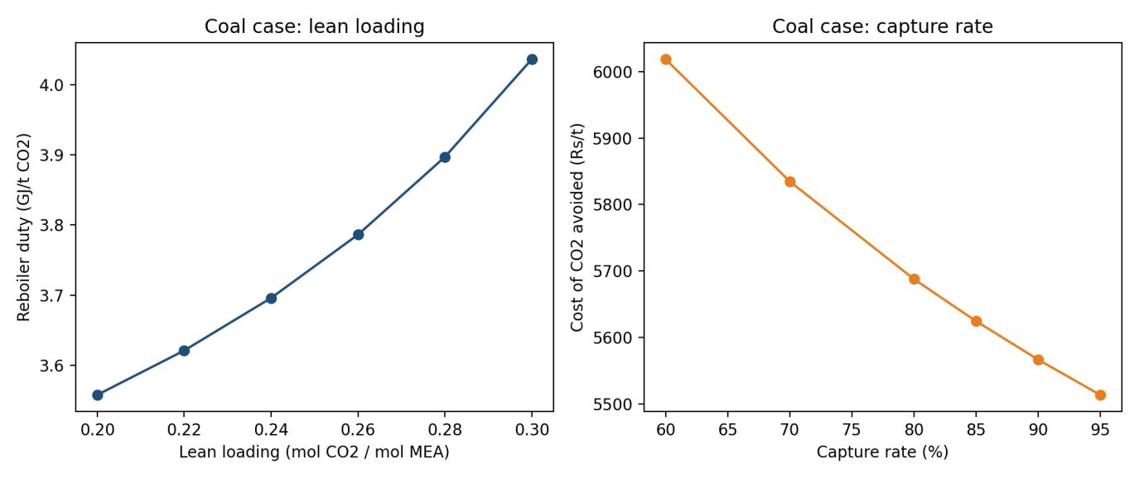
Figure 7. Coal case: reboiler duty against lean loading (left) and cost of CO2 avoided against capture rate (right).

7. What it means for policy
For coal, the plain result is that 90% capture roughly doubles the cost of generating power from a new supercritical unit. The equipment is only part of it. A quarter of the plant's output goes into running the capture unit, and the cost of the original plant has to be recovered from fewer units of electricity. Any support scheme that only covers the capital cost would miss that.
Cement costs about twice as much per tonne avoided, and most of the difference is the steam. A plant with usable waste heat, or one sitting next to a cheap source of low-grade steam, would do much better than the stand-alone boiler I assumed. Where you build it matters as much as what you build.
The carbon price or subsidy needed to break even is close to the avoided cost, so about 5,600 rupees per tonne for coal and 10,000 for cement on my assumptions. I don't expect a near-term carbon price anywhere near those levels. Early projects will probably need a buyer for the CO2 or some form of public money.

8. What this model can't do
The absorber is a short-cut and I haven't checked it against measured equilibrium data. The mass transfer coefficient was tuned, not measured. Capital cost is scaled from a reference value and could be off by a wide margin, which is why it heads both sensitivity charts. Transport and storage are left out, so every figure stops at compressed CO2. The coal case looks at new builds and not retrofits. The cement plant is one representative site and not an average of Indian kilns. Prices for coal, power and boiler fuel, the exchange rate and the grid emission factor are my own estimates, and they need checking against current data before anyone quotes these numbers formally.

9. Where I'd take it next
First I'd swap the short-cut absorber for the rate-based model from my earlier CO2-MEA work and calibrate the equilibrium fit against published data. Then the capital cost needs rebuilding from equipment sizes and Indian quotes instead of scaling. After that I'd add retrofits, waste heat at cement plants, and transport and storage. Running the same study with a different solvent would also show how much of this cost is specific to MEA.

10. References
1. Cost Implications of Carbon Capture and Storage for the Coal Power Plants in India. Energy Procedia, volume 54.
2. Suitability of CO2 capture technologies for carbon capture and storage in India. Greenhouse Gases: Science and Technology, 2016, volume 6, issue 4, pages 519 to 530.
3. Kumar R. and Karmakar S. Exergy analysis of modified supercritical power plant with solar assisted feedwater heating and CO2 capture. International Journal of Exergy, 2023, volume 41, issue 1.
4. World Coal. Indian project to capture CO2 at US$30 per tonne, October 2016.

