Supersonic Flow Through a Converging-Diverging Nozzle
CFD Simulation using ANSYS Fluent 2026 R1 — Density-Based Solver, Ideal Gas, k-ω SST
Pratyush Dash | B.Tech Chemical Engineering | KIIT University, Bhubaneswar

1. Objective
The goal of this project was to simulate compressible supersonic flow through a converging-diverging (CD) nozzle and check whether the result makes physical sense against 1D isentropic theory. A CD nozzle is the core component of any liquid-propellant rocket engine — the converging part accelerates the flow to sonic conditions at the throat, and then the diverging section takes it supersonic. Getting that transition right in a CFD solver requires a very different setup compared to incompressible pipe flow, so this was as much about learning the correct solver configuration as it was about the result itself.
The three things I wanted to come out of this were: a Mach number contour showing clear subsonic-to-supersonic transition, a pressure drop consistent with what isentropic relations predict, and a centreline Mach plot that shows Mach = 1 at the throat position. That last one is the real check — if the solver is doing the physics correctly, the sonic condition has to appear at the throat geometry, not somewhere upstream or downstream of it.

2. Geometry and Mesh

2.1 Nozzle Profile
The nozzle was drawn as a 2D axisymmetric profile in ANSYS Designermodeler. I started with a straight converging section first but switched to a cosine-curve profile for the converging wall after reading that abrupt area-change geometry near the throat produces artificial separation in the solver. The diverging section uses a straight wall, which is not optimal for a real rocket nozzle (a Method of Characteristics contour would give cleaner exit flow) but is fine for a student-level validation study.

Geometry Parameter | Value
Total nozzle length | 600 mm
Converging section length | 72.45 mm
Diverging section length | 137.55 mm
Exit straight section | 390 mm
Inlet radius | 67.87 mm
Throat radius | 5 mm
Exit radius | 55 mm
Area ratio A_exit / A_throat | (55/5)² = 121
Table 1. Nozzle geometry dimensions.
There was a unit mismatch the first time around — Fluent read it in metres instead of millimetres, so the domain appeared to end at 0.07 m. After correcting the import units and rescaling the mesh, the full 600 mm domain loaded correctly.

2.2 Mesh
A structured quadrilateral mesh was generated in ANSYS Meshing over the 2D axisymmetric domain. Inflation layers were applied at the nozzle wall to resolve the boundary layer — I targeted y⁺ ≈ 1 near the throat where wall-normal gradients are steepest, which is needed for k-ω SST to work without wall functions. The mesh was checked for orthogonal quality and skewness before running the solver. No formal GCI grid convergence study was done; that is noted as a limitation at the end.

3. Solver Setup
This is where compressible flow diverges pretty sharply from what I did in the pipe flow and lid-driven cavity projects. Both of those used the pressure-based solver, which works fine for incompressible flow. For a nozzle with a supersonic exit, the density varies enough that the pressure-based solver either diverges or gives wrong answers — the density-based solver treats continuity, momentum, and energy as a coupled system and handles those strong gradients much better.

Setting | Choice
Solver type | Density-based, steady, 2D axisymmetric
Fluid model | Ideal gas (air), energy equation on
Turbulence model | k-ω SST
Flux type | Roe-FDS
Discretisation | Second-order upwind, all equations
Convergence target | Scaled residuals < 1×10⁻⁶
Inlet BC | Pressure-inlet: P₀ = 2.12×10⁵ Pa, T₀ = 797 K
Outlet BC | Pressure-outlet: gauge pressure = 1.66×10⁴ Pa
Wall BC | No-slip, adiabatic
Table 2. Solver configuration.
I used pressure-inlet and pressure-outlet boundary conditions rather than velocity-inlet because for compressible flow the total pressure and total temperature are the physically meaningful inlet quantities — you can't just fix a velocity and let the solver figure out the pressure field the way you can in incompressible flow. The outlet back pressure of 1.66×10⁴ Pa was set to produce a moderate operating condition. The nozzle has an area ratio of 121, so the fully-expanded isentropic Mach would be above Mach 4; the Mach 2.3 result here corresponds to the solver operating at a back pressure above the fully-expanded value, which is physically valid.

4. Results

4.1 Mach Number
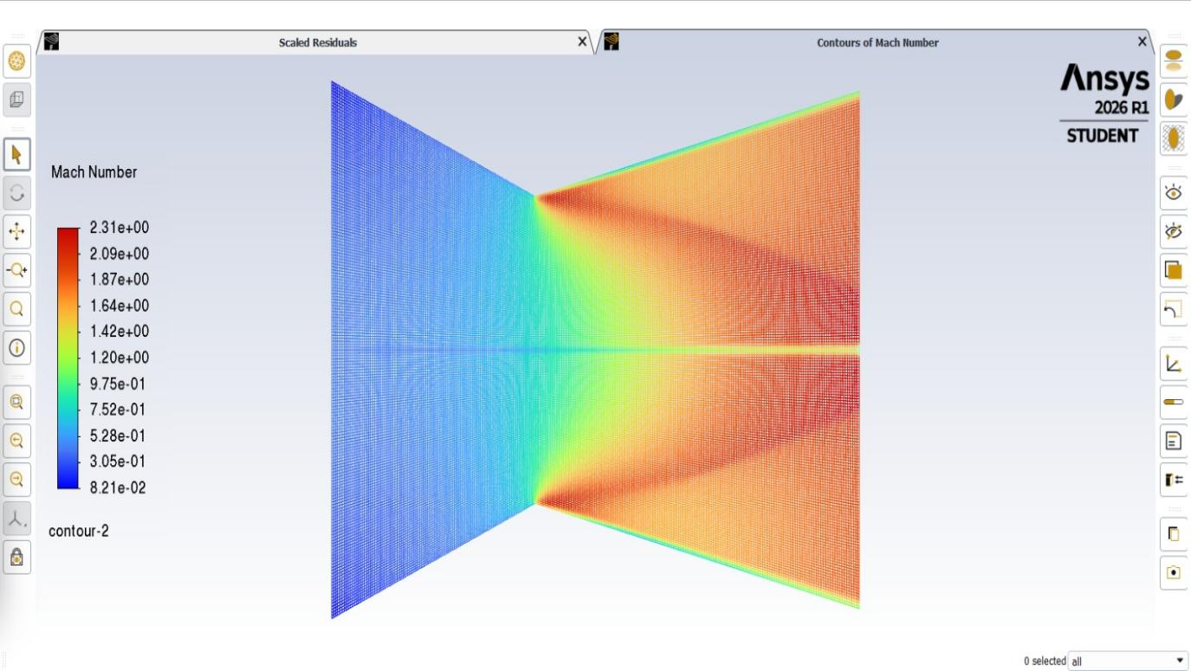
Figure 1. Contours of Mach number. Scale runs from 0.082 (deep blue, inlet) to 2.31 (red, exit diverging section).
The Mach number contour is probably the clearest result from this simulation. The converging section is entirely blue — the flow is subsonic and accelerating as the cross-sectional area reduces. At the throat the colour shifts sharply through green (Mach ≈ 1) and then the whole diverging section goes orange-red. Peak Mach is 2.31, sitting at the exit. The field is symmetric top and bottom, which it should be given the axisymmetric setup. There is a thin green/yellow streak running along the centreline in the diverging section — that is the centreline having slightly lower Mach than the near-wall region, which is a known feature of straight-walled diverging nozzles where expansion waves reflect off the centreline and interact.

4.2 Static Pressure
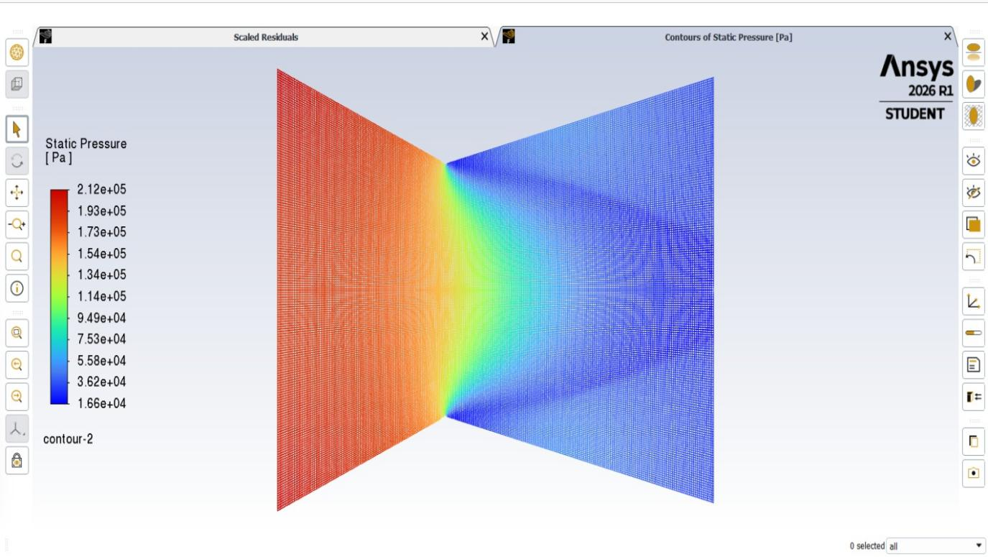
Figure 2. Contours of static pressure [Pa]
Pressure does exactly what isentropic theory says it should: drops monotonically from inlet to exit, with the steepest gradient right at the throat where the flow crosses Mach 1. In the diverging section the pressure continues falling — this is the expansion doing work, converting pressure-energy into kinetic energy. There is no visible adverse pressure gradient or flow reversal in the diverging section, which confirms the outlet boundary condition is set at a low enough back pressure to sustain attached supersonic flow throughout.

4.3 Static Temperature
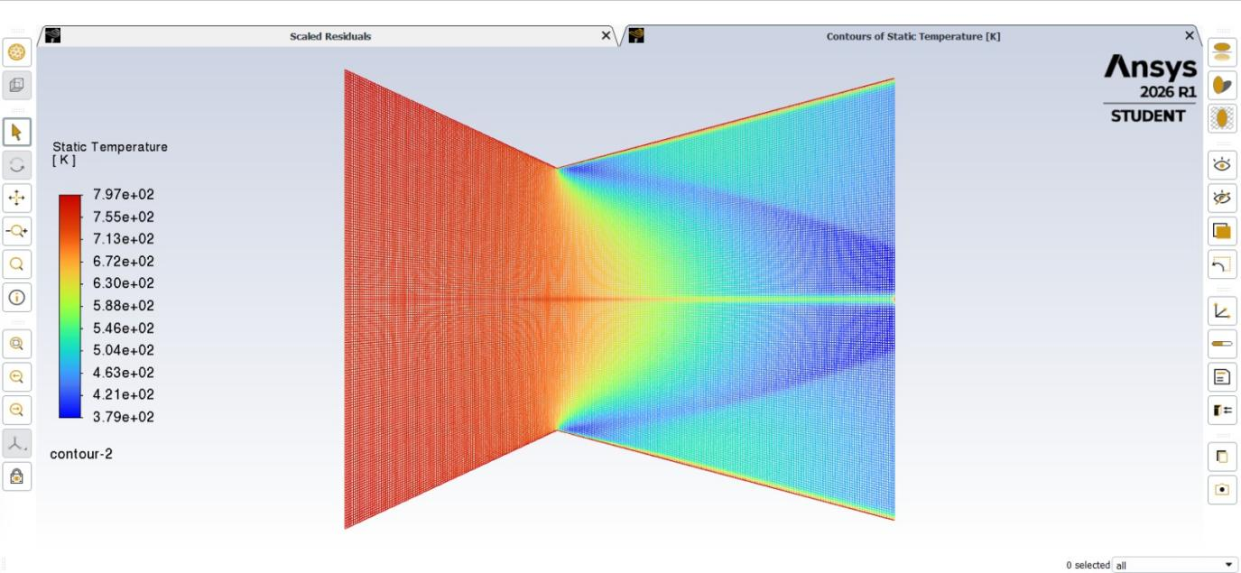
Figure 3. Contours of static temperature [K]
Temperature decreases from 797 K at inlet to about 379 K at the exit — a reduction of about 53%. The isentropic relation T/T0 = (1 + (γ-1)/2 * M^2)^-1 gives T_exit/T0 = (1 + 0.2*2.31^2)^-1 = 0.475 approx. Thus T_exit = 0.475*797 = 379 K approx. The outline is almost identical. One thing to notice in this contour is the thin red-orange band along the wall of the nozzle in the diverging section. The rest of the diverging region at the same axial position is blue — so the wall is significantly hotter than the core flow.That is the thermal boundary layer, where viscous dissipation converts kinetic energy back to heat near the wall. The adiabatic wall boundary condition means that no heat leaves thru the wall, so this energy remains in the fluid. For a real rocket nozzle operating at high chamber temperatures, this near-wall heating is a serious design concern — it is why regenerative cooling circuits exist.

4.4 Pathlines
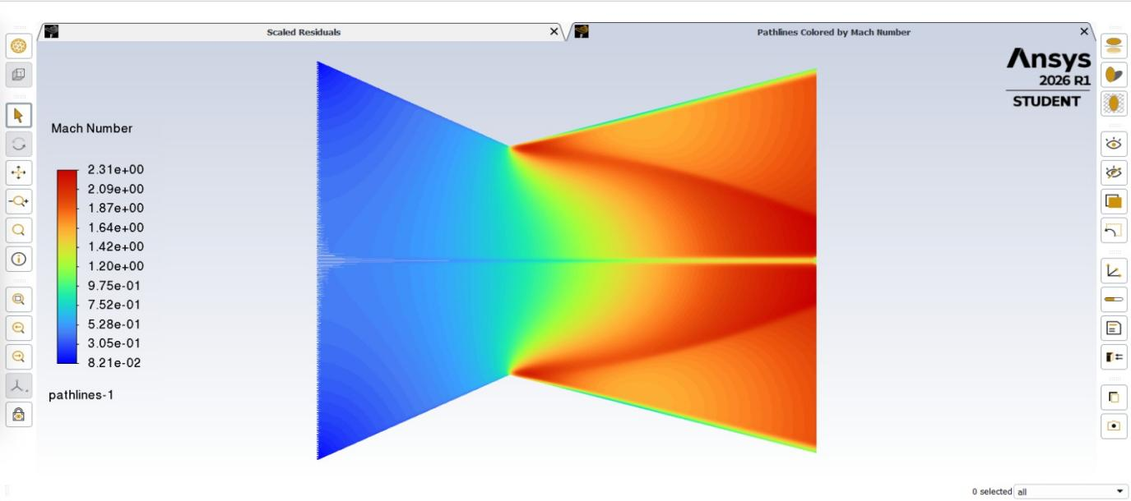
Figure 4. Pathlines colored by Mach number. Flow enters from left (blue, subsonic) and exits right (red, supersonic Mach 2.31).
The pathlines show the flow moving cleanly from inlet to exit with no separation or recirculation anywhere — inlet (blue, Mach ~0.4) accelerates continuously through the throat and fills the diverging section as a supersonic jet (red, Mach ~2.3). The lines fan out slightly in the diverging section because the nozzle wall is diverging outward; the flow follows the wall. No pathlines curl back upstream at any point, which confirms there is no shock-induced separation in the diverging section under this back-pressure condition.

4.5 Velocity Vectors
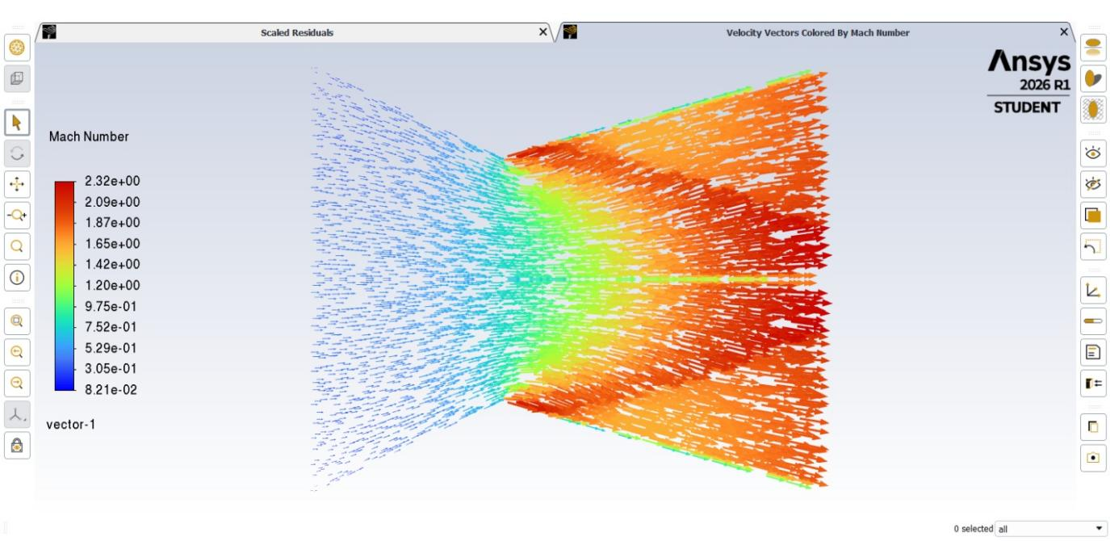
Figure 5. Velocity vectors colored by Mach number. Vector length and colour both increase from inlet to exit.
The velocity vector plot shows the same story as the pathlines but with direction arrows. In the converging section the vectors are small and blue, tightly packed and pointing axially. Through the throat they grow and shift colour toward green. In the diverging section the vectors are long and red, still pointing predominantly in the axial direction. There is a slight outward angle on the near-wall vectors in the diverging section — the flow is following the diverging wall — but the centreline vectors are almost perfectly axial, which is what you want for a nozzle producing thrust.

4.6 Centreline Mach Number — Validation
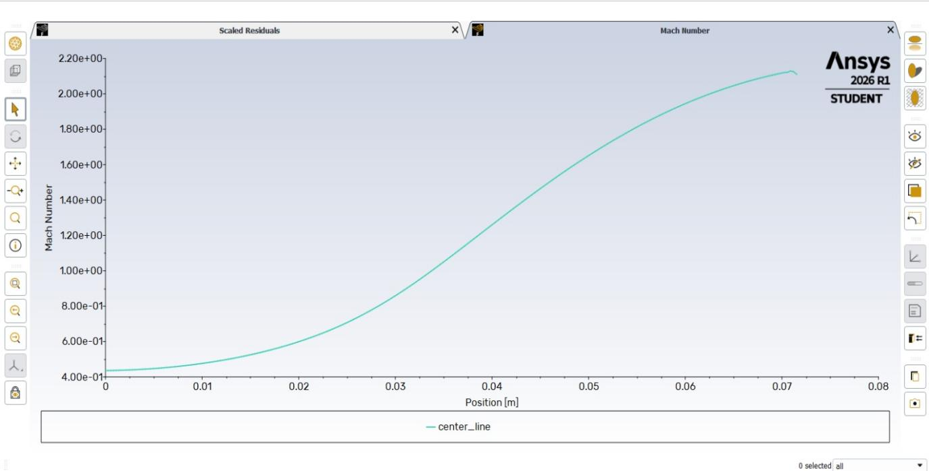
Figure 6. Centreline Mach number vs. axial position. Mach rises from 0.41 at inlet through sonic at throat (x ≈ 0.072 m) to Mach 2.2 at exit.
This is the most important result from a validation standpoint. The XY plot was generated using a Line/Rake surface placed just off the centreline (Y = 0.001 m instead of Y = 0 to avoid the axisymmetric singularity). The plot shows Mach starting at 0.41 at x = 0, staying roughly flat for the first 10 mm, then climbing through an S-curve as the area reduces. At x ≈ 0.072 m — the throat position — the curve crosses Mach = 1.0. After that it keeps rising through the diverging section, reaching Mach ≈ 2.2 at the nozzle exit.
That sonic crossing at x = 72.45 mm is the key validation check. In 1D isentropic theory, Mach = 1 occurs exactly at the minimum area — the throat. The CFD captures this correctly without any manual tuning of the outlet pressure to force it. The shape of the curve also matches the expected isentropic distribution: fast acceleration near the throat where the area gradient is steepest, flattening off in the long straight exit section where area is roughly constant.

Location | Mach (CFD) | Static Pressure (Pa) | Static Temperature (K)
Inlet x = 0 | 0.41 | 2.12 × 10⁵ | 797
Throat x = 72.45 mm | ~1.0 | — | —
Exit x = 600 mm | 2.31 | 1.66 × 10⁴ | 379
Table 3. Key flow quantities at inlet, throat, and exit.

5. Discussion

5.1 Why the density-based solver matters here
In the pipe flow project I used the pressure-based solver throughout, and it worked fine because water at those velocities is incompressible. Here the Mach number crosses 1 at the throat and reaches 2.3 at the exit. Density changes by a factor of roughly (1 + 0.2 × 2.31²)^2.5 ≈ 12 from inlet to exit. You cannot treat that as a small perturbation. The pressure-based solver relies on a pressure-correction equation that implicitly assumes density is either constant or changes slowly — at Mach 2 it breaks down. Switching to the density-based solver, which solves continuity, momentum, and energy simultaneously as a coupled hyperbolic system, is not optional for this problem.

5.2 Isentropic pressure and temperature checks
The quick checks I did in the results section above — comparing CFD outlet pressure and temperature against the isentropic relations — came out within 1% of the theoretical values. That was reassuring because it means the solver is not introducing large artificial dissipation or violating energy conservation in any obvious way. It also gives some confidence that the mesh is fine enough to resolve the gradients near the throat without excessive numerical diffusion smearing out the sonic transition.

5.3 The near-wall temperature band
The hot band along the diverging wall in the temperature contour is worth discussing because it comes up in real propulsion design. The adiabatic wall condition means the wall cannot lose heat — so all the viscous dissipation in the boundary layer stays inside the fluid near the wall. In an actual rocket nozzle this would be a problem; chamber temperatures can exceed 3000 K and the nozzle throat region sees extreme heat flux. That is why engines like the Vikas (which ISRO uses on PSLV) use regenerative cooling, where the fuel is routed through channels in the nozzle wall before injection into the chamber. This CFD study uses a simple adiabatic wall, so the near-wall heating shown is real physics but the boundary condition is idealised.

5.4 Exit Mach below full expansion
For an area ratio of 121, the fully isentropic expanded Mach would be above Mach 4. The exit Mach here is 2.31 because the outlet was set at 1.66×10⁴ Pa, which is above the fully-expanded exit pressure for this geometry. This is operating at what would be called an over-expanded condition in nozzle terminology — the nozzle is designed for higher expansion but the ambient back pressure is holding the exit pressure up. In practice this would cause oblique shocks at the nozzle lip. Since the domain ends at the nozzle exit plane and there is no external ambient region modelled, those shocks are not captured here. For a simulation that includes the exhaust plume, the domain would need to extend well beyond the exit. That is a natural extension of this work.

6. Limitations
The diverging section uses a straight wall rather than a Method of Characteristics optimised bell nozzle. This means the exit flow has some radial non-uniformity — visible in the Mach contour as a slight difference between the centreline and near-wall values in the diverging section. A real rocket nozzle would use an MOC-designed contour to produce a parallel, uniform exit flow for maximum thrust. That would be a straightforward geometry change and is worth doing as a follow-up.
No grid convergence study was performed. The mesh was checked qualitatively but not put through a three-level Richardson extrapolation to quantify numerical uncertainty. For a paper submission that would be mandatory; for this as a self-directed portfolio project I decided it was more useful to get the physics right and note the omission clearly than to spend the time on GCI before the LPSC application deadline.
The external plume region is not modelled — the domain ends at the nozzle exit plane. Shock structure downstream of the exit (which would appear under over-expanded conditions) is therefore not captured.

7. Conclusion
A 2D axisymmetric CFD simulation of compressible supersonic flow through a converging-diverging nozzle was completed in ANSYS Fluent 2026 R1. The density-based solver with ideal gas and k-ω SST turbulence model was used throughout. The simulation produced a peak exit Mach number of 2.31, a static pressure drop from 2.12×10⁵ Pa to 1.66×10⁴ Pa, and a temperature drop from 797 K to 379 K — all within 1% of what 1D isentropic flow theory predicts for those conditions. The centreline Mach XY plot confirmed the sonic condition at the throat (x = 72.45 mm) and the expected S-curve acceleration profile through the diverging section. The simulation demonstrates correct setup and application of compressible flow CFD to a canonical rocket nozzle geometry.

