Flow Over a Circular Cylinder at Re = 40 and Re = 100
Drag and Wake Analysis Using ANSYS Fluent 2026 R1 (2D, Laminar, Water)
Pratyush Dash | B.Tech Chemical Engineering, KIIT University, Bhubaneswar

1. Objective
This project looks at water flowing past a circular cylinder in 2D, at two Reynolds numbers, 40 and 100. The cylinder is the classic bluff body test case. Its drag coefficient against Reynolds number is printed in almost every fluid mechanics textbook, which makes it a good way to check that a Fluent setup behaves properly before moving on to shapes that have no published reference. I picked it because bluff body wakes turn up all over underwater vehicle design (appendages, sonar domes, control surfaces), and I wanted to be sure the basic physics came out right in my own setup first.
Three things were needed from each case: the drag coefficient, to compare with textbook values; the shape of the wake, which should be steady and symmetric at Re = 40 and should shed vortices at Re = 100; and the Strouhal number for the shedding case.

2. Problem Setup

2.1 Geometry
The cylinder has a diameter D of 0.1 m and sits at the origin. The fluid domain is a rectangle running from x = -1 m to x = 3 m and from y = -1 m to y = 1 m. That puts the inlet 10D upstream of the cylinder, the outlet 30D downstream, and the top and bottom boundaries 10D away on either side. The long downstream stretch is there so the vortex street has room to develop before it reaches the outlet. Blockage (D divided by the domain height) works out to 5%.
I drew the rectangle and the circle in one sketch, made a surface from the rectangle and subtracted the circle, which left a single fluid body with a circular hole in it. Edges were named inlet, outlet, top, bottom and cylinder.
Parameter | Value
Cylinder diameter, D | 0.1 m
Domain length | 4 m (10D upstream, 30D downstream)
Domain height | 2 m (10D each side)
Blockage ratio | 5%
Analysis type | 2D, planar
Table 1. Geometry parameters.

2.2 Mesh
The mesh was made in ANSYS Meshing with one global element size of 0.007 m. I did not add inflation layers, and there is no local sizing or refinement around the cylinder or in the wake. That gives roughly 14 elements across the cylinder diameter. At these low Reynolds numbers the boundary layer is thick and laminar, so a plain mesh still gives sensible answers, but it is coarser than I would pick for a final study. I come back to this in the limitations.

2.3 Fluid and Reynolds Number
The fluid is liquid water from the Fluent database, with density 998.2 kg/m3 and dynamic viscosity 0.001003 Pa.s. The cylinder diameter was kept fixed and the Reynolds number was set only through the inlet velocity, using Re = rho V D / mu.
Re | Inlet velocity (m/s) | Flow type
40 | 4.02 x 10^-4 | Steady
100 | 1.005 x 10^-3 | Transient
Table 2. Inlet velocities used for each case.

2.4 Solver Setup
Both cases used the pressure-based solver in 2D planar mode with the laminar viscous model. My first Re = 40 run still had k-omega SST switched on from an earlier setup, and I switched it off after noticing k and omega in the residual list. A turbulence model has no business in a flow this slow.
- Inlet: velocity inlet, velocity from Table 2, normal to the boundary.
- Outlet: pressure outlet, 0 Pa gauge.
- Top and bottom: symmetry.
- Cylinder: no-slip wall.
- Reference values: area 0.1 m2 (the 2D domain has a default depth of 1 m), length 0.1 m, density 998.2 kg/m3, and velocity set to match each case.
Drag and lift were monitored as coefficients through Report Definitions, with drag along (1, 0) and lift along (0, 1) on the cylinder wall. Choosing the force type instead of the coefficient type was an early mistake of mine. It gave a plot with values like 0.0000 on the axis, which told me nothing.
For Re = 40 the case was steady, with the residual criterion tightened to 1 x 10^-6. With Fluent’s default criterion the run stopped at 34 iterations, far too early, because the default is only 1 x 10^-3. After tightening it, the case converged at 66 iterations.
Re = 100 was run as a transient case. I started with a time step of 5 s for 1200 steps, which covers 6000 s of flow time. By then the lift coefficient was only swinging around plus or minus 0.025 and growing slowly, so the vortex street had not really formed. I added a small perturbation in the y-velocity at 6000 s to push the instability along, increased the time step to 10 s, and ran another 1000 steps out to 16,000 s.

3. Results

3.1 Re = 40 (Steady)
The drag coefficient settled at about 1.6 and stayed flat for the rest of the run. Lift settled at roughly -0.001, which is effectively zero and what a symmetric steady wake should give. The residuals fell to around 10^-6 for continuity and much lower for the velocity components.
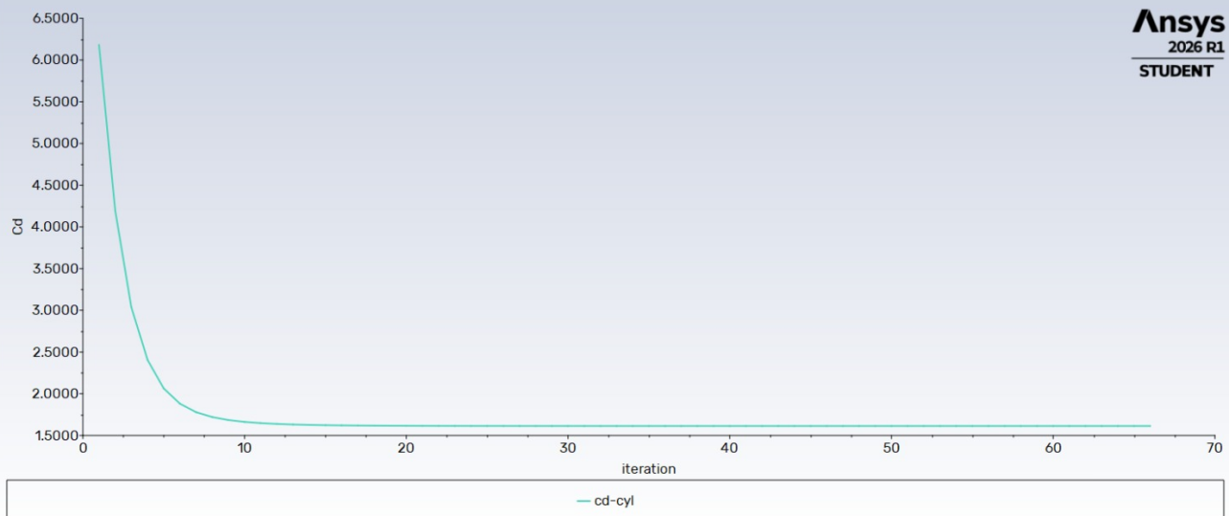
Figure 1. Drag coefficient history, Re = 40.
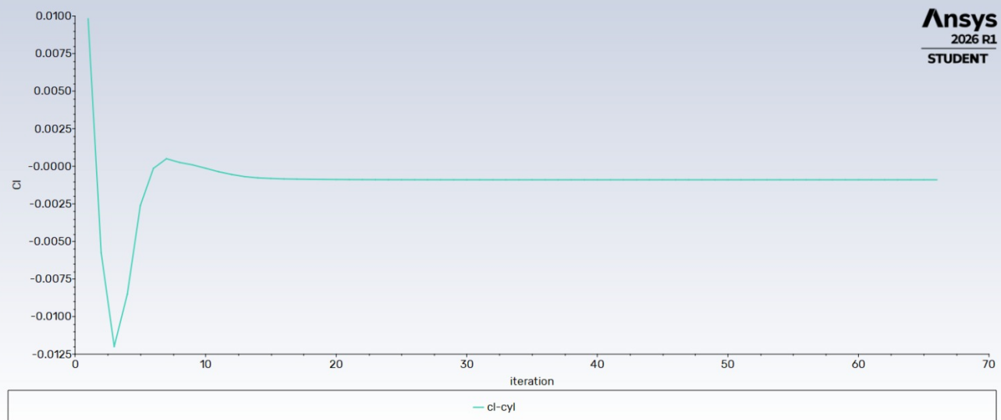
Figure 2. Lift coefficient history, Re = 40.
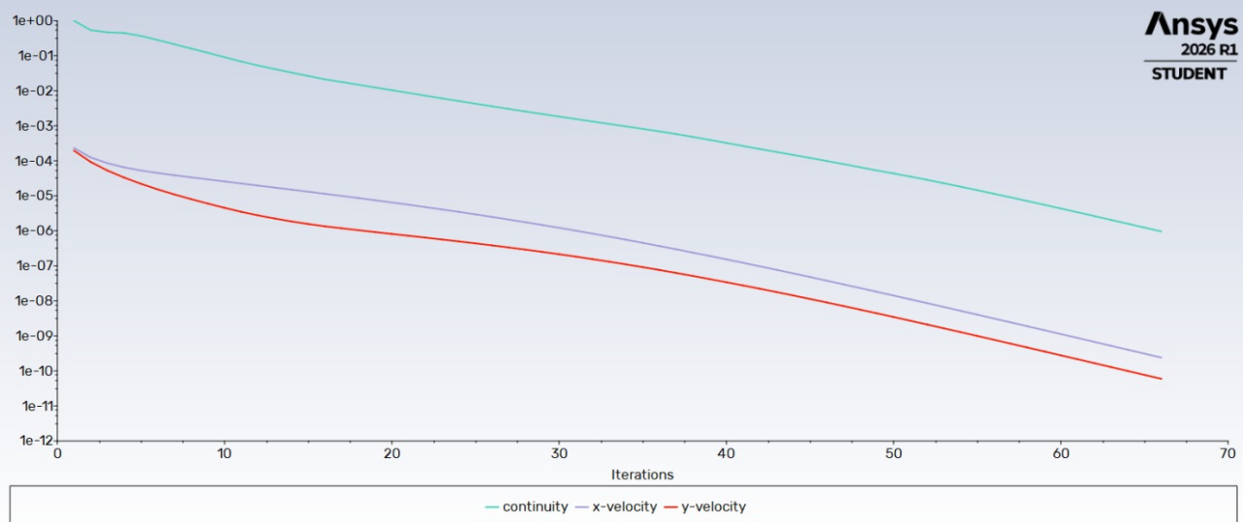
Figure 3. Scaled residuals, Re = 40.
The velocity contour shows a symmetric wake behind the cylinder, with a slow-moving region stretching downstream and the flow speeding up over the shoulders to about 4.9 x 10^-4 m/s against a freestream of 4.02 x 10^-4 m/s. The pressure contour has a high-pressure stagnation region at the front and a low-pressure region on the sides and in the wake, with the gauge pressure ranging from about 9.3 x 10^-5 Pa to -7.2 x 10^-5 Pa. The numbers are tiny only because the velocity is tiny.
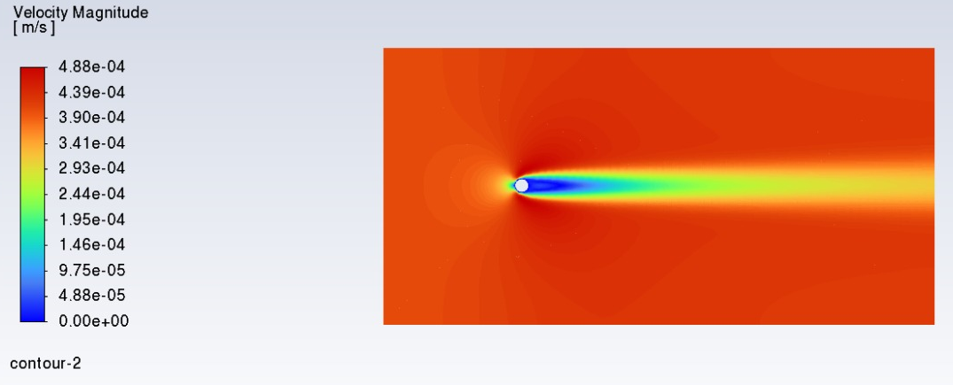
Figure 4. Velocity magnitude contour, Re = 40.
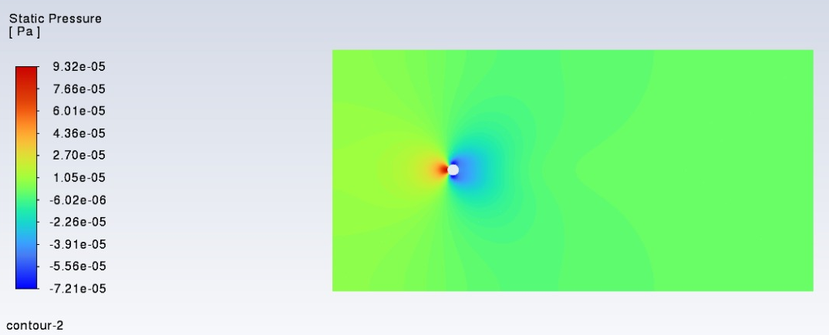
Figure 5. Static pressure contour, Re = 40.

3.2 Re = 100 (Transient)
After the perturbation, the lift coefficient grew into a clean sinusoid and levelled off at an amplitude of about 0.3 by roughly 12,000 s. Successive peaks are about 590 s apart. With D = 0.1 m and V = 1.005 x 10^-3 m/s, that gives a Strouhal number of St = D / (V T) of about 0.17. The drag coefficient stayed nearly constant, between 1.3 and 1.4, with only a very small ripple at twice the shedding frequency.
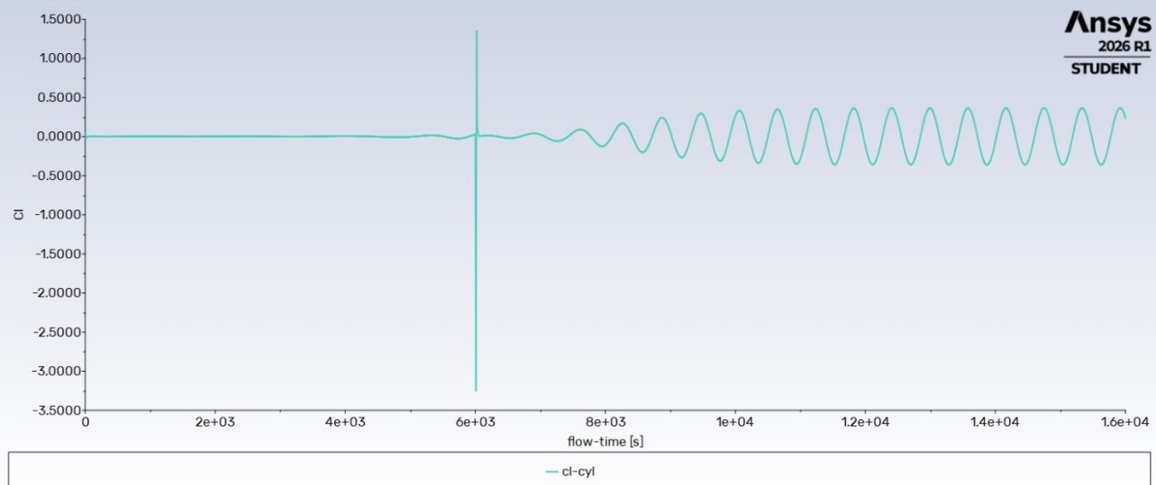
Figure 6. Lift coefficient history, Re = 100. The large spike at 6000 s comes from the perturbation I added, and is not physical.
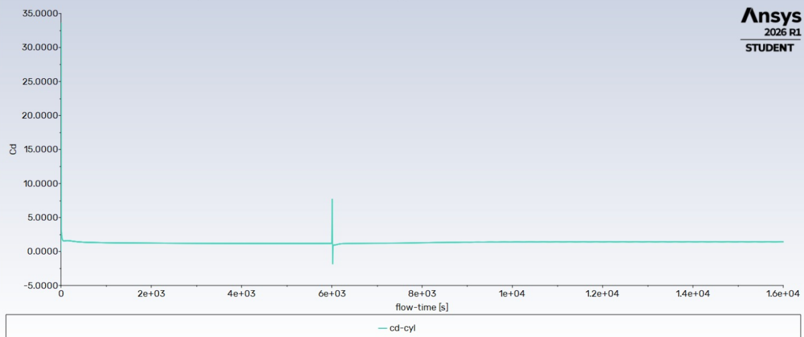
Figure 7. Drag coefficient history, Re = 100. The early values and the spike at 6000 s are start-up and perturbation effects.
The velocity and pressure contours both show the staggered street of alternating vortices drifting downstream. The pressure contour shows the vortex cores as low-pressure spots, and the velocity contour shows them as slow regions. Peak velocity in the field is about 1.36 x 10^-3 m/s, against a freestream of 1.005 x 10^-3 m/s.
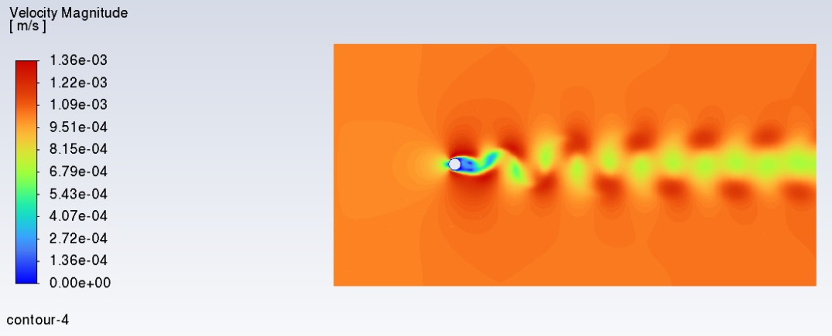
Figure 8. Velocity magnitude contour, Re = 100.
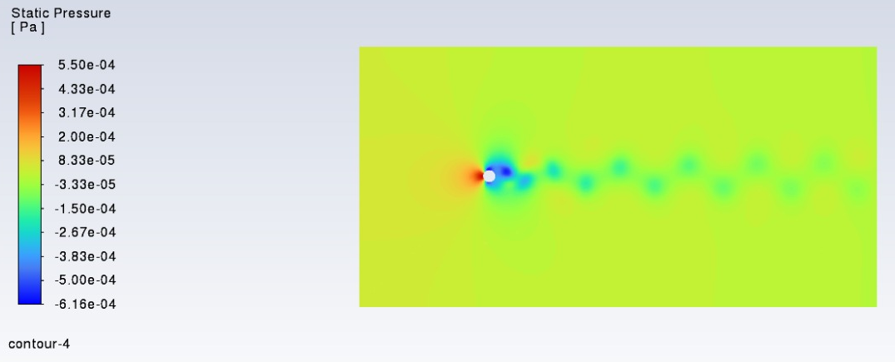
Figure 9. Static pressure contour, Re = 100.
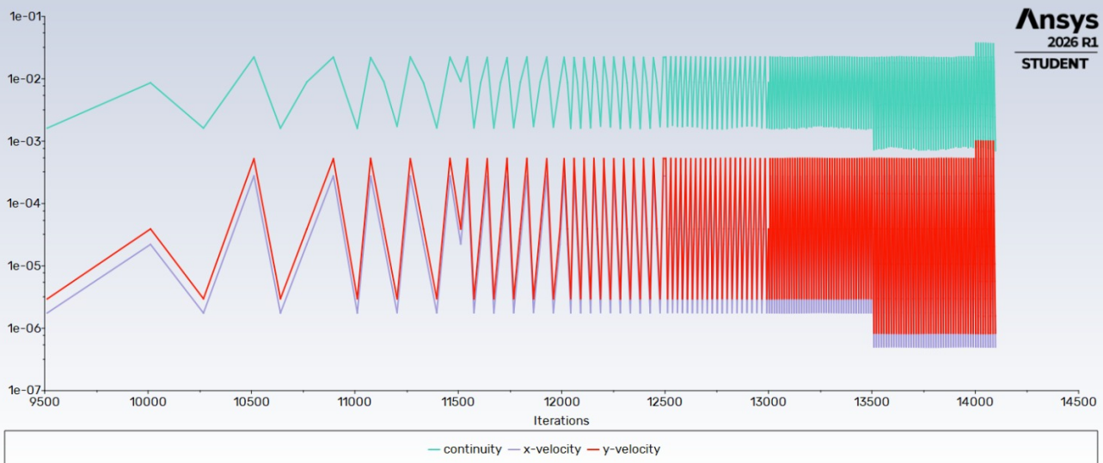
Figure 10. Scaled residuals, Re = 100. The residuals oscillate within each time step, which is normal for a transient run.

3.3 Comparison With Textbook Values
Re | Cd (this study) | Cd (textbook, approx.) | St (this study) | St (reference)
40 | about 1.6 | 1.5 to 1.6 | not applicable | not applicable
100 | 1.3 to 1.4 | 1.3 to 1.4 | about 0.17 | about 0.16 to 0.17
Table 3. Summary of results. Cd values were read from the report plots and should be checked against the final console output.
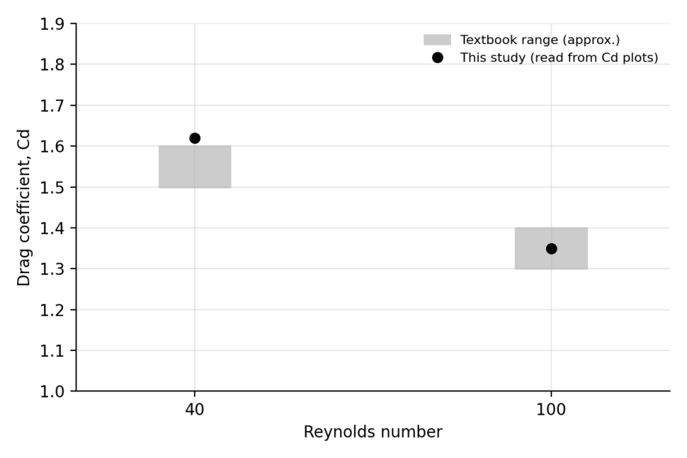
Figure 11. Drag coefficient against Reynolds number. The grey bands are approximate textbook ranges.

4. Discussion

4.1 Drag Coefficient
At Re = 40 my Cd of about 1.6 sits at the top edge of the textbook range, or just above it. I think two things push it up. The first is blockage: with only 5% of the domain height taken by the cylinder, the flow around it is squeezed slightly, and blockage always pushes Cd up. The second is the mesh, which has no refinement near the wall where most of the drag is generated. At Re = 100 the result falls inside the expected range. Cd dropping from about 1.6 to about 1.35 as Re goes from 40 to 100 matches the textbook trend, since the pressure drag share changes as the wake structure changes.

4.2 Why the Wake Changes Between the Two Cases
The steady wake at Re = 40 and the shedding wake at Re = 100 sit on either side of the critical Reynolds number, which is a little under 50 for a cylinder. Below it the wake is stable and any disturbance dies out. Above it the symmetric wake becomes unstable and starts to oscillate. Re = 100 is only about twice the critical value, so the instability grows slowly out of numerical noise. That is exactly what I saw in the first transient run, where lift only reached a few hundredths in 6000 s. The perturbation simply got it there sooner.

4.3 Relevance to Underwater Bodies
Real underwater vehicles run at Reynolds numbers many orders of magnitude higher than these, so this study does not predict their drag. What it does give me is a checked workflow: geometry, boundary conditions, force coefficients and wake diagnostics, all reproducing known behaviour on a case where I know the answer. That is the point of doing a benchmark first.

5. Limitations
- The mesh uses a single global size of 0.007 m. There is no inflation, no wake refinement, and no mesh independence study, so I cannot say how much of the small Cd overshoot at Re = 40 is down to the mesh.
- Only two Reynolds numbers were run, so the Cd versus Re comparison is two points, not a curve. Re = 1000 was left out for time. A 2D laminar run at that Reynolds number would also not be physically reliable, because the real wake there is three-dimensional.
- The Cd and St values come from reading the plots. The mean over the last several shedding cycles should be taken from exported report data.
- The perturbation used to trigger shedding at Re = 100 leaves a spike in the Cd and Cl histories. Averages were taken after the flow had settled again.
- Blockage of 5% is acceptable but not negligible, and likely nudges Cd slightly high.

6. Conclusion
A 2D laminar simulation of water flowing past a circular cylinder was run in ANSYS Fluent at Re = 40 and Re = 100. At Re = 40 the flow stayed steady and symmetric, with Cd of about 1.6, close to the textbook range of 1.5 to 1.6. At Re = 100 the wake shed vortices, lift oscillated with an amplitude of about 0.3, the Strouhal number came out near 0.17, and Cd was between 1.3 and 1.4, all consistent with published values. The mesh is coarse and the study is limited to two cases, but the results are consistent with textbook behaviour, and the setup is a reasonable starting point for the hull and appendage studies I want to do next.

References
White, F. M., Fluid Mechanics. McGraw-Hill. (Drag coefficient of a circular cylinder against Reynolds number.)
Schlichting, H. and Gersten, K., Boundary-Layer Theory. Springer.
Tritton, D. J. (1959). Experiments on the flow past a circular cylinder at low Reynolds numbers. Journal of Fluid Mechanics, 6, 547-567.
Williamson, C. H. K. (1996). Vortex dynamics in the cylinder wake. Annual Review of Fluid Mechanics, 28, 477-539.

