Levelised Cost of Green Hydrogen in India
A Python cost model and a comparison with National Green Hydrogen Mission cost goals
Pratyush Dash, B.Tech Chemical Engineering, KIIT University, Bhubaneswar. October 2026

1. Introduction
The National Green Hydrogen Mission aims for 5 million tonnes of green hydrogen a year by 2030, supported by roughly 125 GW of new renewable capacity. That is a volume target. Whether refineries and fertiliser plants actually buy the hydrogen depends on what a kilogram costs, and on that point the public numbers are all over the place. The MNRE minister has talked about getting down to ₹100/kg, some analysts say ₹200 or more is more realistic, and recent refinery tenders have been awarded somewhere between ₹280 and ₹400/kg.
I wanted to see how these figures fit together, so I wrote a levelised cost of hydrogen (LCOH) calculator in Python. It takes four main inputs, electrolyser capex, electricity tariff, capacity factor and stack efficiency, along with the usual financing and operating assumptions. I used it to run sensitivity plots, build three cost scenarios, and then compared the output with the cost figures people have put forward for India. With the inputs I settled on, today's cost comes out at about ₹334/kg. A 2030 case gives ₹213/kg and an optimistic case gives ₹153/kg. None of them reach ₹100/kg, and only the optimistic one drops below the grey hydrogen reference of ₹180/kg.

2. Method
The model is a plain discounted-cost calculation. Capital cost is spread over the project life with a capital recovery factor (CRF), fixed O&M and stack replacement are added, and the sum is divided by the hydrogen produced in a year. Electricity, water and any other per-kilogram costs are then added on top.
CRF = r(1+r)^n / ((1+r)^n − 1)
kWh per kg = 33.33 / (η × (1 − d))
LCOH = (CRF × capex + O&M + stack replacement) / annual kg + tariff × kWh per kg + water + other
Here r is the discount rate, n the project life, η the system efficiency on a lower heating value (LHV) basis, and d the average efficiency loss from degradation. Annual output per kW is 8,760 hours times the capacity factor, divided by the kWh needed per kg. Stack replacement is treated as a share of capex multiplied by the operating hours per year and divided by the stack life in hours, which spreads the cost evenly rather than putting it in a single year. This is a simplification, and I come back to it in the limitations section.
The code is split into a model file (lcoh/model.py), a script that produces the plots (sensitivity.py), a benchmark script (validate.py) and a small test file. One test checks the code against a hand calculation I did separately, and two others check that cost goes up with tariff and down with capacity factor.

3. Inputs and sources
I used public data wherever I could find a usable number. Table 1 lists the three cases. A few inputs are my own assumptions and I have marked them as such, because I would rather be clear about that than pretend every cell has a citation behind it.
Parameter | Today | 2030 | Optimistic | Basis
Capex (₹/kW) | 65,000 | 43,500 | 30,450 | IMARC alkaline range USD 500 to 1,000/kW, midpoint at ₹87/USD. 2030 and optimistic use the low end of that range and CEEW's bottom-up manufacturing cost (USD 350/kW)
Tariff (₹/kWh) | 3.25 | 2.5 | 2.0 | Midpoint of IMARC solar (2.5 to 3.5) and wind (3 to 4) bids. Lower cases follow CRISIL's point that RE needs to fall below ₹2
Capacity factor | 0.45 | 0.60 | 0.60 | Hybrid RE without storage (my assumption). 0.60 follows CSEP's finding on oversized wind and solar
Efficiency (LHV) | 0.62 | 0.64 | 0.66 | Calibrated to about 56.6 kWh/kg with degradation, against the SIGHT electrolyser limit of 56 kWh/kg
Discount rate | 10% | 10% | 8% | My assumption. I could not find a citable WACC
Life, O&M, stack, water | 20 yr, 2.5%, 30% at 70,000 h, ₹1/kg | same | same | My assumptions. Degradation set to 5% on average
Table 1. Model inputs for the three cases. Sources are listed in data/sources.csv.
For the policy comparison I collected four cost reference points, shown in Table 2. They are not all the same kind of number. The ₹100 figure is a stated aim, the ₹130 figure is the Mission's expected 2030 cost converted from USD 1.5/kg, the ₹279 figure is an actual tender result, and the ₹180 figure is a grey hydrogen estimate from 2022, when gas prices were high.
Reference | ₹/kg | Source
MNRE minister's goal | 100 | Statement reported by Energetica India
NGHM 2030 expectation | 130 | GH2 Country Portal, USD 1.5/kg at ₹87/USD
Numaligarh tender, Feb 2026 | 279 | S&P Global, excluding taxes
Grey hydrogen, India | 180 | KPMG via pv magazine India, midpoint of ₹160 to 200
Table 2. Cost reference points used in the plots.

4. Validation against a published study
Checking a model against its own assumptions proves nothing, so I tried to reproduce a published result. I picked the CSEP technical paper by Tongia and Patel (2024) because it lists its inputs. Their 2030 scenario uses an electrolyser at USD 600/kW (₹57,000/kW at ₹95/USD), 71% LHV efficiency, O&M of 1.5% of capex, and blended electricity at ₹2.92/kWh with a capacity factor above 60%. The paper's modelled cost is ₹209/kg. I put those inputs into benchmark.csv, switched off stack replacement and degradation because the paper does not include them, and used 0.9 ₹/kg for water.
The model gives ₹203.2/kg, which is 2.8% below the published figure. There is a catch. The paper does not state its discount rate or project life, so I used my own 10% and 20 years instead of tuning them to match. Changing the discount rate moves the result to ₹195.5/kg at 8% (−6.4%) and ₹211.3/kg at 12% (+1.1%). So the fair way to put it is that the model lands within about 3% at a 10% discount rate and within about 6% across the 8 to 12% range. This test checks that the equations are right. It says nothing about whether my base case inputs are right, since the paper describes an optimistic 2030 scenario and not today's costs.

5. Results

5.1 Cost breakdown
In the base case, electricity accounts for ₹184/kg, which is 55% of the ₹334 total. Capital cost adds ₹110/kg (33%), fixed O&M ₹23/kg (7%), stack replacement ₹16/kg (5%) and water about ₹1/kg. NITI Aayog and IEEFA put the renewable power share at 60 to 70%, so my 55% is a little low. That probably comes from my capex being on the high side, or from the tariff being on the low side, and I would not read much more into it than that.
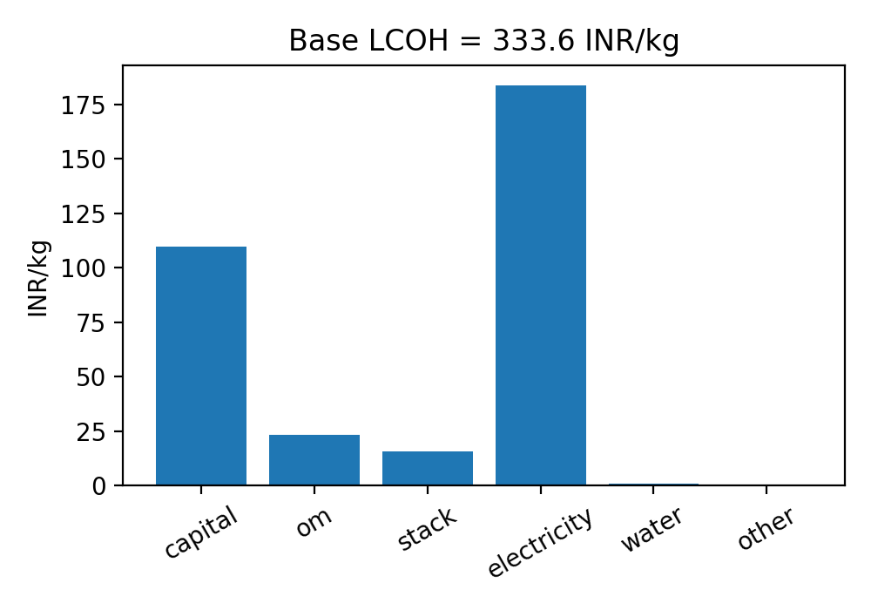  Figure 1. Base case cost breakdown, ₹/kg. | 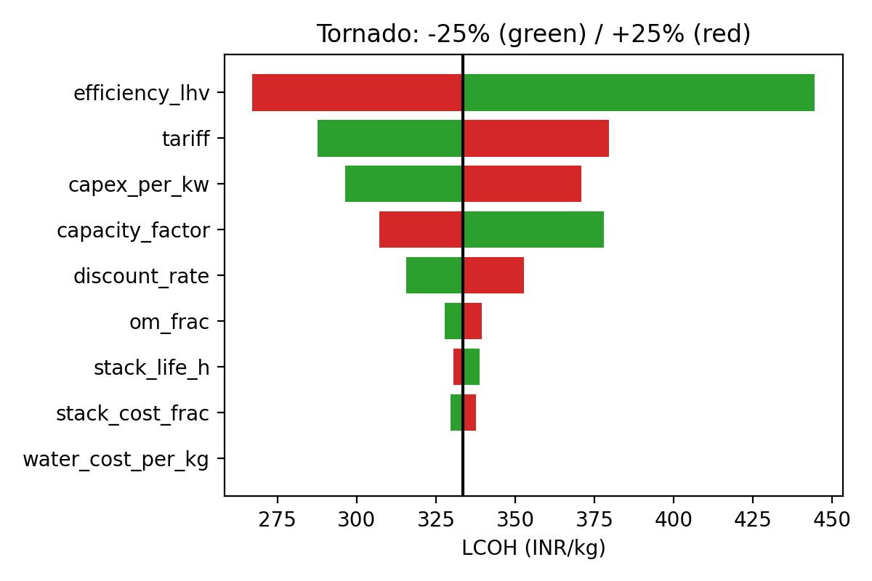  Figure 2. One-at-a-time sensitivity, each input changed by ±25%.

5.2 Sensitivity
Figure 2 shows the effect of moving each input by 25% in both directions. Efficiency has the widest bar, with cost running from ₹267 to ₹445/kg, but that is partly an artefact of the method. A 25% improvement on 0.62 means an efficiency of 0.775, which no commercial system offers, so the real room for improvement is smaller than the bar suggests. Tariff comes next (₹288 to ₹380), followed by capex (₹296 to ₹371) and capacity factor (₹307 to ₹378). The discount rate matters too, giving ₹316 to ₹353. O&M, stack cost and stack life each move the answer by less than ₹10, and water is invisible.
The two heat maps show how pairs of inputs interact. In Figure 3, the line for the ₹279 tender price crosses the base capex of ₹65,000/kW at a tariff of about ₹2.3/kWh. The grey hydrogen line at ₹180 only shows up in the bottom left corner, where capex is below about ₹41,000/kW and power is under ₹2.2/kWh. Figure 4 makes the utilisation point. At a ₹3/kWh tariff the plant needs to run at a capacity factor of roughly 0.7 to match the tender price, and at the base 0.45 it only gets there if power drops to about ₹2.3/kWh or less.
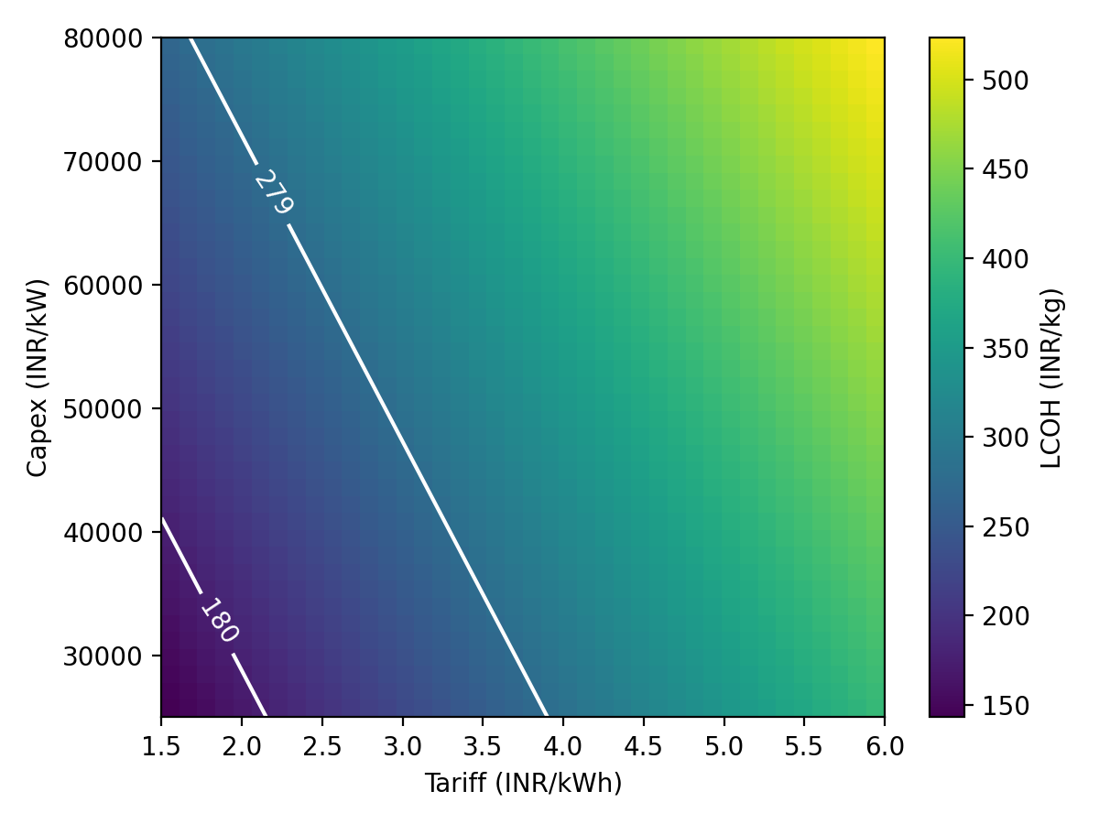  Figure 3. LCOH as a function of tariff and capex. | 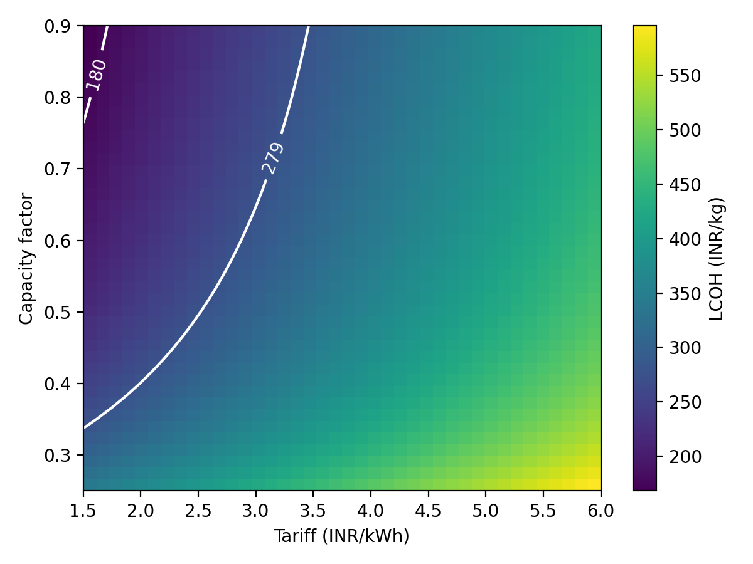  Figure 4. LCOH as a function of tariff and capacity factor.

5.3 Scenarios against the targets
Figure 5 puts the three cases next to the reference lines. The 2030 case comes out at ₹213/kg, with ₹137 of that being electricity. It beats the Numaligarh tender price but stays above grey hydrogen. The optimistic case reaches ₹153/kg. It clears the grey hydrogen line, though it still sits above both the ₹130 and ₹100 goals. One detail stands out. Electricity alone costs ₹106/kg in the optimistic case, so the ₹100 aim cannot be met with these inputs no matter how cheap the rest of the plant gets.

5.4 Break-even tariffs
Figure 6 turns the question around and asks what tariff is needed to hit each target at a given capex, with the other inputs at their base values. For the ₹279 level, the tariff has to be about ₹2.3/kWh at today's capex and about ₹3.7 at ₹30,450/kW. For ₹100/kg the lines go below zero once capex passes roughly ₹43,000/kW, which means the target cannot be reached even with free electricity at that capex. If I also use the optimistic efficiency, capacity factor and discount rate together with ₹30,450/kW, the tariff needed is about ₹1.56/kWh for ₹130/kg and ₹1.00/kWh for ₹100/kg.
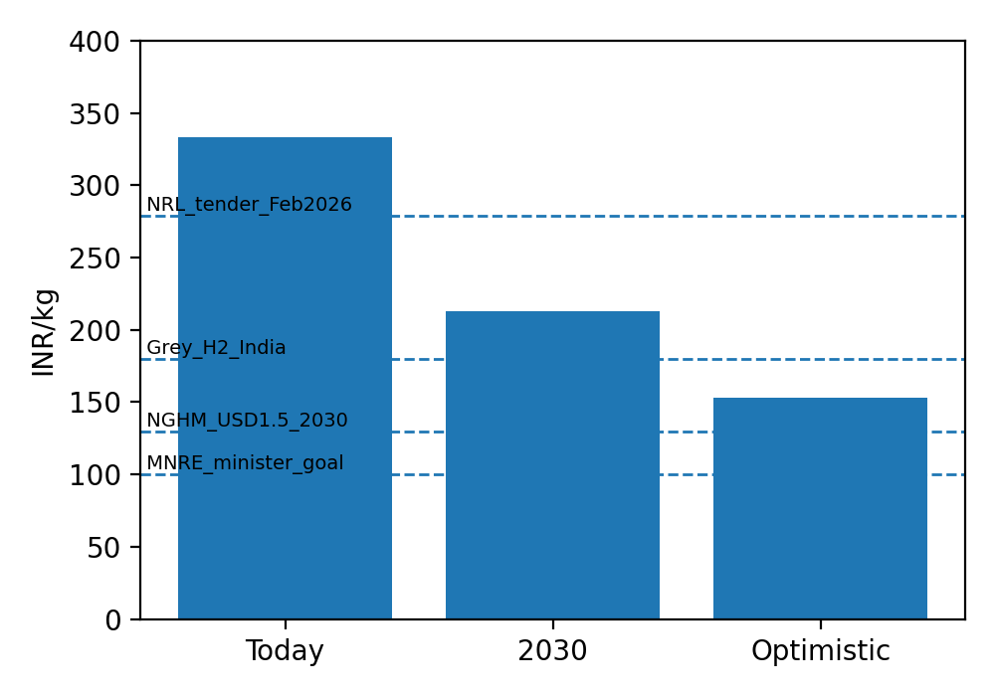  Figure 5. LCOH for the three cases against the reference lines. | 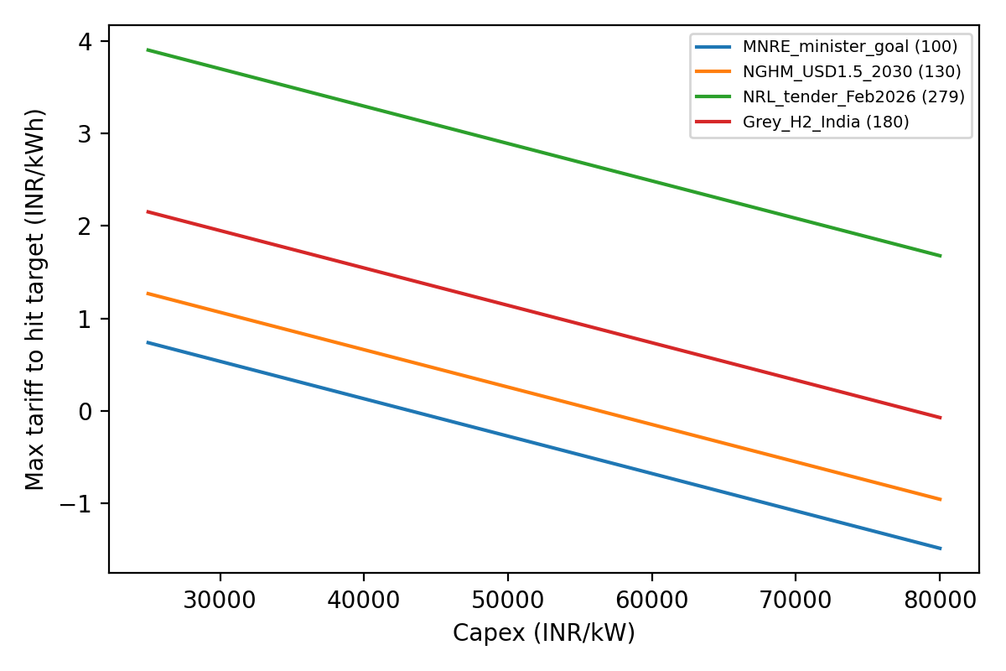  Figure 6. Maximum tariff that meets each target, by capex.

6. Discussion
The most useful thing the model shows is how much of the problem sits outside the electrolyser. Capex gets most of the attention, and bringing it down from ₹65,000 to ₹43,500/kW does take about ₹49/kg off the cost. But dropping the tariff from ₹3.25 to ₹2.5 takes off about ₹42/kg on its own, and raising the capacity factor from 0.45 to 0.60 takes off about ₹33/kg. These gains stack, but each one shrinks as the others improve, which is why the 2030 case ends up at ₹213 and not at some much lower number.
This has a few implications for the Mission's incentives. The ISTS charge waiver and cheaper power go directly at the biggest cost item, and the SIGHT production incentives of ₹50, ₹40 and ₹30/kg over three years (for the hydrogen tender mode) help bridge the gap in the early years. Electrolyser manufacturing support addresses capex, which matters but accounts for a third of the cost at most. The model also points to financing. Going from a 10% to an 8% discount rate is worth about ₹15/kg in the base case, and the tornado plot suggests it matters more than most of the technical details. Cheaper capital for projects in India is probably not discussed as often as it should be.
Tender prices have to be read carefully when set against my numbers. Bids are made with incentives, tax treatment and the bidder's own assumptions about power and utilisation built in, so they are not directly comparable to an unsubsidised LCOH. The fact that my 2030 case lands near the tender range is encouraging, but I would not claim it as confirmation. The conclusion that ₹100/kg looks out of reach by 2030 matches the CSEP paper, which called the USD 1/kg target unlikely for India.

7. Limitations
The model is a single-site, flat-price calculation. It has no inflation, no taxes or GST, and a fixed exchange rate of ₹87/USD. The tariff is a single number, so it does not capture the extra cost of oversizing renewable plants to raise utilisation, beyond what is already in the capacity factor and tariff I chose. Compression, storage and transport are set to zero, which makes the figures production costs rather than delivered costs. Stack replacement is smoothed over the years instead of being placed at the actual replacement date, and efficiency degradation is a single average. The discount rate, project life and most O&M values are assumptions without a citation, and the capex midpoint relies on a secondary source. The sensitivity analysis changes one input at a time, so it ignores the fact that some inputs move together in practice, such as capex and efficiency. Each of these could shift the absolute numbers, though I expect the ranking of inputs in the tornado plot to hold up.

8. Conclusion
The model gives about ₹334/kg for green hydrogen in India today, ₹213/kg for a 2030 case and ₹153/kg for an optimistic case, and it reproduces a published 2030 estimate to within about 3% at a 10% discount rate. Electricity cost and electrolyser utilisation matter most, followed by capex and financing. Reaching ₹100/kg would take power below about ₹1/kWh together with low capex and high utilisation, which is a lot to ask. A cost near grey hydrogen looks more achievable, and that is probably the realistic way to read the Mission's cost ambitions. The next step I would take is to add oversizing and storage costs for the renewable plant explicitly and test a few specific sites.

References
[1] Tongia, R. and Patel, U. (2024). Benchmarking Green Hydrogen in India's Energy Transition. CSEP Technical Paper 4. csep.org/wp-content/uploads/2024/10/Benchmarking-Green-Hydrogen-in-Indias-Energy-Transition.pdf
[2] IEEFA and JMK Research (2024). India's $2.1bn Leap Towards its Green Hydrogen Vision. ieefa.org/resources/indias-21bn-leap-towards-its-green-hydrogen-vision
[3] S&P Global (February 2026). India's Numaligarh hydrogen tender ends at record low Rupees 279/kg. spglobal.com, article 021226
[4] Energetica India. The cost of green hydrogen needs to be reduced to INR 100/kg from INR 300-400/kg: MNRE Minister. energetica-india.net
[5] GH2 Country Portal, India. gh2.org/countries/india
[6] pv magazine India (March 2022). National hydrogen policy: half a step forward (KPMG estimates). pv-magazine-india.com
[7] IMARC Engineering (July 2026). How to set up a green hydrogen production plant in India. imarcengineering.com
[8] CEEW. Electrolyser manufacturing cost study for India. ceew.in/node/4036
[9] CRISIL Ratings (March 2023). Cost reduction critical for spirited adoption of green hydrogen. crisilratings.com
[10] SECI, National Green Hydrogen Mission page. seci.co.in/nghm

