Neutronics Analysis of a Simplified Thermal Reactor Using OpenMC
A Python-Based Monte Carlo Pin-Cell Study — Multiplication Factor, Flux Spectrum, and Moderator Density Coefficient
Pratyush Dash | B.Tech Chemical Engineering, KIIT University, Bhubaneswar

1. Introduction
This report documents a small reactor-physics project I built using OpenMC, a Monte Carlo neutron transport code, to model a single fuel pin from a pressurized water reactor (PWR) and pull out three quantities that matter in real reactor physics work: the neutron multiplication factor (k-eff), the neutron flux spectrum split by region and energy, and the moderator density coefficient of reactivity. Unlike a CFD study, there's no meshing or solver GUI involved here, the entire model, from geometry to materials to the statistical tallies, is defined in Python scripts and handed to OpenMC's C++ transport engine to run.
The pin-cell is the smallest repeating unit of a light-water reactor core that still behaves like the reactor it's part of, in the sense that it captures neutron moderation, absorption, and fission all in one self-contained geometry. That's why it's the standard entry point into computational reactor physics — both in coursework and in real lattice-code benchmarking — and why I picked it as a second computational project to sit alongside CFD work: same idea of build a model, run a solver, validate the output against what theory says should happen, just applied to neutron transport instead of fluid flow.
Three things were the actual point of running this: getting a k-eff that's physically sensible for the model as built (not necessarily close to 1.0 — more on that below), getting a flux spectrum that shows the expected fast-to-thermal moderation behaviour, and getting the sign of the moderator coefficient right, since that number is directly tied to why light-water reactors are considered inherently safe against certain accident scenarios.

2. Model Description

2.1 Geometry
The model is one fuel pin on a square lattice pitch, with reflective boundaries on all four sides. Reflective boundaries are OpenMC's way of saying: any neutron that would cross out of this cell into a neighbouring pin instead bounces straight back in. That's the standard trick for approximating an infinite, uniform lattice using just one unit cell, and it's why this model doesn't need sixteen other pins sitting around it to behave correctly.
Radially, the pin is three regions: a solid UO2 fuel pellet at the centre, a thin annular gap (left as void in the model — this stands in for the helium fill gas in a real rod, which barely interacts with neutrons anyway), and a Zircaloy-4 cladding tube around that. Everything outside the cladding, out to the edge of the square unit cell, is moderator.

Table 1. Pin-cell geometry parameters.
Parameter | Value
Fuel pellet radius | 0.4095 cm
Clad inner radius | 0.418 cm
Clad outer radius | 0.475 cm
Pin pitch (square lattice) | 1.26 cm
These numbers match a standard 17×17 PWR fuel assembly pin cell. I didn't derive them from scratch — there wasn't a reason to, since the goal here was a representative thermal-reactor pin cell rather than a specific licensed design.

2.2 Materials
- Fuel: UO2 enriched to 3.2 w/o U-235, density 10.4 g/cm3 — a fairly ordinary fresh-fuel PWR enrichment.
- Cladding: Zircaloy-4 (mostly Zr, with small amounts of Sn, Fe and Cr mixed in), density 6.56 g/cm3.
- Moderator: light water with 700 ppm of natural boron dissolved in it, which mimics the chemical shim real PWRs use for reactivity control. Density was swept from 0.60 to 0.90 g/cm3 for the study in Section 4.3, with 0.74 g/cm3 taken as the nominal hot-operating base case everywhere else.
One detail that's easy to miss but actually matters: the moderator has the thermal scattering law for hydrogen bound in water attached to it (S(α,β), ENDF/B-VII.1's c_H_in_H2O). Without it, OpenMC would treat the hydrogen as a free gas, which gets the high-energy physics right but doesn't correctly describe how neutrons lose their last bit of energy once they're bouncing around near thermal speeds inside actual water molecules.

3. Implementation
The whole project is three Python scripts, each doing one job, meant to be run in sequence:
pin_cell_model.py -> builds materials, geometry, settings and tallies; runs the base-case criticality calculation
analyze_results.py -> reads the statepoint file, prints k-eff, plots the flux spectrum
moderator_sweep.py -> reruns the model at nine moderator densities and fits k-eff vs. density
pin_cell_model.py sets up the geometry and materials described in Section 2 using OpenMC's Python API (openmc.Material, openmc.ZCylinder, openmc.Cell, and so on), then defines the run settings — 10,000 particles per batch, 150 batches total, with the first 30 discarded as inactive so the fission source has time to settle into its converged spatial shape before any tallying starts. It also sets up an energy-binned flux tally, scored separately in the fuel, clad, and moderator cells, using 50 logarithmically spaced bins from 10⁻⁵ eV up to 2×10⁷ eV — wide enough to cover everything from a nearly-frozen thermal neutron to the high end of the fission spectrum.
analyze_results.py is the post-processing half: it opens the statepoint HDF5 file OpenMC writes out, pulls the k-eff value and its uncertainty straight from it, grabs the flux tally as a pandas dataframe, and converts the raw per-bin flux into flux-per-unit-lethargy before plotting — that conversion is what makes the fast, epithermal, and thermal parts of the spectrum all visually comparable on one log-log plot instead of the fast peak swallowing everything else.
moderator_sweep.py is the least glamorous but most computationally expensive script — it rebuilds the entire model from scratch nine times, once per moderator density, each time in its own subdirectory so the XML files OpenMC writes don't overwrite each other between runs. I dropped the particle count to 5,000 per batch for this one purely to keep the total sweep runtime reasonable; running all nine at the full 10,000-particle setting would have taken a lot longer for not much statistical benefit at this stage.

4. Results

4.1 Multiplication Factor
The base-case run (moderator density 0.74 g/cm3) gave a combined k-eff of 1.30949 ± 0.00083.
That's well above 1.0, and I want to be upfront that this is expected, not a mistake — Section 5.1 explains why.

4.2 Neutron Flux Spectrum
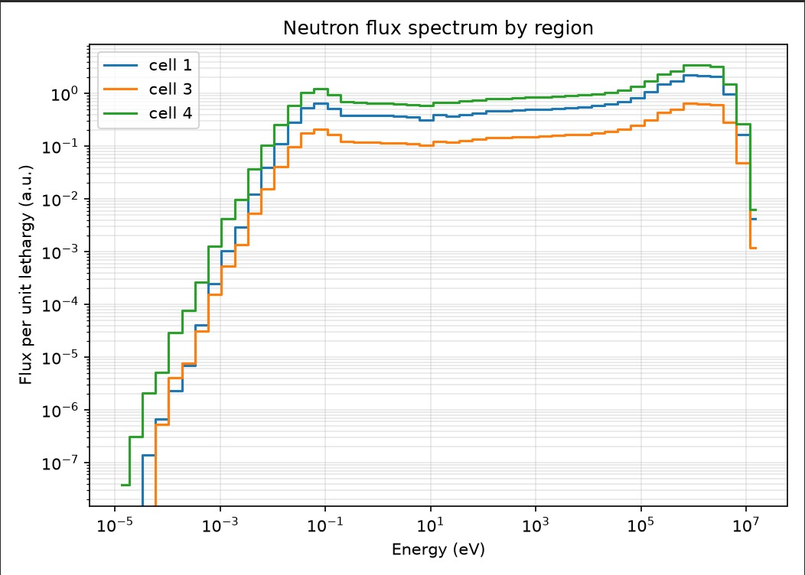
Figure 1. Neutron flux per unit lethargy, tallied separately in the fuel (cell 1), cladding (cell 3), and moderator (cell 4).
The shape is exactly what a thermal reactor's spectrum is supposed to look like: a fast peak somewhere between 10⁵ and 10⁷ eV, straight from fission, a long dip through the slowing-down region where neutrons are shedding energy through elastic collisions with the moderator, and a thermal peak below roughly 1 eV where they've settled into equilibrium with the water's thermal motion. The moderator curve (cell 4) sits above the fuel and cladding curves for almost the whole thermal and epithermal range, which makes sense — thermalisation happens through hydrogen collisions in the water, not inside solid fuel or metal cladding.
The part actually worth stopping on is the gap between the fuel curve (cell 1) and the moderator curve (cell 4) through that same thermal/epithermal stretch — the fuel sits noticeably lower. That's neutron self-shielding: right around the big U-238 absorption resonances, the outer skin of the fuel pellet soaks up incoming neutrons before they can get any deeper, so the flux averaged across the whole fuel region ends up lower than it would be in some idealised, infinitely thin fuel. It's a real effect, not a plotting quirk, and it's exactly the sort of thing full lattice-physics codes spend a lot of their computational budget getting right.

4.3 Moderator Density Coefficient
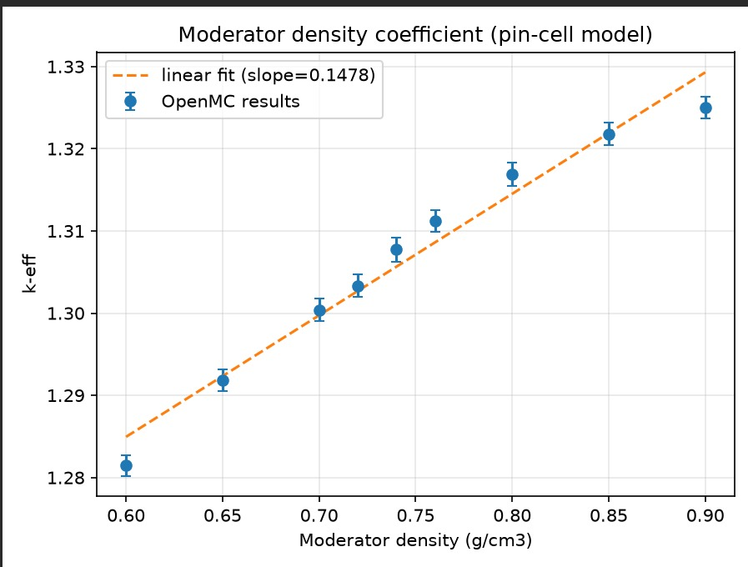
Figure 2. k-eff versus moderator density, swept from 0.60 to 0.90 g/cm3 at fixed enrichment, pitch, and boron concentration.
Table 2. k-eff as a function of moderator density.
Moderator density (g/cm3) | k-eff | Std. dev.
0.60 | 1.28145 | 0.00127
0.65 | 1.29183 | 0.00135
0.70 | 1.30040 | 0.00133
0.72 | 1.30335 | 0.00139
0.74 | 1.30772 | 0.00145
0.76 | 1.31122 | 0.00132
0.80 | 1.31689 | 0.00144
0.85 | 1.32180 | 0.00139
0.90 | 1.32505 | 0.00132
Fitting a straight line through the nine points gives a slope of +0.1478 per g/cm3 — k-eff climbs as moderator density climbs. Worth flagging honestly rather than glossing over: the sweep's k-eff at 0.74 g/cm3 came out to 1.30772, not quite matching the 1.30949 from the base-case run at the same density in Section 4.1. That's not a bug — it's the particle-count difference (5,000 per batch in the sweep versus 10,000 in the base case) showing up as ordinary Monte Carlo statistical scatter. The two values sit within about two standard deviations of each other, which is fine.

5. Discussion

5.1 Why k-eff Lands Well Above 1.0
A reflective-boundary pin-cell has zero neutron leakage by construction — nothing escapes the lattice, because anything that tries to gets reflected straight back in. So what this model is actually computing is k-infinity for fresh, 3.2%-enriched fuel, not the k-effective you'd measure in a real, finite reactor core. An actual PWR core sits at k-eff ≈ 1.0 through a mix of neutron leakage at the core's physical edge, burnable poisons, and boron dissolved in the coolant — none of which exist in, or are needed by, an idealised infinite lattice. A k-infinity around 1.3 for fresh, moderately enriched fuel is completely normal — this is, more or less, the number this style of model is meant to produce.

5.2 What the Moderator Coefficient Means for Safety
The positive slope from Section 4.3 means that if the coolant lost density for any reason — boiling, voiding, or just heating up and expanding — k-eff would drop. Put the other way, this pin-cell has a negative moderator density coefficient, sometimes called a negative void coefficient in casual usage. That's the direction you want: a reactor that loses reactivity when its coolant heats up or voids is self-correcting rather than self-accelerating, and this is a big part of why light-water reactors are considered passively safe against that particular failure mode. If the slope had come out negative instead — losing coolant density pushing k-eff up — that would have been the result worth raising a flag over. It isn't what happened here.

6. Limitations and Future Work
A few things this model doesn't do, worth being upfront about rather than discovering later: it's one infinite pin-cell, not a fuel assembly or a full core, so it has nothing to say about neutron leakage at a real core boundary, spatial power peaking across an assembly, or control-rod worth. The fuel is fresh — zero burnup, no Xe-135 buildup, no depletion of U-235 over time — so this can't speak to how k-eff would fall across an actual operating cycle. The pellet-clad gap is void rather than helium gas, which is fine for the neutronics here (it barely matters) but would need fixing if this were ever coupled to a thermal-hydraulics model. I also didn't run a formal source-convergence diagnostic — something like tracking Shannon entropy of the fission source across the inactive batches — beyond trusting the default settings; the uncertainties quoted throughout are the plain Monte Carlo statistical uncertainty OpenMC reports, not a full uncertainty budget.
If I picked this back up, the next thing I'd try is sweeping enrichment or pin pitch the same way the moderator density was swept here, or hooking in OpenMC's depletion module to watch k-eff decline over a burnup cycle instead of only ever looking at fresh fuel.

7. Conclusion
A simplified thermal-reactor pin-cell — UO2 fuel, Zircaloy-4 cladding, borated water moderator, on a standard 1.26 cm PWR pitch — was built and run in OpenMC using three Python scripts covering model setup, post-processing, and a parameter sweep. The base case returned k-eff = 1.30949 ± 0.00083, which lines up with the k-infinity expected of fresh, moderately enriched fuel sitting in an infinite reflective lattice. The flux spectrum came out with the expected fast/thermal two-peak shape and a clearly visible fuel self-shielding effect through the thermal and epithermal range. A nine-point moderator density sweep gave a positive k-eff/density slope of 0.1478 per g/cm3, which corresponds to a negative — and safety-favourable — moderator density coefficient. Taken together, these three results cover the standard opening moves of a reactor-physics pin-cell study: get a sensible multiplication factor out of the model, check the flux spectrum looks the way theory says it should, and quantify at least one reactivity coefficient that actually matters for reactor safety.

