Partial Cavitation Over a Clark Y Hydrofoil
A CFD study in ANSYS Fluent 2026 R1 with the Schnerr-Sauer cavitation model
Pratyush Dash | B.Tech Chemical Engineering, KIIT University, Bhubaneswar

1. Objective
I wanted to get a cavitating flow working in Fluent, starting from the simplest geometry I could think of: a 2D hydrofoil. The reason I care is supercavitation. Underwater vehicles that use it depend on a vapour cavity that grows as the pressure around the body drops, and partial cavitation on a foil is a good place to watch that start.
I used a Clark Y section at 8 degrees angle of attack and kept the speed fixed. Then I lowered the cavitation number in steps to see when vapour shows up and how far along the surface it reaches.
Four things were looked at: the pressure coefficient along the foil, lift and drag, the total vapour volume in the domain, and wall y+. A flat stretch in the Cp curve at a value close to minus sigma means vapour is sitting on the surface there, so that plot ended up being the main evidence. This is not a validation against an experiment. I explain what is missing in section 4.

2. Computational Setup

2.1 Geometry and flow conditions
The foil coordinates came from the UIUC airfoil database (clarky.dat). I scaled them to a 0.1 m chord, reformatted them as a coordinate file for DesignModeler, and built the foil as a surface. The water domain is a rectangle that runs from 5 chords upstream to 10 chords downstream of the foil, with 5 chords above and below. I cut the foil out of the rectangle with a Boolean subtract.
The foil stays flat in the mesh. The 8 degree angle of attack is set by tilting the inlet velocity instead, which kept the geometry and mesh much simpler.
Parameter | Value
Chord, c | 0.1 m
Angle of attack | 8°
Free-stream speed | 10 m/s
Inlet velocity (x, y) | 9.903 m/s, +1.392 m/s
Domain | x from −0.5 to 1.1 m, y from −0.5 to 0.5 m
Water at 25 °C | ρ = 997 kg/m³, μ = 8.9×10⁻⁴ Pa·s
Vapour pressure | 3169 Pa
Reynolds number (chord) | about 1.1×10⁶
Table 1. Geometry and flow conditions.

2.2 Mesh
The mesh was made in ANSYS Meshing with triangular elements. Five named selections were set up: inlet, outlet, top, bottom and foil. On the foil I used an edge sizing, plus an inflation layer with a first cell height of 2×10⁻⁶ m, 40 layers and a growth rate of 1.15. That first height comes from a flat-plate estimate for y+ near 1. A sphere of influence (radius 0.18 m, centred at x = 0.15 m) refines the cells around the foil and the first part of the wake. The final mesh has [add element count] elements.
After the first converged run, wall y+ on the foil was between roughly 0.1 and 1.0, with the highest value just over 1 at the leading edge. That is fine for a wall-resolved SST k-ω model.

2.3 Solver and cavitation model
I used the pressure-based solver in 2D planar mode, double precision, steady. Water is the primary phase and vapour the secondary phase in a mixture model. Mass transfer from liquid to vapour uses the Schnerr-Sauer model with a vaporization pressure of 3169 Pa and the default bubble number density of 1×10¹³. Turbulence is SST k-ω. Operating pressure was set to zero, so every pressure in the setup is an absolute value.
The inlet, top and bottom boundaries are velocity inlets with the tilted velocity from Table 1 (turbulence intensity 1 %, viscosity ratio 10, no vapour). The foil is a no-slip wall. The outlet is a pressure outlet, and its pressure is what sets the cavitation number. With ½ρU² = 49,850 Pa, the outlet pressure is 3169 Pa + σ × 49,850 Pa.
The three cases ran one after the other from the previous solution, without re-initialising: iterations 0 to 1000 at σ = 5, 1000 to 2500 at σ = 2.0, and 2500 to 4000 at σ = 1.6. After each step I checked the real σ with an area-weighted average of static pressure on the inlet, because the pressure level around the foil is not exactly the number typed at the outlet.
Target σ | Outlet pressure (Pa) | Inlet pressure measured (Pa) | σ reached
5.0 | 252,419 | 251,867 | about 5.0
2.0 | 102,869 | 102,505 | about 1.99
1.6 | 82,929 | 82,548 | about 1.59
Table 2. Pressure settings and the cavitation number actually reached.

3. Results

3.1 Baseline at σ = 5
At σ = 5 there is no lasting vapour. The vapour volume has a short spike at the very start of the run and then sits at zero, which I read as a start-up transient. The residuals dropped steadily and the force plots flattened out.
The Cp plot is the useful part. The suction side reaches a minimum of about −1.9 close to the leading edge. Since vapour should form once σ falls below the magnitude of that minimum, I expected nothing at σ = 3 or σ = 2.5 and the first signs of cavitation somewhere near σ = 1.9. That is why I skipped straight to σ = 2.0 and 1.6.
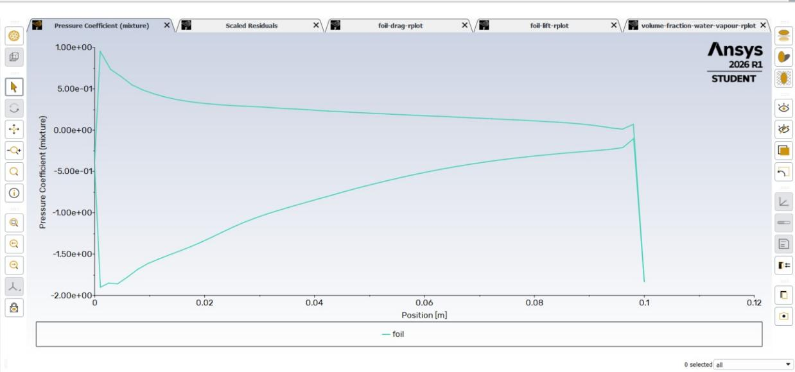
Figure 1. Pressure coefficient along the foil at σ = 5.
Lift at the end of this block was about 5,300 N per metre of depth (Cl of about 1.06) and drag about 270 N (Cd of about 0.054). The lift was still drifting down slowly when I moved on, so I would not treat these numbers as final.

3.2 σ = 2.0
The measured inlet pressure of 102,505 Pa corresponds to σ of about 1.99. Vapour starts to appear at around iteration 1080 and keeps growing slowly until the end of that block. The amount is small. Lift settled near 4,550 N (Cl about 0.91) and drag near 305 N (Cd about 0.061).
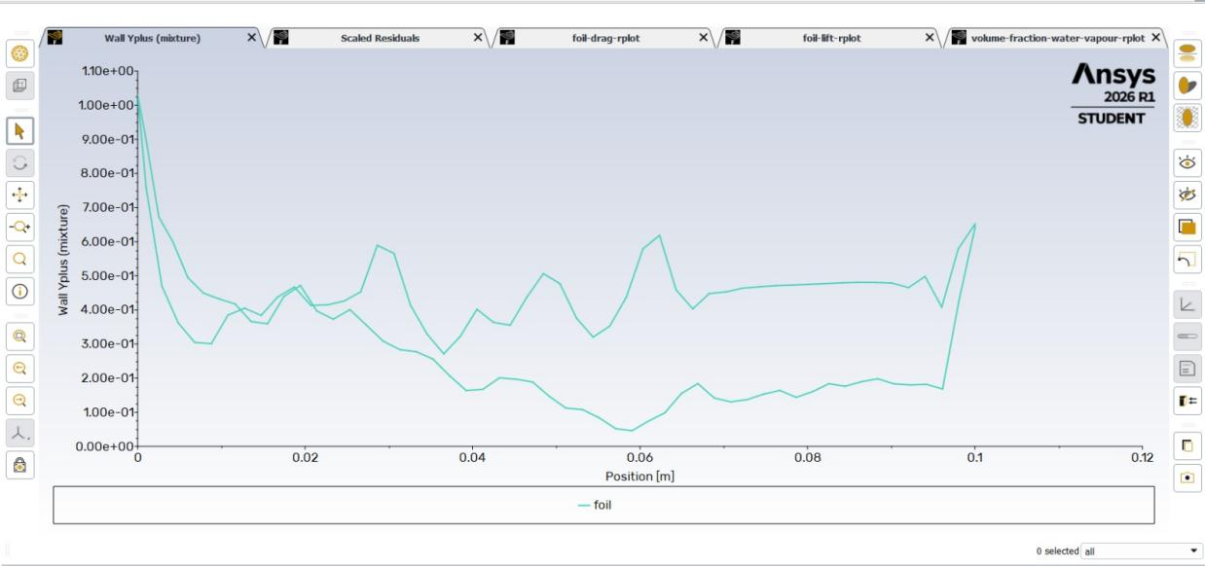
Figure 2. Wall y+ along the foil after the σ = 2.0 run.

3.3 σ = 1.6
The inlet pressure of 82,548 Pa gives σ of about 1.59. The Cp plot now has a flat section at roughly −1.6 along the suction side, from the leading edge to about x = 0.01 m. That puts the cavity length at about a tenth of the chord. The highest local vapour fraction in the domain was about 0.87. Lift was about 4,600 N (Cl about 0.92) and drag about 300 N (Cd about 0.06).
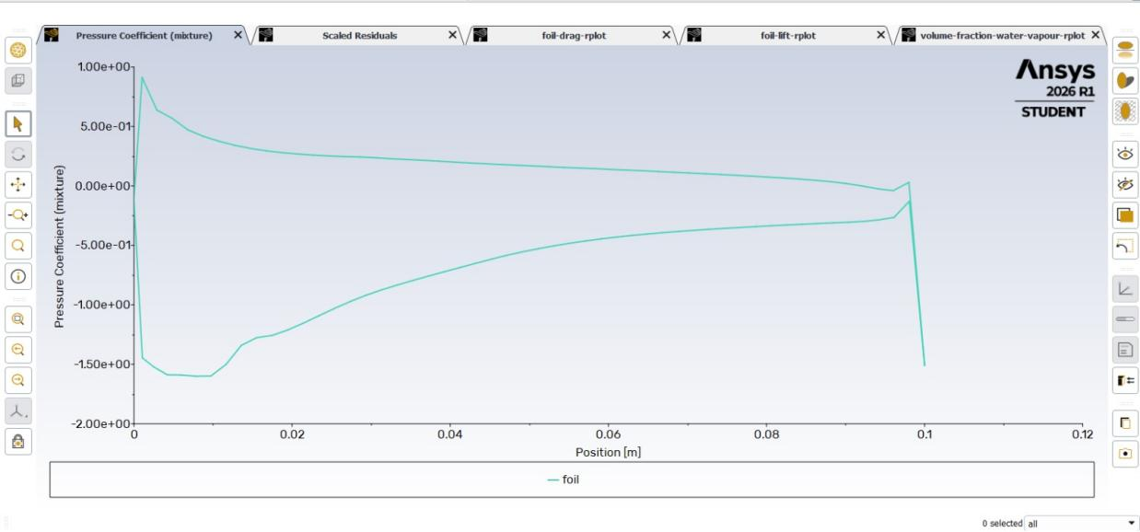
Figure 3. Pressure coefficient at σ = 1.6, with the flat section under the cavity.
The vapour volume was still going up at iteration 4000, even though lift and drag had levelled off. So the cavity was not fully settled when I stopped.
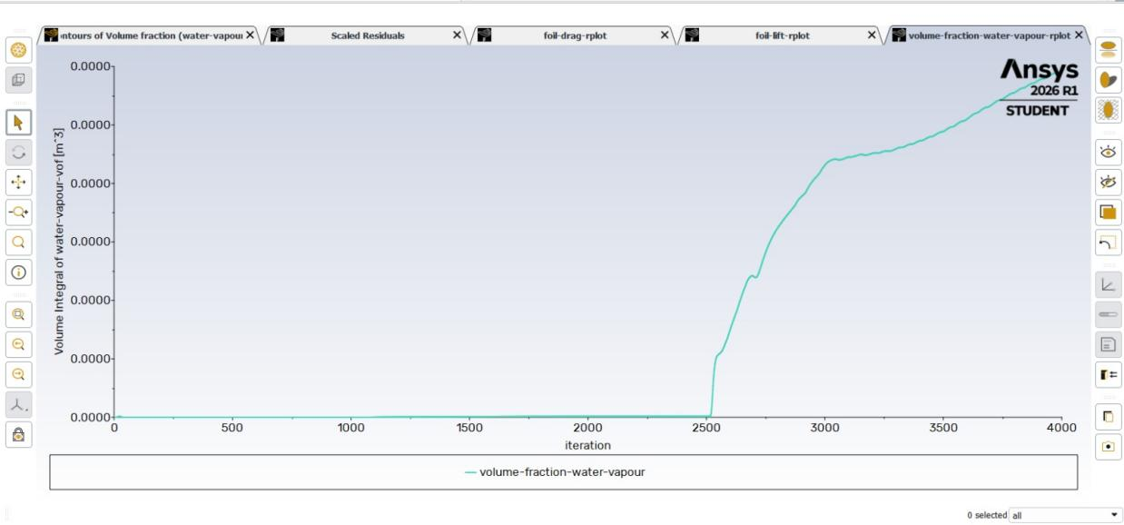
Figure 4. Total vapour volume over the full run. The jumps at iterations 1000 and 2500 are where σ was lowered.
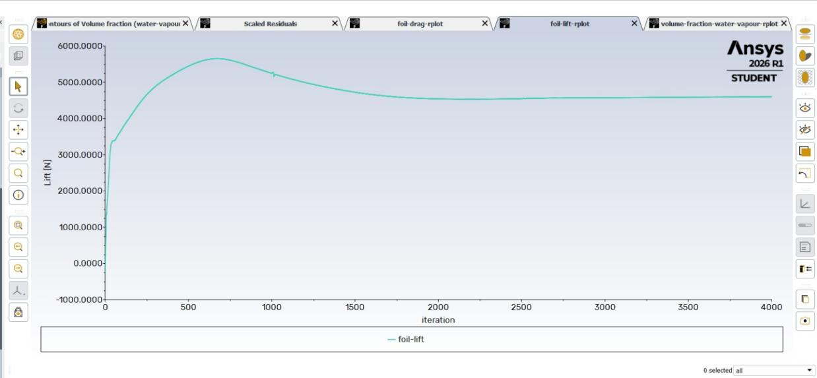
Figure 5. Lift history over the full run.
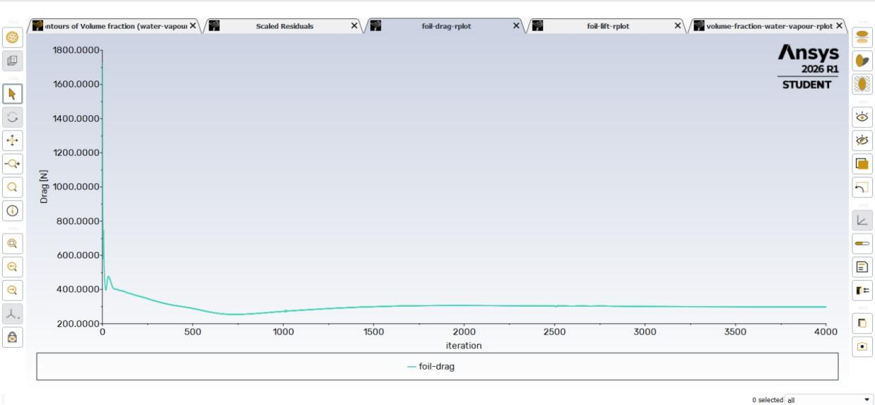
Figure 6. Drag history over the full run.
σ (target) | σ (reached) | Cl | Cd | Cavity
5.0 | about 5.0 | about 1.06* | about 0.054 | None
2.0 | about 1.99 | about 0.91 | about 0.061 | Just starting, very small
1.6 | about 1.59 | about 0.92 | about 0.060 | Thin sheet, L/c about 0.1
Table 3. Summary. Forces are per metre of depth, divided by ½ρU²c = 4,985 N/m, and were read off the plots by eye. *Not fully settled.

4. Discussion

4.1 Two things that went wrong first
My first run diverged at around iteration 620. The continuity residual shot up by many orders of magnitude, drag and lift went to absurd values, and the vapour fraction showed about 0.5 almost everywhere in the domain. At σ = 5 that cannot be physical. Lowering the Courant number and the relaxation factors gave a stable run.
The first stable run then gave a lift of around −3,000 N, which meant the foil was effectively at −8 degrees. I had the sign of the inlet y-velocity wrong. Flipping it to +1.392 m/s and correcting the lift and drag force vectors fixed it. I only caught this because the lift plot was negative, which is a good reason to look at the plots before trusting a converged residual.

4.2 Using Cp to predict where cavitation starts
The Cp minimum of about −1.9 at σ = 5 turned out to be a good predictor. Nothing worth reporting happens above σ of about 1.9, vapour begins at σ = 2.0 where the margin is thin, and a clear plateau at Cp near −σ shows up at 1.6. Inside a cavity the pressure is held at the vapour pressure, so Cp has to sit at −σ there. Seeing it in the plot is a better check than the vapour contour, which at full-domain scale just looks blue.

4.3 Limitations
- No mesh independence study. I planned three meshes of about 50k, 100k and 200k cells but ran only one, so the numbers are qualitative.
- No comparison with an experiment. I did not compare cavity length with a published Clark Y cavitation tunnel result. My only checks are internal: Cp close to −σ under the cavity, y+, and convergence.
- Only three cavitation numbers. I planned σ = 1.3, 1.0 and 0.8 as well but ran out of time. So there is no lift breakdown and no cloud shedding in these results.
- The cavity was still growing at the end of the σ = 1.6 run, and the baseline lift was still drifting. Cl at σ = 5 should not be compared directly with the other two.
- Drag looks high. A Cd of 0.055 to 0.06 is more than I would expect for a Clark Y at this Reynolds number, and I have not checked it against XFOIL. The blunt trailing edge may be part of the reason, but I have not tested that.
- I did not manage to save a zoomed-in vapour contour. Fluent froze when I tried, so there is no clear picture of the cavity shape.
- The bubble number density stayed at the default value and was not tuned.

5. Conclusion
I set up a cavitating Clark Y hydrofoil in Fluent with the Schnerr-Sauer model and ran it at three cavitation numbers. At σ of about 5 there was no vapour. At σ of about 2.0 vapour had just started to form, and at σ of about 1.6 there was a thin sheet cavity of around 0.1 chord length, shown by a flat section in Cp at about −1.6. The Cp minimum from the non-cavitating run predicted this onset well.
The study is limited. It has one mesh, no experimental comparison and only the start of cavity growth, so it does not reach the full supercavity regime that motivated it. The next steps would be a three-mesh independence check, a few lower cavitation numbers with a transient run to see shedding, and a proper comparison with a published cavity length.

