CFD Simulation of Steam Condensation on a Vertical Cold Wall
Using VOF Multiphase Model and Lee Evaporation-Condensation Model in ANSYS Fluent

Abstract

The present report is a transient Computational Fluid Dynamics (CFD) simulation of steam condensation on a vertical cold wall using ANSYS Fluent 2026 R1 . The Lee Evaporation-Condensation model was implemented using the Volume of Fluid (VOF) multiphase model to capture the liquid-vapor interface and determine the phase change mass transfer. A 2D rectangular domain (0.1 m wide × 0.5 m tall) was meshed with inflation layers on the cold wall surface to resolve the thin condensate film . Steam at 380 K entered from the base of the domain and condensed on contact with a cold wall maintained at 350 K, 23 K below the saturation temperature of 373.15 K. After running over 20,000 transient time steps, a well-defined liquid film formed on the cold wall, reaching a peak volume fraction of 0.273. Velocity, temperature, and wall shear stress contours confirmed physically consistent behaviour in agreement with classical Nusselt film condensation theory.

- Introduction
Condensation of film on cooled surfaces is a fundamental phenomenon in thermal engineering and is encountered in steam power cycles, heat exchangers, nuclear reactor containment safety systems, and refrigeration equipment. Vapor contacting a surface maintained below its saturation temperature liberates latent heat and forms a liquid film that is gravity drained. The rate of heat transfer through this film governs the efficiency of condensation-based thermal systems.
Numerical simulation of film condensation is challenging for several reasons. The process is inherently transient, involves a moving liquid-vapor interface, and requires accurate modelling of both latent heat release and interfacial mass transfer. The VOF method is well suited to this class of problems because it tracks the phase interface on a fixed Eulerian mesh without requiring interface reconstruction at every step. The Lee model provides a physically motivated, temperature-driven mass transfer rate between phases.
The motivation for this project was to build practical experience with multiphase CFD in ANSYS Fluent — specifically the combination of VOF, Lee model phase change, and wall heat transfer — using a geometry and boundary condition set that maps directly onto real thermal-hydraulic research problems. The vertical wall condensation configuration is a classic benchmark and is directly relevant to containment thermal-hydraulic studies in nuclear safety research.

2. Problem Description

2.1 Geometry
The geometry is a 2D rectangle which is 0.1 m wide and 0.5 m tall. The tall, narrow geometry was chosen to give the condensate film sufficient wall height to develop and accelerate under gravity before reaching the domain exit. The domain represents a vertical section of cold wall exposed to a steam environment on one side.

2.2 Mesh
The domain was meshed using a quadrilateral element scheme with a global element size of 5 mm, giving approximately 20 elements across the width and 100 along the height. Inflation layers were applied on the cold wall edge to resolve the thin liquid film: 10 layers with a first layer thickness of 0.1 mm and a growth rate of 1.2, giving a total inflation thickness of approximately 2.6 mm. The total element count was approximately 2,000–3,000 cells, well within the ANSYS Student version limit.

3. Numerical Methodology
3.1 Multiphase Model
The Volume of Fluid (VOF) model was employed with a Sharp interface formulation. VOF is a volume tracking method that tracks the volume fraction of each phase in each cell rather than the interface position directly, and thus is well suited for free-surface and film flows. The Implicit Body Force option was enabled to account for the pressure gradient-buoyancy imbalance introduced by gravity, which would otherwise cause numerical instability.
Two phases were defined: water-vapor as the main phase and water-liquid as the secondary phase. The material properties were taken from the ANSYS Fluent database without modification, to avoid introducing errors in the enthalpy reference values.
3.2 Phase Change Model
Mass transfer between phases was modelled using the Lee Evaporation-Condensation model. In this model the mass transfer rate is proportional to the departure of the local temperature from the saturation temperature, multiplied by a frequency coefficient. When the local temperature drops below T_sat = 373.15 K, then mass transfer from vapor to liquid or condensation takes place. The tests showed default value of 0.1 s⁻¹ for the frequency coefficient and produced no detectable phase change after 1,000 time steps. So 100 s⁻¹ was used for both evaporation and condensation.
The surface tension between the phases was set to 0.0589 N/m, the physical value of water at 373 K, with Wall Adhesion turned on at the cold wall boundary.

2.2 Boundary Conditions
Steam at 380 K and 0.1 m/s enters the domain from the bottom (inlet) as pure vapor, with liquid volume fraction set to zero. The top edge is a pressure outlet at atmospheric pressure and 373 K. The left wall is held at a fixed temperature of 350 K — 23 K below the saturation point — which drives condensation. The right wall is adiabatic (zero heat flux) and treated as a stationary no-slip wall.

4. Results and Discussion

4.1 Liquid Volume Fraction
The volume fraction contour of the secondary phase (water-liquid) is the primary result of this simulation. The contour, zoomed into the cold wall region, clearly shows the formation of a condensate film along the left wall surface. The peak liquid volume fraction reached 0.273 at the wall, with the bulk domain remaining at zero liquid fraction — confirming that condensation is localised entirely at the cold wall and has not artificially spread through the domain.
The sharp gradient from the wall into the bulk steam is physically consistent with Nusselt film condensation theory, which predicts that all phase change occurs within the thin film region adjacent to the cold surface. The VOF Compressive scheme successfully maintained this sharp interface without significant smearing.

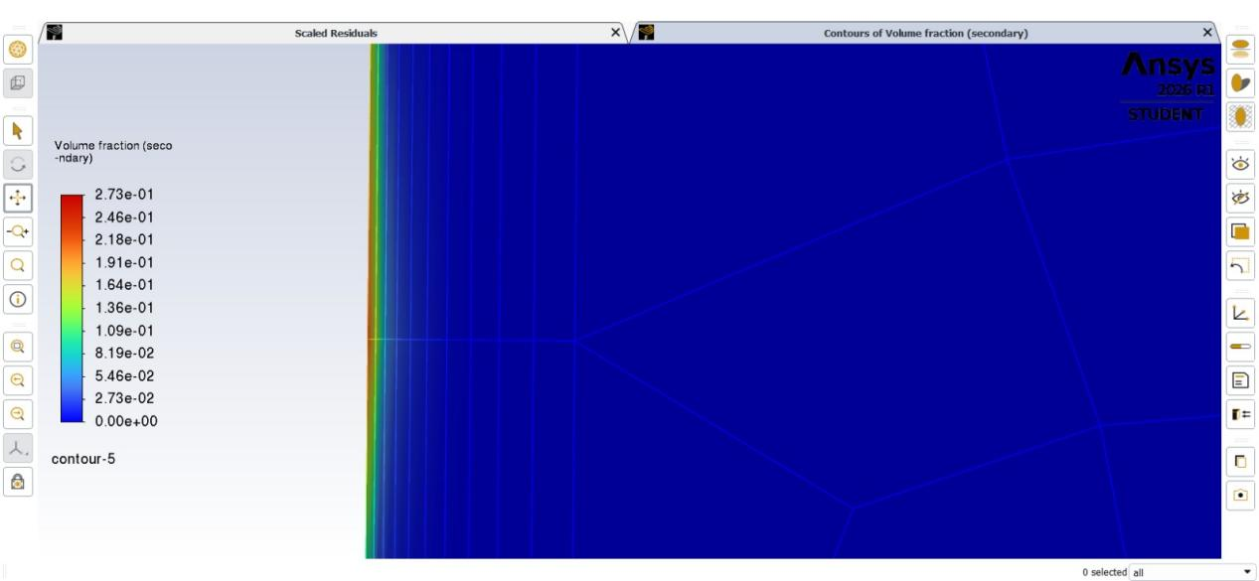

Figure 1: Contours of liquid water volume fraction (secondary phase) — zoomed view of cold wall region. Peak value 0.273 at wall surface; bulk domain at zero liquid fraction.

4.2 Static Temperature
The temperature contour confirms the expected thermal structure of the condensation problem. A narrow thermal boundary layer is visible immediately adjacent to the cold wall (350 K), transitioning sharply to the bulk steam temperature of approximately 377–380 K within a few millimetres. The thinness of this temperature gradient region is physically meaningful — it reflects the fact that the liquid film acts as the primary thermal resistance between the wall and the steam, exactly as Nusselt theory predicts. The near-uniform temperature in the bulk domain confirms that the steam supply is not being significantly cooled away from the wall, providing a consistent driving temperature difference for condensation throughout the domain height.
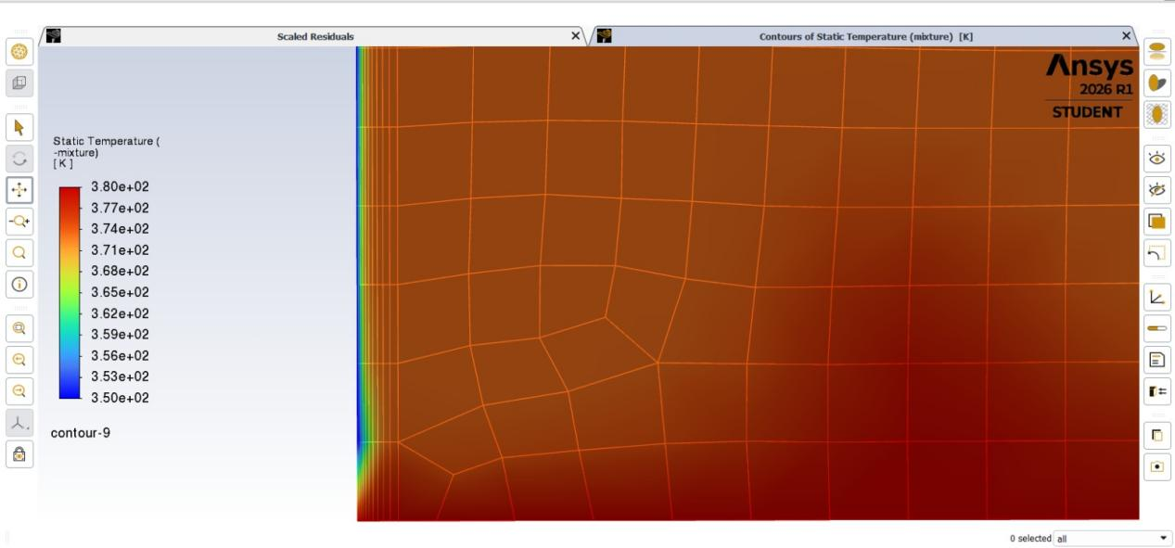
Figure 2: Contours of static temperature (mixture) — zoomed view of cold wall region. Left edge at 350 K; bulk domain at 377–380 K. Thin thermal boundary layer visible at wall.

4.3 Velocity Magnitude
The velocity magnitude contour shows the most physically interesting result of this simulation. The peak velocity of 0.487 m/s is concentrated near the bottom of the cold wall, where condensate that has accumulated along the full wall height drains downward at its highest speed. Above this zone, the condensate film moves more slowly, reflecting the fact that it has had less wall length over which to accelerate.
This distribution — increasing condensate velocity from top to bottom — is the direct CFD manifestation of the momentum balance in Nusselt's analytical solution. The steam in the bulk domain moves relatively slowly (blue region), with the velocity field dominated by the faster-moving condensate film near the wall.
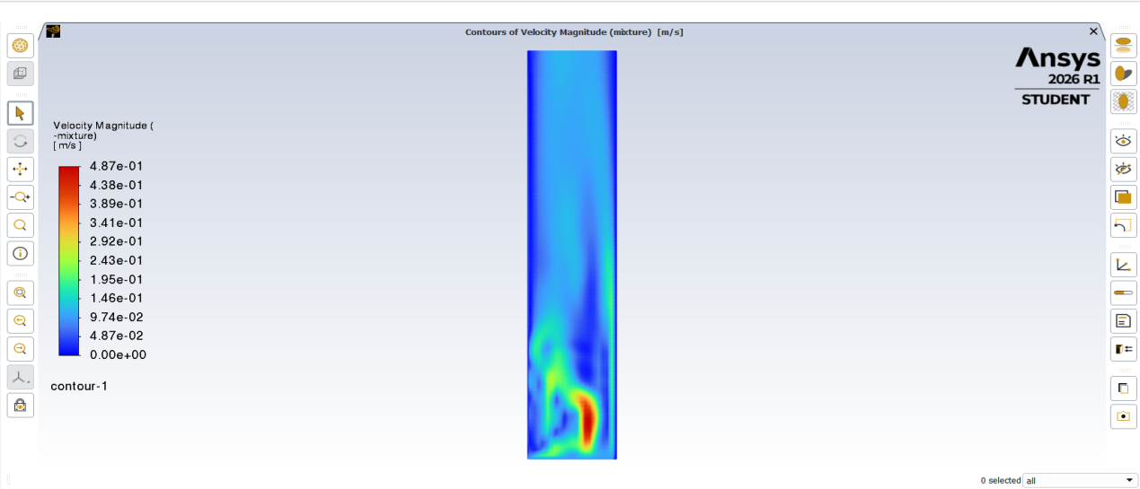
Figure 3: Contours of velocity magnitude (mixture). Peak velocity 0.487 m/s at base of cold wall, showing condensate film accelerating under gravity. Bulk steam at low velocity.

4.4 Wall Shear Stress
Wall shear stress along the cold wall ranged from 8.32×10⁻⁵ Pa near the top to 0.264 Pa near the bottom. This increasing shear from top to bottom reflects the growing momentum of the condensate film as it thickens and accelerates downward along the wall. The variation is consistent with the expectation from Nusselt film condensation theory that the film Reynolds number increases along the wall height as more condensate accumulates.
Higher shear stress at the base also explains the higher velocity observed in that region — the condensate is moving fast enough to exert a measurable viscous drag on the wall surface below it.
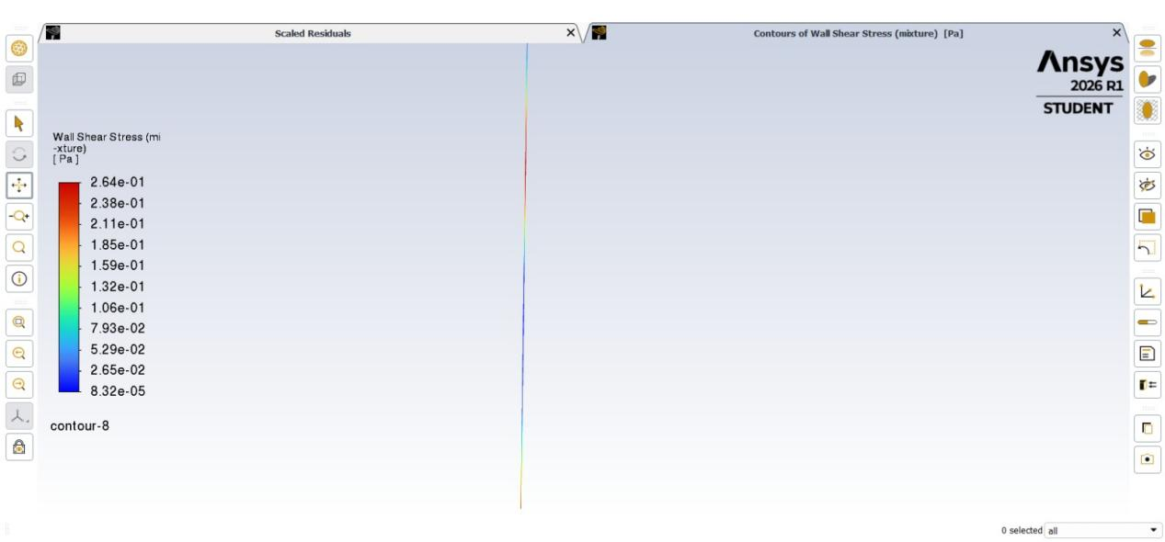

Figure 4: Wall shear stress along cold wall (mixture). Color varies from 8.32×10⁻⁵ Pa (top, blue) to 0.264 Pa (bottom, red), reflecting condensate film acceleration under gravity.

5. Discussion
Across all four result types — volume fraction, temperature, velocity, and wall shear stress — the simulation produces behaviour that is qualitatively consistent with classical Nusselt film condensation theory. The liquid film forms at the cold wall and nowhere else, the thermal boundary layer is confined to the film region, the condensate accelerates toward the base of the wall, and the wall shear stress increases in the same direction. These are not just expected outputs from a working simulation — they are physically diagnostic. Each one confirms a different aspect of the underlying physics.
The Lee model frequency coefficient of 100 s⁻¹ was higher than some values cited in literature, which typically range from 0.1 to about 10 s⁻¹ for water-steam systems. The default value of 0.1 s⁻¹ produced no condensation at all across 1,000 time steps at this mesh resolution and time step size, which suggests that the effective interfacial area resolved by the mesh was insufficient to drive condensation at low coefficients. Increasing the coefficient compensates by raising the volumetric mass transfer rate per unit temperature difference. A sensitivity study comparing results at different coefficient values against the Nusselt analytical prediction for local heat flux would be the most useful quantitative check to add.
The negative latent heat error encountered during setup ("Latent Heat cannot be less than zero") was resolved by correcting the phase direction convention in the Lee model — setting From = liquid, To = vapor rather than the reverse. This is a known source of confusion in Fluent VOF condensation setups and is worth documenting explicitly for anyone attempting to reproduce this work.

6. Limitations and Future Work
• No formal validation against Nusselt's analytical solution for local heat flux or condensate film thickness was performed. This would be the natural next step — comparing the simulated wall heat flux profile along the wall height against the Nusselt prediction q = h(T_sat − T_wall) with h from the analytical film thickness expression.
• Grid independence was not formally verified through a GCI study. The mesh was checked qualitatively, but a Richardson extrapolation across at least three mesh levels should be done before treating the quantitative results as mesh-independent.
• The Lee model frequency coefficient sensitivity was not systematically studied. Results should be tested at 10 s⁻¹ and 1 s⁻¹ to understand how strongly the film thickness and heat flux depend on this parameter.
• The simulation was 2D and laminar. Real condensation flows at higher wall heights or steam velocities can develop interfacial waves and eventually transition to turbulence — a 3D simulation with a turbulence model would be needed to capture those effects.

- Conclusion
A transient CFD simulation of steam condensation on a vertical cold wall was completed in ANSYS Fluent 2026 R1 using the VOF multiphase model and the Lee Evaporation-Condensation model. The simulation successfully produced a well-defined liquid condensate film on the cold wall, with peak liquid volume fraction of 0.273, a clearly resolved thermal boundary layer confined to the film region, and a condensate velocity profile showing gravity-driven acceleration toward the base of the wall — all consistent with Nusselt film condensation theory.
The setup required careful attention to the Lee model phase direction convention, the frequency coefficient value, and the use of PRESTO! pressure discretisation with active gravity. These are documented above in sufficient detail to reproduce the results. The project demonstrated end-to-end use of ANSYS Fluent for a multiphase phase-change problem, from geometry and meshing through to physically interpretable post-processing results.

- References
- Lee, W. H. (1980). A pressure iteration scheme for two-phase flow modeling.
2. Nusselt, W. (1916). Die Oberflächenkondensation des Wasserdampfes. Zeitschrift des Vereines Deutscher Ingenieure, 60, 541–546.
3. ANSYS Fluent Theory Guide, Release 2026 R1. ANSYS Inc., Canonsburg, PA.
4. Alizadehdakhel, A., Rahimi, M., & Alsairafi, A. A. (2010). CFD modeling of flow and heat transfer in a thermosyphon.
5. Fadhl, B., Wrobel, L. C., & Jouhara, H. (2013). Numerical modelling of the temperature distribution in a two-phase closed thermosyphon.

