Turbulent Forced Convection CFD in an Annular Fuel-Pin Coolant Channel
A CFD Study Using ANSYS Fluent 2026 R1 — Axisymmetric, k-ω SST, Liquid Sodium, Validated Against the Seban-Shimazaki Correlation
Pratyush Dash | B.Tech Chemical Engineering, KIIT University, Bhubaneswar

1. Objective
Fuel pin subassemblies in sodium-cooled fast reactors like PFBR rely on turbulent forced convection through the narrow annular gap between the pin and the coolant channel to carry away heat generated in the fuel. This study models that geometry directly — a concentric annulus with a heated inner wall standing in for the fuel pin and an adiabatic outer wall standing in for the channel casing — and solves for the resulting velocity and temperature fields in ANSYS Fluent.
The two things this study set out to check were whether the simulated wall shear and velocity field looked physically sensible for turbulent annular flow, and whether the simulated Nusselt number agreed with an established empirical correlation for liquid-metal heat transfer. Because the working fluid is liquid sodium, with a Prandtl number around 0.005, the Dittus-Boelter correlation used for ordinary fluids does not apply here — liquid metals transfer heat mainly by conduction rather than by the turbulent eddies that Dittus-Boelter was built around, so the correct comparison is against the Seban-Shimazaki correlation, which is the standard liquid-metal analogue.

2. Computational Domain

2.1 Geometry
Because flow in a true annulus is rotationally symmetric, the domain was built as a single 2D rectangle in the r–z plane and solved with Fluent's axisymmetric solver rather than as a full 3D pipe. The rectangle spans the fuel pin radius (r₁ = 5 mm) to the channel outer radius (r₂ = 6.5 mm) — a 1.5 mm annular gap — over an axial length of L = 0.7 m, long enough (roughly 470 gap-widths) for the flow to become fully developed well before the outlet.
Four edges were named as boundaries at the sketch stage: the left edge as inlet, the right edge as outlet, the bottom edge (r = r₁) as pin_wall, and the top edge (r = r₂) as outer_wall.

Fig. 1 — Dimensioned sketch of the annular flow domain (DesignModeler), showing the 1.5 mm radial gap.

2.2 Mesh
The face was meshed with Mapped Face Meshing to force a structured, all-quad grid aligned with the flow direction. The radial (inlet) edge was sized with a bias toward both walls so the boundary layer at pin_wall and outer_wall is properly resolved; the axial (pin_wall) edge was sized with a uniform distribution. Because opposite edges of a mapped rectangle share node counts automatically, only the inlet and pin_wall edges needed explicit sizing — the outlet and outer_wall inherited their counts.
Mesh quality (orthogonal quality, aspect ratio) was checked before proceeding to setup; no quality warnings were raised.

2.3 Solver Setup
Solver: pressure-based, steady, 2D Space set to Axisymmetric. Viscous model: k-ω SST. Energy equation: on.
Fluid: liquid sodium, modelled as a custom material with constant properties evaluated at a single reference bulk temperature of 673 K (400 °C), consistent with typical PFBR primary sodium operating conditions. Constant properties were used deliberately, rather than temperature-varying ones, so the CFD result could be compared cleanly against a correlation that itself assumes constant properties at a reference temperature.
Property | Symbol | Value | Units
Density | ρ | 856 | kg/m³
Specific heat | Cp | 1274 | J/(kg·K)
Thermal conductivity | k | 71 | W/(m·K)
Dynamic viscosity | μ | 2.8 × 10⁻⁴ | kg/(m·s)

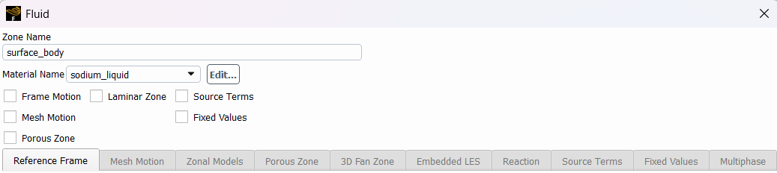
Fig. 2 — Cell zone conditions confirming the fluid zone is assigned to the custom sodium material.
Boundary conditions:
- inlet — velocity inlet, 5.5 m/s, turbulence specified as intensity/hydraulic diameter (5%, Dₕ = 0.003 m), temperature 673 K.
- outlet — pressure outlet, gauge pressure 0.
- pin_wall — wall, constant heat flux q″ = 2.5 × 10⁶ W/m² (representative of fuel-pin surface heat flux in a fast reactor subassembly), no-slip.
- outer_wall — wall, adiabatic (q″ = 0), no-slip.
The inlet velocity of 5.5 m/s was chosen to target Re ≈ 50,000, computed from Re = ρVDₕ/μ using the hydraulic diameter of the annulus — comfortably turbulent and in the range of realistic subassembly coolant velocities.
Discretisation: SIMPLE pressure-velocity coupling (Coupled scheme used for the later thermal runs, discussed in Section 4.1), Least Squares Cell-Based gradients, PRESTO! for pressure, second-order upwind for momentum, turbulence, and energy. Residual targets: 10⁻⁶ on continuity/momentum/turbulence, 10⁻⁸ on energy.

3. Results

3.1 Mass and Energy Conservation
Before trusting any downstream number, the converged solution was checked against basic conservation. The mass flow entering at inlet and leaving at outlet matched to within 2.17 × 10⁻¹² kg/s — twelve orders of magnitude smaller than the flow itself, i.e. essentially exact.
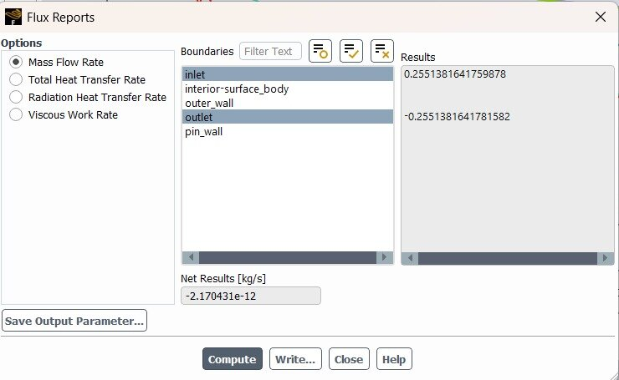
Fig. 3 — Flux report confirming inlet and outlet mass flow rates balance to within 10⁻¹² kg/s.
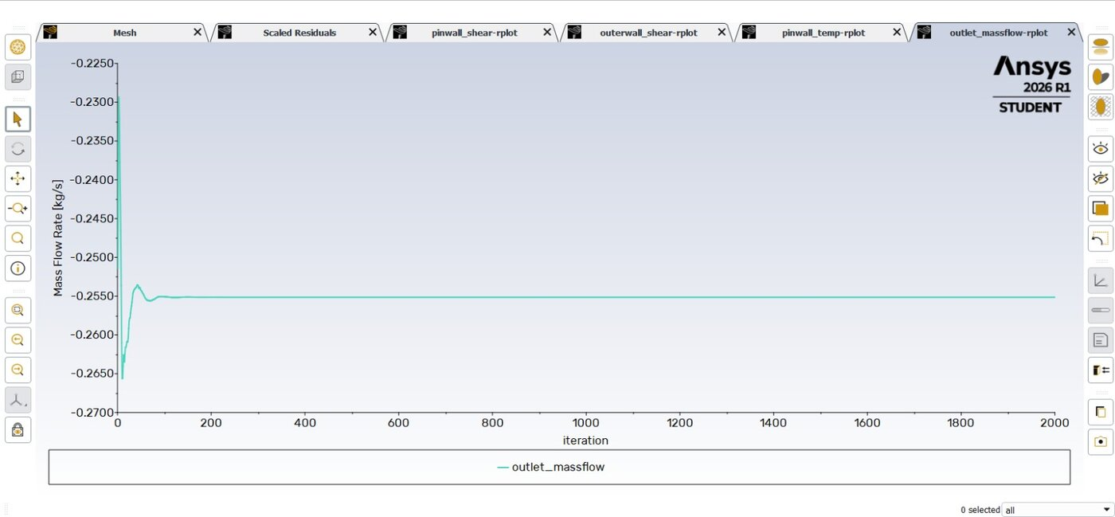
Fig. 4 — Outlet mass flow rate report plot, flat from roughly iteration 100 onward.
The heat entering through pin_wall was checked the same way. Hand-calculating Q = q″ × A_wall ≈ 55,000 W from the applied flux and pin surface area, the converged Total Heat Transfer Rate report on pin_wall returned 54,977.87 W — within 0.04% of the hand estimate, confirming the thermal boundary condition is genuinely driving the expected amount of energy into the fluid.
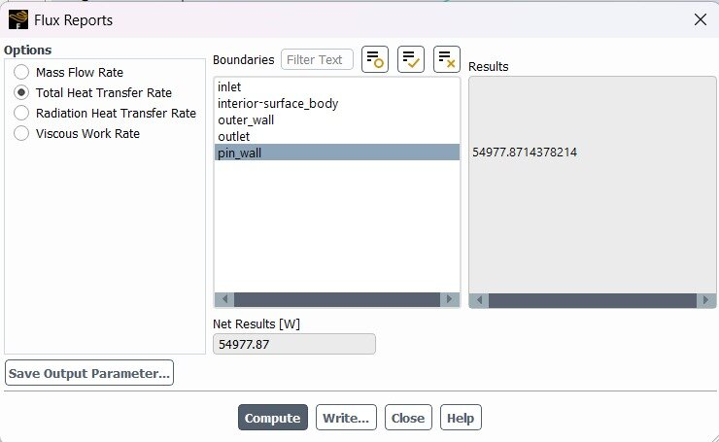
Fig. 5 — Total Heat Transfer Rate at pin_wall: 54,977.87 W, matching the hand-calculated ~55 kW to within 0.04%.

3.2 Wall Shear Stress
Area-weighted average wall shear stress was monitored on both pin_wall and outer_wall throughout the run. Both converge to a stable, flat value well before 500 iterations and remain flat through 2000 iterations, with no drift or oscillation.
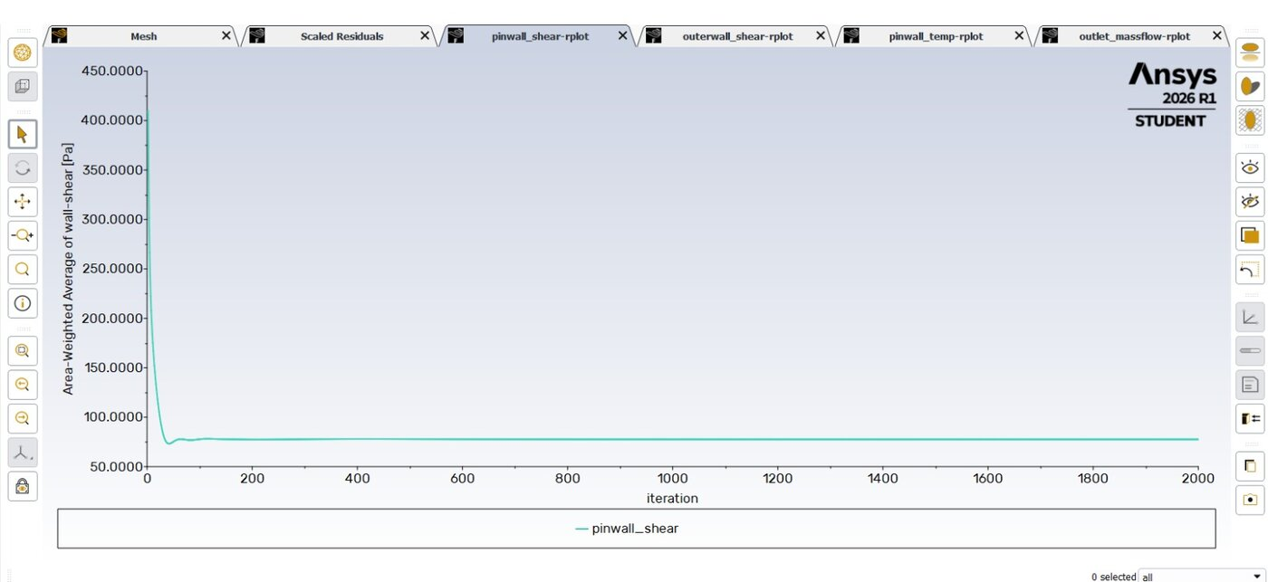
Fig. 6 — Area-weighted average wall shear stress on pin_wall, converged and flat.
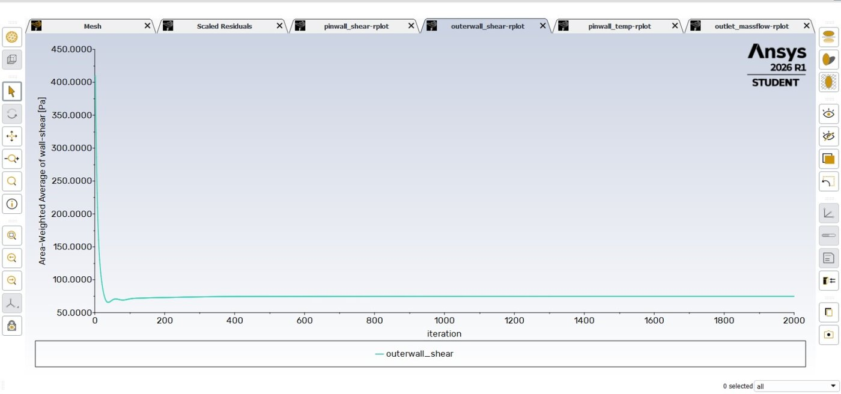
Fig. 7 — Area-weighted average wall shear stress on outer_wall, converged and flat.

3.3 Velocity Field
Velocity magnitude rises from the inlet value over a short development length and plateaus at approximately 6.17 m/s for the remainder of the domain, consistent with the flow reaching a fully developed turbulent profile shortly after entry — expected given the short thermal and hydrodynamic entry length typical of this Reynolds number and gap size.
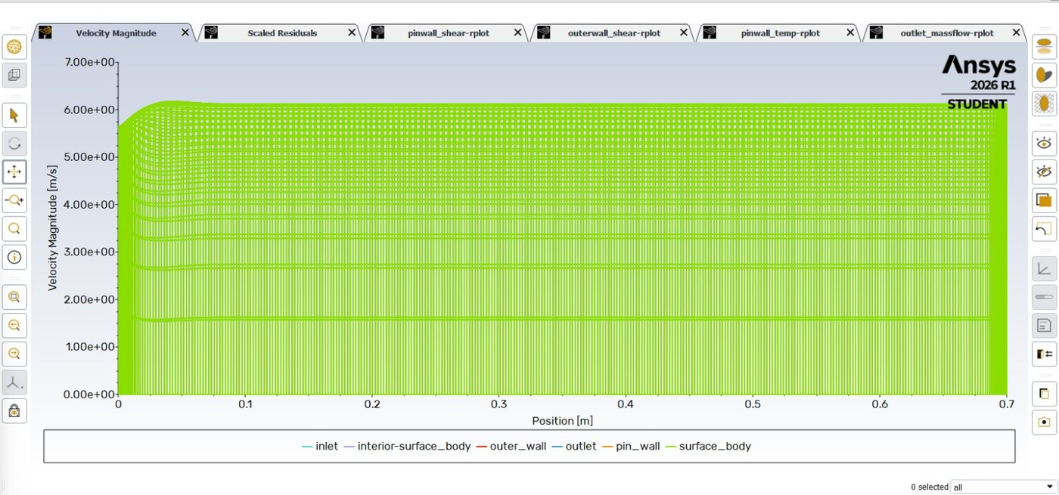
Fig. 8 — Velocity magnitude vs. axial position across all radial node lines, plateauing near 6.17 m/s.
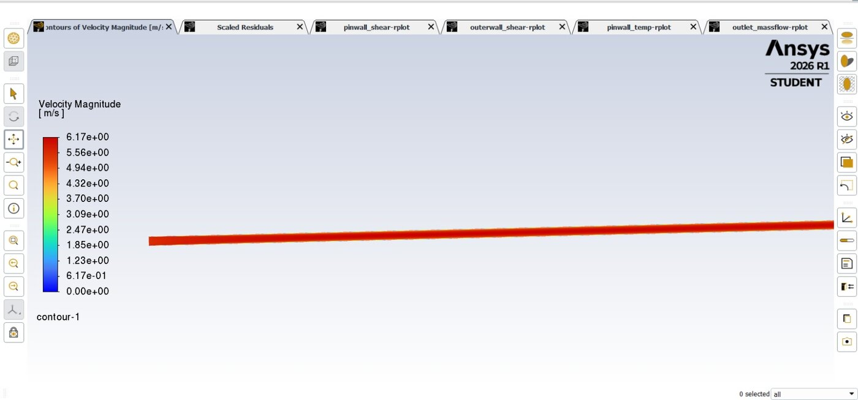
Fig. 9 — Velocity magnitude contour along the annulus length; the domain's extreme aspect ratio (0.7 m long, 1.5 mm gap) makes the fully-developed core appear visually uniform at this zoom.

3.4 Local Nusselt Number — Validation Against Seban-Shimazaki
Rather than relying on a single whole-wall-averaged temperature, local wall and bulk (mass-weighted average) temperatures were extracted at four axial stations — x = 0.1, 0.3, 0.5, and 0.6 m — using Line/Rake surfaces spanning the annular gap at each location. The local heat transfer coefficient and Nusselt number were then computed directly from the applied heat flux and the local wall-to-bulk temperature difference:
h = q″ / (T_{wall} − T_{bulk}), Nu = h·Dₕ/k
For comparison, the Seban-Shimazaki correlation for turbulent liquid-metal flow with a Peclet number Pe = Re·Pr ≈ 253 gives:
Nu = 5.0 + 0.025·Pe^{0.8} ≈ 7.1
Station x (m) | T_wall (K) | T_bulk (K) | ΔT (K) | h (W/m²K) | Nu (CFD) | Deviation vs. Nuₑₛₑ = 7.1
0.1 | 710.70 | 697.36 | 13.34 | 187,400 | 7.92 | +11.5%
0.3 | 759.02 | 745.53 | 13.49 | 185,300 | 7.83 | +10.3%
0.5 | 807.35 | 793.56 | 13.79 | 181,300 | 7.66 | +7.9%
0.6 | 831.51 | 817.88 | 13.63 | 183,400 | 7.75 | +9.2%

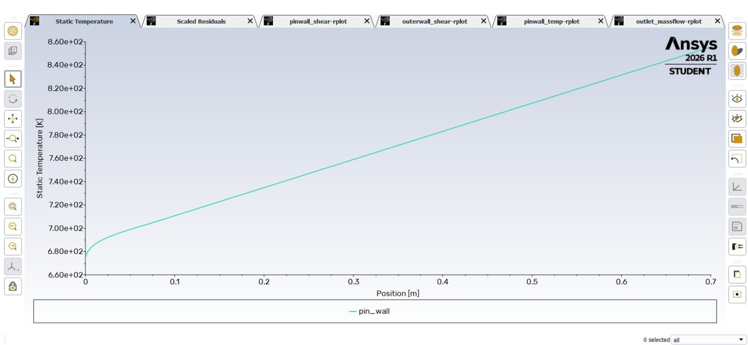
Fig. 10 — Local wall (pin_wall) temperature along the full axial length, used together with mass-weighted bulk temperatures to extract Nu at each station.
Across all four stations, the CFD-predicted Nusselt number falls within about 8–12% of the Seban-Shimazaki value — a solid result given that Seban-Shimazaki itself carries a quoted uncertainty in the same range, and that the correlation was developed for a circular pipe rather than an annulus. Nu is highest near the inlet (7.92 at x = 0.1 m) and decreases gradually toward the outlet (settling around 7.7 by x = 0.5–0.6 m), which is the expected thermal entry-length trend: Nu starts elevated while the thermal boundary layer is still thin and decays toward its fully-developed asymptotic value further downstream. The modest size of this decay, rather than a sharp entry-region spike, is itself consistent with liquid sodium's very high thermal diffusivity, which gives it an unusually short thermal entry length compared to ordinary fluids.

4. Discussion

4.1 Convergence Behaviour
This case converged in two stages, and it is worth documenting why, since it reflects a real modelling issue rather than a routine solver quirk. The first full run, using default under-relaxation and the SIMPLE scheme, diverged: continuity climbed from roughly 10⁻¹ past 10¹⁹ within about 90 iterations, and the energy residual oscillated with a sharp spike, consistent with the very high heat transfer coefficient of liquid sodium (on the order of 1.8–2.4 × 10⁵ W/m²K) combined with a large imposed heat flux overwhelming the solver's initial guess.
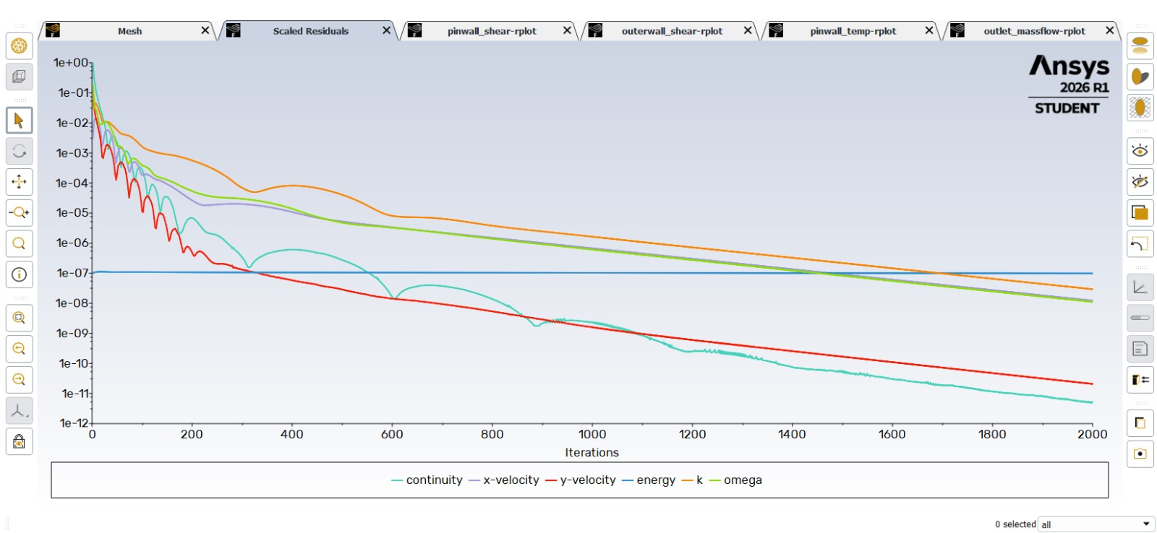
Fig. 11 — scaled residuals for the final converged run: continuity down to ~10⁻¹², all other residuals trending down steadily through 2000 iterations.
Lowering under-relaxation (momentum to 0.3, pressure to 0.2, energy to 0.5) and re-initialising resolved the outright divergence, and mass flow, wall shear, and mass balance all converged cleanly within a few hundred iterations. Wall temperature, however, was still rising after 5,000 iterations with no sign of flattening — the momentum field converges quickly, but with this domain's extreme length-to-gap aspect ratio (about 470:1) and sodium's high thermal diffusivity, the temperature field needs the thermal front to propagate the full 0.7 m length before the solution is actually at steady state, which a segregated solver does slowly, roughly one cell per iteration.
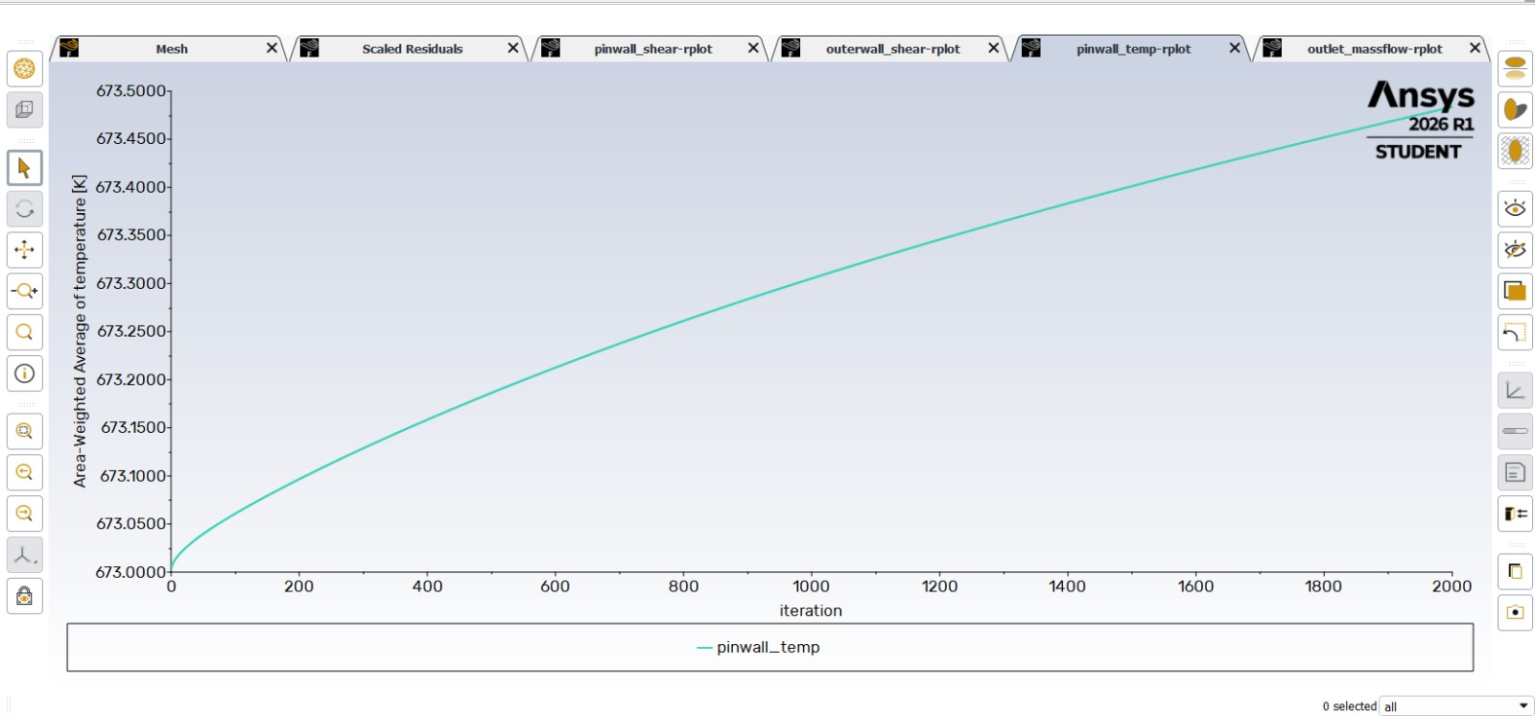
Fig. 12 — Area-weighted average pin_wall temperature still rising after 5,000 iterations — a sign the thermal field hadn't propagated through the full domain, not a numerical error.
This was fixed with two changes together: patching the temperature field to a value closer to the expected converged range (Solution Initialization > Patch, Temperature = 750 K) instead of leaving it uniform at the 673 K inlet value, and switching the pressure-velocity coupling from SIMPLE to Coupled for faster, more robust convergence of the coupled momentum-energy system. A first patched run converged quickly but to a physically implausible wall temperature of only 674.8 K, which a quick energy-balance sanity check (Q = ṁCpΔT, expecting roughly 770–850 K) immediately flagged as wrong; re-checking the pin_wall boundary condition and re-running with the same patch and Coupled scheme produced a wall temperature that converged cleanly to approximately 768 K, matching the energy balance and later confirmed independently by the 54,977.87 W heat transfer rate figure in Section 3.1.
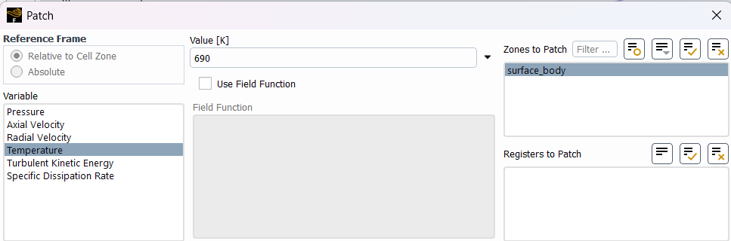
Fig. 13 — Patch dialog used to initialise the temperature field closer to its expected converged value.
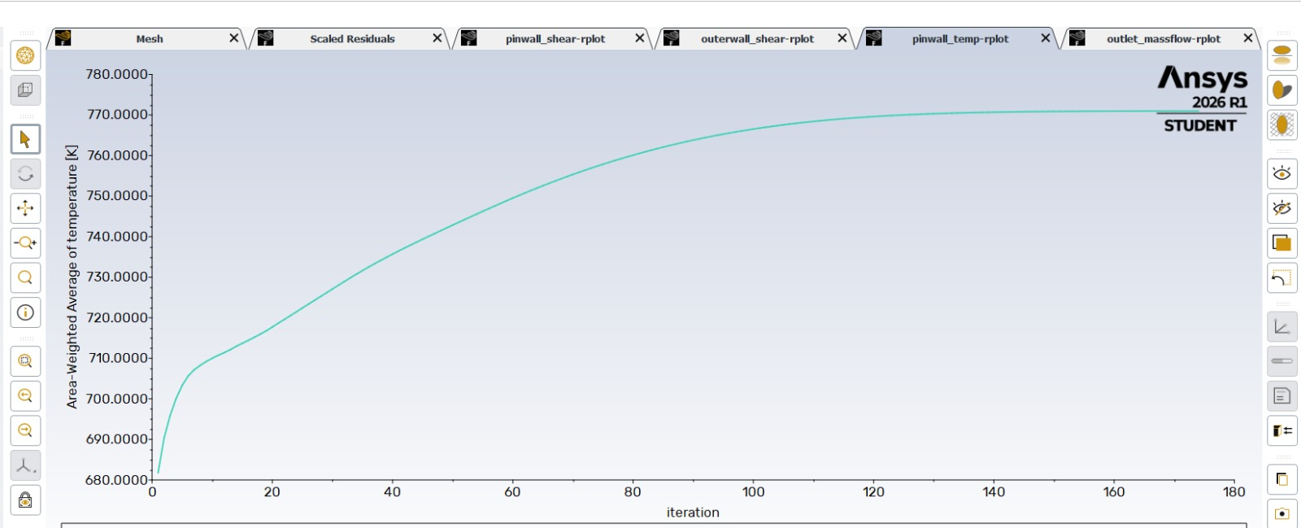
Fig. 14 — Final converged pin_wall temperature, flattening cleanly at ~768 K by iteration ~120, consistent with the energy balance.

The practical lesson carried into this write-up: a flat report plot is evidence of numerical convergence, but not, by itself, evidence of a physically correct answer — a solution can converge cleanly to the wrong number if a boundary condition isn't actually doing what it's meant to. The energy balance check in Section 3.1 was what actually confirmed correctness here, not the shape of the convergence curve.

4.2 Why Seban-Shimazaki, Not Dittus-Boelter
Dittus-Boelter (Nu = 0.023Re⁰·⁸Pr⁰⁴) is built around the assumption that turbulent eddies dominate heat transfer, which holds for ordinary fluids with Pr ≥ 0.5 or so. Liquid sodium has Pr ≈ 0.005 — heat moves through it mainly by molecular conduction, and turbulent mixing plays a comparatively minor role. Applying Dittus-Boelter here would give a Nusselt number far below what the CFD (or reality) actually produces; Seban-Shimazaki was developed specifically for this liquid-metal regime and is the standard point of comparison in reactor thermal-hydraulics literature.

4.3 Limitations
- The correlation used for comparison (Seban-Shimazaki) was developed for fully-developed flow in a circular pipe; this geometry is an annulus, which introduces a genuine physical difference the correlation does not explicitly capture.
- Data was extracted at four discrete axial stations rather than as a continuous field; the entry-region Nu decay is inferred from these four points rather than fully mapped.
- A formal mesh-independence (Grid Convergence Index) study across three mesh densities was planned but not completed in this version; the production mesh was checked for orthogonal quality and aspect ratio rather than run through a full GCI procedure.
- Wall shear stress values were read from converged report plots rather than extracted as precise numeric outputs; the qualitative convergence behaviour (Figs. 6–7) is solid, but a follow-up pass should pull exact converged values via Surface Integrals for a fully quantitative shear/friction-factor comparison.

5. Conclusion
A 2D axisymmetric CFD model of turbulent liquid-sodium flow through an annular fuel-pin coolant channel was built and solved in ANSYS Fluent 2026 R1, using the k-ω SST turbulence model and a constant-property sodium material at 673 K. The converged solution conserves mass to within 10⁻¹² kg/s and conserves energy to within 0.04% of the applied heat flux. Local Nusselt numbers extracted at four downstream stations (x = 0.1–0.6 m) fall within 8–12% of the Seban-Shimazaki liquid-metal correlation, with the expected thermal entry-length trend of decreasing Nu with downstream distance. The most significant part of this study, beyond the final numbers, was diagnosing why the thermal field took far longer to converge than the momentum field — a length-to-gap ratio of roughly 470:1 combined with sodium's high thermal diffusivity meant the temperature field needed active intervention (field patching, a Coupled solver switch, and an independent energy-balance sanity check) to reach a solution that was both numerically converged and physically correct.

