Week - 5

Microservices with API gateway

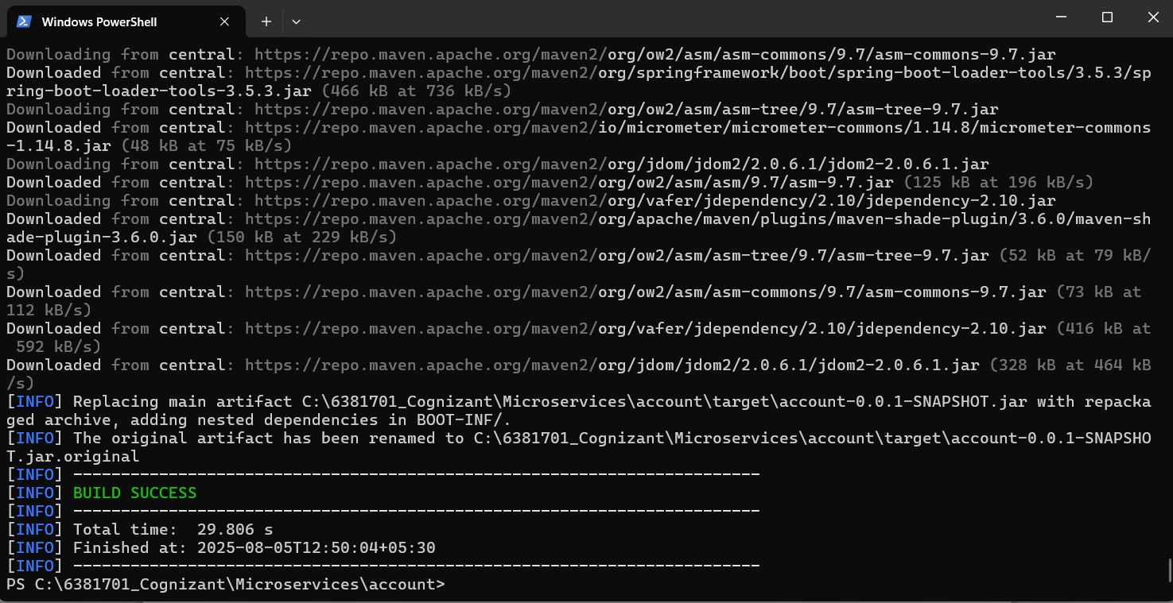

Eclipse code :-

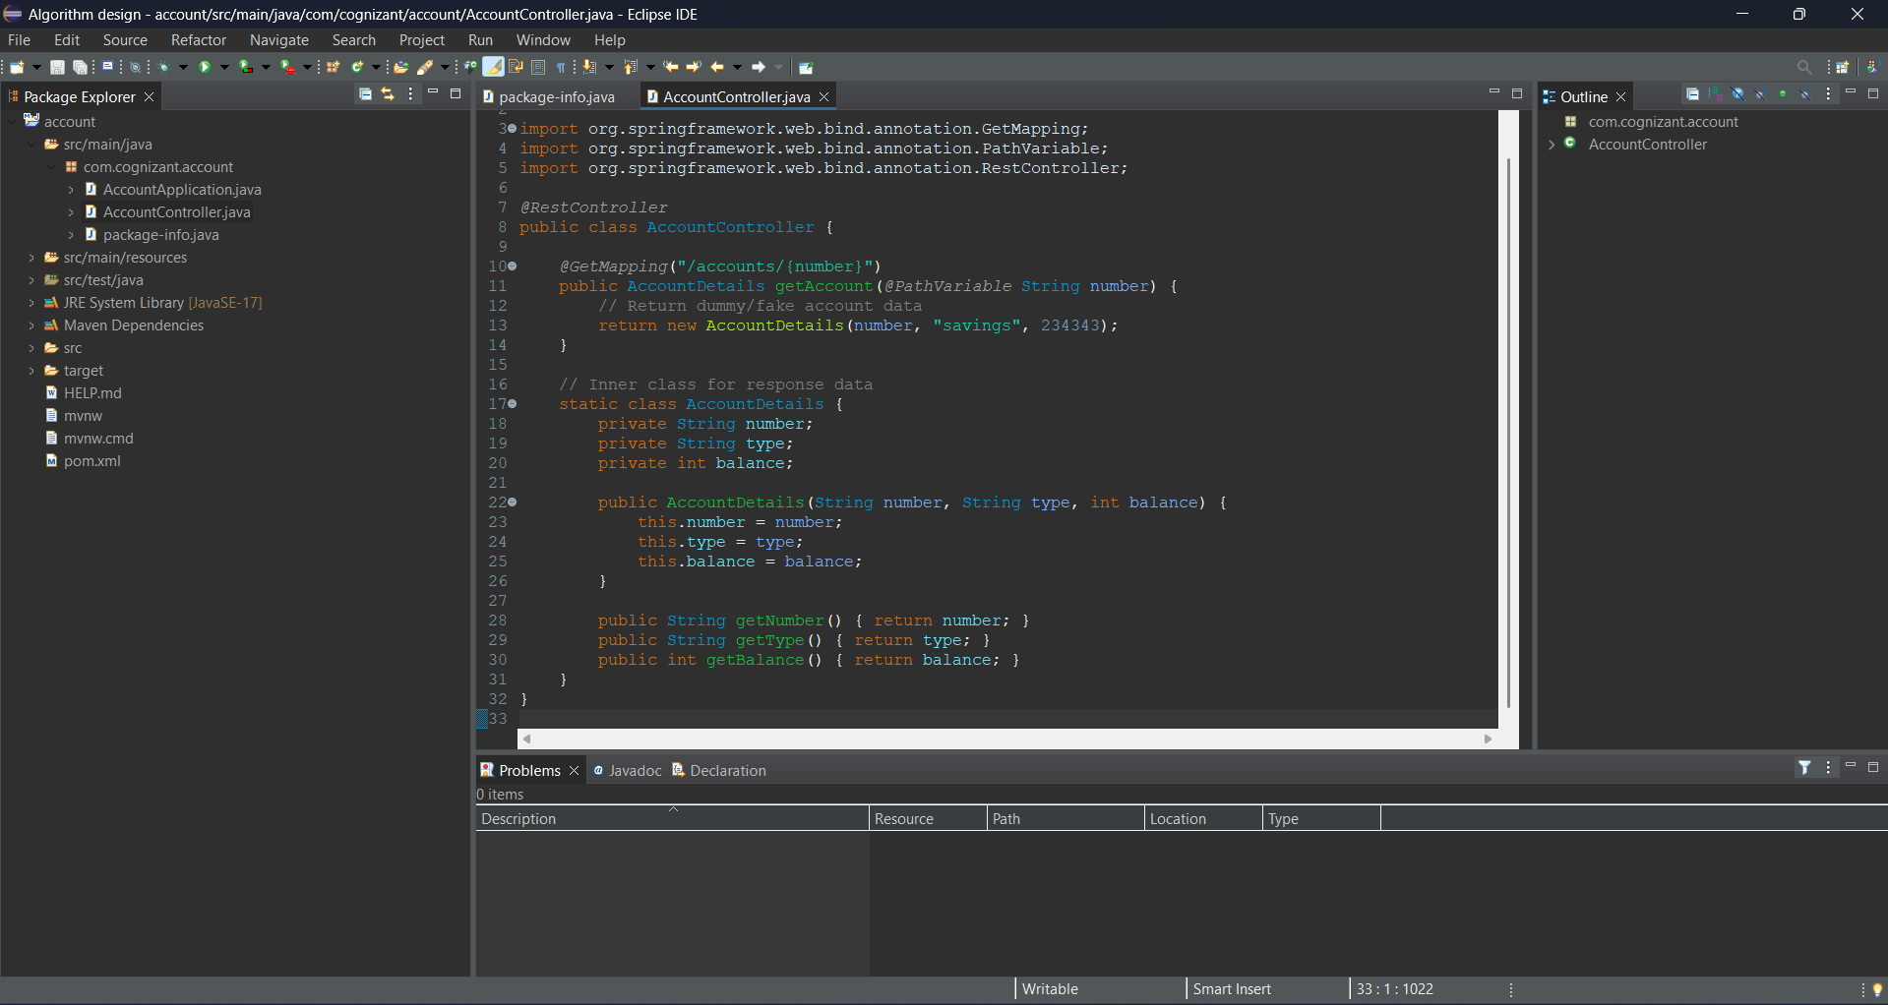

Output in eclipse :-

C:\Users\91917\OneDrive\Pictures\Screenshots\Screenshot 2025-08-05 131229.png

Web Browser Output :-

