**WEEK 6 REACT**

**1. ReactJS-HOL**

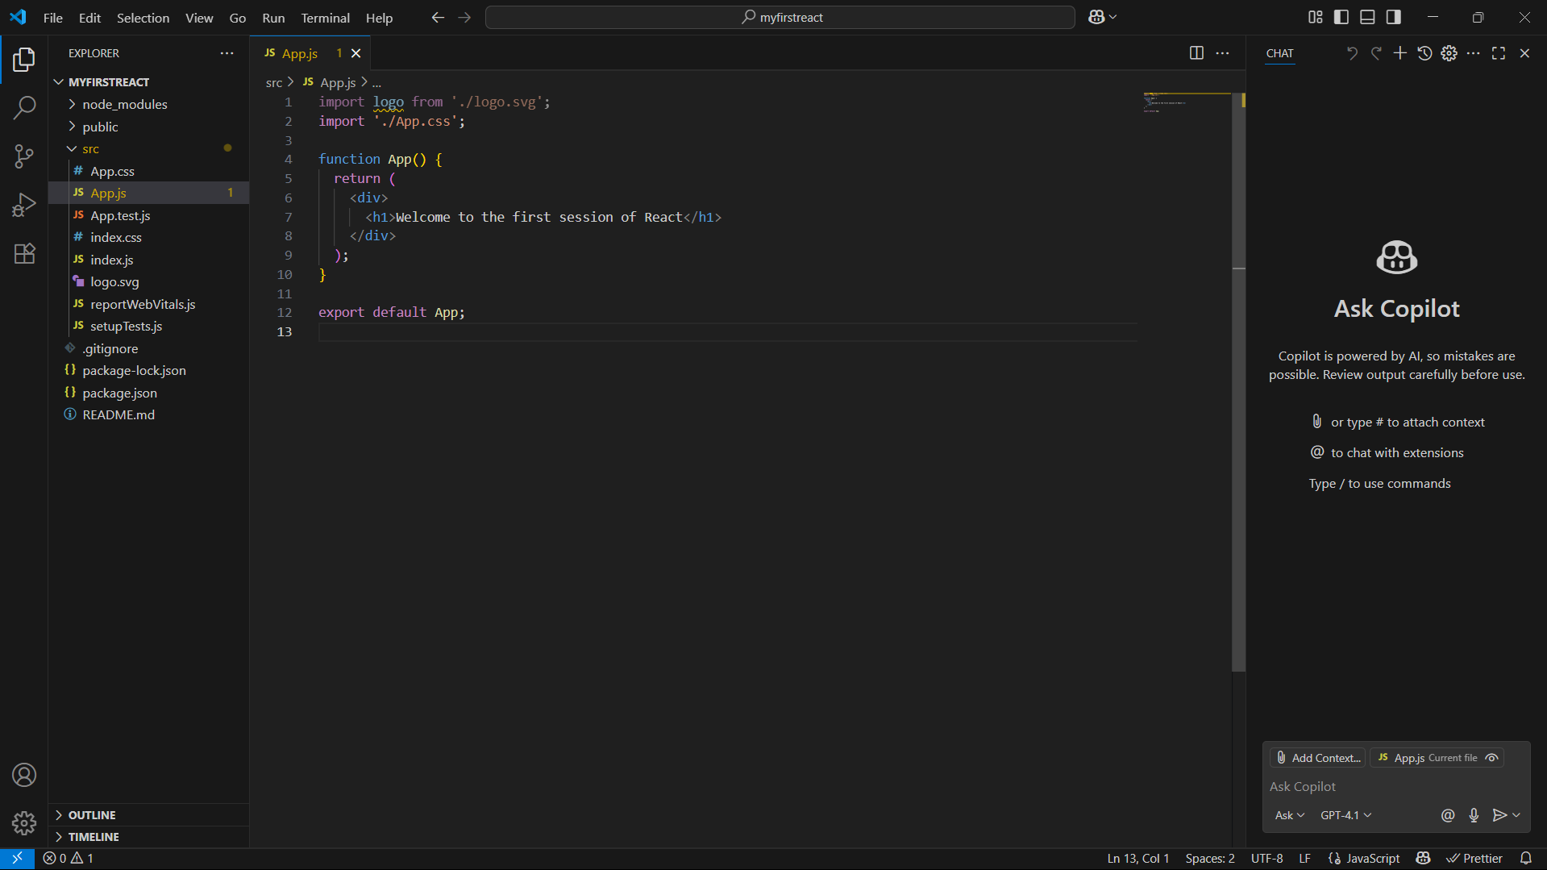Code:

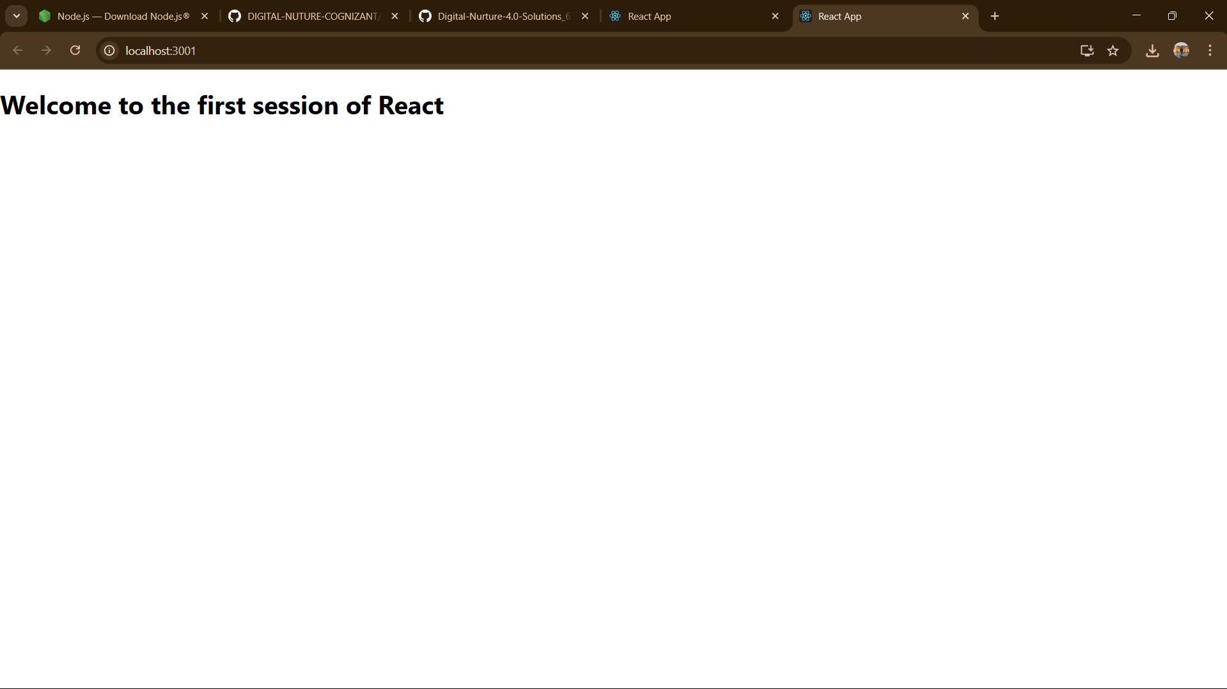**OUTPUT:**

**2. ReactJS-HOL**

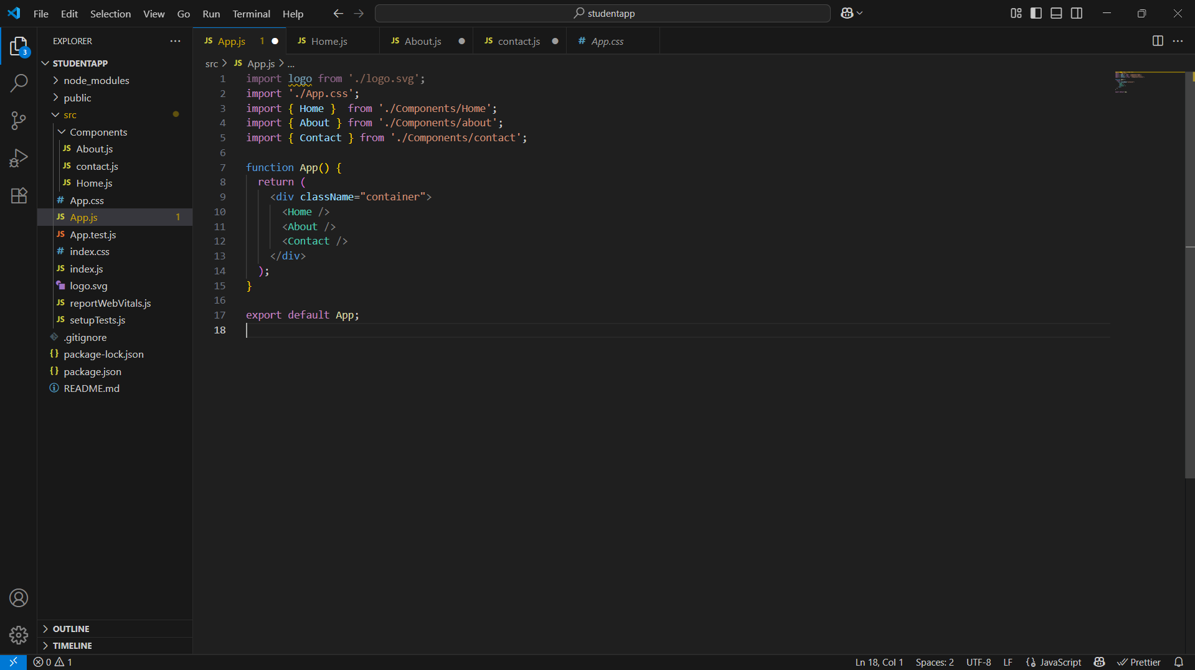**App.js code**

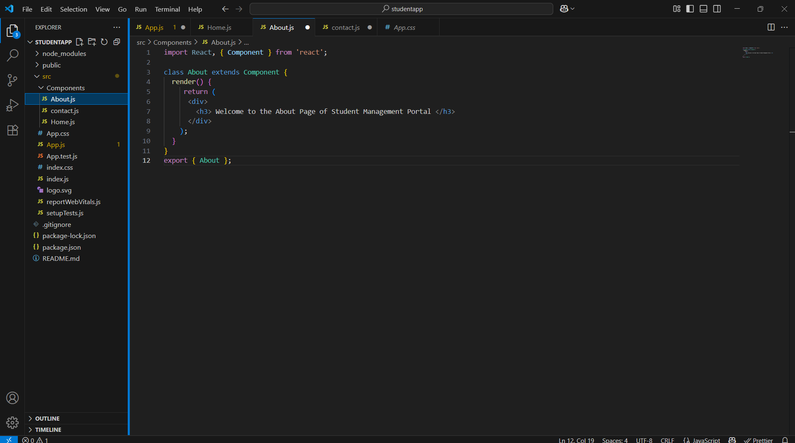**ABout.js**

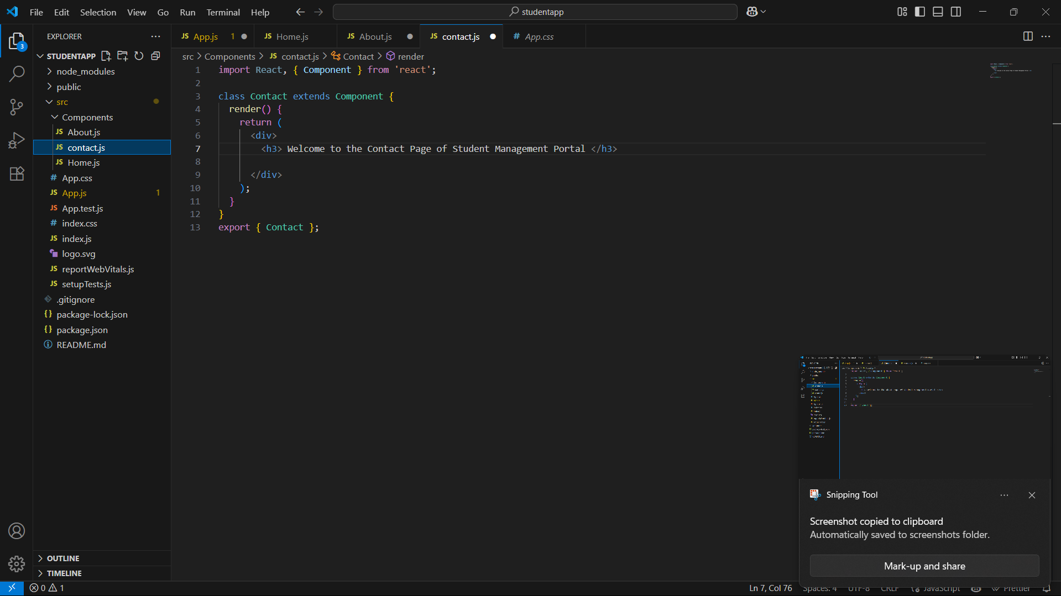**Contact.js**

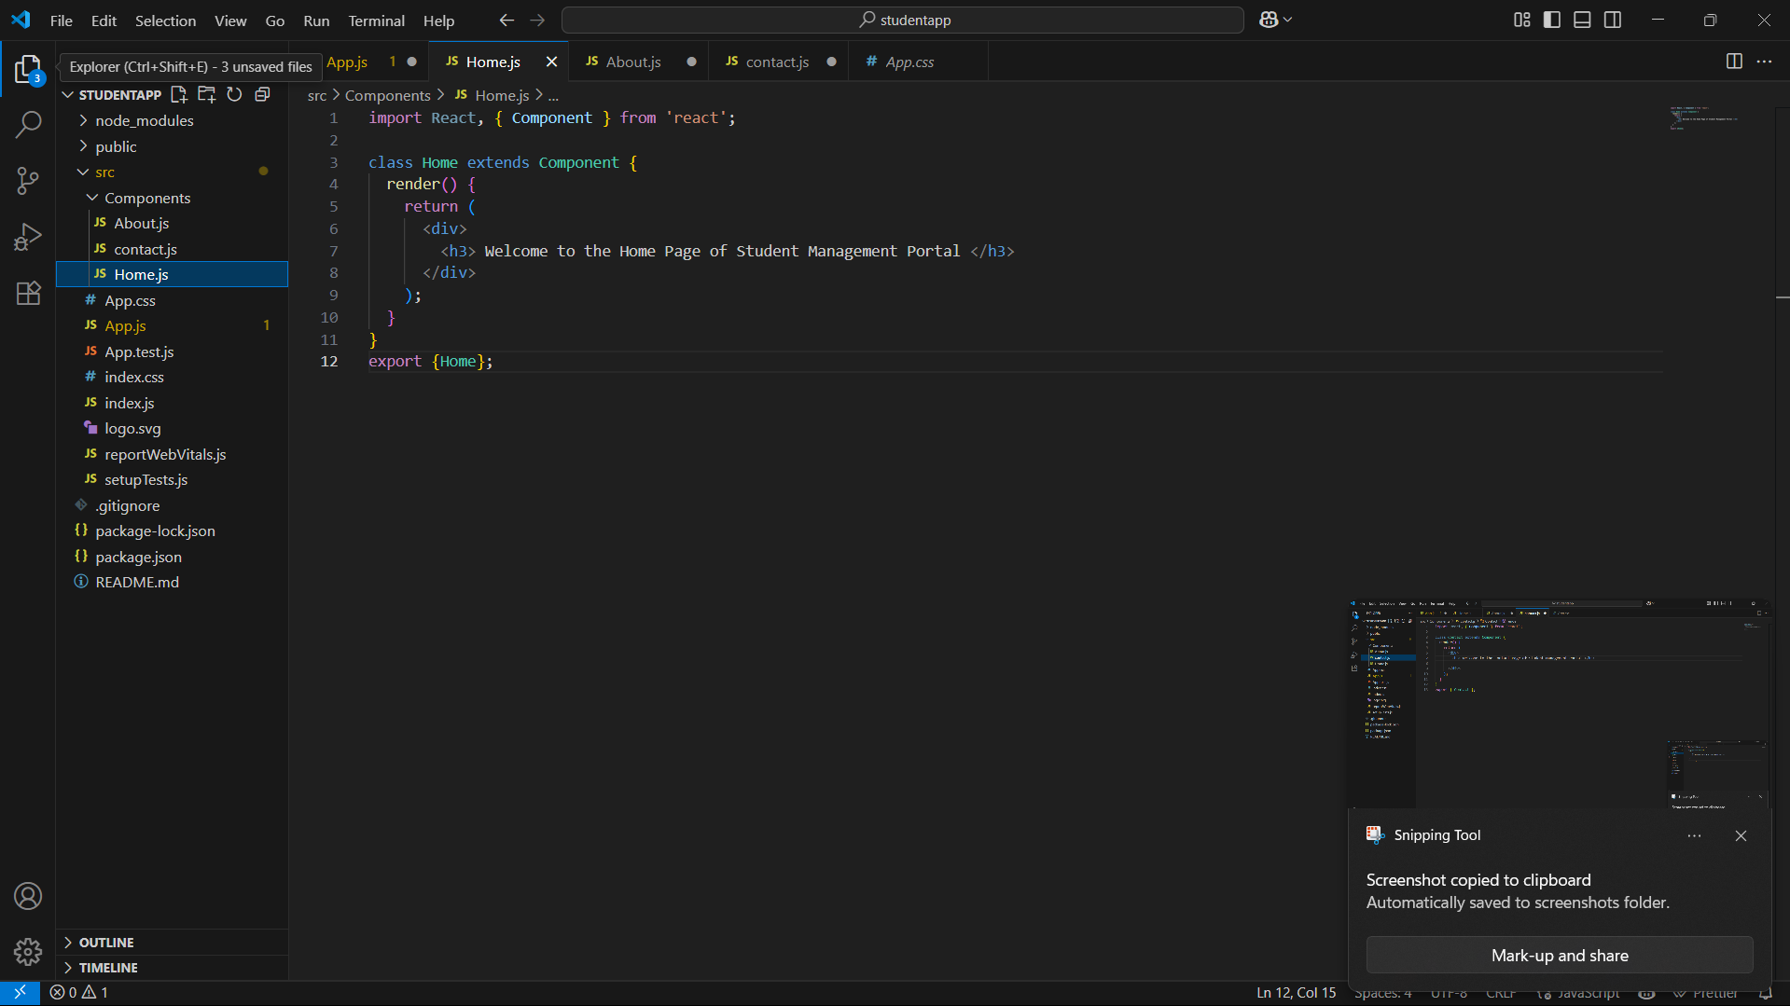**Home.js**

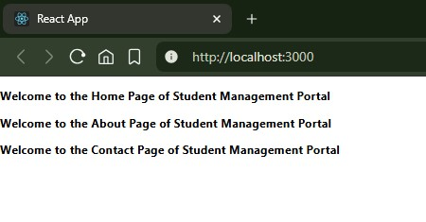**Output**

**3. ReactJS-HOL**

**calculatorScore.js**

import '../Stylesheets/mystyle.css'

const percentToDecimal = (decimal)=>{

return(decimal.toFixed(2)+'%')

}

const calcScore = (total,goal)=>{

return percentToDecimal(total/goal)

}

const CalculateScore = ({Name, School, Total, goal}) => {

return(

<div className="formatstyle">

<h1><font color="Brown">Student Details:</font></h1>

<div className="Name">

<b><span>Name: </span></b>

<span>{Name}</span>

</div>

<div className="School">

<b><span>School: </span></b>

<span>{School}</span>

</div>

<div className="Total">

<b><span>Total: </span></b>

<span>{Total}</span>

<span>Marks</span>

</div>

<div className="Score">

<b>Score:</b>

<span>

{calcScore(Total, goal)}

</span>

</div>

</div>

);

}

export {CalculateScore};

**Mystyle.css**

.Name

{

font-weight:300;

color:blue;

}

.School

{

color:crimson;

}

.Total

{

color:darkmagenta;

}

.formatstyle

{

text-align:center;

font-size:large;

}

.Score

{

color:forestgreen;

}

**APP.js**

import {CalculateScore} from '../src/Components/CalculateScore';

import './App.css';

function App() {

return (

<div>

<CalculateScore Name={"Steeve"}

School={"DNV Public School"}

Total={284}

goal={3}

/>

</div>

);

}

export default App;

**output**

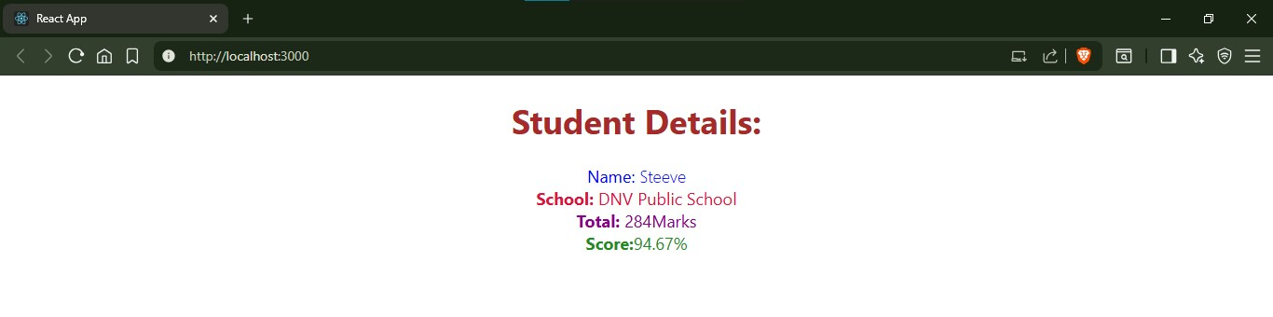

**4. ReactJS-HOL**

**App.cs**

.App {

text-align: center;

}

.App-logo {

height: 40vmin;

pointer-events: none;

}

@media (prefers-reduced-motion: no-preference) {

.App-logo {

animation: App-logo-spin infinite 20s linear;

}

}

.App-header {

background-color: #282c34;

min-height: 100vh;

display: flex;

flex-direction: column;

align-items: center;

justify-content: center;

font-size: calc(10px + 2vmin);

color: white;

}

.App-link {

color: #61dafb;

}

@keyframes App-logo-spin {

from {

transform: rotate(0deg);

}

to {

transform: rotate(360deg);

}

}

**App.js**

import Posts from './Posts';

import React from 'react';

import './App.css';

function App() {

return (

<div className="App"><Posts/></div>);

}

export default App;

**POST.js**

import React from 'react';

class Post extends React.Component {

render() {

const { id, title, body } = this.props;

return (

<div className="post">

<h3>Post #{id}</h3>

<h2>{title}</h2>

<p>{body}</p>

</div>

);

}

}

export default Post;

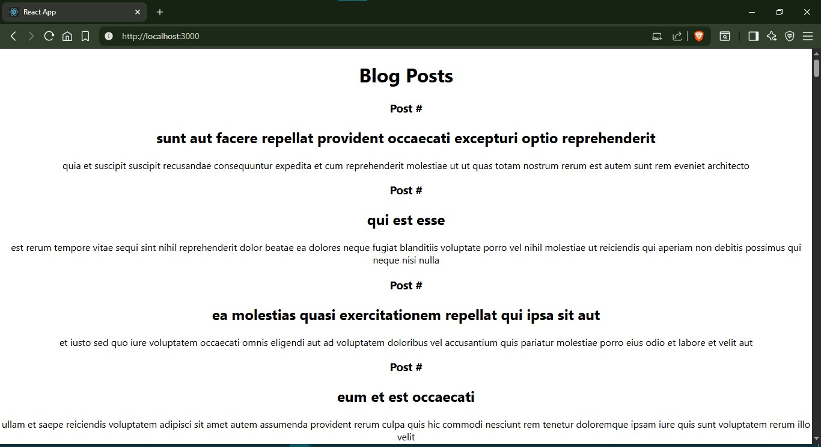**output**

**5. ReactJS-HOL**

**COHORT.JS**

class Cohort {

constructor(cohortCode,

startDate,

technology,

trainerName,

coachName,

currentStatus) {

this.cohortCode = cohortCode;

this.coachName = coachName;

this.trainerName = trainerName;

this.technology = technology;

this.startDate = startDate;

this.currentStatus = currentStatus;

}

}

const CohortsData =[

new Cohort('INTADMDF10','22-Feb-2022', '.NET FSD', 'Jojo Jose','Aathma', 'Scheduled'),

new Cohort('ADM21JF014','10-Sep-2021', 'Java FSD', 'Elisa Smith','Apoorv', 'Ongoing'),

new Cohort('CDBJF21025','24-Dec-2021', 'Java FSD', 'John Doe','Aathma', 'Ongoing'),

new Cohort('INTADMJF12','22-Feb-2022', 'Java FSD', 'To Be Assigned','Ibrahim', 'Scheduled'),

new Cohort('CDE22JF011','24-Dec-2021', 'Java FSD', 'Emma Swan','Apoorv', 'Ongoing'),

new Cohort('INTADMDF09','22-Feb-2022', 'Dataware Housing', 'Babjee Rao','Aathma', 'Scheduled'),

new Cohort('ADM22DF001','10-Sep-2021', '.NET FSD', 'Marie Curie','Ibrahim', 'Ongoing'),

];

export {Cohort, CohortsData};

**CohortDetails.js**

import React from 'react';

import styles from './CohortDetails.module.css';

function CohortDetails({ cohort }) {

const statusStyle = {

color: cohort.currentStatus.toLowerCase() === 'ongoing' ? 'green' : 'blue'

};

return (

<div className={styles.box}>

<h3 style={statusStyle}>

{cohort.cohortCode} - {cohort.technology}

</h3>

<dl>

<dt>Started On</dt>

<dd>{cohort.startDate}</dd>

<dt>Current Status</dt>

<dd>{cohort.currentStatus}</dd>

<dt>Coach</dt>

<dd>{cohort.coachName}</dd>

<dt>Trainer</dt>

<dd>{cohort.trainerName}</dd>

</dl>

</div>

);

}

export default CohortDetails;

**APP.JS**

import React from 'react';

import './App.css';

import styles from './CohortDetails.module.css';

import { CohortsData } from './Cohort'

import CohortDetails from './CohortDetails';

function App() {

return (

<div className={styles.container}>

<h2>Cohorts Details</h2>

<div className={styles['cards-wrapper']}>

{CohortsData.map((cohort, index) => (

<CohortDetails key={index} cohort={cohort} />

))}

</div>

</div>

);

}

export default App;

**OUTPUT**

