1. ReactJS-HOL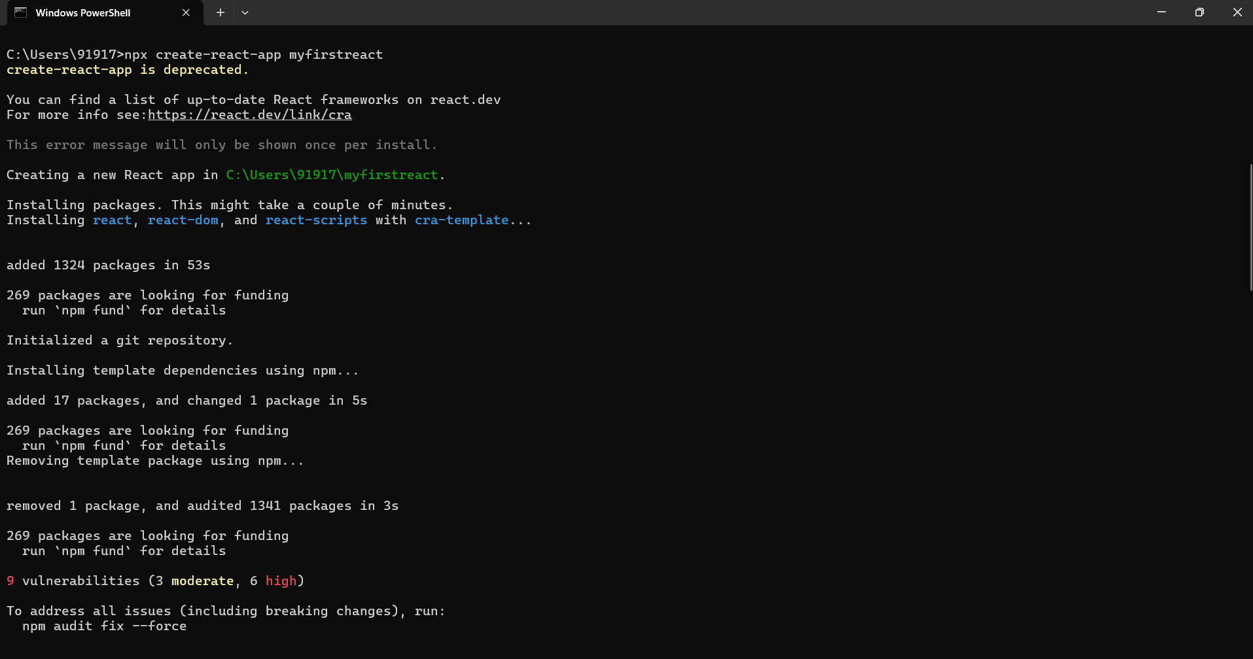

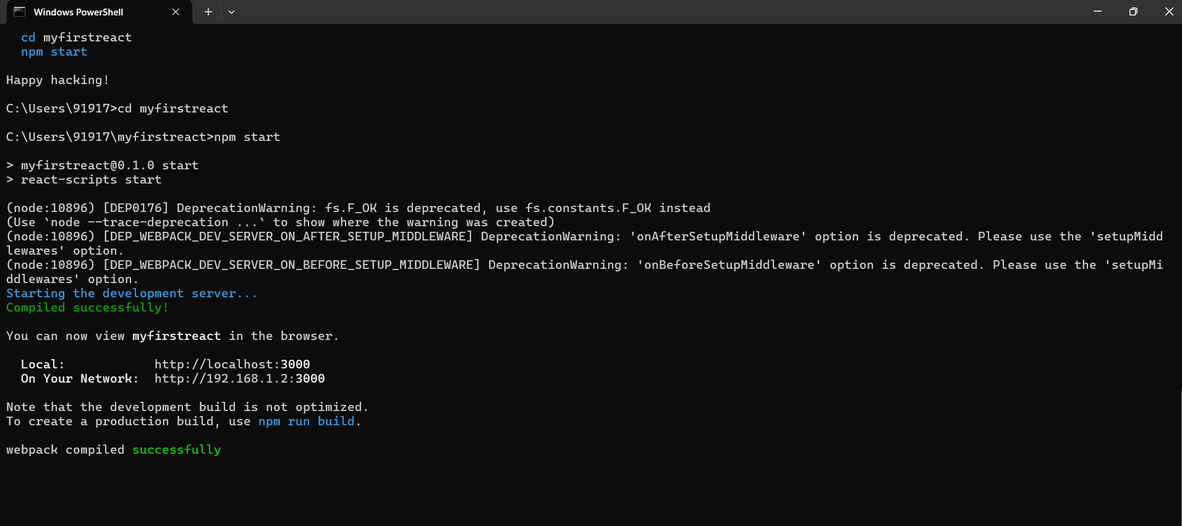



2. ReactJS-HOL

About.js

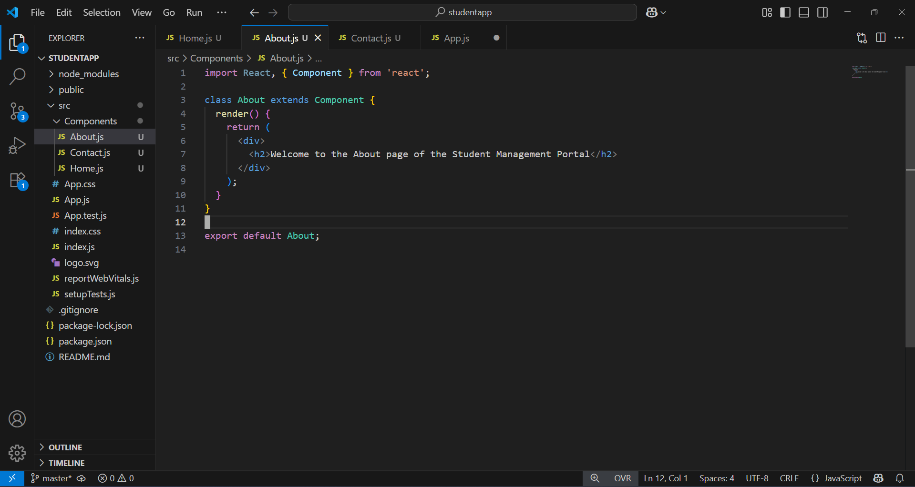

Contact.js

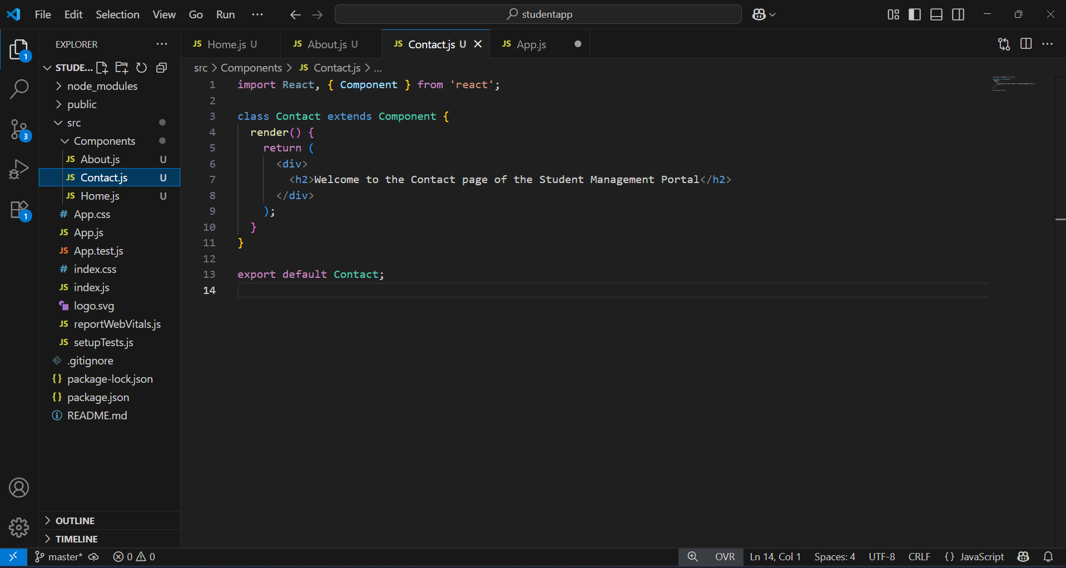

Home.js

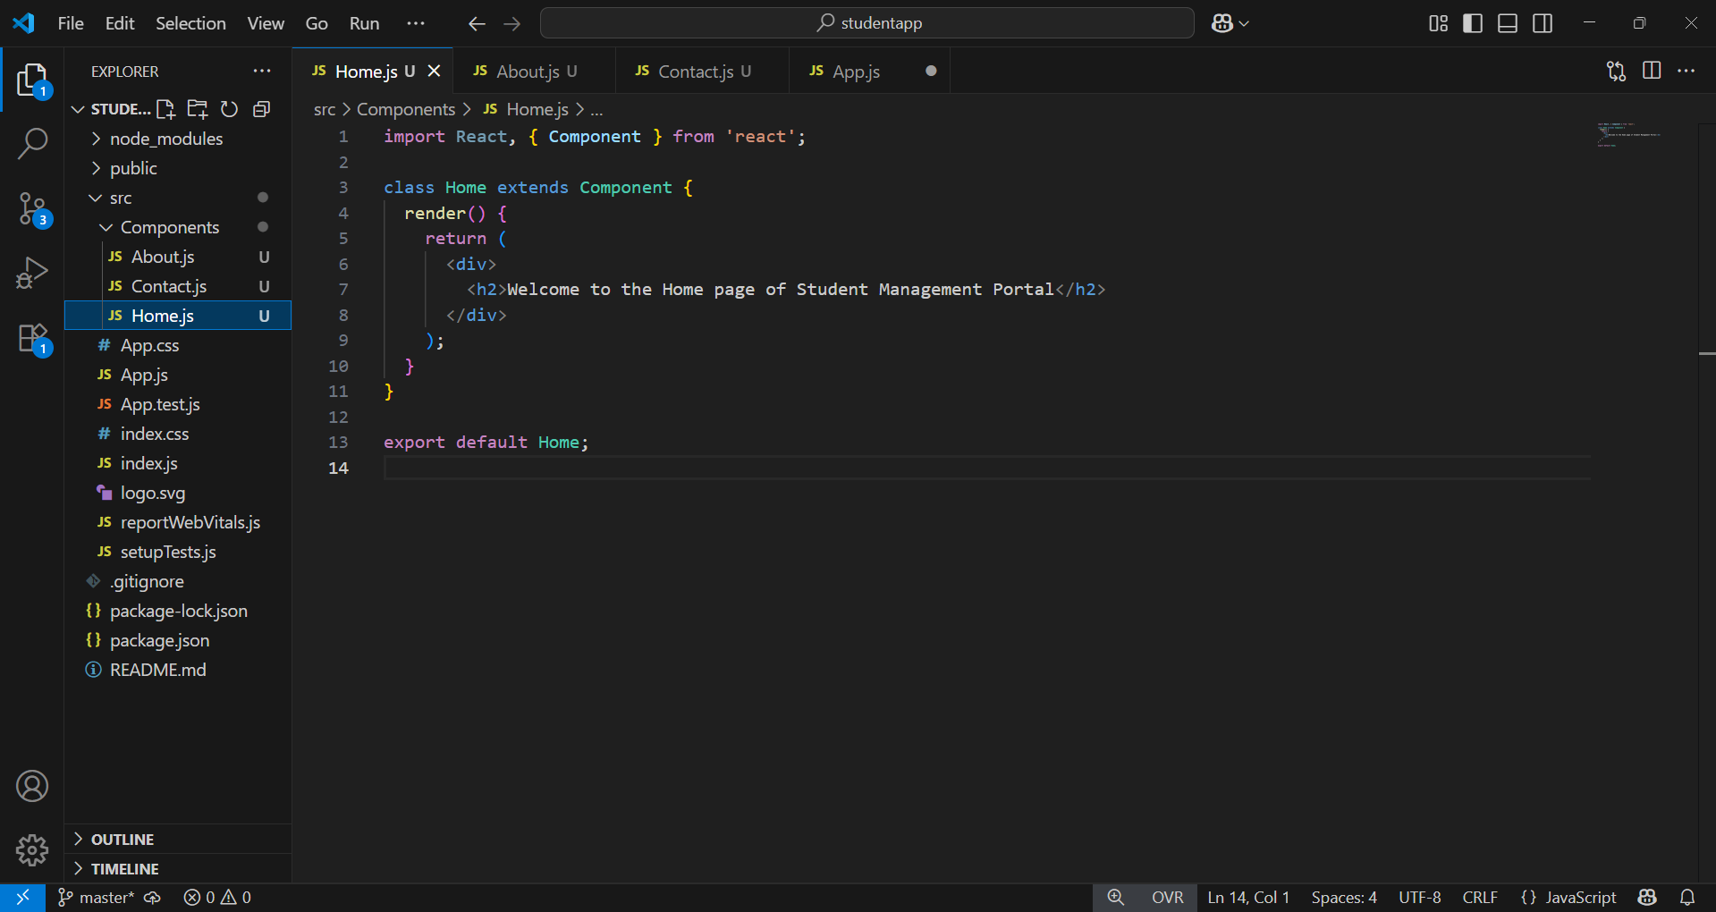

App.js

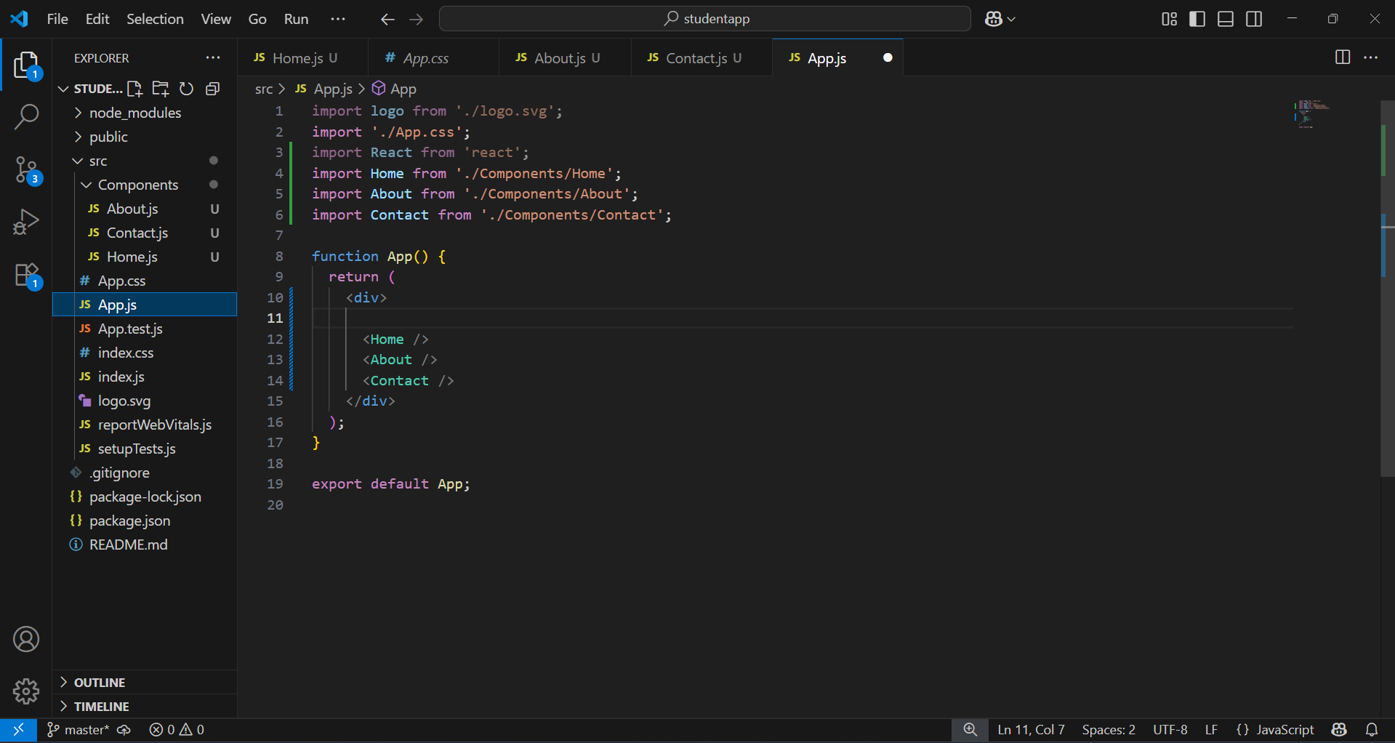

Output

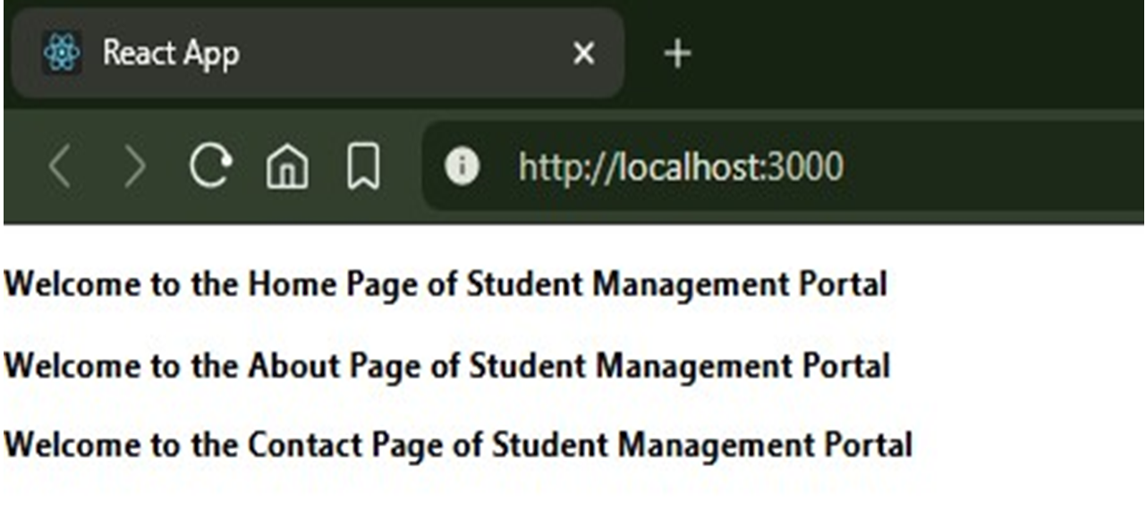

3. ReactJS-HOL

CalculateScore.js

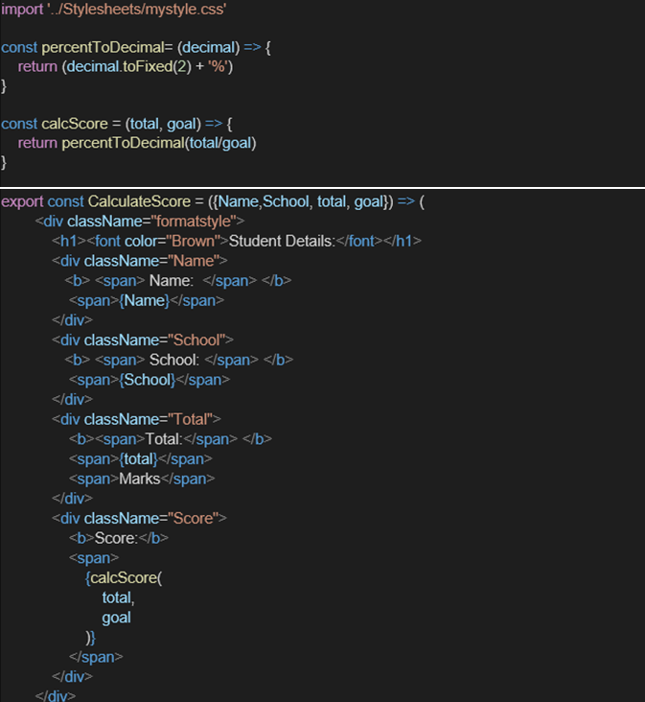

MyStyle.css

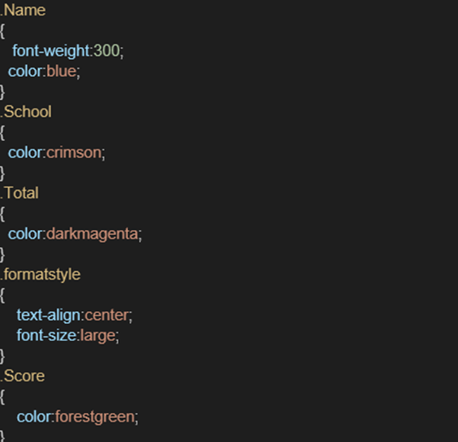

App.js

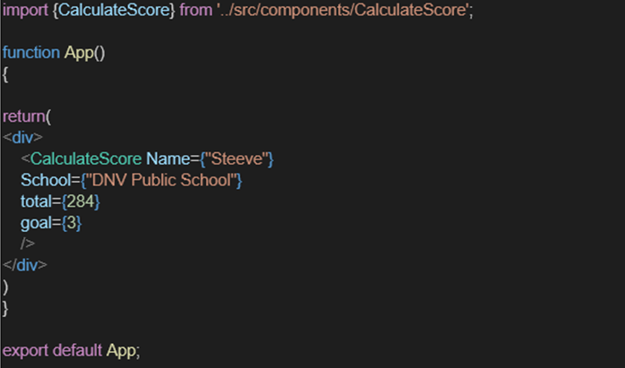

Output

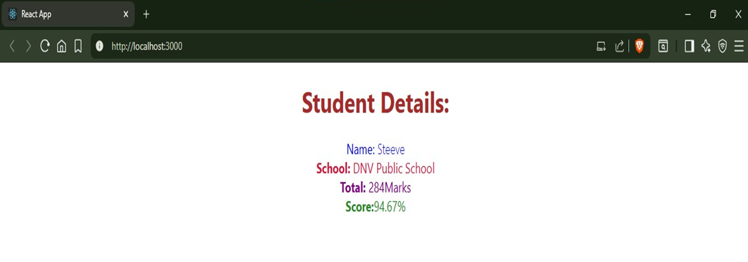

4. ReactJS-HOL

Create post.js in src

##### **class Post {**

##### **constructor(id, title, body) {**

##### **this.id = id;**

##### **this.title = title;**

##### **this.body = body;**

##### **}**

##### **}**

##### **export default Post;**

post.js

**import React from 'react';**

**import Post from './Post';**

**class Posts extends React.Component {**

**constructor(props) {**

**super(props);**

**// Initialize state with an empty posts array and error**

**this.state = {**

**posts: [],**

**error: null**

**};**

**}**

**// Method to load posts using fetch**

**loadPosts = () => {**

**fetch('https://jsonplaceholder.typicode.com/posts')**

**.then(response => {**

**if (!response.ok) {**

**throw new Error('Network response was not ok');**

**}**

**return response.json();**

**})**

**.then(data => {**

**// Map data to Post class instances**

**const posts = data.map(**

**item => new Post(item.id, item.title, item.body)**

**);**

**this.setState({ posts });**

**})**

**.catch(error => {**

**// Set error in state for error boundary**

**this.setState({ error });**

**throw error;**

**});**

**};**

**// Lifecycle method: fetch data when component mounts**

**componentDidMount() {**

**this.loadPosts();**

**}**

**// Error boundary method**

**componentDidCatch(error, info) {**

**alert("An error occurred: " + error.message);**

**}**

**// Render posts or error message**

**render() {**

**if (this.state.error) {**

**return <div>Error loading posts: {this.state.error.message}</div>;**

**}**

**return (**

**<div>**

**<h1>All Posts</h1>**

**{this.state.posts.length === 0 ? (**

**<p>Loading posts...</p>**

**) : (**

**this.state.posts.map(post => (**

**<div key={post.id} style={{marginBottom: '16px'}}>**

**<h3>{post.title}</h3>**

**<p>{post.body}</p>**

**</div>**

**))**

**)}**

**</div>**

**);**

**}export default Posts**

App.js

**import React from 'react';**

**import Posts from './Posts';**

**function App() {**

**return (**

**<div>**

**<Posts />**

**</div>**

**);**

**}**

**export default App;**

Output

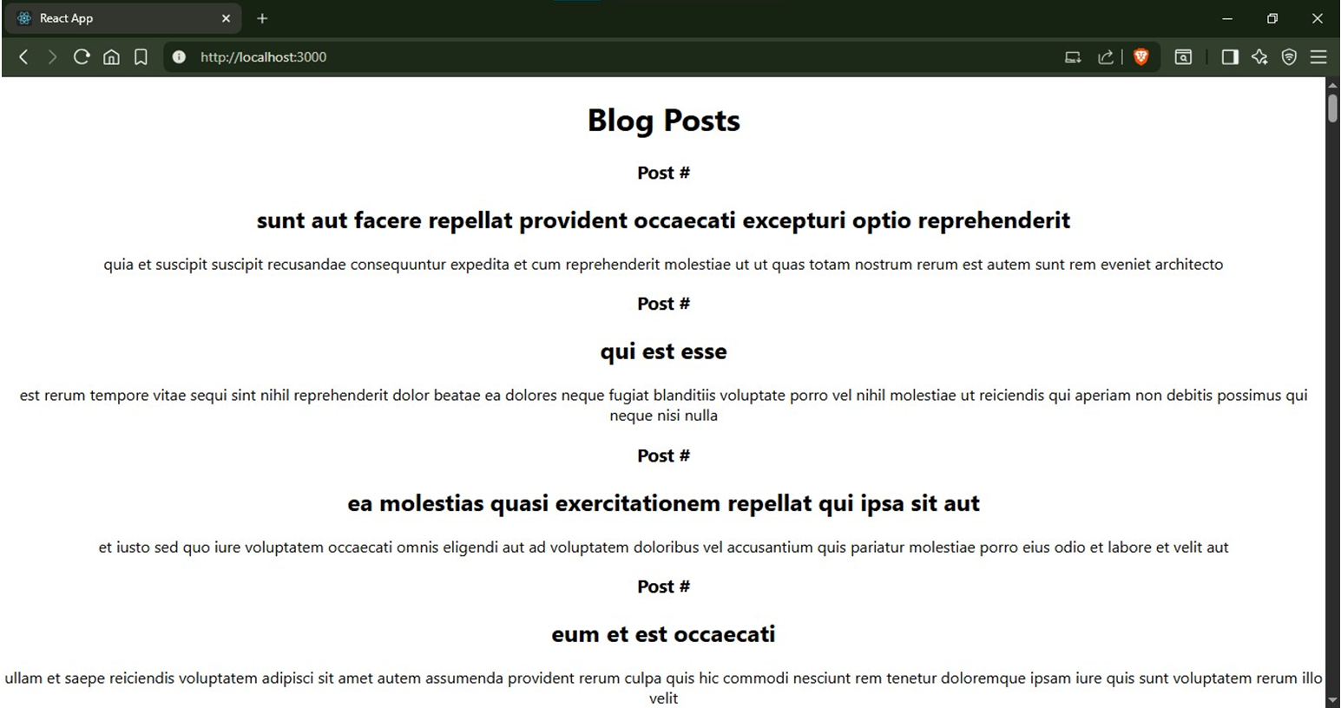

5. ReactJS-HOL

Cohort.js

class Cohort {

constructor(cohortCode,

startDate,

technology,

trainerName,

coachName,

currentStatus) {

this.cohortCode = cohortCode;

this.coachName = coachName;

this.trainerName = trainerName;

this.technology = technology;

this.startDate = startDate;

this.currentStatus = currentStatus;

}

}

const CohortsData =[

new Cohort('INTADMDF10','22-Feb-2022', '.NET FSD', 'Jojo Jose','Aathma', 'Scheduled'),

new Cohort('ADM21JF014','10-Sep-2021', 'Java FSD', 'Elisa Smith','Apoorv', 'Ongoing'),

new Cohort('CDBJF21025','24-Dec-2021', 'Java FSD', 'John Doe','Aathma', 'Ongoing'),

new Cohort('INTADMJF12','22-Feb-2022', 'Java FSD', 'To Be Assigned','Ibrahim', 'Scheduled'),

new Cohort('CDE22JF011','24-Dec-2021', 'Java FSD', 'Emma Swan','Apoorv', 'Ongoing'),

new Cohort('INTADMDF09','22-Feb-2022', 'Dataware Housing', 'Babjee Rao','Aathma', 'Scheduled'),

new Cohort('ADM22DF001','10-Sep-2021', '.NET FSD', 'Marie Curie','Ibrahim', 'Ongoing'),

];

export {Cohort, CohortsData};

CohortDetails.js

import React from 'react';

import styles from './CohortDetails.module.css';

function CohortDetails({ cohort }) {

const statusStyle = {

color: cohort.currentStatus.toLowerCase() === 'ongoing' ? 'green' : 'blue'

};

return (

<div className={styles.box}>

<h3 style={statusStyle}>

{cohort.cohortCode} - {cohort.technology}

</h3>

<dl>

<dt>Started On</dt>

<dd>{cohort.startDate}</dd>

<dt>Current Status</dt>

<dd>{cohort.currentStatus}</dd>

<dt>Coach</dt>

<dd>{cohort.coachName}</dd>

<dt>Trainer</dt>

<dd>{cohort.trainerName}</dd>

</dl>

</div>

);

}

export default CohortDetails;

App.js

import React from 'react';

import './App.css';

import styles from './CohortDetails.module.css';

import { CohortsData } from './Cohort'

import CohortDetails from './CohortDetails';

function App() {

return (

<div className={styles.container}>

<h2>Cohorts Details</h2>

<div className={styles['cards-wrapper']}>

{CohortsData.map((cohort, index) => (

<CohortDetails key={index} cohort={cohort} />

))}

</div>

</div>

);

}

export default App;

Output

