**Week3 Mandatory Handson**

**1.Spring rest Handson**

**Hands on 1**

**Create a Spring Web Project using Maven**

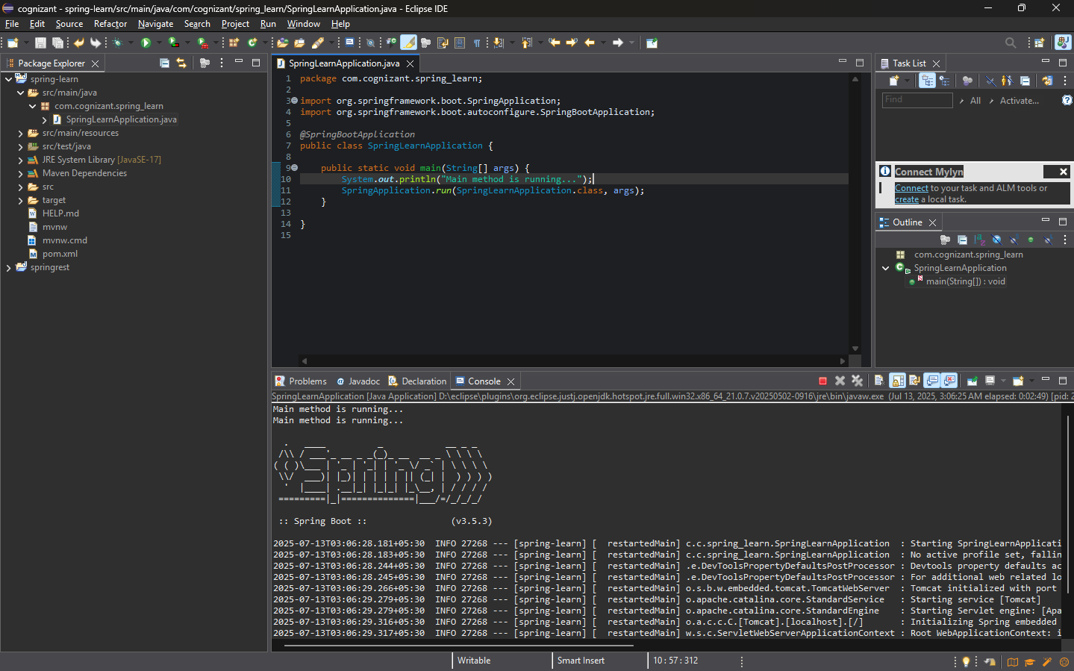**9. Include logs to verify if main() method of SpringLearnApplication**

**5. Purpose of @SpringBootApplication annotation**

It comprises of 3 things in @SpringBootApplication

* @configuration-marks class as a source of bean
* @Enableautoconfiguration-enable spring boot auto configuration
* @Componentscan-scan the packet of components

**Hands on 4**

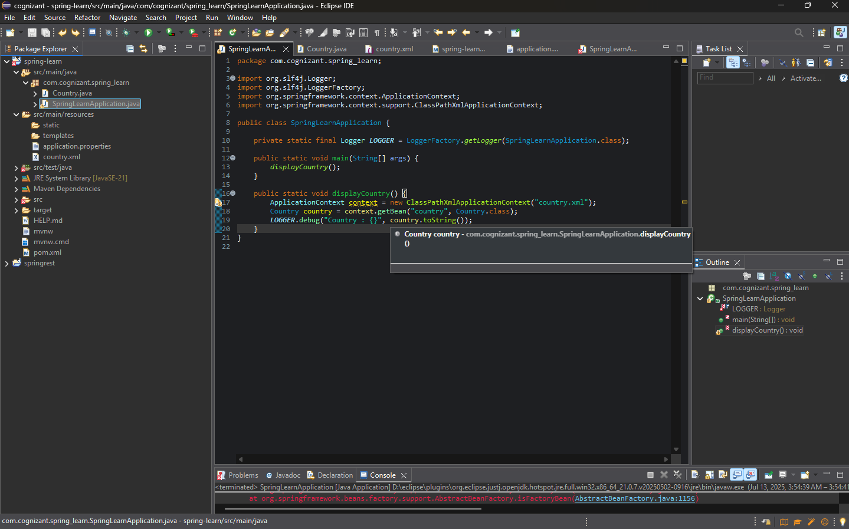**Spring Core – Load Country from Spring Configuration XML**

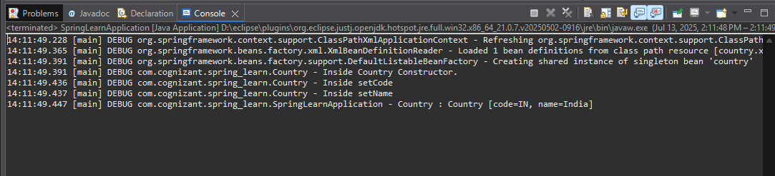Output –

**2.Spring – rest HandsOn**

**Hello World RESTful Web Service**

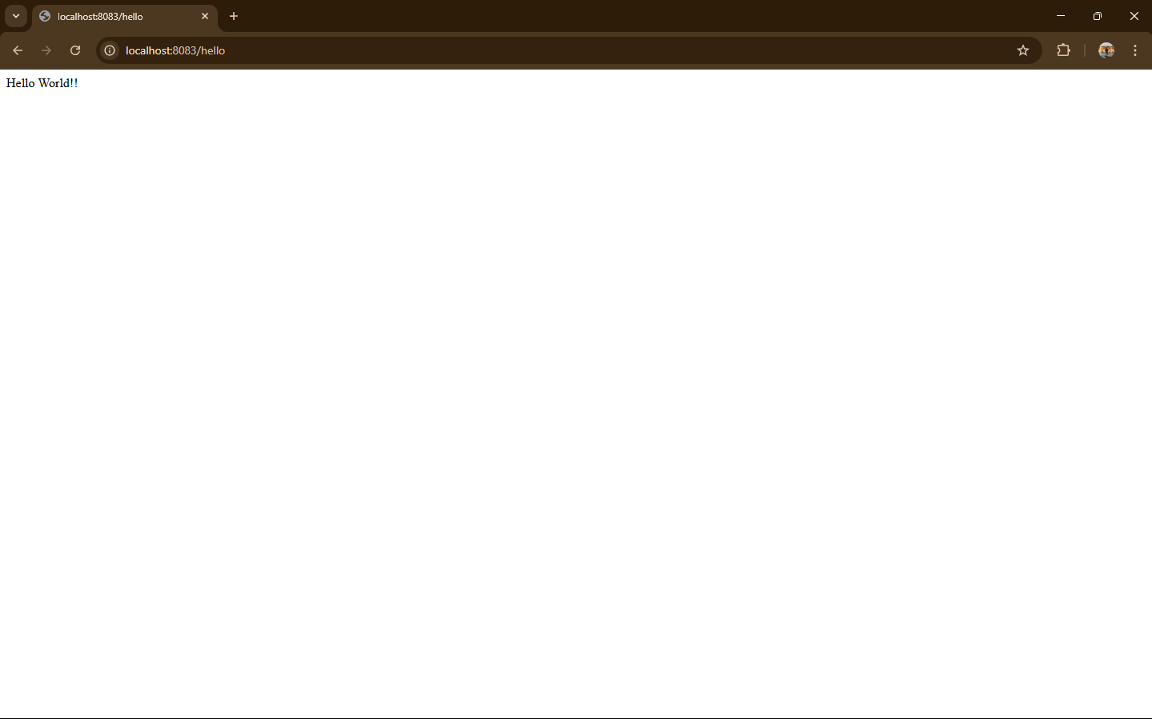**Try the URL http://localhost:8083/hello in both chrome browser and postman.**

**LOG CONSOLE**

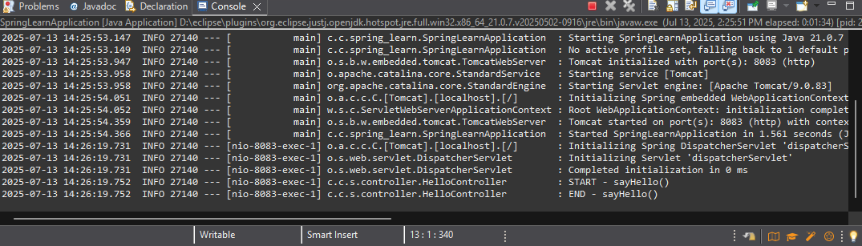

**REST - Country Web Service**

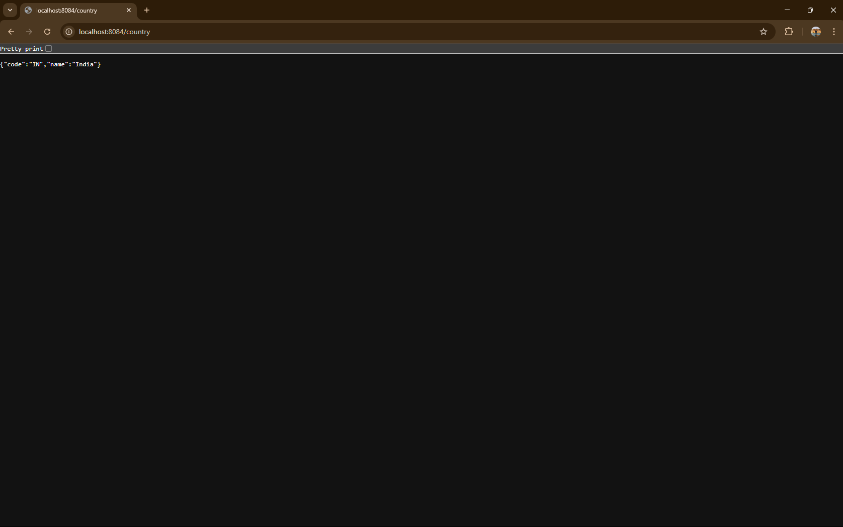**Output**

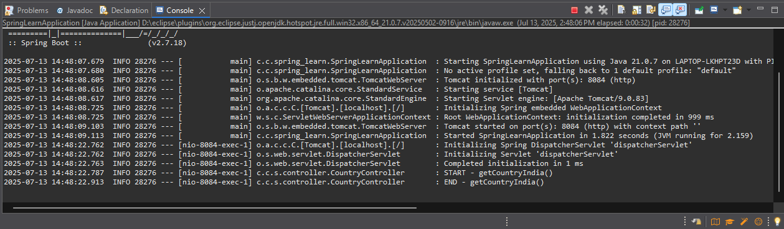**Log console**

**3.JWT HANDSon**

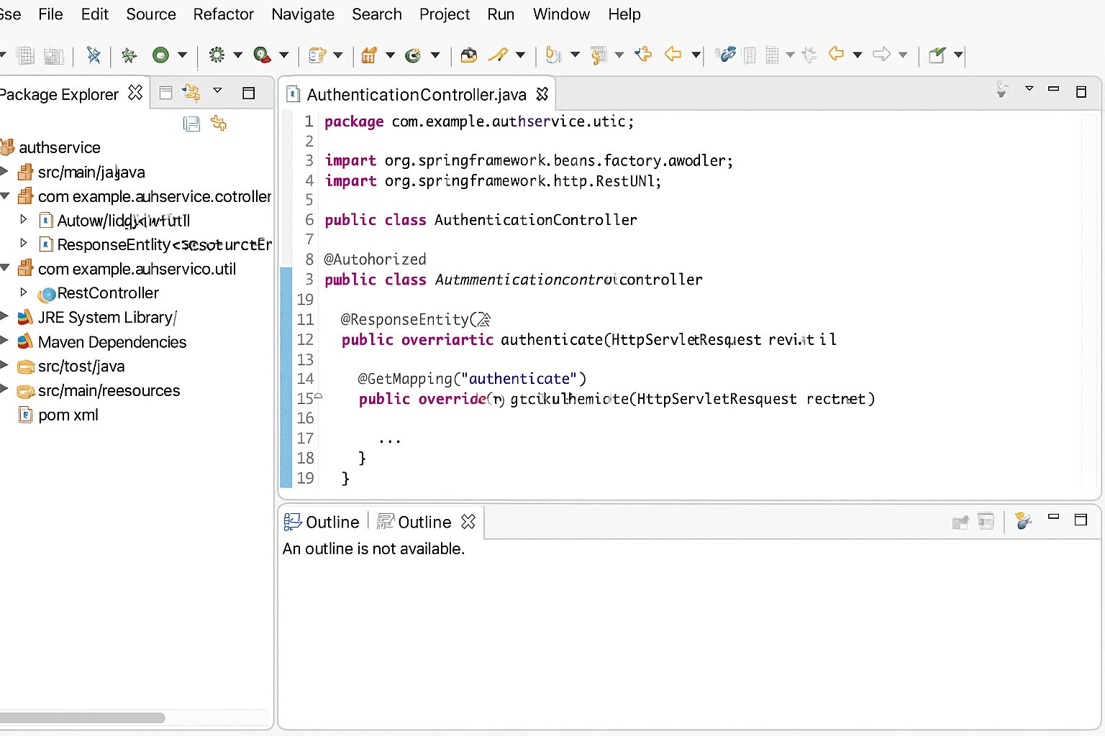**Create authentication service that returns JWT**