**Week 2**

***PLSQL Exercises***

**Control Structures**

CREATE TABLE customers (

customer_id NUMBER PRIMARY KEY,

name VARCHAR2(100),

dob DATE,

balance NUMBER,

is_vip CHAR(1) DEFAULT 'N'

);

INSERT INTO customers VALUES (1, 'Alice', DATE '1950-05-10', 12000, 'N');

INSERT INTO customers VALUES (2, 'Bob', DATE '1970-01-15', 8000, 'N');

ALTER TABLE customers ADD (interest_rate NUMBER DEFAULT 5);

UPDATE customers SET interest_rate = 5;

DECLARE

CURSOR c_cust IS

SELECT customer_id, dob, interest_rate

FROM customers;

v_age NUMBER;

v_new_rate NUMBER;

BEGIN

FOR rec IN c_cust LOOP

SELECT TRUNC(MONTHS_BETWEEN(SYSDATE, rec.dob) / 12)

INTO v_age

FROM dual;

IF v_age > 60 THEN

v_new_rate := rec.interest_rate - 1;

UPDATE customers

SET interest_rate = v_new_rate

WHERE customer_id = rec.customer_id;

DBMS_OUTPUT.PUT_LINE(

'Cust ' || rec.customer_id

|| ' age ' || v_age

|| ': new rate = ' || v_new_rate

);

END IF;

END LOOP;

COMMIT;

END;

/

BEGIN

FOR cust_rec IN (

SELECT customer_id

FROM customers

WHERE balance > 10000

) LOOP

UPDATE customers

SET is_vip = 'Y'

WHERE customer_id = cust_rec.customer_id;

DBMS_OUTPUT.PUT_LINE(

'Cust ' || cust_rec.customer_id

|| ' flagged as VIP'

);

END LOOP;

COMMIT;

END;

/

CREATE TABLE loans (

loan_id NUMBER PRIMARY KEY,

customer_id NUMBER NOT NULL,

principal NUMBER(12,2),

interest_rate NUMBER(5,2),

start_date DATE,

due_date DATE,

status VARCHAR2(20)

);

INSERT INTO loans VALUES (101, 1, 5000, 5.50, SYSDATE - 100, SYSDATE + 10, 'ACTIVE');

INSERT INTO loans VALUES (102, 2, 15000, 6.25, SYSDATE - 200, SYSDATE + 40, 'ACTIVE');

INSERT INTO loans VALUES (103, 3, 8000, 4.90, SYSDATE - 400, SYSDATE - 10, 'PAID');

BEGIN

FOR loan_rec IN (

SELECT l.loan_id, l.customer_id, l.due_date, c.name

FROM loans l

JOIN customers c

ON l.customer_id = c.customer_id

WHERE l.due_date BETWEEN TRUNC(SYSDATE)

AND TRUNC(SYSDATE) + 30

) LOOP

DBMS_OUTPUT.PUT_LINE(

'Reminder: Loan ' || loan_rec.loan_id

|| ' for Customer ' || loan_rec.customer_id

|| ' (' || loan_rec.name || ') '

|| 'is due on ' || TO_CHAR(loan_rec.due_date, 'DD-MON-YYYY')

);

END LOOP;

END;

/

**Stored Procedures**

CREATE TABLE Accounts (

AccountID NUMBER PRIMARY KEY,

customer_id NUMBER NOT NULL,

AccountType VARCHAR2(20) NOT NULL,

Balance NUMBER(15,2) DEFAULT 0 CHECK (Balance >= 0),

LastModified DATE DEFAULT SYSDATE,

FOREIGN KEY (customer_id) REFERENCES customers(customer_id)

)

INSERT INTO Accounts (AccountID, customer_id, AccountType, Balance, LastModified)

VALUES (1, 1, 'Savings', 1000, SYSDATE)

INSERT INTO Accounts (AccountID, customer_id, AccountType, Balance, LastModified)

VALUES (2, 2, 'Checking', 1500, SYSDATE)

CREATE OR REPLACE PROCEDURE ProcessMonthlyInterest AS

BEGIN

UPDATE accounts

SET balance = ROUND(Balance * 1.01, 2)

WHERE AccountType = 'SAVINGS';

COMMIT;

DBMS_OUTPUT.PUT_LINE(SQL%ROWCOUNT || ' savings accounts updated with 1% interest.');

END ProcessMonthlyInterest;

CREATE TABLE Employees (

EmployeeID NUMBER PRIMARY KEY,

Name VARCHAR2(100),

Position VARCHAR2(50),

Salary NUMBER,

Department VARCHAR2(50),

HireDate DATE

);

INSERT INTO Employees VALUES (1, 'Alice Johnson', 'Branch Manager', 75000, 'Operations', DATE '2015-06-15');

INSERT INTO Employees VALUES (2, 'Bob Singh', 'Customer Support', 45000, 'Customer Service', DATE '2018-09-01');

INSERT INTO Employees VALUES (3, 'Carol Chen', 'Loan Officer', 55000, 'Lending', DATE '2019-11-20');

INSERT INTO Employees VALUES (4, 'David Kumar', 'IT Analyst', 65000, 'IT', DATE '2017-03-05');

INSERT INTO Employees VALUES (5, 'Eva Patel', 'HR Coordinator', 48000, 'Human Resources', DATE '2020-01-10');

CREATE OR REPLACE PROCEDURE UpdateEmployeeBonus (

p_department IN VARCHAR2,

p_bonus_pct IN NUMBER

) AS

BEGIN

UPDATE Employees

SET Salary = Salary * (1 + p_bonus_pct/100)

WHERE Department = p_department;

COMMIT;

DBMS_OUTPUT.PUT_LINE(

'Updated salaries in department "' || p_department ||

'" by ' || p_bonus_pct || '%, rows affected: ' || SQL%ROWCOUNT

);

END UpdateEmployeeBonus;

/

CREATE OR REPLACE PROCEDURE TransferFunds (

p_from_acct IN NUMBER,

p_to_acct IN NUMBER,

p_amount IN NUMBER

) AS

v_balance NUMBER;

BEGIN

-- Lock the source account row and check current balance

SELECT Balance INTO v_balance

FROM Accounts

WHERE AccountID = p_from_acct

FOR UPDATE;

IF v_balance < p_amount THEN

RAISE_APPLICATION_ERROR(-20001, 'Insufficient funds in account ' || p_from_acct);

END IF;

-- Deduct from source account

UPDATE Accounts

SET Balance = Balance - p_amount,

LastModified = SYSDATE

WHERE AccountID = p_from_acct;

-- Add to destination account

UPDATE Accounts

SET Balance = Balance + p_amount,

LastModified = SYSDATE

WHERE AccountID = p_to_acct;

COMMIT;

DBMS_OUTPUT.PUT_LINE('Transferred ' || TO_CHAR(p_amount) ||

' from account ' || p_from_acct ||

' to ' || p_to_acct);

EXCEPTION

WHEN NO_DATA_FOUND THEN

ROLLBACK;

RAISE_APPLICATION_ERROR(-20002, 'One or both account IDs not found');

WHEN OTHERS THEN

ROLLBACK;

RAISE;

END TransferFunds;

/

***JUnit Basic Testing Exercises***

**Setting Up JUnit**

The pom.xml file

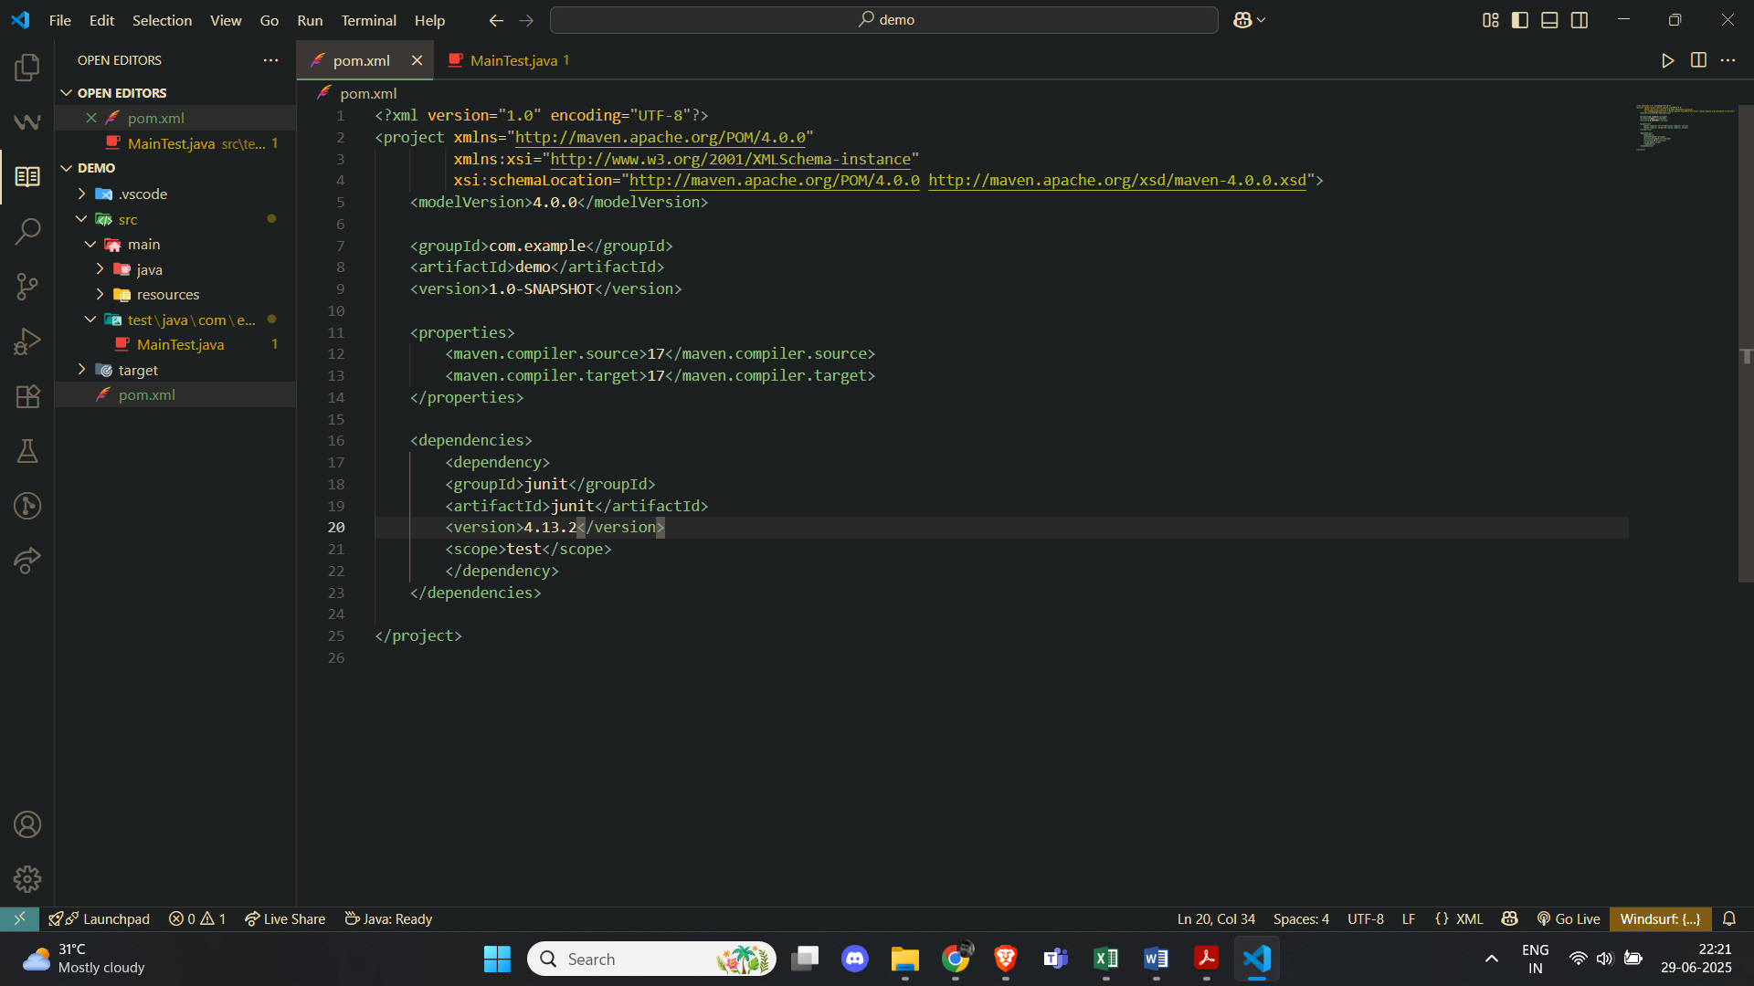

Test class in my project

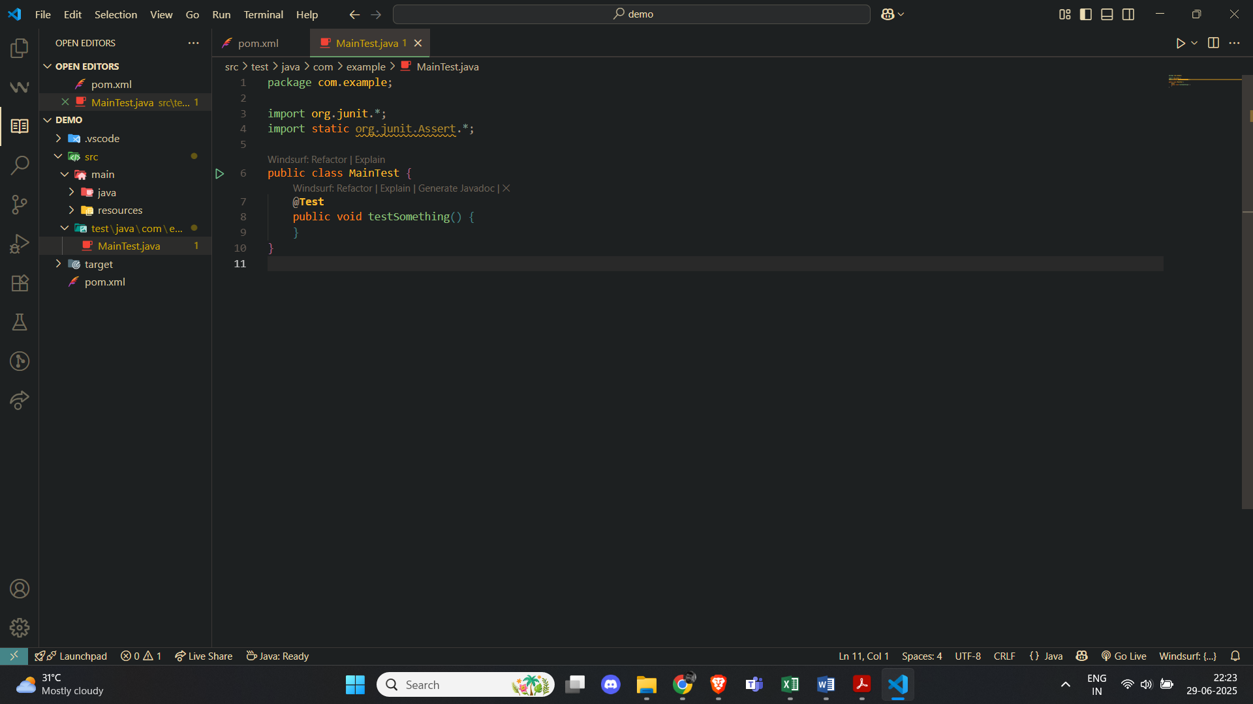

**Assertions in JUnit**

AssertionTest.java

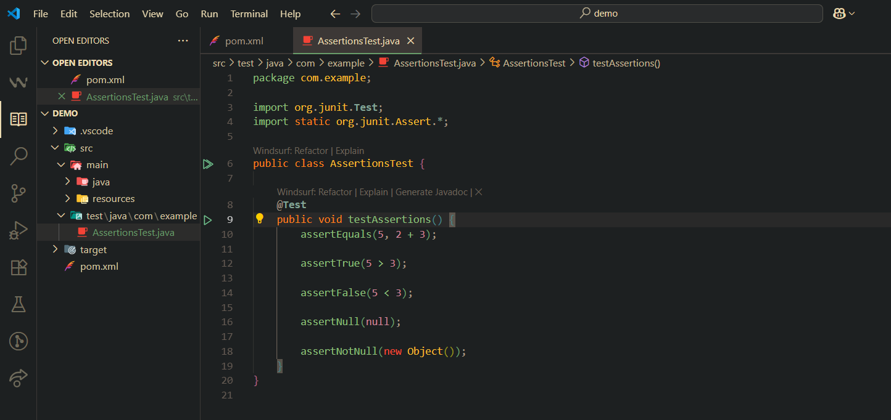

Output

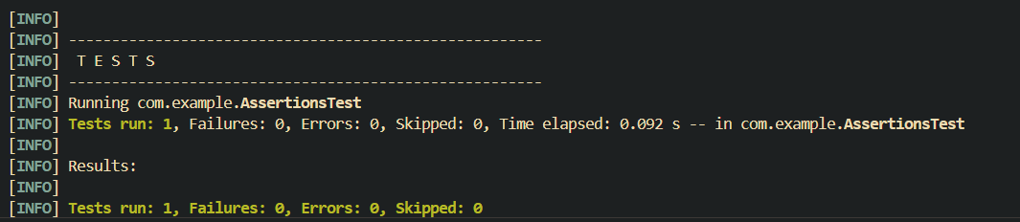

**Arrange-Act-Assert (AAA) Pattern, Test Fixtures, Setup and teardown Methods in JUnit**

CalculatorTest.java

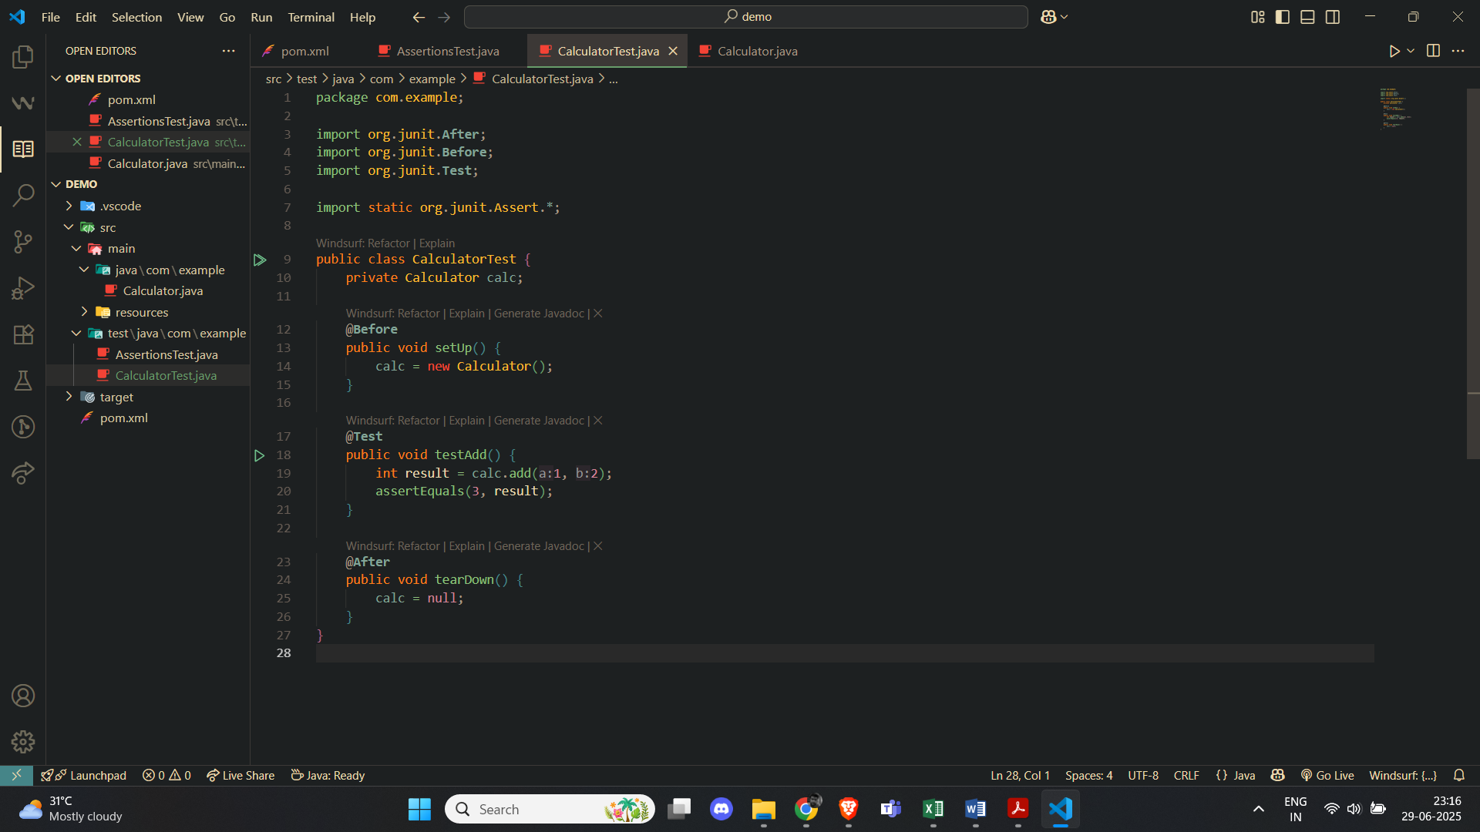

Output

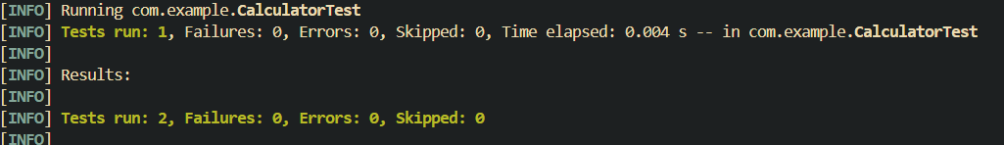

***Mockito exercises***

**Mocking and Stubbing**

import static org.mockito.Mockito.*;

import static org.junit.jupiter.api.Assertions.*;

import org.junit.jupiter.api.Test;

import org.mockito.Mockito;

class MyServiceTest {

@Test

void testExternalApiReturnsMockData() {

ExternalApi mockApi = Mockito.mock(ExternalApi.class);

when(mockApi.getData()).thenReturn("Mock Data");

MyService service = new MyService(mockApi);

String result = service.fetchData();

assertEquals("Mock Data", result);

}

}

**Verifying Interactions**

import static org.mockito.Mockito.*;

import static org.junit.jupiter.api.Assertions.*;

import org.junit.jupiter.api.Test;

import org.mockito.Mockito;

class MyServiceTest {

@Test

void testVerifyApiCall() {

ExternalApi mockApi = Mockito.mock(ExternalApi.class);

MyService service = new MyService(mockApi);

service.fetchData();

verify(mockApi, times(1)).getData();

verifyNoMoreInteractions(mockApi);

}

}

***SL4J Logging exercises***

**Logging Error Messages and Warning Levels**

pom.xml

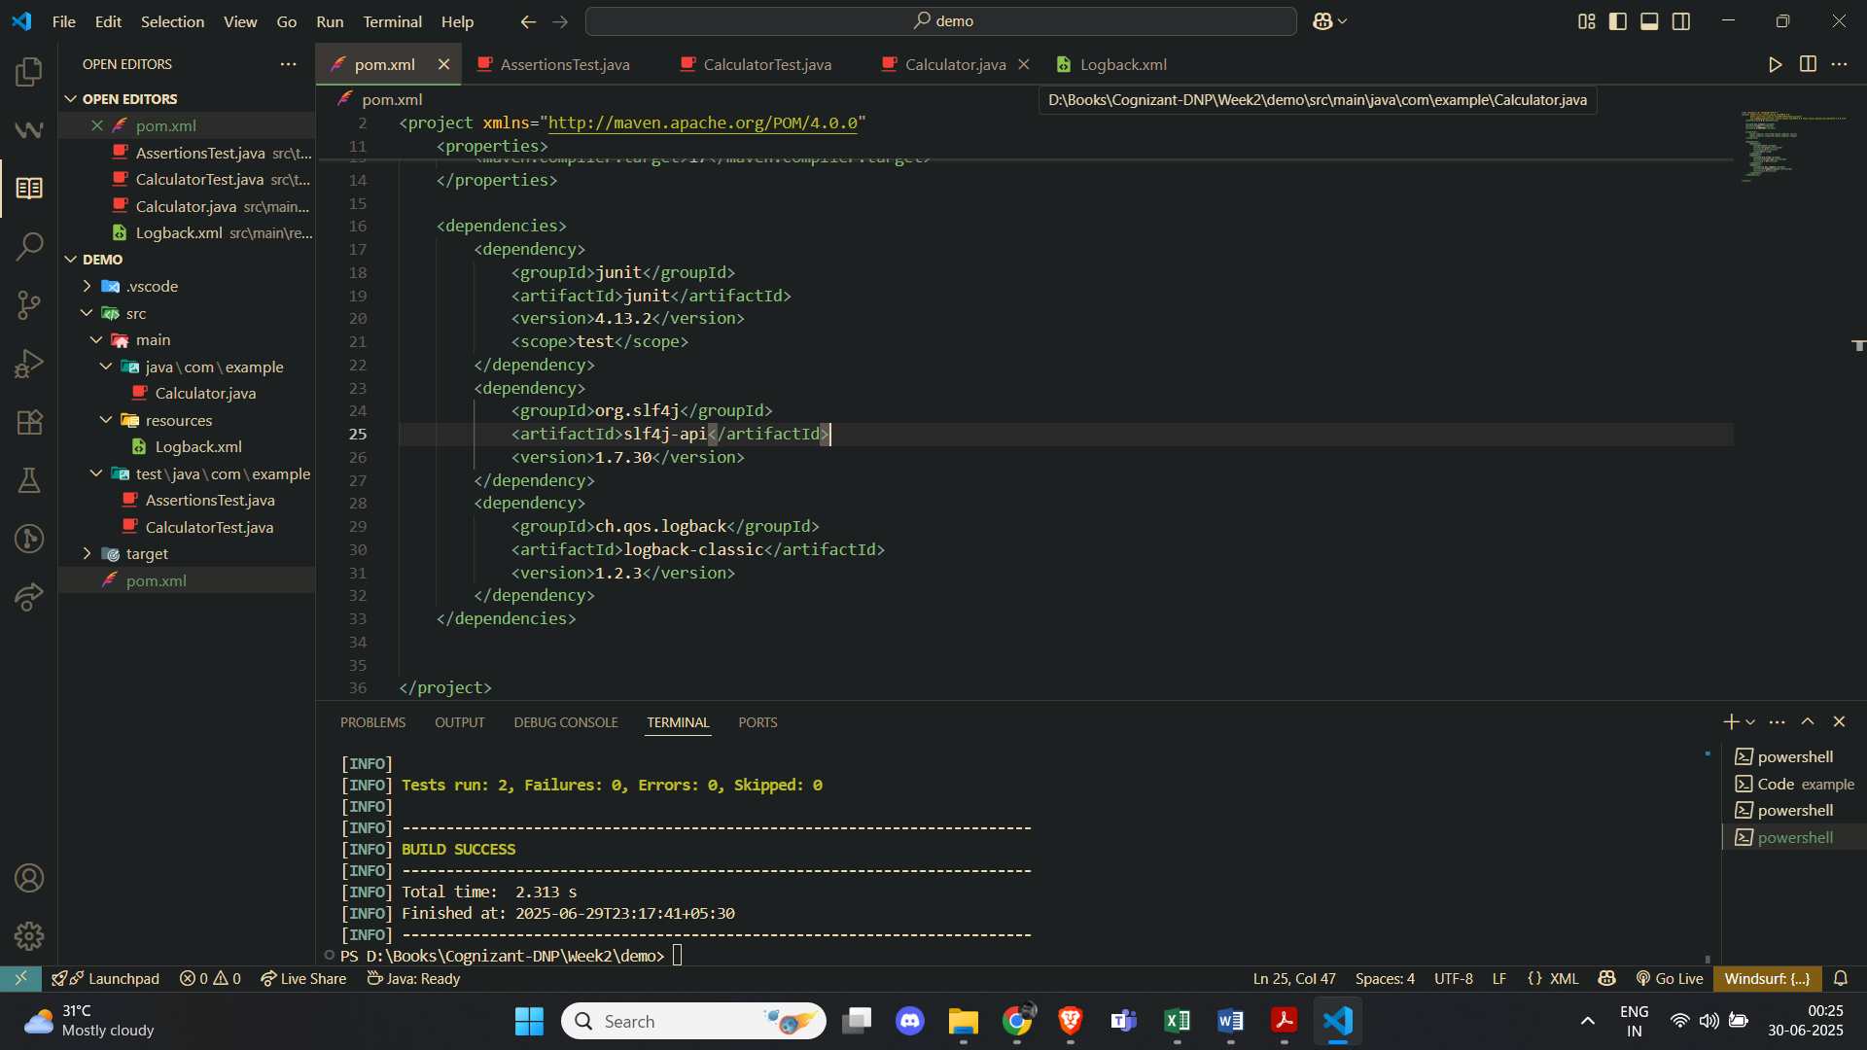

logback.xml

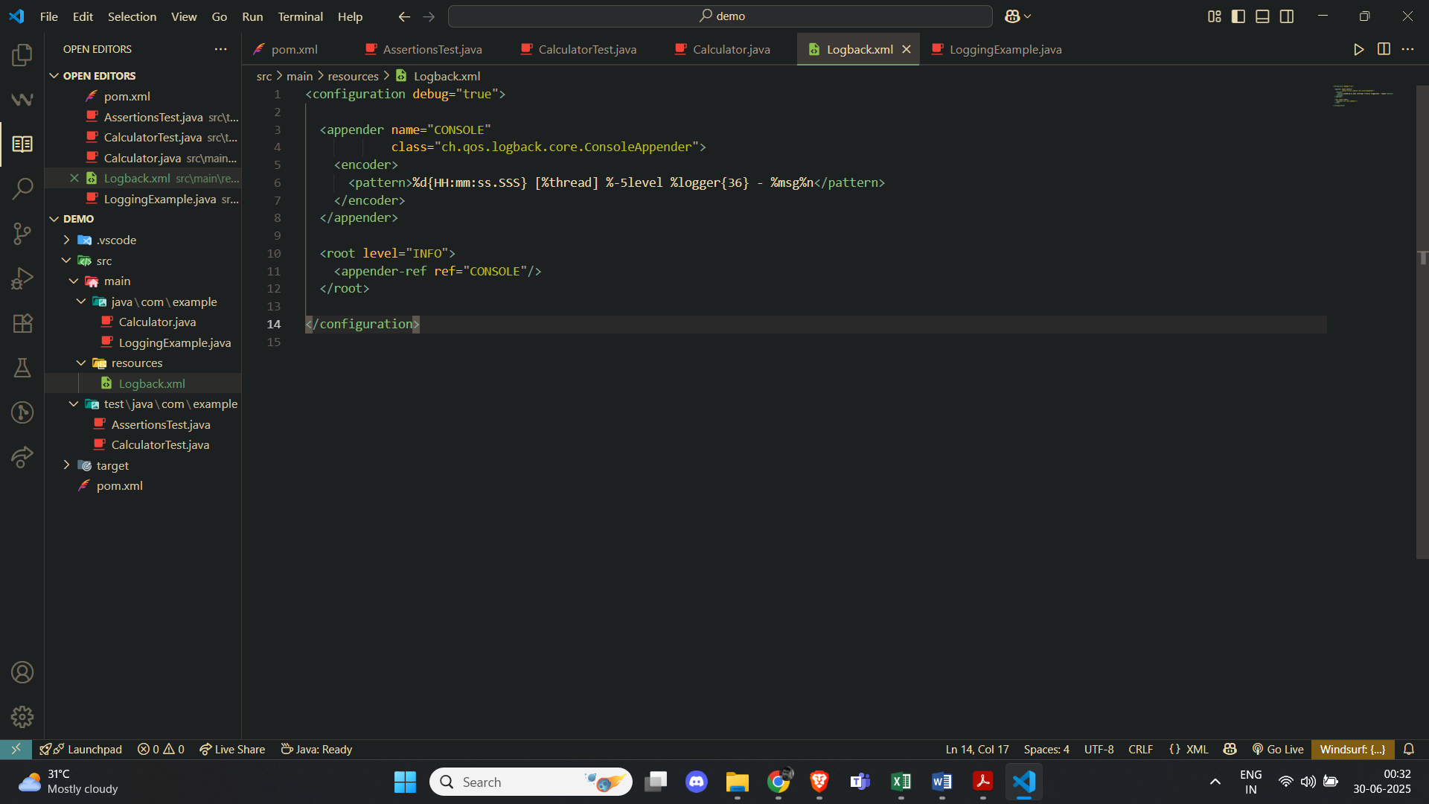

LoggingExample.java

