**Spring REST using Spring Boot 3**

**Create a Spring Web Project using Maven**

**pom.xml**

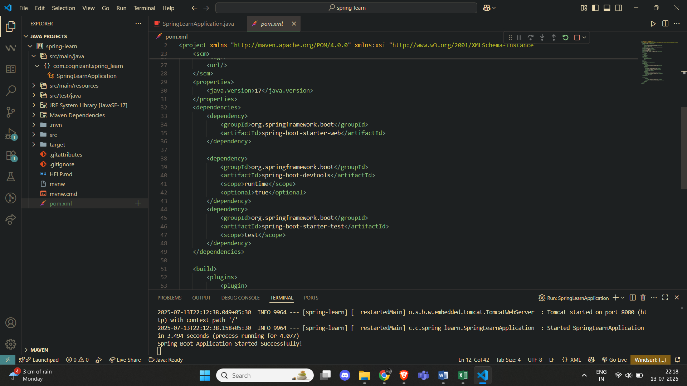

**SpringLearnApplication.java**

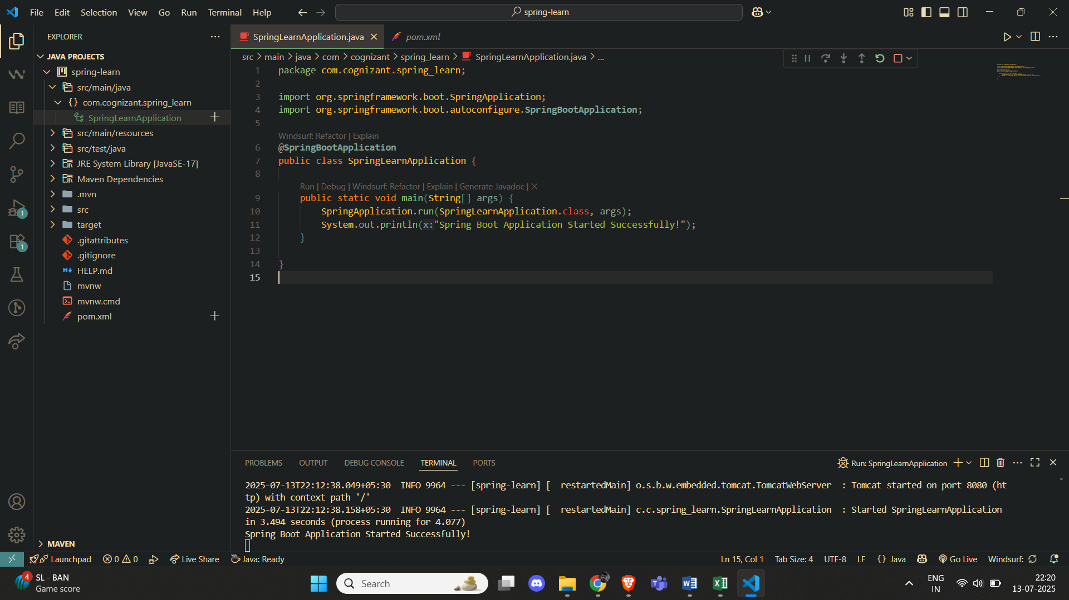

**Output**



**Spring Core – Load Country from Spring Configuration XML**

**SpringLearnApplication.java**

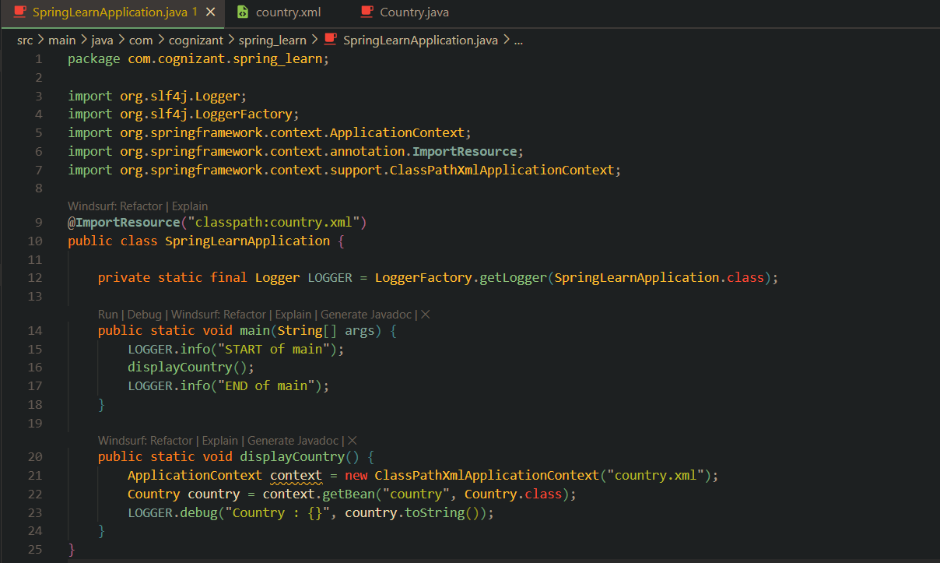

**Country.java**

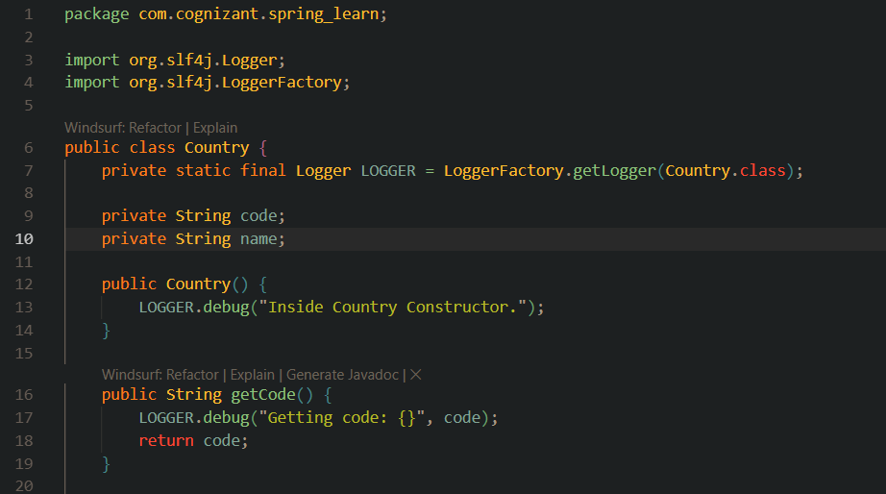

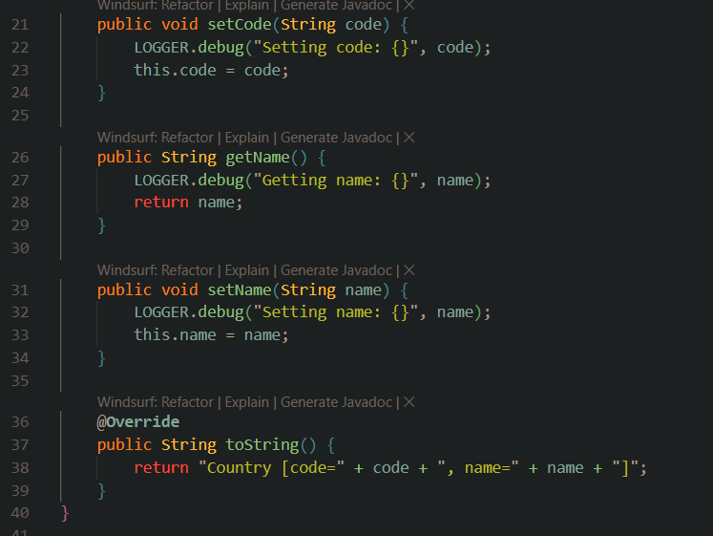

**country.xml**

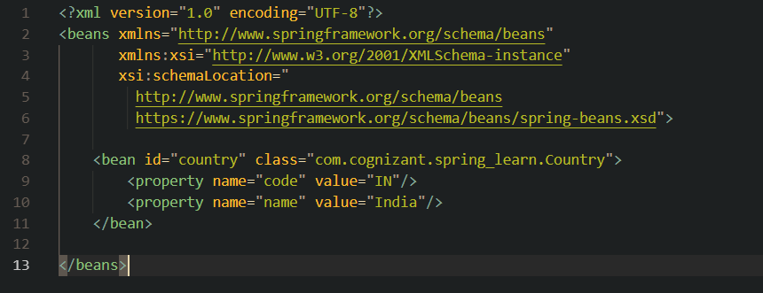

**Output**



**Hello World RESTful Web Service**

**HelloController.java**

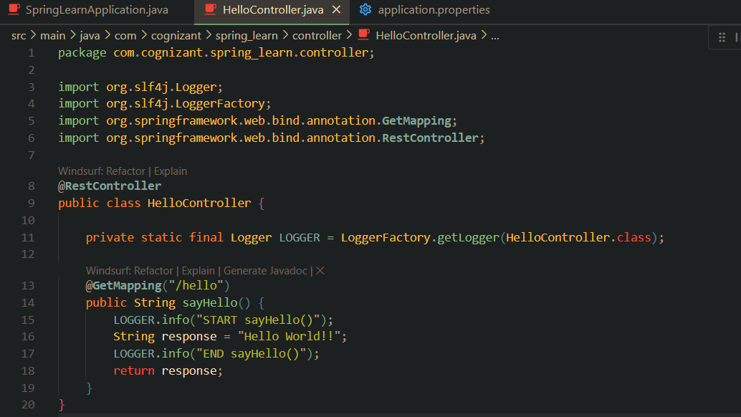

**application.properties**

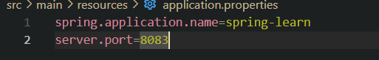

**Output (Chrome Browser)**

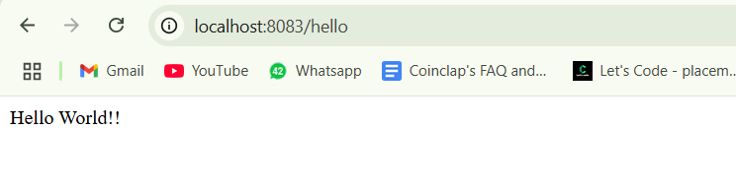

**Output (Console)**



**REST - Country Web Service**

**CountryController.java**

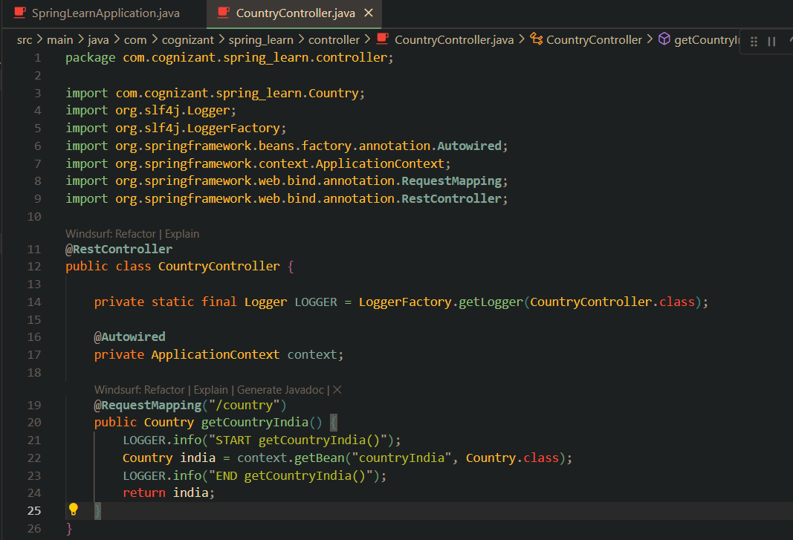

**Output (Chrome Browser)**

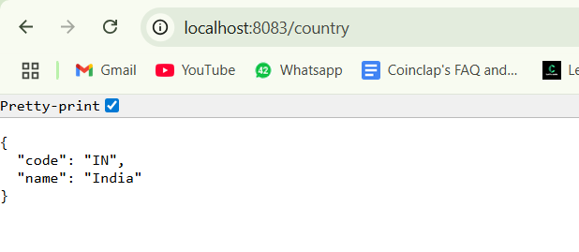

**REST - Get country based on country code**

**country.xml**

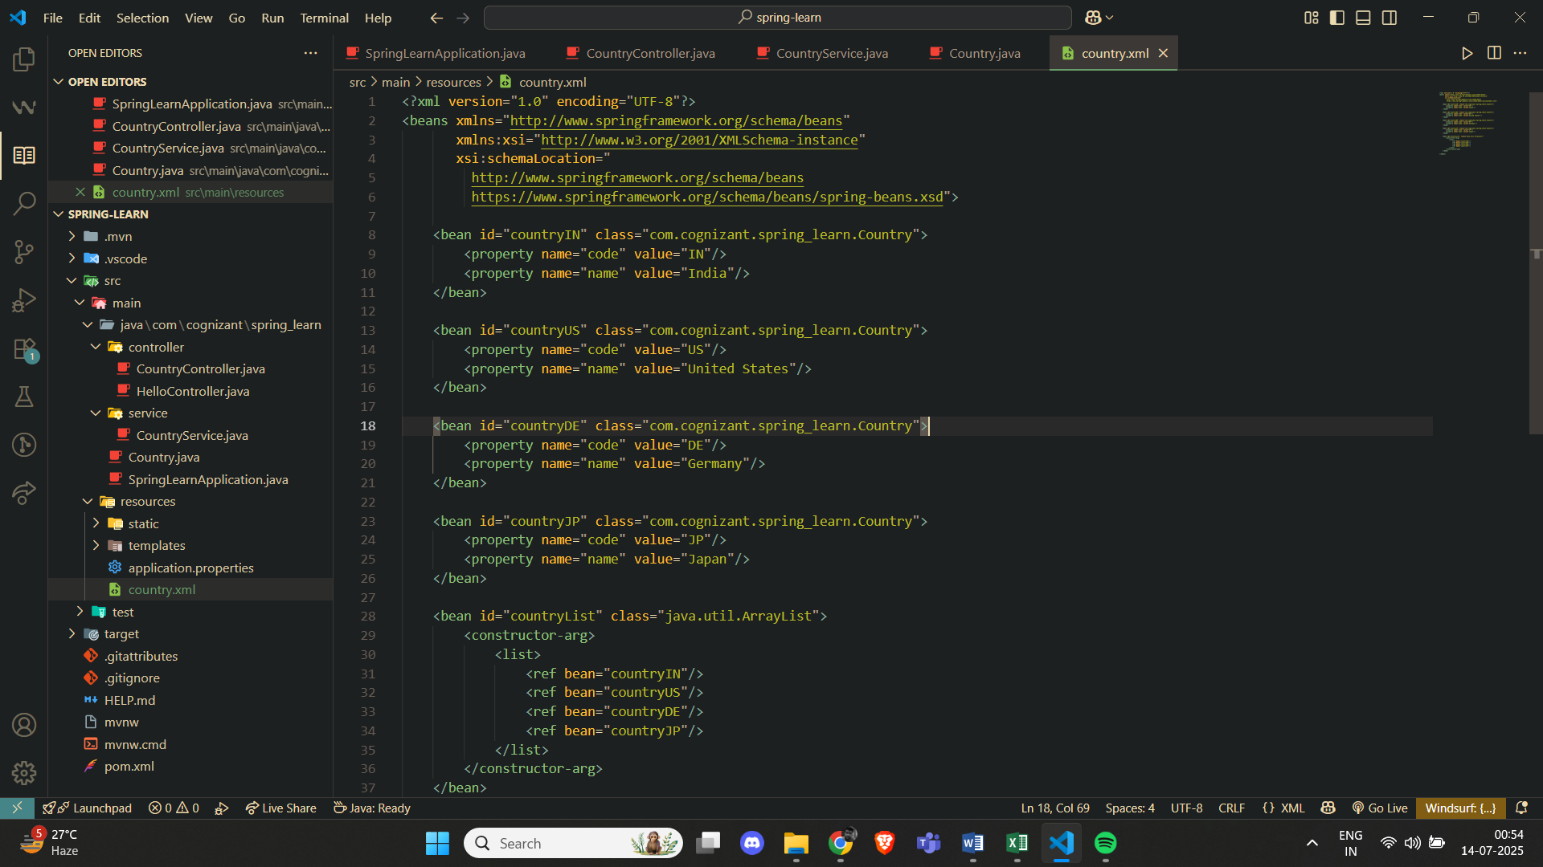

**CountryService.java**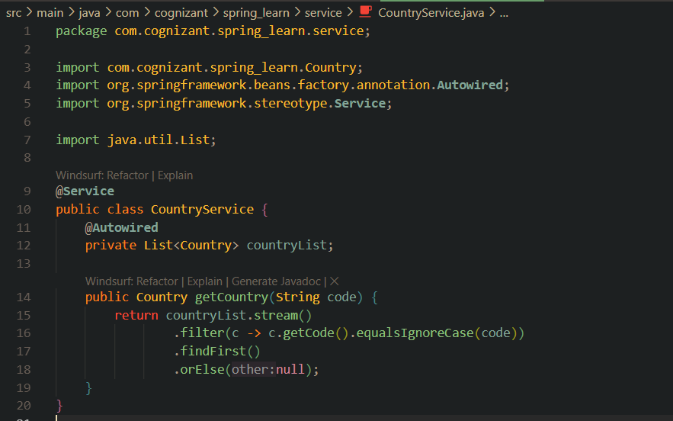

**CountryController.java**

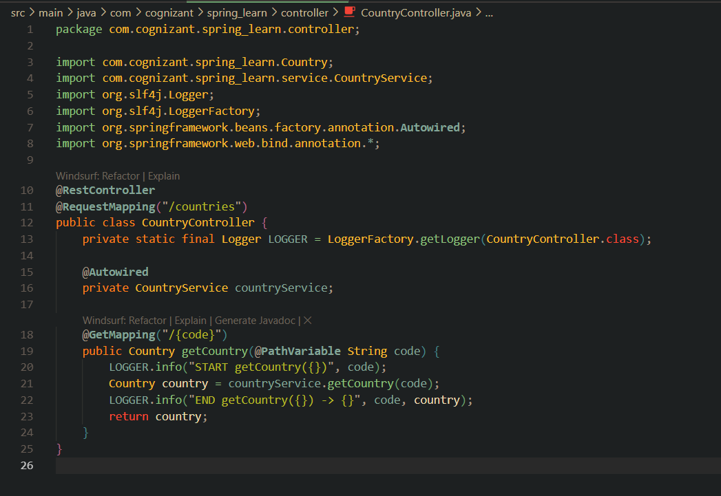

**Output (Chrome Browser)**

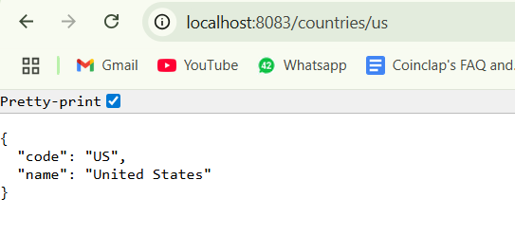

**Create authentication service that returns JWT**

**AuthController.java**

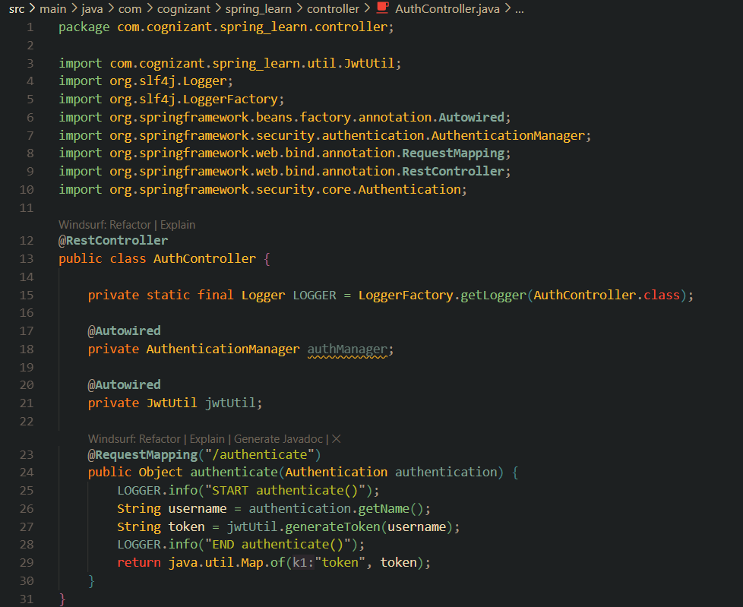

**JwtUtil.java**

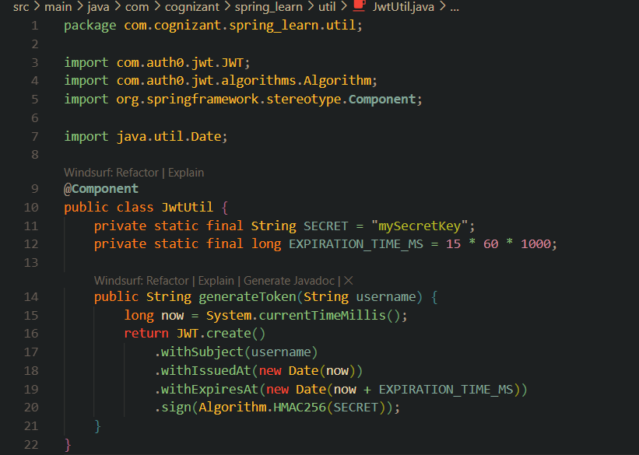

**SecurityConfig.java**

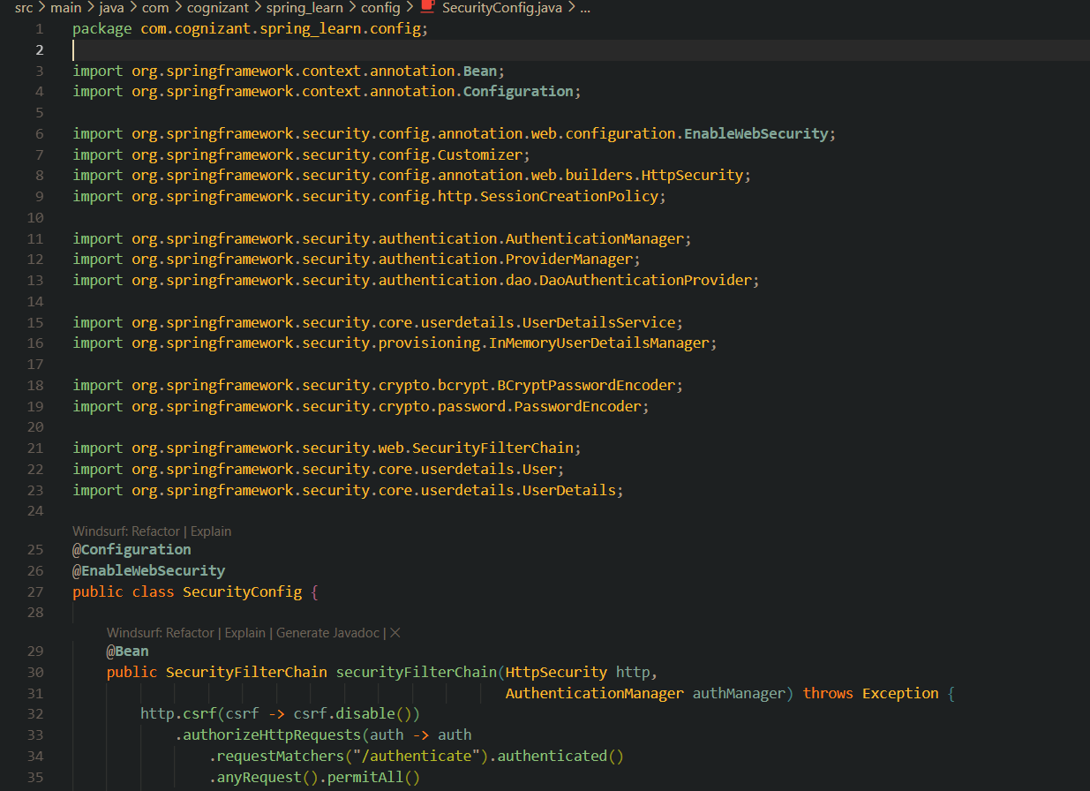

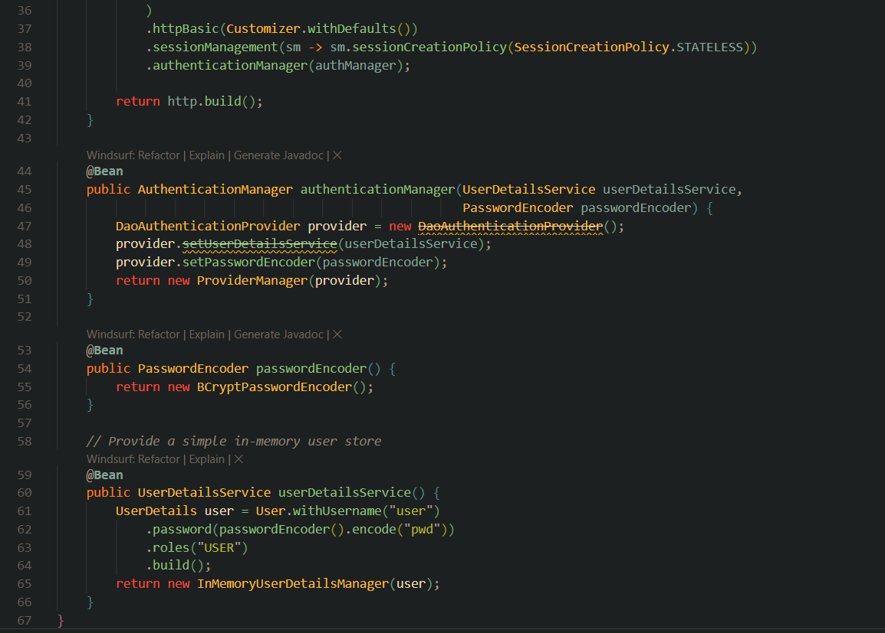

**Output (Chrome Browser)**

