**Week 6**

Create a new React Application with the name “myfirstreact”, Run the application to print “**Welcome to the first session of React**” as heading of that page.

**App.js**

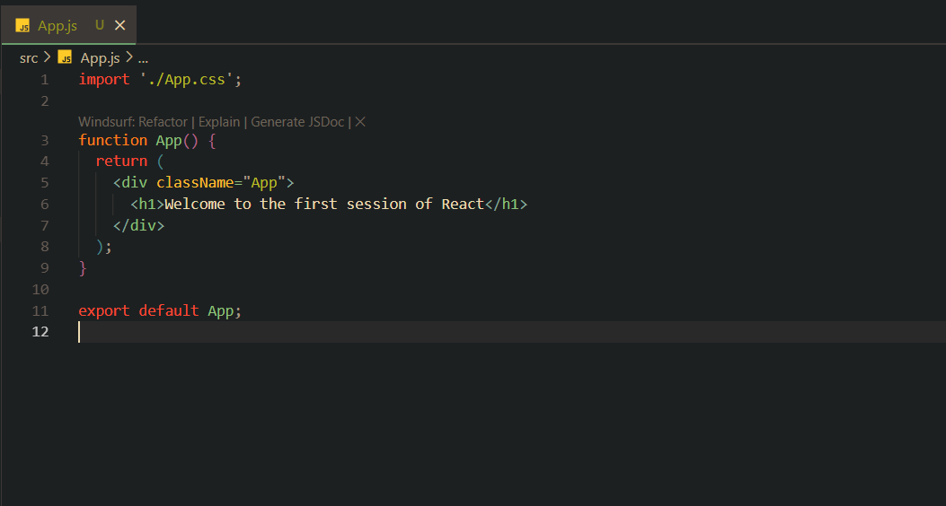

**Terminal**

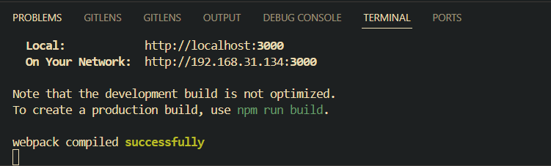

**Output(Browser)**

