**Week 6**

Create a react app for Student Management Portal named scorecalculatorapp and create a function component named “CalculateScore” which will accept Name, School, Total and goal in order to calculate the average score of a student and display the same.

**CalculateScore.jsx**

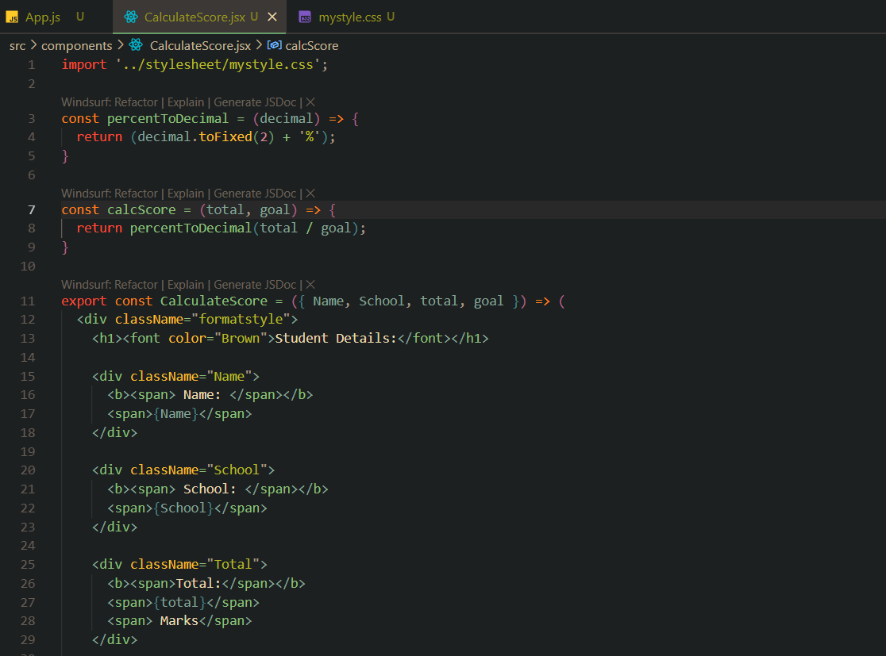

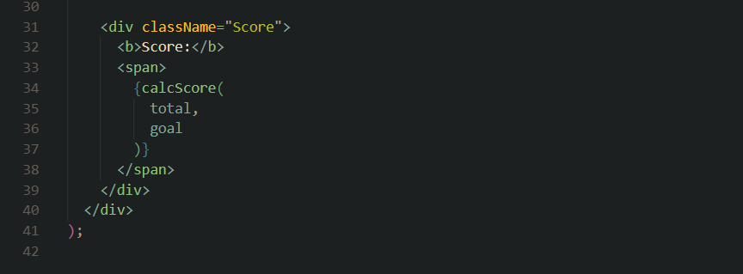

**mystyle.css**

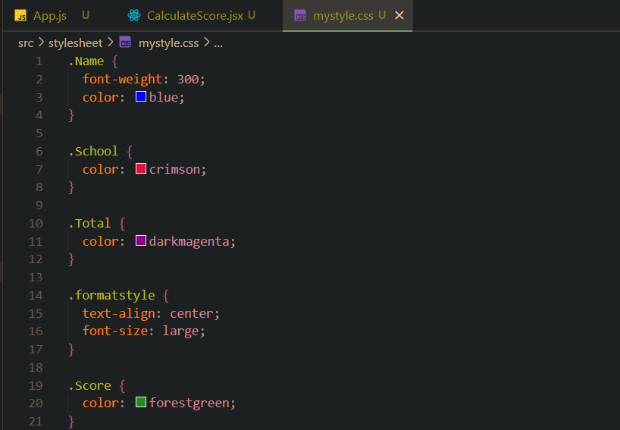

**App.js**

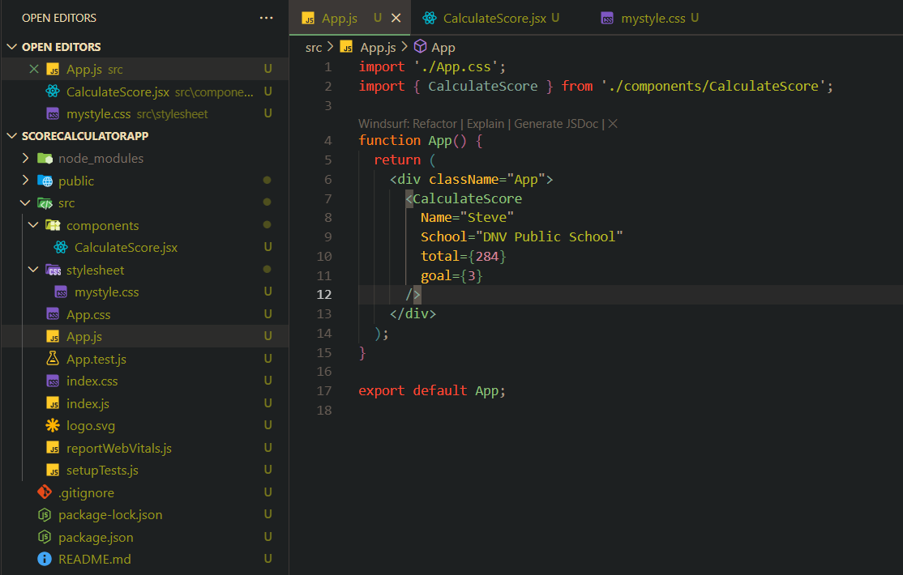

**Terminal**

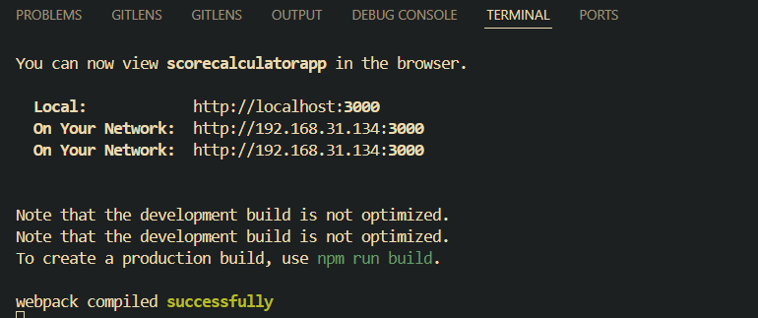

**Output (Browser)**

