Week 8
Git Version:
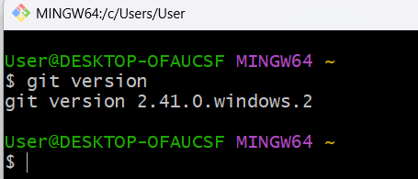

Git Configurations:
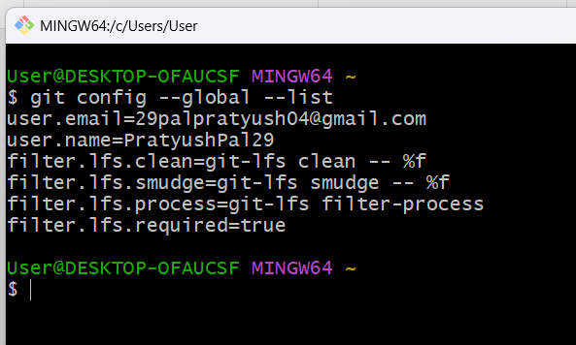

Verify that notepad++ is default editor:
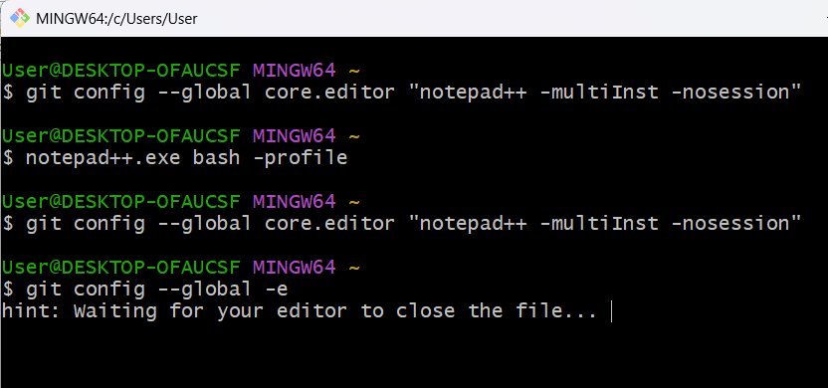

Global Configuration:
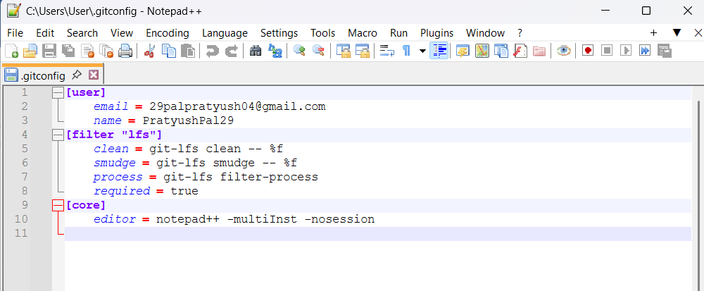
Initialize the GitDemo:
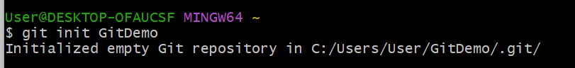
Create the welcome.txt file in the repository:

Verify the file:
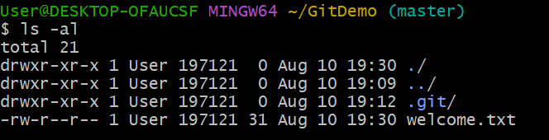
Verify the content:
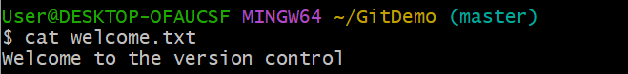
Add the files for staging:
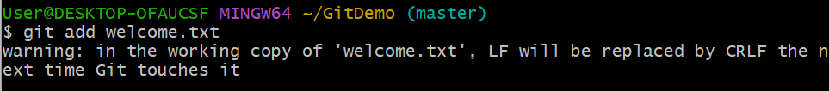
Commit the file:
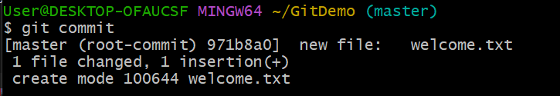
Git status:
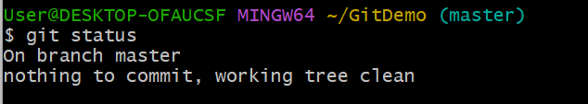

Final commit:
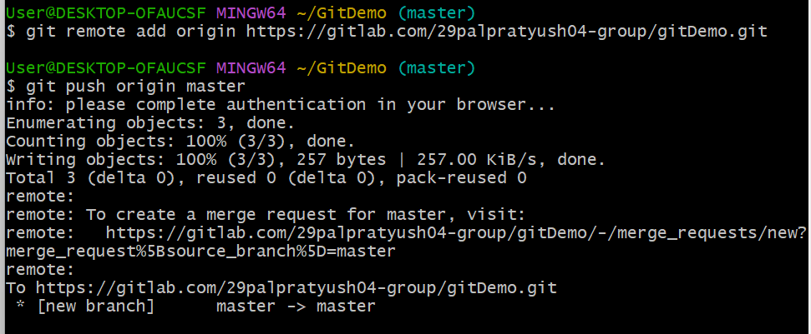

Output (Gitlab Browser):
