Week 8
Creating the debug.log file and log folder with info.txt:
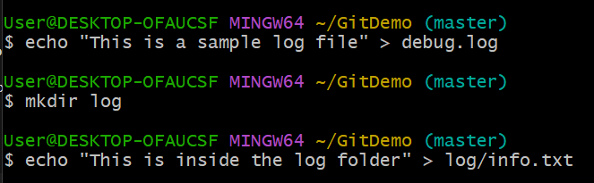
Creating .gitignore:
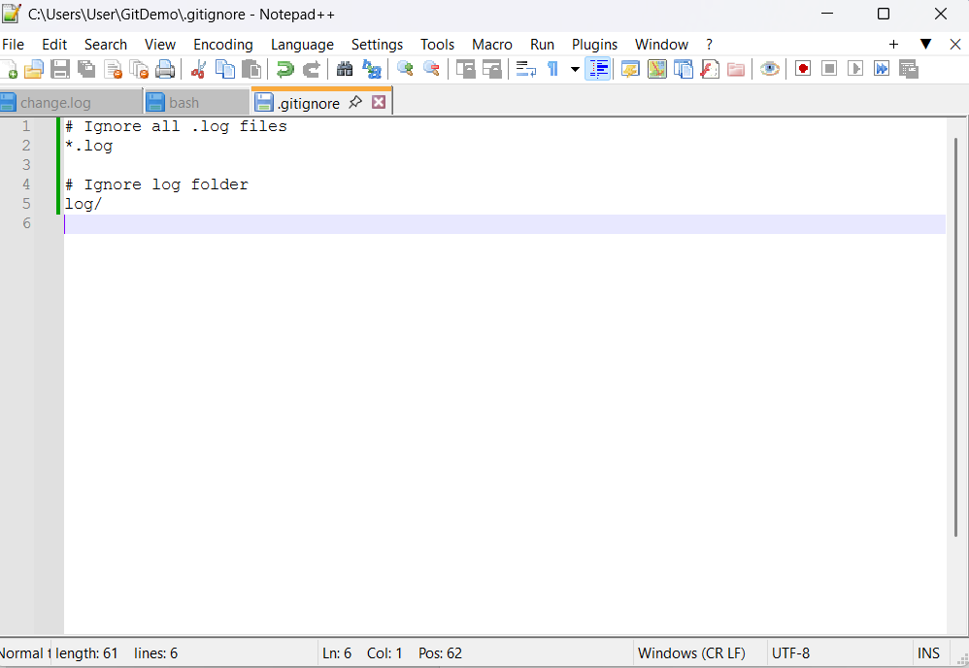

The log files and folders are ignored:
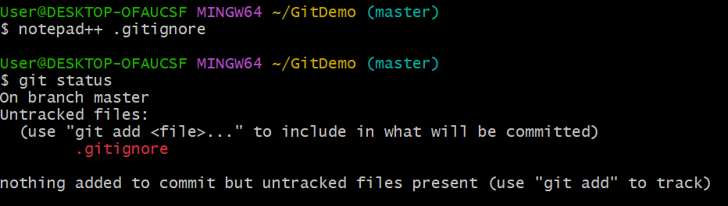
Commit the .gitignore file:
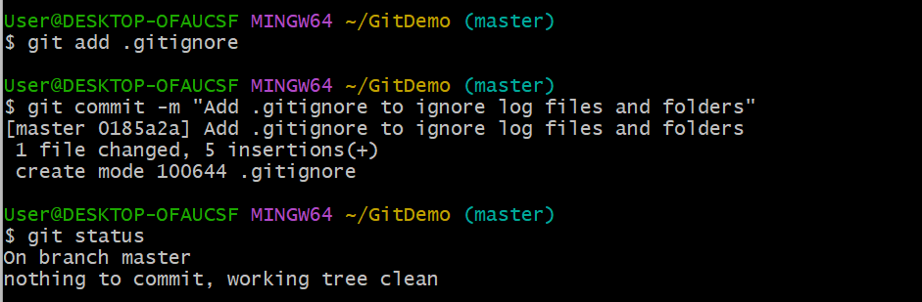
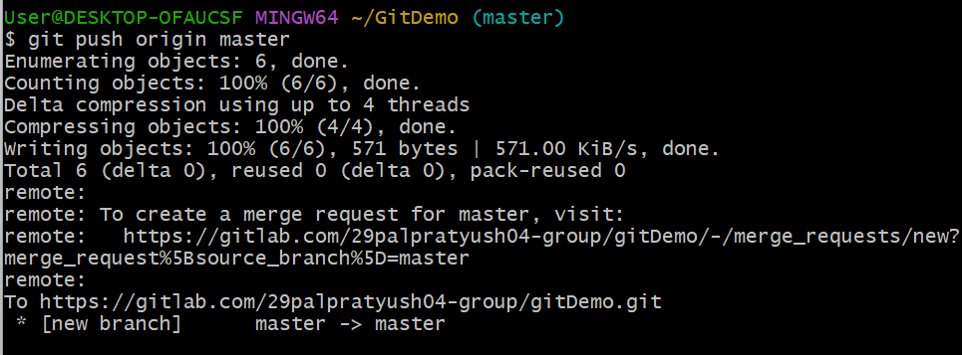
Output (Browser Gitlab)
