Week 8
Creating a new branch and listing the available branches:
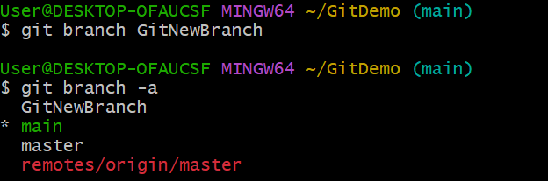

Switching branches and creating 2 files:
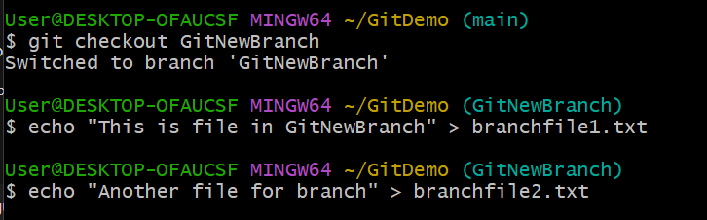

Add the two files:
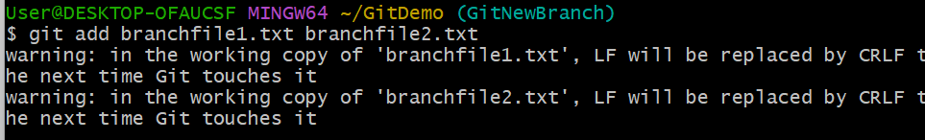
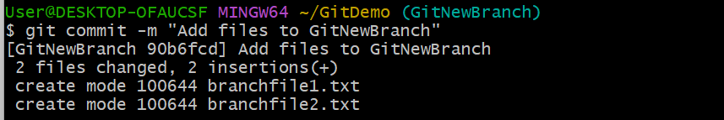

Comparing the two branches:
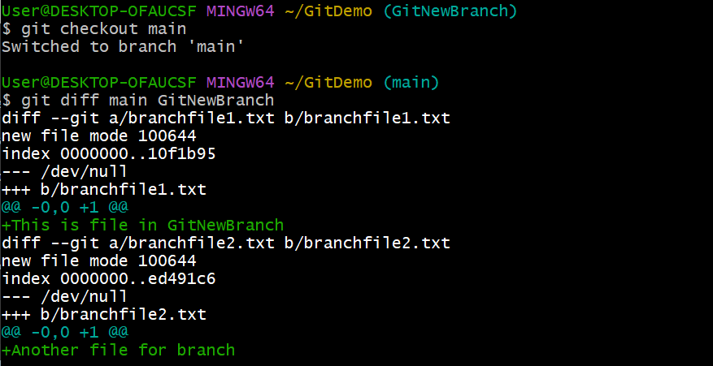
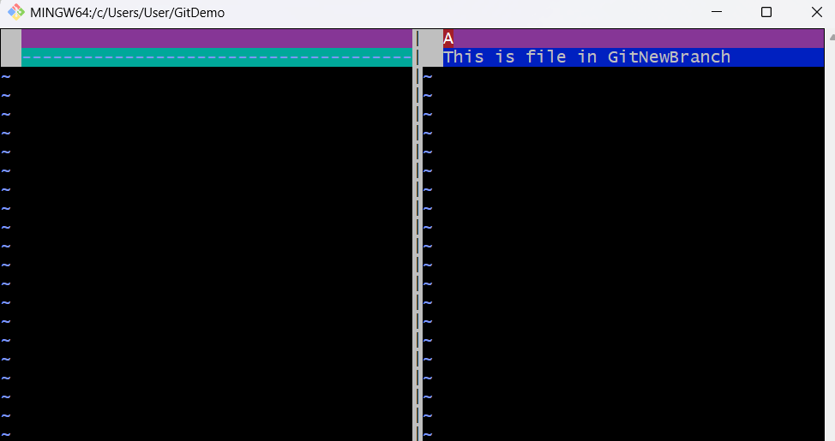
Merge the GitNewBranch in the main:
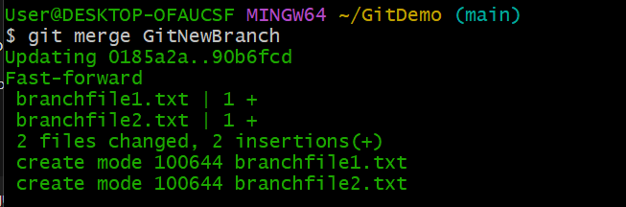
git log --oneline --graph –decorate:
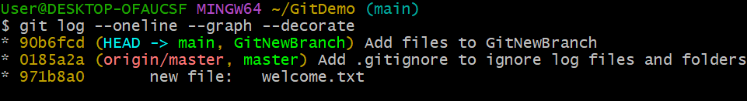
The branch is deleted:
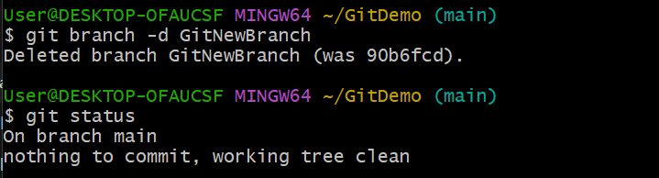
Pushing the code:
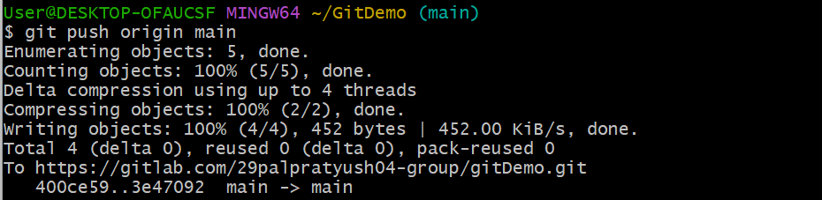
Output (Gitlab Browser):
