Week 8
Verify if master is in clean state:
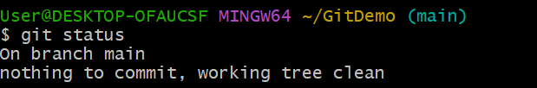
Create branch GitWork and add and edit file:
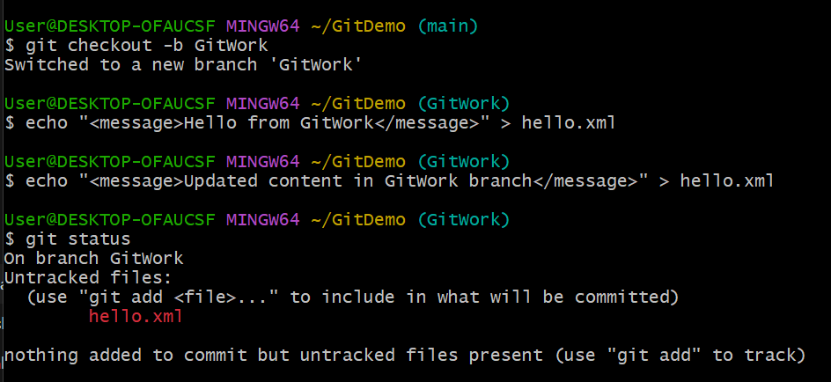
Add and commit hello.xml:
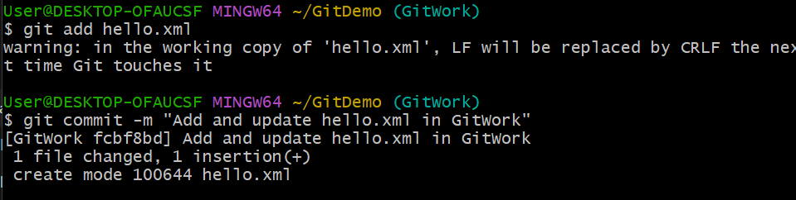
Create a new hello.xml in the main branch:
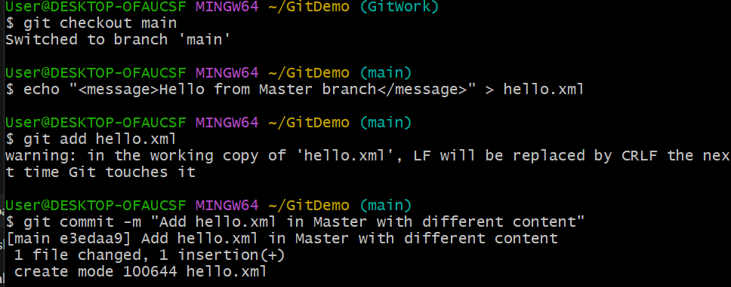
git log --oneline --graph --decorate –all:
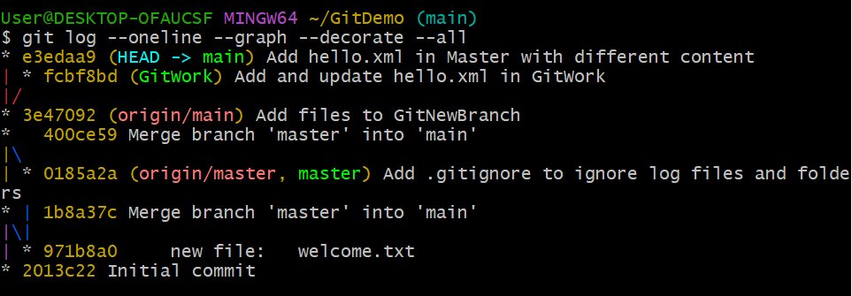
git diff master GitWork:
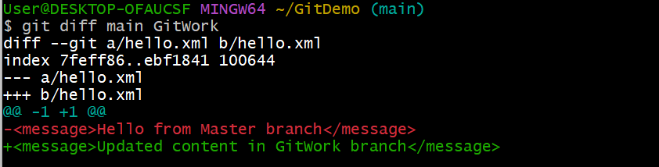
Merge conflict on merge:
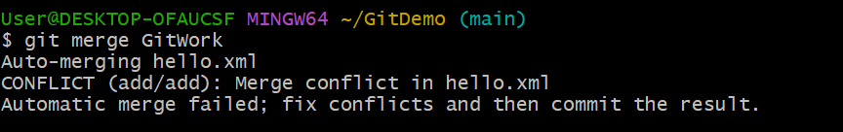
Merge conflict resolved:
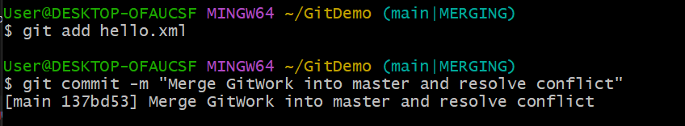

Add .gitignore and commit:
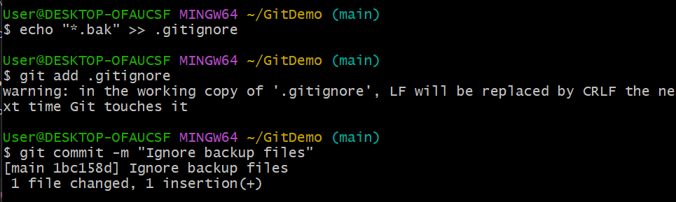
Show the branches and delete the GitWork branch:
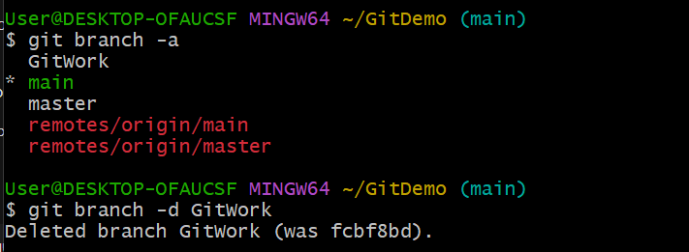
git log --oneline --graph –decorate:
