Week 8
Checking the main in clean state:
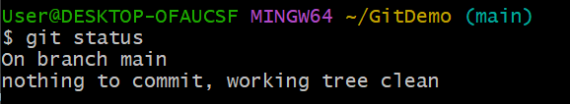

All the branches:
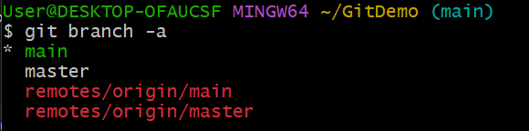

Push the code:
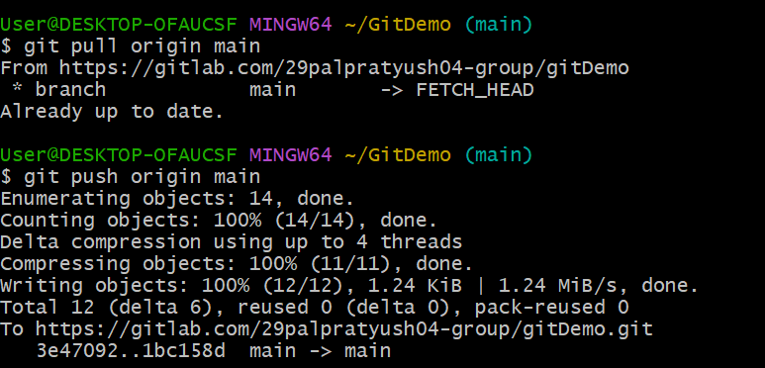

Output (Gitlab browser):
