Week 7
Create a React Application named “officespacerentalapp” which uses React JSX to create elements, attributes and renders DOM to display the page.
App.jsx
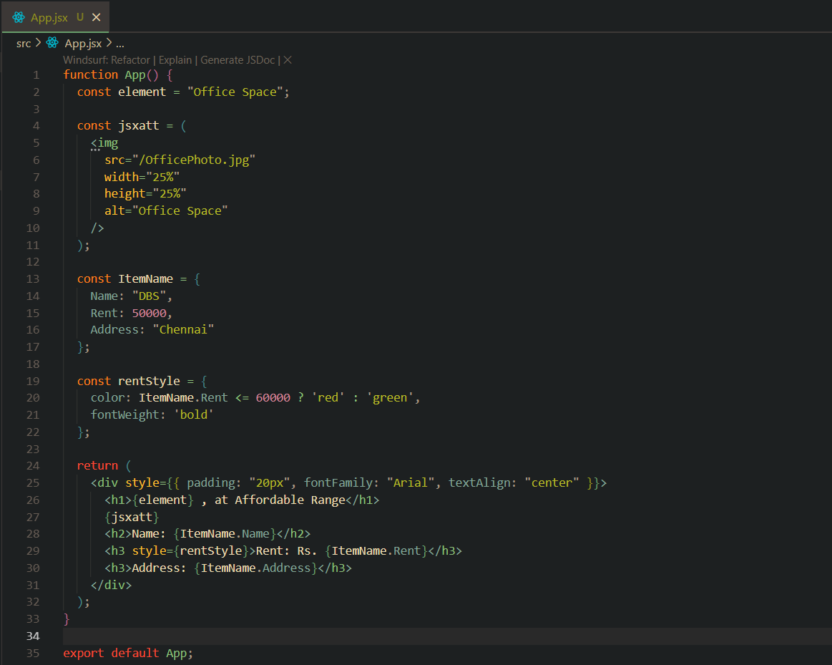

Terminal
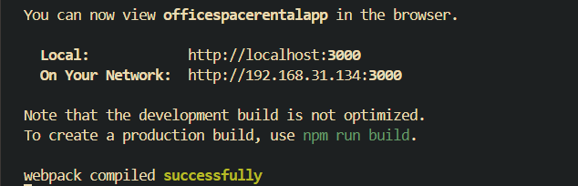

Output (Browser)
