Week 7
Create a React App named “bloggerapp” in with 3 components.

- Book Details
- Blog Details
- Course Details

data.js
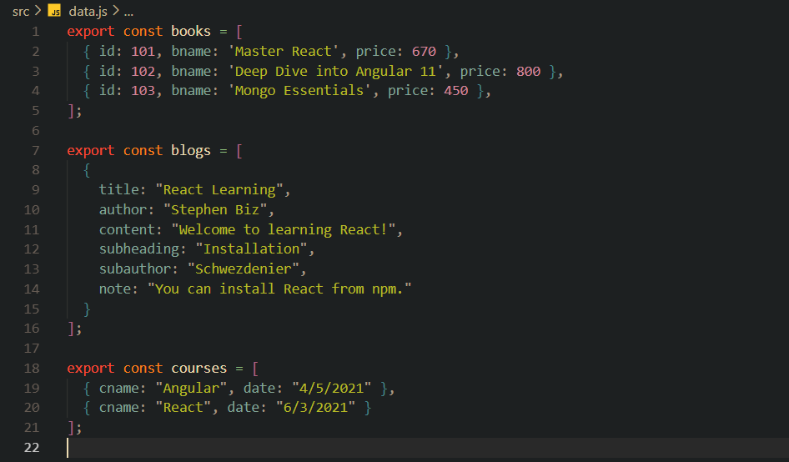
BookDetails.jsx
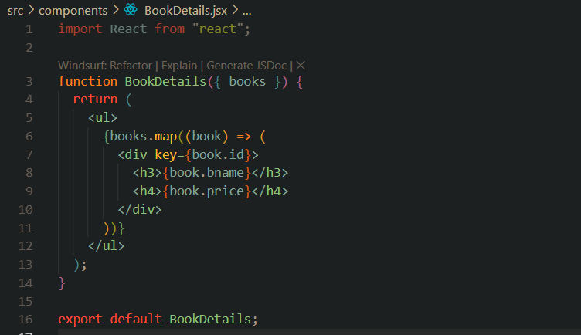
BlogDetails.jsx
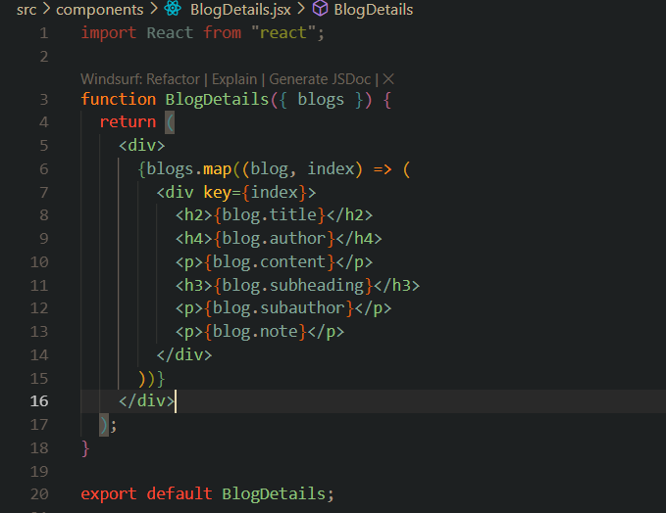
CourseDetails.jsx
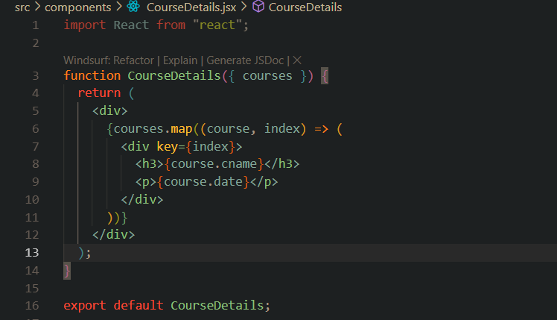

App.jsx
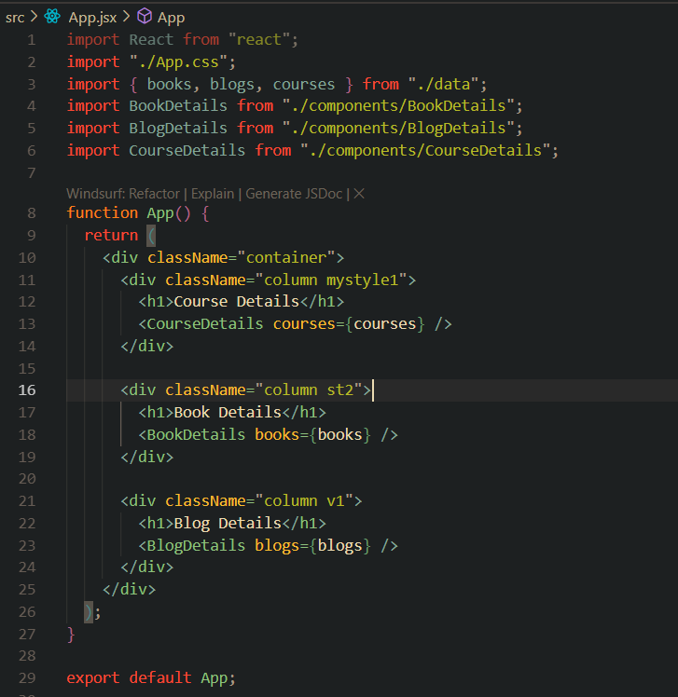

App.css
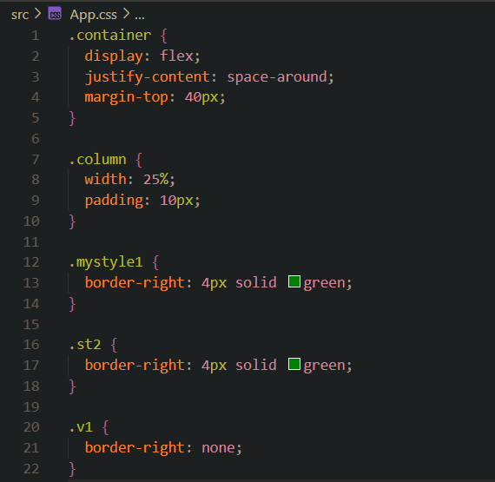

Terminal
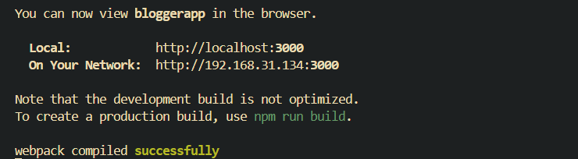

Output (Browser)
