**QUESTIONNAIRE FOR DROPOUTS:**

**VERBAL:**

1. Identify the grammatically CORRECT sentence

a) The woman to who I sold my house was a doctor.

b) The woman that I sell my house was a doctor.

**c) The woman to whom I sold my house was a doctor.**

d) The woman who the house I sold to was a doctor.

2. Choose the exact opposite. Rebuked

a) awarded

b) invited

c) received

**d) praised**

3. He has not recovered fully _______the shock of his failure.

a) Against

**b) From**

c) Of

d) Off

4. To pick holes:

a) To find some reason to quarrel

b) To destroy something

**c) To criticise someone**

d) To cut some part of an item

5. Animate: Find the synonym.

a) Kill

b) Dead

**c) Energize**

d) Calm

**SITUATIONAL (ENTERPRISING):**

1. You are a department manager and you have recently thought of a new procedure that you believe would improve the work process. Some of the employees in your department agree with the change and some do not. One of your employees openly criticizes the idea to your director.

What would you do and why? Choose one option.

a) You decide not to respond to the critics in order to avoid unnecessary conflict.

b) You reprimand the employee for going over your head to the director and work to promote your idea with even more enthusiasm.

**c) You meet the employee for talk and explain that bypassing your authority is unacceptable.**

d) Employees trust in their manager is important so you decide to implement only some of the changes to keep my employees satisfied.

2. While you find a suitcase beneath your seat. You would:

**a) Report the matter to the police**

b) Open up the suitcase to look through its contents.

c) Try to find out the address of the owner from the papers etc., in suitcase.

d) Finding no one to claim it, take it into your own possession.

3. You are interviewed for a new job. Which of the following questions is most important to you?

a) Opportunities for promotions.

b) Remuneration you will be paid.

c) Scope to develop your ideas and use them to improve the working of the organization.

**d) All the above are equally important**.

4. Which expressions are likely to make someone like a stimulus more?

a. Shaking their head

**b. Contracting the zygomaticus major (smiling) muscle**

c. Extending their arm

d. All of the above

5. What type of behaviour might be predicted especially well by implicit measures?

**a. A person’s tone of voice when talking with an outgroup member**

b. A person’s ratings on a scale that measures their feelings of prejudice

c. What a person says to an outgroup member

d. All of the above

**SITUATIONAL (SOCIAL):**

1. While travelling in your car, certain person’s stop you on the way asking you to take an injured child to the hospital. You would-

a) Ask them to leave your way and then drive away

b) Ask them to first call the police

**c) Immediately take the child to hospital**

d) Get out of the ask some other person to help to take the child to hospital

2. Main objective of educational guide is to bring what change in the pupil _____.

a) Psychological development of the child

b) Responsibility of self-direction

**c) Both the above**

d) None of the above

3. Which of following should be considered the most important quality of a teacher at primary level?

a) Eagerness to teach

**b) Patience and perseverance**

c) Competence in method of teaching and knowledge of subjects

d) Competence to teach in highly standardized language

4. A social worker is receiving a client with long-standing depression. It becomes known that the client has racist beliefs. The social worker should:

a) respectfully confront the client’s prejudiced beliefs

b) educate the client about the negative effects of racism

c) refer the client to another therapist who might have similar belief

**d) respect the client’s beliefs and focus on the presenting problem**

5. Parents continually refuse to communicate with their child who is in a residential treatment facility. The social worker should FIRST:

a) Respect the parents need for separation by not contacting them

b. Request that the child be discharged

c. Contact the parents about the child’s placement

**d. Assess the child’s response to the parent’s actions**

**SPATIAL AND TEMPORAL REASONING:**

1. What comes next?

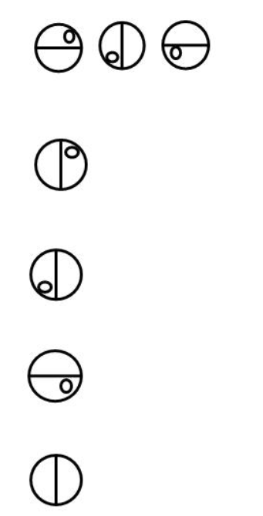

**Ans 1**

2. How many triangles are there in the given figure?

**a) 9**

b) 13

c) 16

d) 11

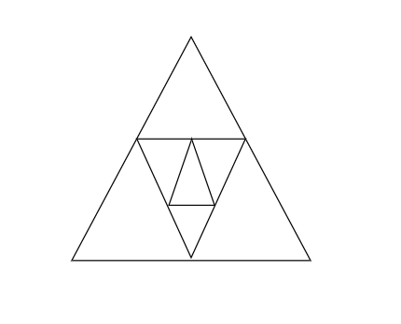

3. Which figure is identical to the first?

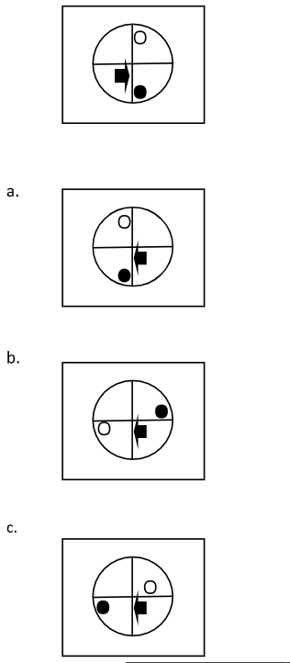

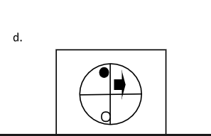

**ANS A**

4. Which option is suitable?

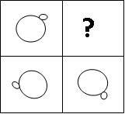

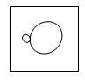

a)

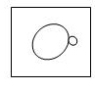

**b)**

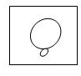

c)

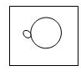

d)

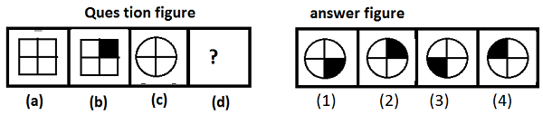5.

**Answer** − Option (2)

**DATA MANIPULATION:**

1.Runs scored by 10 batsmen in a one - day cricket match are given. Find the average runs scored.

23, 54,08,94,60,18,29,44,05,86

**a) 42.1**

b) 55.32

c) 43.6

d) 39.9

2. Accuracy refers to how closely a calculated value agrees with

a) Each other

**b) True value**

c) No other value

d) Same value

3. Precision refers to how closely a calculated value agrees with ______.

**a) Each other**

b) Same value

c) No other value

d) True value

4. The equation x2 +3x+1= 0 is known as

**a) Algebraic equation**

b) Polynomial equation

c) Cubic equation

d) Transcendental equation

5. Study the pie chart below and answer the questions that follow:

[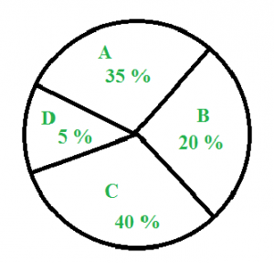](https://media.geeksforgeeks.org/wp-content/cdn-uploads/gq/2016/04/di-pie.png)

The above pie chart shows the sales of four different types of articles in a shop. What is the difference between the central angle of C and D?

**a) 126degrees**

b) 43degrees

c) 120degrees

d) 110degrees

**QUANTITATIVE:**

1. . What is 3/11 divided by 18/44 to the smallest fraction?

a)4/11

b)8/11

**c) 2/3**

d)3/4

2. Five years ago the ratio between ages of Meena and Sita was 3:4. After five years from now the ratio between their ages will be 5:6. Find the present age of Meena?

a) 22 years

b) 25 years

c) 15 years

**d) 20 years**

3. Find the factors of 3m^2+9m+6

**a) -1, -2**

b)-2, -3

c) -1, -3

d) -2, 3

4. What percentage of numbers from to 70 have 1 or 9 in the unit’s digit?

a) 1

b) 14

**c) 20**

d) 21

5. P, Q and R can do a piece of work in 18, 24 and 36 days on the second day and P on the third day, again R on the fourth day and so on. Then in how, many days will the work be completed?

a) 25

**b) 24**

c) 22

d) 20