**QUESTIONNAIRE FOR GRADUATES:**

**DATA MANIPULATION:**

Study the table below and answer the question that follows:

**The Numbers in the Brackets give the Maximum Marks in Each Subject.**

|  |  |  |  |  |  |  |
| --- | --- | --- | --- | --- | --- | --- |
| **Student** | **Subject (Max. Marks)** | | | | | |
| **Maths** | **Chemistry** | **Physics** | **Geography** | **History** | **Computer Science** |
| **(150)** | **(130)** | **(120)** | **(100)** | **(60)** | **(40)** |
| Ayush | 90 | 50 | 90 | 60 | 70 | 80 |
| Aman | 100 | 80 | 80 | 40 | 80 | 70 |
| Sajal | 90 | 60 | 70 | 70 | 90 | 70 |
| Rohit | 80 | 65 | 80 | 80 | 60 | 60 |
| Muskan | 80 | 65 | 85 | 95 | 50 | 90 |
| Tanvi | 70 | 75 | 65 | 85 | 40 | 60 |
| Tarun | 65 | 35 | 50 | 77 | 80 | 80 |
|  |  | | | | | |
|  | | | | | |
|  | | | | | |

1. What are the average marks obtained by all the seven students in Physics?

a) 77.26

**b) 89.14**

c) 91.37

d) 96.11

2. The number of students who obtained 60% and above marks in all subjects

a) 1

**b) 2**

c) 3

d) None

3. What was the aggregate of marks obtained by Sajal in all the six subjects

a) 409

b) 419

c) 429

**d) 449**

4. In which subject is the overall percentage best?

**a) Maths**

b) Chemistry

c) Physics

d) History

5. What is the overall percentage of Tarun?

a) 52.5%

b) 55%

**c) 60%**

d) 63%

**QUANTITATIVE:**

1. A dealer buys an article marked at Rs. 50,000 at 25% and 10% successive discount. He spends Rs. 5000 on its repair and sells it for Rs. 50,000. What is his loss or gain percentage?

a) 33.63% loss

b) 26.43% gain

c) 1.25% gain

**d) 29.03% gain**

2. What is 3/11 divided by 18/44 to the smallest fraction?

a)4/11

b)8/11

**c) 2/3**

d)3/4

3.. The cost price of 20 articles is the same as the selling price of x articles. If the profit is 25%, then the value of x is:

a) 15

**b) 16**

c) 18

d) 25

4. What percentage of numbers from 1 to 70 have 1 or 9 in the unit’s digit?

1. 1

2. 14

**3. 20**

4. 21

5. Tickets numbered 1 to 20 are mixed up and then a ticket is drawn at random. What is the probability that the ticket drawn has a number which is a multiple of 3 or 5?

1. 1/2

2. 2/5

3. 8/15

**4. 9/20**

**VERBAL:**

1. Replace the phase printed in **bold.**

The orator **had been left** the auditorium before the audience stood up.

a) had been leaving

b) was left

**c) had left**

d) No correction required

2. Find the correct alternative for the underlined world.

His speech *went down well with* the majority of the audience.

a) found acceptance with

b) was attentively listened to by

c) **was appreciated by**

d) was applauded by

3. Pick out the most effective word from the given words for the underline.

Government buildings are _______ on the Republic Day.

a) enlightened

b) lightened

**c) illuminated**

d) glowed

4. Pick up the most nearest word for the word written in **bold**

No one will invite her to a tea party for she is so **garrulous**

**a) talks a lot**

b) giggles all the time

c) laughs a lot

d) repeats gossip

5. Choose the one which can be substituted for the given sentence

To slap with a flat object

a) Chop

b) Hew

c) Gnaw

**d) Swat**

**SITUATIONAL (ENTERPRISING):**

1. In the elaboration likelihood model, what motivates people to “elaborate” on a message?

1. **Wanting to have correct attitudes**
2. Wanting to have consistent attitudes
3. Wanting to agree with others
4. All of the above

2. Suppose one day you decided to support a new policy that had been recommended by an expert. What route was most likely used to persuade you?

1. Central route
2. Peripheral route
3. Both routes simultaneously
4. **It depends**

3. If your friend manages to convince you of something by using a very long list of arguments, which route to persuasion is in effect?

1. Central route
2. Peripheral route
3. Both routes simultaneously
4. **It depends**

4. What type of behaviour might be predicted especially well by implicit measures?

1. **A person’s tone of voice when talking with an outgroup member**
2. A person’s ratings on a scale that measures their feelings of prejudice
3. What a person says to an outgroup member
4. All of the above

5. If you respond more quickly to the word “great” than you do to the word “terrible” after being primed with a picture of a puppy, what might you conclude from this event?

1. You have a relatively strong association between puppies and greatness
2. Your attitude toward puppies is relatively accessible
3. **Both A and B**
4. Neither A nor B

**SITUATIONAL (SOCIAL):**

1. A fifteen year old girl has been sent home from school on three occasions for drinking alcohol at school. Each time, the mother becomes angry and threatens to punish the girl but is convinced by the father to give her another chance. Which of the following BEST characterizes the father's behaviour in this situation?

a) Triangulation

**b) Enabling**

c) Advocating

d) Manipulating.

2. Which of the following approaches would be MOST appropriate to use in evaluating client satisfaction with the social worker's provision of services?

a) using a single system design, evaluate the quality of services

b) in the final interview, ask the client about their level of satisfaction

c) after submitting process recordings, ask supervisor for feedback

**d) at termination, ask clients to complete a service evaluation and satisfaction form**

3. When conducting an assessment of the risk factors of child abuse for a child of a different ethnic background, a social worker must FIRST:

a**) be aware of how personal cultural biases affect the social worker's ability to deal with issues of diversity**

b) realize that assessment models are not a substitute for clinical judgment or experience

c) use a strengths' perspective rather than a deficit model to form a partnership with the child's family

d) understand the need for appropriate eye contact, tone of voice and question techniques during the assessment

4. Social Work refers to

a) Providing social service to people

**b) Helping people to help themselves**

c) Organizing charitable works

d) Orphanages, destitute homes, poor homes

5. Parents continually refuse to communicate with their child who is in a residential treatment facility. The social worker should FIRST:

a) Respect the parent's need for separation by not contacting them

b) Request that the child be discharged

c) Contact the parents about the child's placement

**d) Assess the child's response to the parents' actions**

**SPATIAL/TEMPORAL REASONING:**

1. Which option will suit the given figure

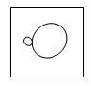 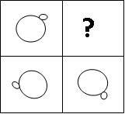

a)



**b)**

c)

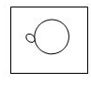

d)

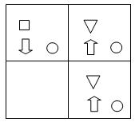

2.

**a)** 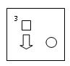

b) 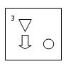

c) 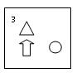

d) 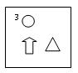

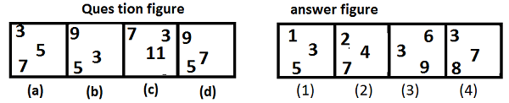

3.

**Answer** − Figure (1)

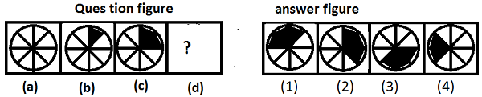

4.

**Answer** - Option (2)

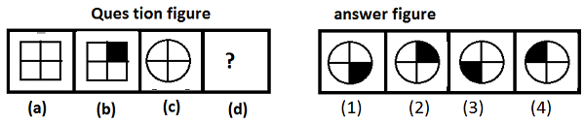

5.

**Answer** − Option (2)