**PRATYUSH LENKA T**

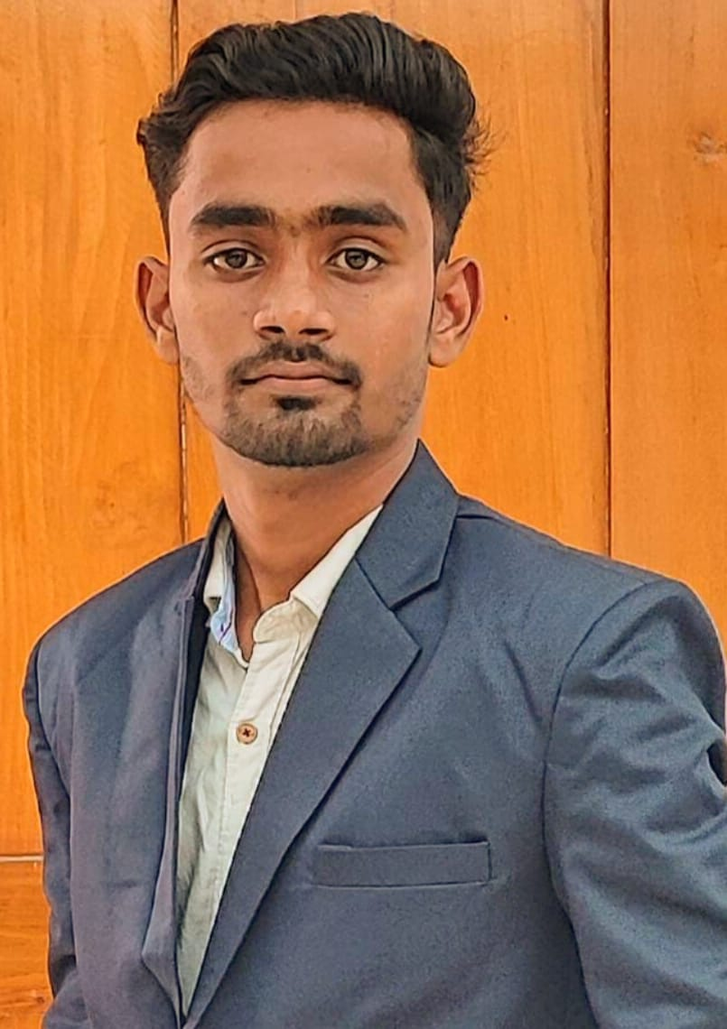

**Email:** pratyush2003raj@gmail.com

**Mobile** :+91 9498387853

**CAREER OBJECTIVE:**

Self-motivated and hardworking fresher seeking for an opportunity to work in a challenging environment and use my knowledge for the growth of the organization.

**ACADEMIC QUALIFICATION**:

|  |  |  |  |  |
| --- | --- | --- | --- | --- |
| **COURSE** | **INSTITUTION** | **UNIVERSITY/BOARD** | **YEAR OF PASSING** | **PERCENTAGE /CGPA** |
| B-TECH | Velammal Institute of Technology, Chennai | Anna University ,  Chennai | 2022-2026 | 8.3 |
| HSC | DR Nalli Kuppuswami Vivekananda Vidyalaya, Chennai | CBSE | 2022 | 70.0 |
| SSLC | DR Nalli Kuppuswami Vivekananda Vidyalaya, Chennai | CBSE | 2020 | 76.5 |

**TECHNICAL QUALIFICATION**:

**Programming languages known**: Python

**Others**  : MS Office (Word, Power point, Excel)

**SUBJECT OF INTEREST:**

* UI Design
* Cloud (AZURE)

**CO-CURRICULAR ACTIVITIES:**

* Participated in the event "**SPACE HACKATHON 2023**” organized by India International Science Festival and powered by Hack2skill.
* Participated and won **Best Performer** in the workshop during Industrial Visit conducted by "DATADNA" Chennai.
* Participated in the "**LARGE LANGUAGE MODELS** “conducted as a part of TALOS 3.0 National level technical workshop organized by Chennai Institute Of Technology.

**EXTRA-CURRICULAR ACTIVITIES:**

**SPORTS**: Has participated in the Anna University Zonal Level Cricket Tournament for the 2022-2023 at Vel Tech High Tech, Chennai from 16.10.2023 19.10.2021

**PERSONALITY TRAITS:**

* Fast Learner
* Leadership
* Adaptable

**ACHIEVEMENTS:**

* Placed as first in the event **"BINARY BRIANS OZMENTA24** conducted In Velammal Engineering Collage on 20 JANUARY 2024
* **Won SILVER medal in Anna University Zonal Level** Cricket Tournament conducted by Anna University of Chennai in 2023
* Completed internship in “**PYTHON PROGRAMMING**” at InternPe from 04.03.2024 to 31.03.2024.

**PERSONAL DETAILS:**

**Father's Name:** Mr. Thanuj Kumar Lenka

**Date of Birth:** 30/11/2003

**Languages Known :** Tamil, Hindi, Odia and English

**Residential Address** : 143C Pillaiyar Kovil Street Panchetti Village Ponneri-601204

**Hobbies**

* Listening Music
* Sports

**DATE:** 14-08-2024

**PLACE:** PONNERI **(Pratyush Lenka)**