Q1, create a user group and assigned that group with read only permissions of EC2 and S3 services

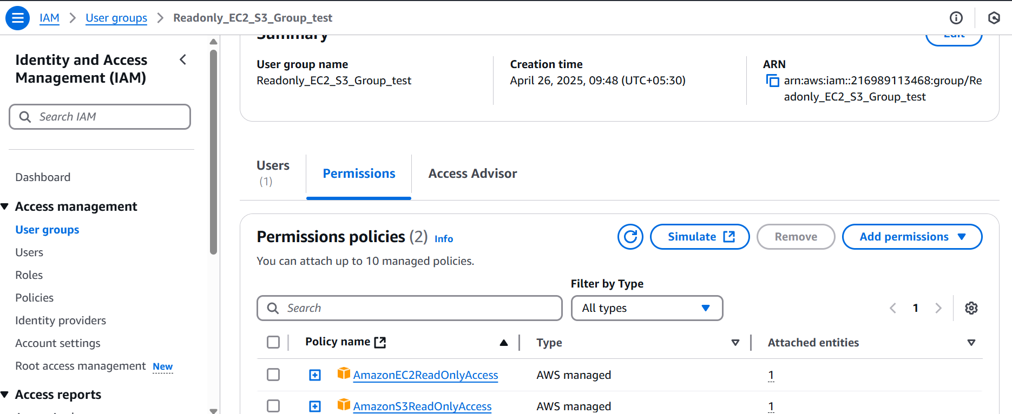

Q2. create a role and assign that role with the permission to handle the RDS and EC2 feature only.

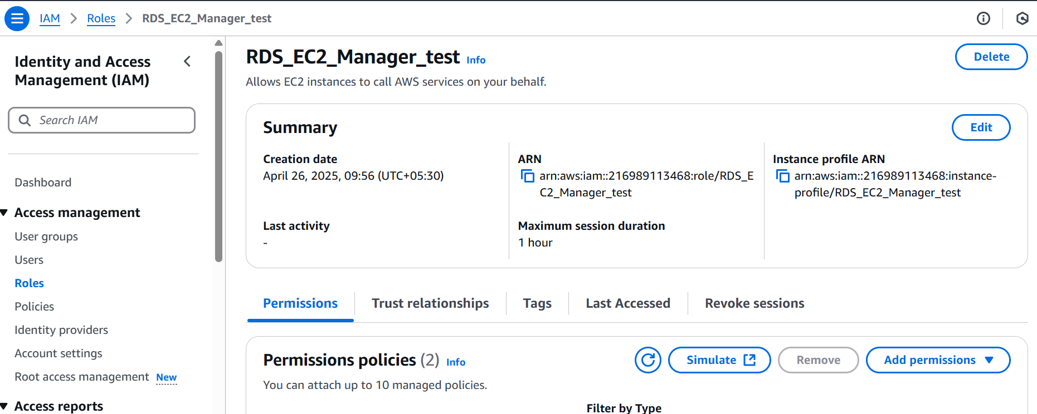

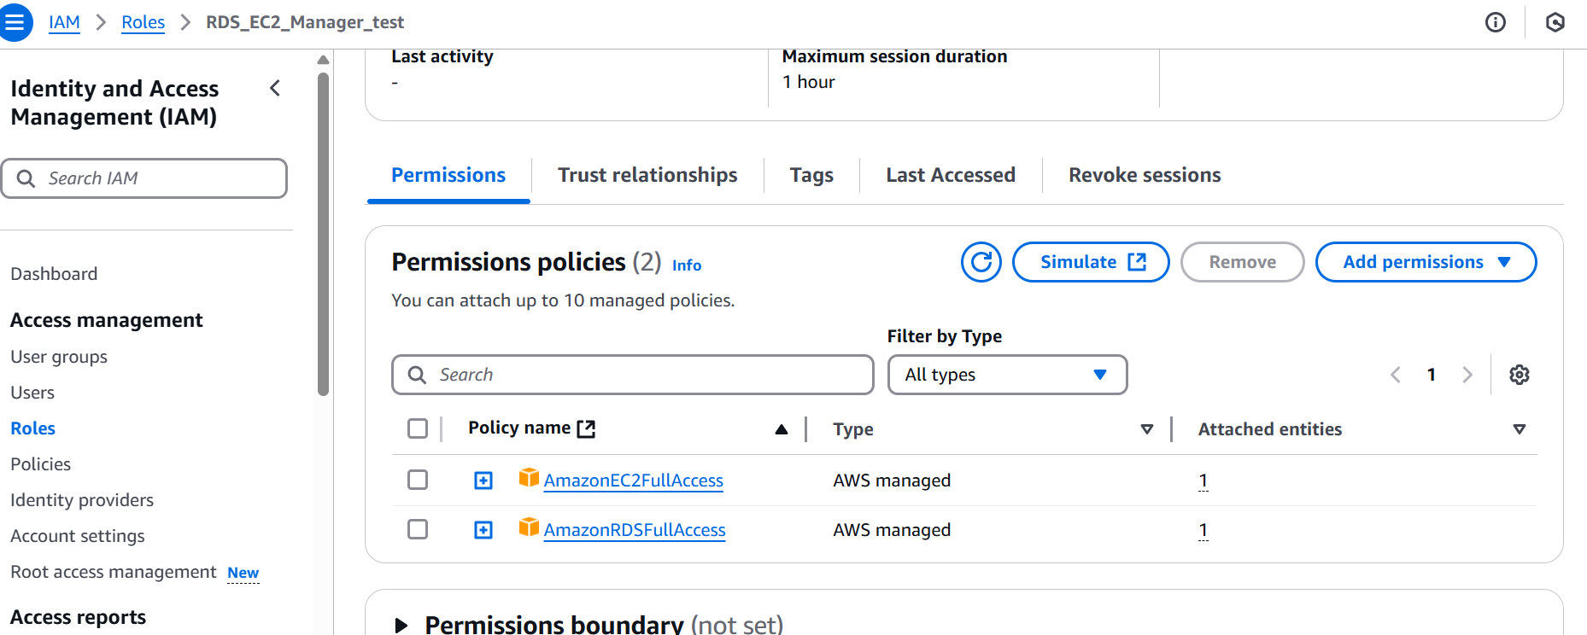

Q3. create one S3 bucket and upload two images into it and from the IAM user who has only access to IAM (not any other role) create a new user

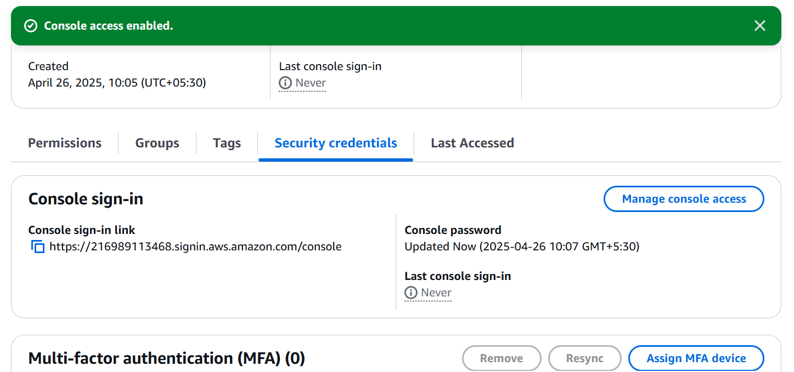

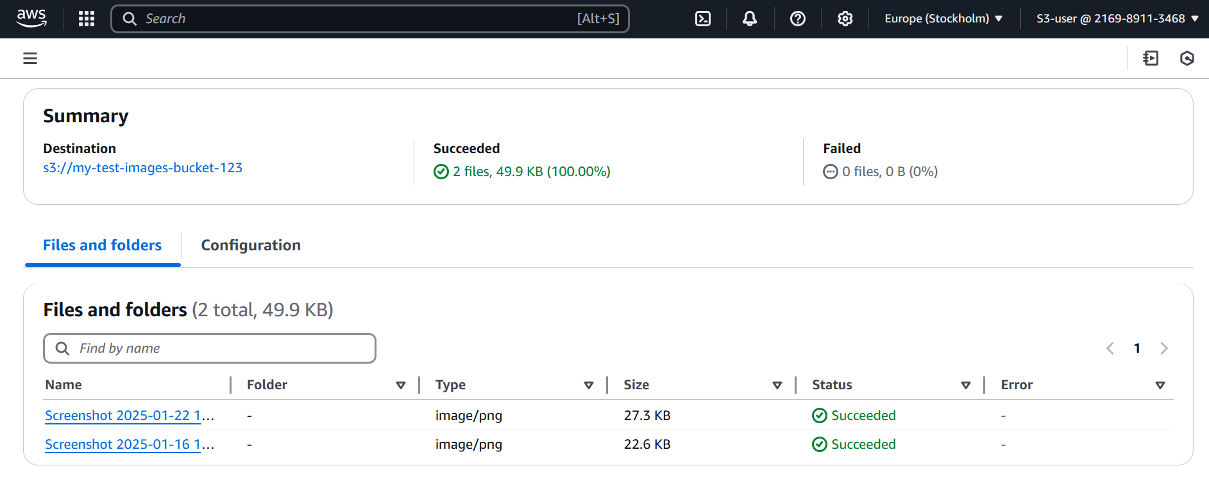

Q4. launch 1 EC2 instance and try to attach EBS volume of 4 GB with it After that remove the EBS volume and detach it and also take snapshot before detatching

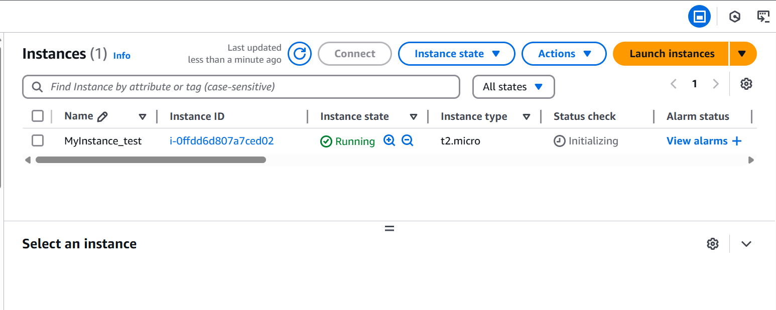

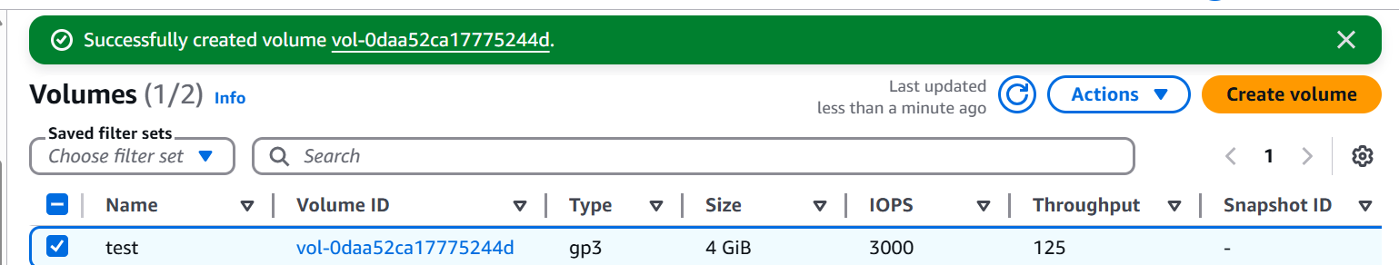

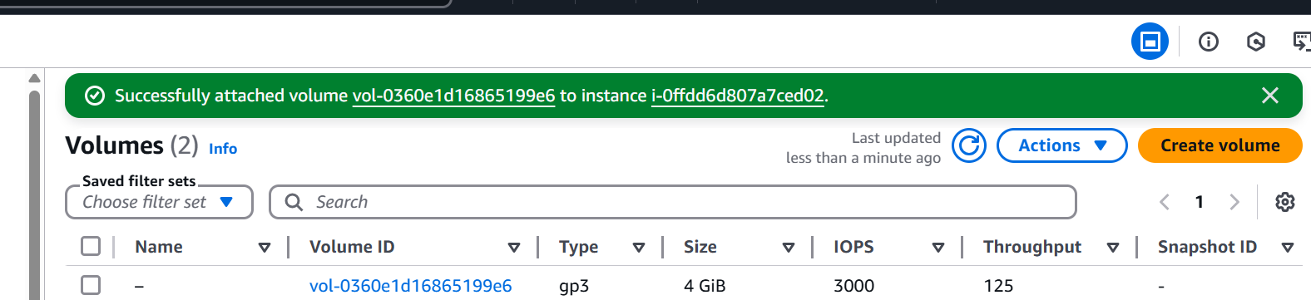

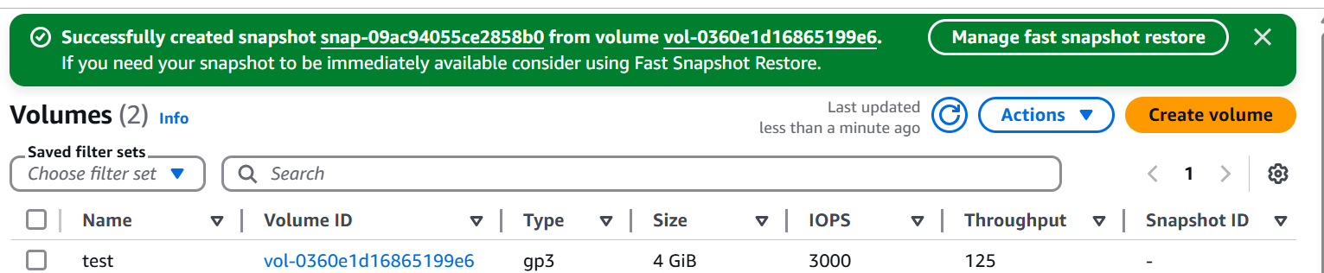

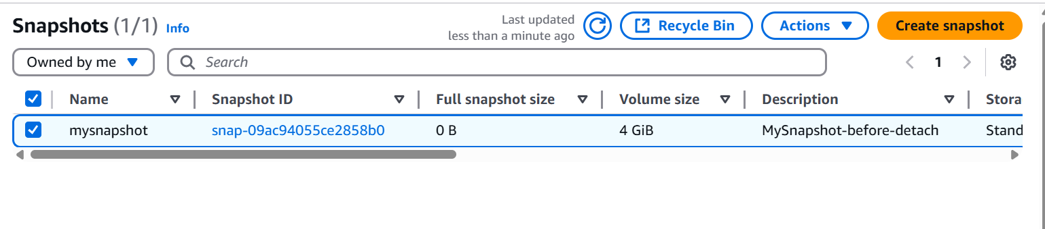

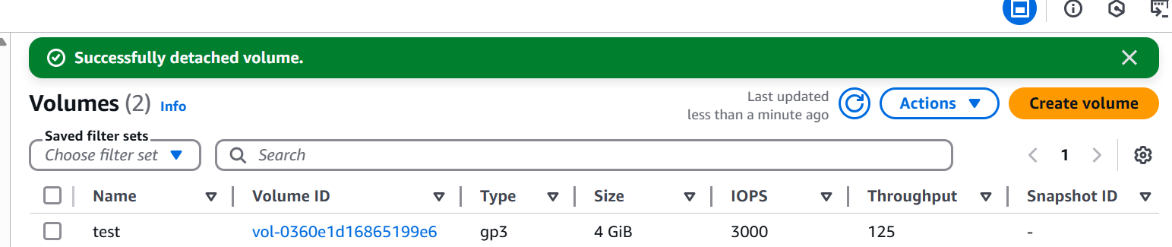

Q6. create 1 cloudformation template to launch 1 EC2 with the security groups attached to it.

